Appendix

This is a document explaining everything about Kingdoms of Catan.

This is a custom expansion for the base game Catan, but works with Seafarers and other expansions as well.

# Extra Pieces Included

- 1d12 Communist Die

- Egyptian Pyramid piece

- Constantinople piece

- Khan piece

- 8 Chinese Year Development Cards (4.4cm x 6.8cm) (520px x 804px)

- 1 Hinduism Development Card

- 4 Indus Water Wells

- (*) 1 extra 5. token, and one extra 9. token (for Japan) (you can use another expansion’s pieces)

- (*) 1 extra 4. token, and one extra 10. token (for Aztec) (you can use another expansion’s pieces)

- (*) 4 Dacian Barbarian settlements (you can use the 5-6 player expansion’s pieces for them)

- (*) 5 extra Aztec hexagonal tiles, one for each resource (only if you don’t have 5 extra spares)

# How it works

Before the game starts, have each player choose a Civilization card (or distribute them randomly).

Each Civilization card provides 3 special powers to that player (e.g. extra buildings, extra rules, etc).

These are usually simple, but game-changing powers.

Civilizations should be fairly balanced, so none should be much stronger than another.

If any of the powers seem strange, consult the **Weird Civilization Powers Explained** section of this appendix.

# Special Rules

When playing with Catan: Civilizations, apply the following rules:

- **Longest Road** is worth only **1 Victory Point**

- **Largest Army** is worth only **1 Victory Point**

- **China** and **Greece** can only be in games with at least 3 players

- Certain Civlizations have a fixed turn order (this is written on some Civilization cards) (e.g. don’t roll to see who goes first).

# Weird Civilization Powers Explained

## **Aztecs**

The first time you build a settlement using resources (NOT placing your starting settlements), you can take one hexagonal Tile that's unused (e.g. from another expansion) and place it directly on the edge of the board (you choose if it intersects with 2 tiles or just 1 tile). Now, your new settlement should be on the intersection of a normal tile (or 2 normal tiles) and the new tile. Then add either a 4 or a 10 token to it.

The new tile you just placed acts as a normal tile. Other players can use it too if they have a settlement near it.

If you're playing with expansions, you can only place a standard resource tile (e.g. Gold tile is not allowed).

If you're playing with Seafarers and you build your settlement right near a water tile, you can replace the water tile with another normal resource tile.

If the tile overlaps any ports, those ports are no longer usable.

## **Egypt**

For Excavation Roads, you can literally build 2 roads directly ON a hexagonal tile. The advantage is you can connect 2 opposite corners using only 2 roads instead of 3 if you used normal edges (and also other players can't block your road construction as easily). This is optional, of course.

The 2 roads must be built at the same time (on the same turn).

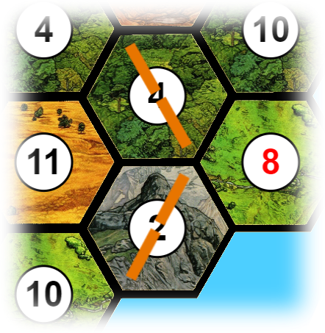

## **Indus**

For Peacefulness, you can use any resource to substitute for Ore.

For example, instead of paying 1 Sheep, 1 Wheat and 1 Ore for a Development card, you can pay 1 Sheep, 1 Wheat and 1 Wood, or 2 Sheep and 1 Wheat, and so on. Note that you don't gain Ore even if you have a settlement near a Mountain tile!

For **Hinduism**, the effect is the same as Year of Plenty for the player drawing it. Then, the Hinduism card goes to the Indus player to mark that Hinduism has started. From now on, the Indus player can use Ore as if it were any other resource. For example, the Indus player could build a road with 1 Wood and 1 Ore, or 1 Brick and one Ore, or even 2 Ores! Also, the Indus player can now gain Ore from Mountains with adjacent Settlements normally.

The Hinduism card starts as the 7th card in the deck, e.g. 6 other Development cards need to be drawn to get to Hinduism.

**NOTE**: Whenever the deck is shuffled, the Hinduism card stays on the same position. For example, if it is currently the 4th card in the deck and the deck must be shuffled, shuffle the deck without Hinduism, then put Hinduism back as the 4th card.

## **Dacians**

After each player has finished placing their pieces, take 4 extra settlements of no color (e.g. use a color that’s not in the game) and place them wherever you like (respecting the minimum 2 edge distance limit).

If anyone has a road leading to one of those settlements, they can effectively buy the settlement for (1 Wood, 2 Sheep, 1 Ore). If you do, replace the settlement with one of yours.

**Note**: you can’t have more settlements than the number of available settlement pieces (5)! If you have no settlement piece available, you can’t buy a barbarian settlement.

You, as the Dacian, can buy these settlements for any 3 of the 4 mentioned resources.

Regarding Blend In, you can build roads on edges other players already have roads, and other players can build their roads on edges where you have roads.

Regarding Zamolxis, if you shuffle a used knight back into the deck, choose either to move the robber without drawing a resource from a nearby player, or draw 1 resource from a player who has a settlement near where the robber currently is, without moving the robber.

## **Mesopotamia**

In the example image, the City of Babylon is placed between the 3. and the 9.

It produces resources from the 6. (ore), 3. (Wood), 9. (Sheep) and 5. (Wood).

The semi-roads are normal roads filling the rest of the edge where the City of Babylon is. Semi-roads count as normal roads, and can’t be built normally.

Settlements can’t be placed too close to the City of Babylon. For example, the intersection of 6. (ore), 3. (wood) and 9. (sheep) is not usable for settlements, but 6. (ore), 2. (wheat) and 9. (sheep) is usable.

Naturally, you need to have more roads leading to those intersections to build settlements.

## **Arab**

Assuming you are the purple player, given this situation, the closest settlement with no roads blocking the way to your settlement is the orange one on the bottom left. The orange one on the top is not valid because it has a road blocking the way.

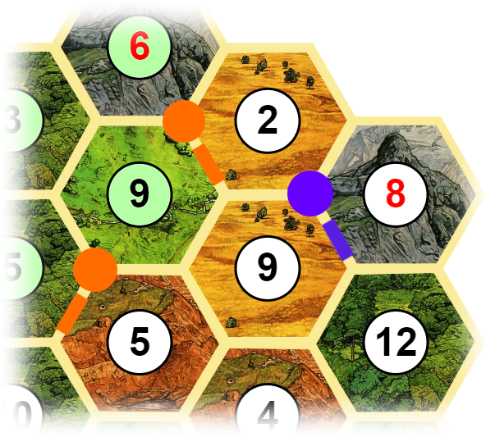

So, you build roads to connect your purple settlement to the bottom left orange settlement.

