Applying Machine Learning to Detect Somatic Structural Variation in Bulk Whole Genome Sequencing

Dan Averbuj
Thesis

San Diego State University 2020

Abstract:
Somatic structural variation (SSV) is an established hallmark of cancer and is emerging as an important contributor to the pathogenesis of neurological diseases such as autism and schizophrenia, but detecting SSVs in silico is challenging due to the extreme imbalance of false positive predictions to true positive events. While many methods have been able to successfully resolve germline structural variation (GSV) detection, unbiased SSV detection remains particularly difficult due to the dampened signal in comparison to GSV. Existing somatic variant callers are limited by detection of only single nucleotide variants and mobile-element insertions, targeting of tumor cells, or suffer from low resolution from using

methods employed by microarrays. Here, I developed a machine learning method to classify detect and filter GSV and SSV, processing an initial prediction set of millions of SVs down to a manageable number of high confident predictions. The program, named CHONK, utilizes machine learning to aid in the discovery and filtering of SSV using alignments from bulk whole genome sequencing. CHONK operates on unpaired samples and is able to confidently identify GSV, and SSV with wide degrees of allelic frequency (down to 1%) and varying length (50bp – 1Mb). The GSV classifier employs a random forest model; genotyping with a false discovery rate (FDR) of 3-12%, sensitivity of 88-99%, and an area under the receiver operating characteristic curve (ROC) of 91-99%, depending on the size and type of SV. CHONK’s germline genotyping performance is comparable to existing commonly-used genotypers, and outperforms when genotyping large (≥1kb) deletions and duplications. The SSV classifier also uses a random forest classifier; predicting somatic events with an FDR of 9-26%, sensitivity of 25-85%, and ROC of 62-91%, depending on the size and type of SV. This application will help detect these elusive mutations and help researchers and clinicians further their understanding of the effects of mosaicism on evolution and disease.

Introduction
Structural variations (SVs) are mutations in the DNA larger than 50 nucleotide base pairs 1. Due to their size, these mutations alter the linear and three-dimensional structure of the genome, which in some cases can result in copy number variations (CNV), breaking or linking of genes, or changes in gene regulation 2–4. These alterations have significant effects on evolution, diversity, and disease 2,3. SVs are implicated in a variety of genetic disease from autism and schizophrenia to cancer and rare developmental disorders 3,5–8.
In the human population, 13% of the genome is characterized as structurally variable, designating SVs as a major contributor to human diversity 9,10. While SV events are about 2000 times less frequent than smaller mutations such as single nucleotide variants (SNV) or Insertion/Deletions (Indel) 11,12, cumulatively they affect more base pairs and are responsible for 0.5-1% of heritable differences between individuals compared to 0.1% in SNVs 2,12.

Smaller mutations such as SNVs and Indels have straightforward bioinformatics pipelines for variant calling and annotation 13,14. SVs on the other hand, vary based on the type of genomic rearrangement, requiring different methods to detect each SV class 15. For example, SVs can be classified as insertions, deletions, duplications, inversions, and translocations, although more complex SV events that encompass more than one type of rearrangement can occur 1,16 (Figure 1). An insertion is the addition of a novel DNA sequence into the genome. A deletion is the removal of DNA sequence from the genome. A duplication is the copying of a sequence and pasting it to another location in the genome. An inversion is the complete reversal of a sequence in the genome, where the 5’ to 3’ strand and 3’ to 5’ are switched, resulting in a reverse complement of the original sequence. A translocation is the cutting of a sequence and pasting it to another location in the genome. Both duplications and translocations can also be categorized as interchromosomal or intrachromosomal depending on where the new sequence is inserted. Furthermore, deletions, insertions, and duplications alter the copy number of the genome, while inversions and translocations do not.
SVs can be further classified into germline or somatic based on inheritance pattern and allelic frequency 17 (Figure 2). It is important to note that in the context of this project, the term allele frequency is used to denote the frequency of alleles in a population of cells within a body as opposed to alleles in a population of people. Germline SVs (GSV) are found in the germ cells, and therefore can be passed on to offspring 18. Since GSVs are inherited from the parents and propagate from the zygote, every cell in the body will possess the SV. The expected allele frequency of a GSV in a diploid organism is either 0.5 (heterozygous) or 1.0 (homozygous), depending on whether one or both of the parents passed on the variant, respectively 18. On the other hand, somatic SVs (SSV), also called mosaicism, are defined as de novo mutations that arise postzygotically and are found in a subset of cells in the body, and therefore may be passed on to offspring depending on whether they are present in the germ cells 7,16,19. In reality, there are specific types of mosaicism depending on whether the variant is found exclusively in the soma (somatic mosaicism), exclusively in the germ cells (germline mosaicism), or in both the soma and germ cells (gonosomal mosaicism), but for the purposes of this paper I will use the term “somatic” to denote any postzygotic mosaicism event.

Since SSVs emerge during development, only a fraction of the cells in the body will harbor the SV, specifically those that propagated from the mutation event 20. This produces two or more populations of cells with distinct genotypes. The maximum allele frequency of an SSV in a diploid organism is 0.25 where 50% of all cells in the body have the mutation on one haplotype. This would be observed when the mutation event occurs after the first cell division (refer to Figure 2) 18,20,21. The anatomic distribution of mosaic variants is dependent on how early in embryogenesis the mutation occurred, where earlier events are more wide-spread and later events more anatomically constrained 7,21.

While both germline and somatic SVs may be neutral, they can also result in genetic diseases by alteration of gene copy number or change of gene regulation 1–3,17,22. Developmental disorders caused by GSVs are fairly common, occurring at a rate of 1 in 200 live individuals at birth, and in greater than 50% of spontaneous miscarriages 21. In fact, 1 in 5 humans have at least one de novo SV, a mutation that is present in the offspring but not in either parent 23. GSVs have been found to be etiologically tied with a range of psychiatric disorders such as autism, schizophrenia, and bipolar disorder, as well as in various developmental disorders 24,25. One example of an SV-caused genetic disorder is a 226 bp inversion in the IDS gene which causes a deficiency in the iduronate-2-sulphatase enzyme resulting in Hunter syndrome, a rare disorder that causes abnormalities in many organs and may result in death 22. Another example is a 3.7 Mb deletion on Chr17 which can cause Smith-Magenis syndrome, a developmental disorder that may cause intellectual disability 26.
As opposed to GSVs where the variation is found in every cell and therefore every cell can exhibit a phenotypic impact, the effects of SSVs differ in that only the cells that harbor the SV can exhibit the phenotype 21. The first clinical observations of mosaicism were from abnormalities in skin development, pigment variation, and hair distribution among patients 21. Mutations during embryogenesis that elicit a cutaneous response, presented as recognizable patterns across the body such as checkerboard, patchy, or thin line patterns 21,27. The most well known example that has long been understood to be caused by somatic variations is cancer 18,21. CNVs can activate cell-growth regions or inactivate tumor-suppressing genes, resulting in unregulated cell growth; a loss of the tumor-suppressing RB1 gene, or the gain of the ERBB2 oncogene, culminates in retinoblastoma and breast carcinoma 8,18,28. Gene fusion events can also result in cancer; a common SSV observed in tumor DNA in lung cancers are inversions causing an EML4-ALK gene fusion 21,29. However, mosaic events are also found in a diverse range of other clinical disorders.
An area with rising interest is the effect of SSV on neurological disorders. The human brain is
especially vulnerable to mosaicism during neurogenesis, when 10⁵ neurons are produced per minute 7. Even post-mitotic neurons continue to acquire somatic mutations, and the amount of mutations present correlates linearly with age 30. Since genes that are critical for brain development are under strong functional constraints, mutations affecting these genes undergo strong purifying selection, and so consequently require de novo, or somatic, mutations to persist in a population 31. A few well-recognized neurological and psychiatric conditions that have been shown to be influenced by SSVs include autism, schizophrenia, Rett syndrome, and focal cortical dysplasia 7. Some genetic disorders are obligatory somatic mutation diseases meaning they are only ever observed in mosaic circumstances 7,21. For example, Sturge-Weber syndrome is caused solely by a somatic mutation in the GNAQ38 gene 32. The phenotypic severity of a disease caused by mosaicism sometimes shares a relationship with the allele frequency; as the allele frequency of the causative mutation in double-cortex syndrome increases, there is a corresponding increase in the severity of the diseased state 33. Altogether, although SSVs play a critical role in important clinical conditions, annotation of these functionally significant events remains a major hurdle 6,34.

Due to the importance of SVs in diversity, evolution, and disease, an accurate method for detecting both GSV and SSV is crucial for research and clinical needs. There are currently many GSV callers that utilize varying detection techniques to identify virtually all GSVs 1. However, although there are many solutions with good performance to call and genotype GSVs 35–37, unbiased detection of SSVs still remains largely unresolved. SSV events are especially difficult to identify using high throughput methods due to the extreme imbalance of false positive predictions to true positive events. Since SSVs are usually found in very

low allelic frequencies, the true positive signal is dampened compared to GSVs where the allele frequency is either 0.5 or 1.0 and therefore easier to elucidate. Other attempts at identifying SSV events are limited by detection of only single nucleotide variants and mobile element insertions, targeting of tumor-specific cells, or suffer from low resolution from using microarrays or methods restricted to mega-basepair scale SVs.
Machine learning is a promising strategy to utilize to resolve SSVs, specifically due to the disproportionate number of true events to false events that are found. The essential idea behind machine learning is to create a model designed around a training dataset, from which the model can learn to make predictions based on patterns in the data. A training set can be thought of as the “golden standard,” being made up of only high-confident data that is representative of real world data. This dataset is comprised of features which the model uses to create patterns or inferences, and a label which the model attempts to predict. For example, a training set built to predict the genotype of a variant could be comprised of features such as read coverage, GC content, or sequence complexity, while the label would be the genotype of the variant. By finding patterns and fitting a model to the training dataset, this classifier would then be able to predict an unknown variant’s genotype based on the features given.
The performance of a trained model can be used to understand and make inferences as to how well the model will predict using outside data. Generally this is done by splitting the majority of the training set for training and the rest of the dataset for testing. By fitting a model to the subset of the data reserved for training, and then predicting the labels for the subset of the data reserved for testing, an evaluation of the efficacy of the model can be made by comparing the predicted labels to the known labels. In doing this, not only is the performance of the model evaluated, but also how it can be expected to perform using data that is not present in the training set.
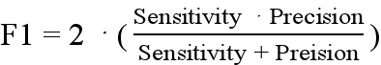
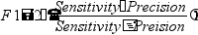
Common performance measures are sensitivity, precision, false discovery rate (FDR), F1 score, the area under the receiver operating characteristic curve (ROC), and Matthew’s Correlation Coefficient (MCC). Sensitivity describes the percent of all real true positives that were correctly identified, while precision describes the percent of predicted positives that are indeed true positives. FDR is the inverse of precision, describing the percent of predicted positives that were incorrectly predicted. F1, ROC, and MCC are scores that take into account both sensitivity and precision to characterize the overall performance of a model. F1 is

the harmonic mean of sensitivity and precision, .
ROC is the area under the curve that is created by plotting the true positive rate against the false positive rate at various threshold settings, providing a measure of the general usefulness of a test. MCC is especially useful for measuring the quality of binary classifications with large class imbalances, and is considered more informative than the more commonly-used F1 score 38. A class, or label, imbalance is when there is a disproportionate number of one label to another in a training set. The MCC is calculated as,
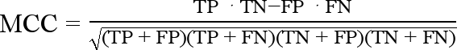
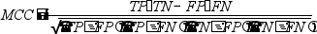
, where TP, FP, TN, and FN stand for true positive, false positive, true negative, and false negative, respectively.
Random forest is a commonly used machine learning strategy due to its relative simplicity and effectiveness, and is a promising model to use for detecting SVs owing to the fact that it can accommodate a large number of features 39,40. Random forest is an ensemble learning method that is comprised of various decision trees, predicting the label based on the mode and probability of the resulting trees. A decision tree is a flowchart-like model, that makes decisions based on the values of the features, and predicts the most-likely label based on the combination of those decisions (figure 3). A random forest model harnesses the simplicity of a decision tree, and increases the predictive power by using numerous decisions trees, each made of a subset of the training data, to make a stronger classification.
In order to address all these limitations and allow for high throughput analysis of these elusive SVs using paired-end bulk sequencing data, I developed a novel, easy-to-use, GSV genotyping and SSV calling program. The tool, named CHONK, utilizes machine learning to filter an initial prediction set of millions of SVs down to a manageable number of high confidence predictions.

Methods
CHONK is an open source application written in Python that requires short-read paired-end alignments from whole genome sequencing (BAM format) file as input, and outputs a VCF file for the

reported GSVs and SSVs (Figure 4). The source code and documentation for CHONK can be found at https://github.com/daverbuj/CHONK, and can be installed locally using the Python Package Installer, pip. GSV and SSV detection is performed using random forest machine learning classifiers. The germline classification model is trained on high confidence calls from three distinct datasets, and the somatic classification model is trained on four datasets using digital and physical mixtures, or spike-ins. CHONK exclusively classifies deletion (DEL), duplication (DUP), and inversion (INV) SV types. CHONK employs a 5-stage approach to detect somatic structural variations: 1) metadata extraction (metadata), 2) breakpoint calling (breakpoints), 3) feature extraction (features), 4) GSV genotyping (genotype), and lastly 5) SSV calling (somatic). The final step processes many putative events and filters them down to a manageable number of somatic calls for each human genome sample, facilitating downstream assessment of somatic variants.
  - Workflow
First, “chonk metadata” extracts the sample’s relevant data which is used downstream for normalization of features such as depth of coverage and characterization of novel breakpoints. Data includes information on the sequenced sample such as mean depth of coverage per chromosome and mean read lengths, and information on chosen variables such as the chromosomes to investigate and the number of windows to use in feature extraction. The purpose of the metadata step, largely, is to define features of the genome that are observed given no variation or ambiguity; this can also be thought of as the “null”, and is used to compare to putative SV regions to determine whether the SV is real or false. This data is attained by first removing areas of the sample that intersect with a mask file containing regions that are repetitive, self-chaining, or ambiguous. Also, due to the correlation between read depth and GC content, the mean read depth in different GC regions was calculated 41. This was done by partitioning the “clean” genomic regions into consecutive non-overlapping windows of size 25 bp and 1 kb, and counting the reads in each window. The two window sizes were chosen in order to accurately investigate both small and large SVs. The output from this step is a JSON file that is used for all subsequent subcommands.
Second, “chonk breakpoints” is run to make the initial SV predictions. These predictions are made using split-reads (SR) and discordant paired-ends (DPE). Short read paired-end sequencing results in two sequenced reads of known length, on opposite strands, with an unsequenced insert of known length between the two reads (Figure 5). SR are reads that map, or align, to the reference genome in at least two locations (Figure 5b). DPE are two reads that are mapped discordantly to the reference genome; either by having both the reads on the same strand, having an insert that is longer than the known insert length, or having an insert shorter than the known insert length (Figure 5c). Both of these types of alignments are indicative of a structural change in the genome. In order to maintain high sensitivity, any evidence of an SV based on SRs or DPEs, even from one alignment, is enough to be determined as a potential SV. The output from this step is a BED file with all the reported SVs, the type of SV, and confidence region of the breakpoints determined by merging the variants according to an 80% reciprocal overlap. This list of candidate SVs will be used in the following step to extract feature data and then ultimately classify as either high confidence germline, somatic, or noise.
Third, “chonk features” extracts a multitude of features that are indicative of structural changes in the sequence for each individual SV. The features obtained can be categorized into four classes depending on the type of data extracted. More information on the feature classes can be found in the features section below and in Table 1. The output from this subcommand is a BED file with SV information and all feature data. The features extracted during this step will be used for both the germline and somatic classifiers.
Fourth, “chonk genotype” determines the ploidy of all the predicted SVs with probability scores for each possible genotype (homozygous reference [0/0], heterozygous [0/1], homozygous derived [1/1) on DELs, DUPs, and INVs of size small (<1kb) and large (≥1kb) independently. Accordingly, a total of six distinct models make up the germline classifier, or “chonk genotype” step. Random forest machine learning models trained on GSVs are used to determine the germline genotype. The output is a VCF file containing GSVs that classified with a high probability (≥80%), and a BED file containing SVs that genotyped poorly (<80%) which will be used to predict as somatic (Figure 6).
Finally, “chonk somatic” classifies the SVs that genotyped poorly from the previous step, as either “somatic” or “not somatic,” on DELs, DUPs, and INVs of size small (<1kb) and large (≥1kb) independently. Similar to the germline step, a total of six distinct models make up the somatic classifier, or “chonk somatic” step. Random forest machine learning models trained on SSVs are used for somatic classification. The output is a VCF file of the SVs predicted as somatic.

  - Features
There are 63 features used for classification which can be categorized into four classes; coverage, supporting alignment, k-mer alignment, and context-based (Table 1). The goal was to maximize sensitivity for all SVs by leveraging many orthogonal features encompassing various aspects of the purported variant.
Coverage features help determine the veracity of SVs based on relative sequencing read depth.
Pedersen and Quinlan (2019), noted that there were distinctive patterns that distinguished confident DEL and DUP calls from apparent false positives. True DEL and DUP events are likely to exhibit a change in read depth compared to the neighboring regions, particularly near the SV breakpoints 42. The primary features in this category are the fold change of the coverage of the putative SV to the mean of the chromosome for which the SV resides in, and the fold-change of the read count of the SV region to regions with similar GC-content.
Supporting alignment features are based on the number, type, and quality of sequenced fragments (individual reads and paired-ends) supporting the SV. Since the sensitivity is very high in the breakpoint step where one supporting alignment is enough to qualify an SV, it is important to now filter out the uninformative SVs. The three types of supporting alignments are SR, DPE, and clipped reads (CR). SR are alignments where the read is split in a way that alludes to the SV type, DPE are paired discordantly pointing towards a rearrangement, and CR are reads that are split but without a secondary alignment indicating the presence of an SV. The number and quality of these supporting alignments within the SV confidence region are extracted. The amount of supporting alignments paired with their quality indicates true SVs compared to noise. For example, an SV with one low quality SR is less likely to be “real” than an SV with various high quality SR and DPE supporting alignments. The main features include number of SR, DPE, and clipped reads; mean and median mapping quality scores; and mean and median base quality scores.
K-mer alignment features rely on unique sequences to determine whether the SV is true or noise. One method parses out the unique k-mers from the reads in the BAM file and calculates whether those more closely resemble the k-mers from the reference or the purported SV. These features are calculated as a ratio of the k-mers from the reads near the left and right SV breakpoints to the k-mers of the reference sequence near the left breakpoint, right breakpoint, and SV sequence. The other method looks specifically at the unaligned sequence of soft clipped reads to determine whether the k-mers from the clipped region match to the flank near the breakpoints. These features are calculated as a ratio of the k-mers in the soft clipped reads on the left and right breakpoint to the k-mers in the reference sequence of the flanks of the left and right SV breakpoints.
Context-based features report the general SV information to inform what true SVs look like. The features in this category are GC-content, sequence complexity characterized by how compressible the sequence is, overlap to repetitive regions, confidence of the breakpoints, and SV size.
  - Training Set
The germline and somatic SV training sets are comprised of 5 cohorts; 4 public datasets, and 1 private dataset (Table 2). The datasets differ widely from the read length and coverage at which they were sequenced, to the aligner and reference genomes used to map the reads. This variety between the cohorts allows the models to be more generalizable, facilitating classification of future data regardless of the sequencing performed or the alignment method used. The datasets are from the 1000 Genomes Project Platinum genomes 9, Polaris genomes 43, Human Genome Structural Variation Consortium (HGSV) trios 44, Genome in a Bottle Ashkenazi Jewish (GIAB) trios, and internal Pontine Tegmental Cap Dysplasia (PTCD) trio data.
Since the training sets used in a machine learning model need to be comprised of high confidence data in order to perform well, certain methods were employed to ensure that every SV in the training set was accurate for genotype in the germline training set, and true positive (TP) and false positive (FP) label in the somatic training set (Figure 7).
The germline training set is made up of the Polaris, PTCD, and HGSV cohorts. First, SV calls in these cohorts had to be established in order to then genotype for inclusion into the final training set. These SV calls differ from the ones that are produced using the breakpoints subcommand in that these calls have a high level of confidence. For the HGSV cohort, a previously identified SV callset was used 44. For Polaris and PTCD, commonly-used SV callers LUMPY36 and Manta45 were used to create SV calls. Next, high confidence genotypes were identified using a consensus genotype and Mendelian inheritance expectation method (Figure 7a). Genotypes were chosen based on the consensus decision of four existing genotypers. The genotypers used were SVTyper37 and Delly46 , which are both probabilistic-based methods; SV235, a machine learning method; and Paragraph47, a graph-based method. Using four different genotypers that employ different

methods to characterize SVs and using their consensus genotype ensures that the training set is comprised of only high-confident data and furthers CHONK’s generalizability. Finally, since the cohorts are trios, only the GSVs that were consistent with Mendelian expectations were included in the final germline training set. For example, if the mother had a DEL in both chromosomes (1/1) and the father did not carry any deletion allele (0/0), then the expectation would be that the child will have a DEL on the maternal haplotype (0/1). SVs that did not follow Mendelian expectations were discarded. This method allowed me to gather high confidence GSV calls from varying datasets using divergent methods to compile a training set that could be representative of future testing data (Table 3).
The somatic training set is made up of the Polaris, PTCD, and GIAB cohorts, as well as a sample created by the Brain Somatic Mosaicism Network (BSMN). Due to the previously-described challenges of calling SSVs and the lack of an established SSV dataset, I created a somatic training set using digital and physical spike-ins of the established GSVs with known genotypes (Figure 7b, Table 4a). Spike-ins, or mixtures, are created by mixing samples with known genotypes at predetermined ratios, resulting in a new sample with what appears to look like somatic events at known allele frequencies. Using this strategy, 12 children in the Polaris and PTCD cohorts were downsampled and mixed together to create a mixture with a coverage of 196x containing various SSVs at allele frequencies ranging from 1 to 50%. Since the GIAB cohort is one trio, the two parents were mixed instead, resulting in a new mixture with a coverage of 250x with allele frequencies ranging from 1.25 to 50%. The BSMN sample, on the other hand, is a physical spike-in where a variety of samples were physically titrated and mixed followed by sequencing of the final mixture (Table 4b). The BSMN physical mixture is comprised of the Platinum and HGSV cohorts, and control samples. Due to the titrations performed and only having SV calls for one sample in the 1kgp cohort and the 3 samples in the HGSV cohort, the known allele frequencies range from approximately 0.1-2% and 32-67.76%.
In order for the somatic classifier to accurately predict somatic events, examples of events that are known to not be somatic are necessary in order to distinguish between the two possibilities. Therefore, labels categorizing true positive (TP) and false positive (FP) SSVs were created using various filters (Figure 7c).
First, the mixtures that were created digitally and physically were processed through the CHONK breakpoints subcommand to determine whether they would be detected by the program. SVs from the breakpoints command that overlapped to the SVs in the mixtures, and that also genotyped poorly with the CHONK genotype subcommand with a probability of less than 80% were labeled as TP and included in the final somatic training set. SVs from the breakpoints command that did not overlap with the mixture, did not overlap to SVs in the parents, did not overlap to region of known and common SVs, and also genotyped poorly with less than 80% probability were labeled as FP and included in the final somatic training set. All other SVs were discarded resulting in a final somatic training set consisting of only high confidence TP and FP SSVs (Table 4c). Since data on parents’ SVs is required to create the FP label, and GIAB and the BSMN sample lack data on parent SVs, those cohorts contain only TP labels, lacking FPs entirely.
  - Classifiers
The python module Scikit-learn49 was used to create the CHONK classifiers. There are a total of 12 trained models, six to classify GSVs and six to classify SSVs, and all of them trained on the same features. During the GSV genotyping step there is a separate random forest model trained specifically to classify small (<1kb) and large (≥1kb) DELs, DUPs, and INVs independently. The output, or label, from the GSV classifier is the genotype of the SV, either 0/0, 0/1, or 1/1. If the prediction has a high probability (>0.8), then the SV will be considered a GSV and the genotype is reported in the outputted VCF file that reports GSV. If the genotype prediction probability is low (<0.8), then the SV will not be considered GSV, and will be considered as a potential SSV (Figure 5).
In the SSV classifying step, there is a separate random forest model trained specifically to evaluate the badly genotyped small (<1kb) and large (≥1kb) DELs, DUPs, and INVs independently. The SSV classification is binary, deciding whether the SV is “somatic” or “not somatic.” The predicted somatic SVs with probabilities greater than 50% are reported in the outputted VCF file that report SSV.
Hyperparameters are values chosen before training the models that dictate the rules for how the models will behave. For example, in a random forest classifier, the number of decision trees to be used in the forest can be chosen beforehand; depending on the data or classification problem, having a fewer number of trees may outperform having a large number of trees. Other hyperparameters include “criterion” which is the scoring function used to measure the quality of a split for each decision, “max depth” allotting the depth, or

number of layers, of the tree, or “bootstrap” determining whether bootstrap samples are used when building the trees. Therefore, optimizing the hyperparameters chosen for each model is important in achieving the best results. In order to determine the best hyperparameters, all possible combinations of the most influential parameters and options were employed and compared. The best-performing hyperparameters were chosen and used for all subsequent models (Table 5).
2.6 Evaluating Performance Results
Performance results for the germline and somatic models were evaluated using two different strategies (Figure 8). In order to choose the hyperparameters as mentioned above, and to assess the power of the model given ideal conditions, the whole training set evaluation strategy was implemented (Figure 8a). This intra-sample strategy involves mixing the final training set comprised of all the cohorts used, and reserving 60% for training the model and the other 40% for testing the performance of the trained model. To determine how well the model can be expected to perform on new data to classify, a leave-one-out evaluation strategy was used (Figure 8b). This inter-sample strategy involves creating iterations of models where one cohort is left out exclusively for testing and the rest are used to train the model.
While there are no other known SSV classifiers that investigate non-tumor, bulk WGS to compare performance results to, there are a handful of state-of-the-art genotypers that I was able to compare CHONK’s germline genotyping results to. The four genotyping programs that used to compare to CHONK were the same genotypers used in the consensus-mendelian method; DELLY, SVTyper, SV2, and Paragraph. DELLY46 is an SV caller as well as an SV genotyper that operates on SRs and DPEs to genotype DELs, DUPS, INVs, and translocations. SVTyper37 uses a Bayesian likelihood model on SRs and DPEs to genotype DELs, DUPs, INVs, and translocations.

Results
Since most of the training sets are still being processed, so far I have trained and evaluated the performance of the GSV and SSV classifiers using only the Polaris data. Additionally, since the feature code was still being worked on, the context-based features were not included in the evaluation.
I evaluated the GSVs using different machine learning classifying models to find which one performed best on the three SV types. The results were exceptional; random forest was found to perform best on DELs, DUPs, and INVs with F1 scores of 82%, 75%, and 93% respectively (figure 5). An F1 score is a measure of the overall performance of a classifier by calculating the harmonic mean of the sensitivity and precision. Sensitivity measures the proportion of actual positives that are correctly identified as such, and it is calculated by dividing the number of predicted true SVs by the total number of true SVs. Precision is the number of predicted true SVs divided by the total predicted true SVs. These results mean that of the SVs that were genotyped, 82% of the DELs, 75% of the DUPs, and 93% of the INVs were genotyped correctly.
The machine learning model that performed best for the SSVs was a neural network, with a sensitivity of 70% and a false discovery rate of 5%. The somatic classifier was able to correctly predict 9 of the 13 somatic variants in the validation set (figure 6a). The 9 true somatic SVs that were identified were in allelic frequencies from 1% to 25% (figure 6b).
While all features are important and show significance in helping classify the SVs, certain feature classes are more informative than others depending on the type of SV rearrangement (figure 7). The k-mer alignment features were most informative in identifying the genotypes for the DELs, the coverage features were most informative in genotyping the DUPs, and the supporting alignment features were most informative for genotyping the INVs.
I have not yet compared CHONK’s performance results to DELLY and SVTyper.

Conclusion:
CHONK’s performance results for the GSV and SSV classifiers are very promising. These results show that the classifiers are able to distinguish between signal and noise, filtering down the initial thousands of SV calls to a manageable number of high confident calls that can be validated downstream. Additionally, CHONK is able to positively identify variants in allelic frequencies as low as 1%. Still, these are preliminary result which should improve with more tuning. I expect the classifiers will perform even better after

optimizing the parameters, and that the program will be more generalizable after training the models on the rest of the training set. Since the proposed training set is made up of a diverse set of samples with varying sequencing coverage (40x-200x), read lengths (150-250), and aligners (BWA and Isaac), CHONK can be expected to not be overfit and to perform well on a wide range of sequenced data.
CHONK is unique to existing somatic variant callers in a few ways. All publicly available somatic callers either target tumor cells, rely on low-resolution microarrays, or focus on smaller variants such as SNVs or indels. While identifying somatic mutations in tumor cells is more difficult than finding GSVs, analyzing tumor cell DNA is easier than using bulk DNA because the tumor cells are generally mixed with normal cells at predetermined levels, and so there is an expected allele frequency. Because of this, there is currently no available somatic caller targeted toward bulk tissue analysis. There are some SSV callers that are used in the field, but they rely on microarrays as opposed to next generation sequencing (NGS). Microarrays are low-resolution and target specific DNA regions, which does not allow for efficient WGS analysis.
CHONK is different from other existing callers in that it detects SVs in low allelic frequencies using non-targeted, bulk, WGS using short-read sequencing technologies, and is sensitive to small SVs.
Identification of these elusive SVs has been made possible by the decreasing costs of DNA sequencing. From the options available today, short-read paired sequencing is the best for calling SVs due to a mix of cost and detection power. However, with further decreases in the cost of long-read sequencing technology and decrease in sequencing error, long-reads will be more more commonly used due to its improved detection power.
The ability to detect SSVs in a high throughput system, using programs like CHONK, will play a vital role in the clinic as well as in research. Precise and sensitive detection of these SVs in low allelic frequencies can hopefully allow researchers to discover the etiology of rare genetic disorders, gain insight on early to late cell lineage, or understand the basis of human disease. Clinically, identification of SSVs could help in diagnosing pre-cancerous cells or even preventing transmission of high risk variants such as those involved in autism. Breuss et al. (2019)19 found that ¼ fathers with an autistic child with a damaging de novo mutation had the risk allele in appreciable amounts in their sperm (5-15% allelic fraction). There are currently no methods to prevent or predict autism, however by identifying mosaicism in paternal sperm, the risk of transmitting a damaging variant can be assessed; this may be the only known method of preventing autism.

Timeline of proposed research:
- February
  - Finish processing the other training sets and train the classifier using all data
    - Add the total number of data points to paper and update tables
    - Create the simulated SSV dataset
- March
  - Further optimize the classifiers’ parameters (hyper-parameter optimization)
  - Compare CHONK’s GSV results to Delly and SVTyper
- April
  - Add regression analysis to predict SSV AF
  - Defend

- Time permitting
  - Identify a previously unknown somatic SV in sample, and validate
  - Create training set and train on Arabidopsis genomes

Figure 1. The different types of SVs most commonly observed. The bottom bar represents the SV as found in a sample, while the top bar represents the original sequence from the reference genome. The blue and red bars indicate the unchanged sequence, and the orange bar is the SV sequence that is altered and rearranged.
Dashed lines show the alignment between the sample sequence and reference sequence. This figure is based off of Guan P., Sung W. (2018).

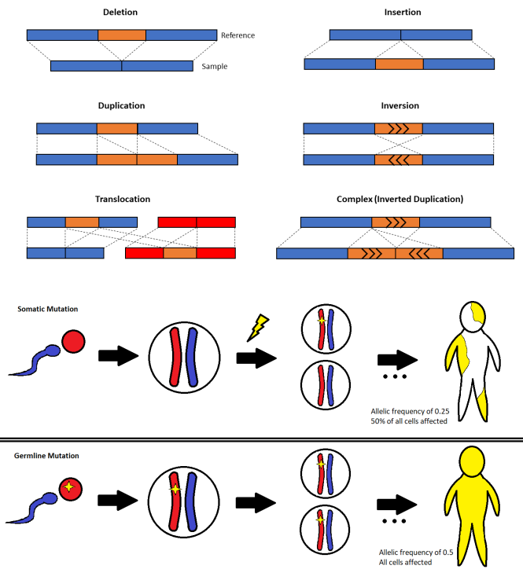
Figure 2. A representation of somatic mutation and germline mutation in a human at different points during development. The blue color indicates the paternal haplotype and the red color indicates the maternal haplotype. The yellow star represents a mutation on the chromosome, the lightning indicates the occurrence of a mutation event, and the yellow shaded region on the human denotes areas with affected cells. In the representation of somatic mutation, a mutation event occurs during the first cell division, resulting in two cells; one without a mutation, and one with a mutation on one haplotype. After development, the resulting organism will have 50% of their cells affected with the mutation, and an allelic frequency of 0.25. It is important to note that a sample of tissue from this organism may not have the same allelic frequency as the whole body due to localization of the mutation and tissue type analyzed. In the representation of germline mutation, the maternal germ cell contained a mutation, resulting in a zygote with the mutation on the maternal haplotype. During cell division and after development, the resulting organism has all cells affected by the mutation at an allelic frequency of 0.5. If the paternal and maternal germ cells both had the same mutation, the resulting allelic frequency would be 1.0. In the germline scenario, analysis of tissue would show around the same allelic frequency as what is present in the whole body.
Figure 3. A representation of the CHONK workflow, comprised of five subcommands to filter out the SSVs. The inputs required are a short read paired-end BAM file, a BED file with ambiguous regions, and a reference FASTA. Notable steps include Breakpoint which outputs a BED file with raw SV calls, Genotype

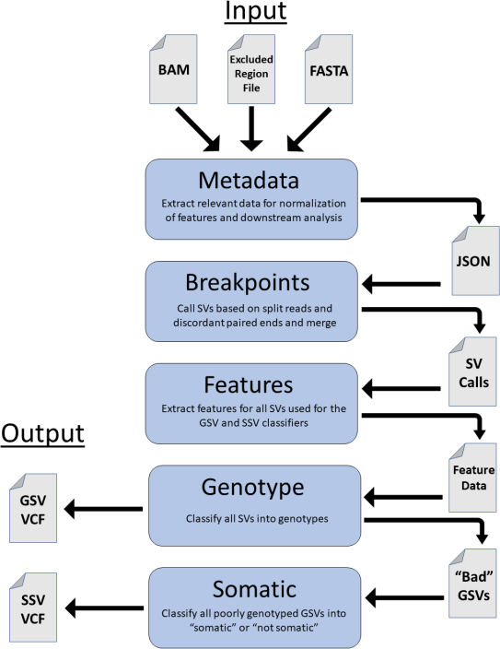

which outputs high-confident GSVs in VCF format, and Somatic which output SSVs in VCF format. It is important to note that the JSON file resulting from the Metadata steps contains file paths from the original inputs and is used as input for all subsequent subcommands.
Figure 4. A depiction of the three SV types that CHONK classifies and the different alignment types of short paired-end reads to the reference genome. The left side shows the sample sequence (top bar) and the sequenced reads (arrows), and the right side shows the alignment of the same reads when mapped to the reference genome. The blue arrow represents the sequenced read on the forward strand, the red arrow represents the sequenced read on the reverse strand, and the dashed line in between the two arrows represents the unsequenced insert. (a) This fragment is unchanged when mapped to the reference and shows that there is no rearrangement in the sample sequence. (b) This fragment has a read on the reverse strand that is split between the breakpoints, resulting in a split read (SR) that aligns to two non-contiguous regions when mapped to the reference. This type of supporting alignment provides single base pair resolution of the SV. (c) This fragment has the insert intersecting the breakpoint in the sample, resulting in two unbroken reads that are mapped discordantly, resulting in a discordant paired-end (DPE). Fragments, in CHONK, can be considered DPE if the insert size is larger than the expected insert size, the two reads switch strands, or the two reads are on the same strand. DPEs do not provide single base pair resolution. (c) This fragment depicts a

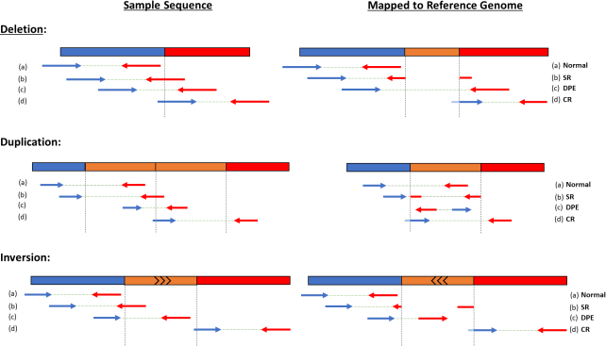
clipped read (CR), a type of split read where the part of the read that is clipped is too small to be accurately aligned to the opposing breakpoint. CRs provide evidence of an SV, but only show their presence on side of the breakpoint. Please note that CR were not used for breakpoint detection, but were included as supporting alignments in the feature extraction step.
Figure 5. Preliminary performance results for the germline structural variation genotyping classifier. The four heatmaps show the performance on four different evaluating standards; False Discovery Rate, Sensitivity, Area under the Receiver Operating Curve, and F1. The y-axis on the heat maps show the common machine learning classifying models, and the x-axis shows the SV types. The random forest model worked best on all SV types and was chosen as the GSV classifier moving forward. These preliminary results are not optimized and are expected to perform better with optimization.

a.
b.

Figure 6. Preliminary performance results for the somatic structural variation classifier. (a) The left confusion matrix shows the number of predictions based on the truth label. The classifier was able to successfully filter out a substantial amount of noise and predict 9/13 SSVs. (b) The allelic frequency of the 13

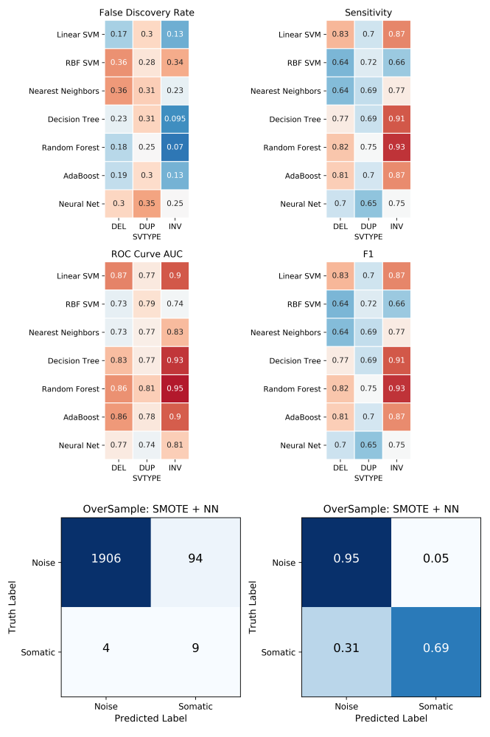
SSVs
found and

missed. CHONK was able to accurately predict from 0.1 to 0.25 allelic frequency. The feature “sf_ratio” appears to be a good indicator of allelic frequency.

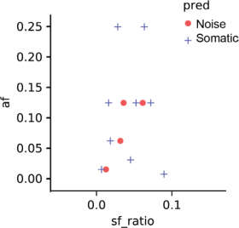
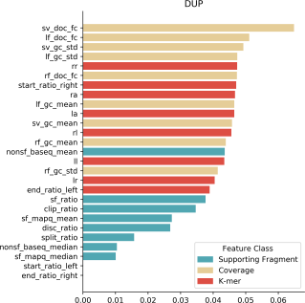

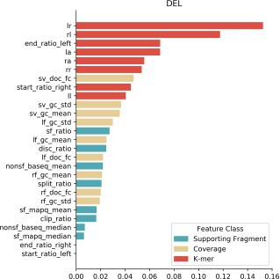
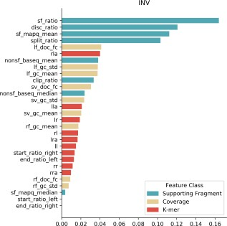
Figure 7. Feature importance for the three GSV classifiers. Red represents k-mer alignment features, beige represents coverage features, and blue represents supporting alignment features. Note that certain feature classes are more informative for some SV types than others.

Table 1. The features used in the GSV and SSV classifiers.

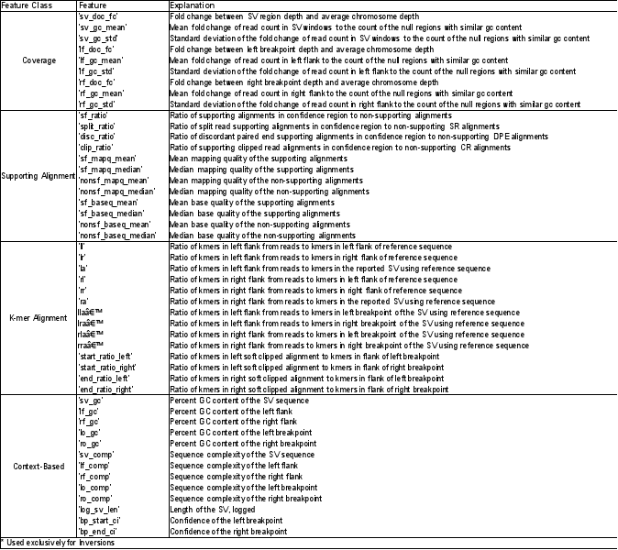
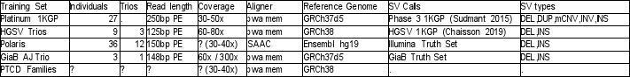
Table 2. Information for the training sets used. Note that the training set is made up of data utilizing different sequencing and alignment method (different read lengths, coverage, and aligning programs), this allows the CHONK classifier to be generalizable and work on various datasets.

Table 3. Training set information from using the consensus and Mendelian expectation method, and number of genotypes used for each SV type.

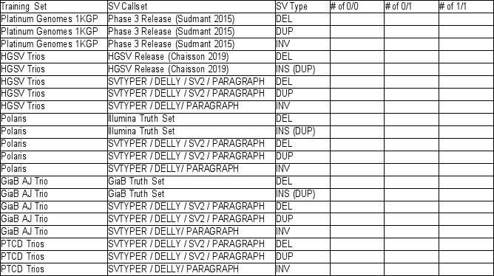
5

References

- Guan, P. & Sung, W.-K. Structural variation detection using next-generation sequencing data. Methods
102, 36–49 (2016).
- Weischenfeldt, J., Symmons, O., Spitz, F. & Korbel, J. O. Phenotypic impact of genomic structural variation: Insights from and for human disease. Nat. Rev. Genet. 14, 125–138 (2013).
- Collins, R. L. et al. An open resource of structural variation for medical and population genetics.
bioRxiv 578674 (2019). doi:10.1101/578674
- Sebat, J. et al. Large-scale copy number polymorphism in the human genome. Science (80-. ). 305, 525–528 (2004).
- Zhu, X. et al. Machine learning reveals bilateral distribution of somatic L1 insertions in human neurons and glia. bioRxiv 660779 (2019). doi:10.1101/660779
- Han, L. et al. Functional annotation of rare structural variation in the human brain. bioRxiv 711754 (2019). doi:10.1101/711754
- D’Gama, A. M. & Walsh, C. A. Somatic mosaicism and neurodevelopmental disease. Nat. Neurosci.
21, 1504–1514 (2018).
- Yun, J., Li, Y., Xu, C. T. & Pan, B. R. Epidemiology and Rb1 gene of retinoblastoma. Int. J. Ophthalmol. 4, 103–109 (2011).
- Sudmant, P. H. et al. An integrated map of structural variation in 2,504 human genomes. Nature 526, 75–81 (2015).
- Antaki, D. Disparity between Maternal and Paternal Contributions to Inherited Risk for Autism. (2018).
- The International HapMap Consortium. A second generation human haplotype map of over 3.1 million SNPs. Nature 449, 851–861 (2007).
- Redon, R. et al. Global variation in copy number in the human genome. Nature 444, 444–454 (2006).
- DePristo, M.A., E. Banks, R.E. Poplin, K.V. Garimella, J.R. Maguire, C. Hartl, A.A. Philippakis, G. del Angel, M.A Rivas, M. Hanna, A. McKenna, T.J. Fennell, A.M. Kernytsky, A.Y. Sivachenko, K.

Cibulskis, S.B. Gabriel, D. Altshuler, and M. J. D. A framework for variation discovery and genotyping using next- generation DNA sequencing data. Nat. Genet. 43, 491–498 (2011).
- Wang, K., Li, M. & Hakonarson, H. ANNOVAR: Functional annotation of genetic variants from high-throughput sequencing data. Nucleic Acids Res. 38, 1–7 (2010).
- Heller, D. & Vingron, M. SVIM: structural variant identification using mapped long reads.
Bioinformatics 35, 2907–2915 (2019).
- Feuk, L., Carson, A. R. & Scherer, S. W. Structural variation in the human genome. Nat. Rev. Genet. 7, 85–97 (2006).
- Meyerson, W. & Gerstein, M. B. Genomic variants concurrently listed in a somatic and a germline mutation database have implications for disease-variant discovery and genomic privacy. bioRxiv 450239 (2018). doi:10.1101/450239
- Li, M. M. et al. Standards and Guidelines for the Interpretation and Reporting of Sequence Variants in Cancer: A Joint Consensus Recommendation of the Association for Molecular Pathology, American Society of Clinical Oncology, and College of American Pathologists. J. Mol. Diagnostics 19, 4–23 (2017).
- Breuss, M. et al. Quantification of autism recurrence risk by direct assessment of paternal sperm mosaicism. Doi.Org 208165 (2017). doi:10.1101/208165
- Freed, D., Stevens, E. L. & Pevsner, J. Somatic mosaicism in the human genome. Genes (Basel). 5, 1064–1094 (2014).
- Biesecker, L. G. & Spinner, N. B. A genomic view of mosaicism and human disease. Nat. Rev. Genet.
14, 307–320 (2013).
- Bondeson, M. L. et al. Inversion of the IDS gene resulting from recombination with IDS-related sequences in a common cause of the hunter syndrome. Hum. Mol. Genet. 4, 615–621 (1995).
- Brandler, W. M. et al. Frequency and Complexity of de Novo Structural Mutation in Autism. Am. J. Hum. Genet. 98, 667–679 (2016).
- Sebat, J. et al. Strong Association of De Novo Copy Number Mutations with Autism Interdepartmental Program in the Neurosciences, Program in. Science (80-. ). 316, 445–449 (2007).
- Malhotra, D. & Sebat, J. CNVs: Harbinger of a Rare Variant Revolution in Psychiatric Genetics Genetic Variation’s Other Half. 148, 1223–1241 (2013).
- Bi, W. et al. Genes in a refined Smith-Magenis syndrome critical deletion interval on chromosome 17p11.2 and the syntenic region of the mouse. Genome Res. 12, 713–728 (2002).
- Happle, R. Mosaicism Human. Arch Dermatol. 129, 1460–1470 (1993).
- Gariglio, P. Oncogenes and tumor suppressor genes. Mol. Oncol. Princ. Recent Adv. 64–82 (2012). doi:10.2174/978160805016111201010064
- Sabir, S. R., Yeoh, S., Jackson, G. & Bayliss, R. EML4-ALK variants: Biological and molecular properties, and the implications for patients. Cancers (Basel). 9, (2017).
- Lodato, M. A. et al. Aging and neurodegeneration are associated with increased mutations in single human neurons. Science (80-. ). 359, 555–559 (2018).
- Power, R. A. et al. Fecundity of patients with schizophrenia, autism, bipolar disorder, depression, anorexia nervosa, or substance abuse vs their unaffected siblings. Arch. Gen. Psychiatry 70, 22–30 (2013).
- Shirley, M. D. et al. Sturge–Weber Syndrome and Port-Wine Stains Caused by Somatic Mutation in GNAQ. N. Engl. J. Med. 368, 2016 (2013).
- Jamuar, S. S. et al. Somatic mutations in cerebral cortical malformations. N. Engl. J. Med. 371, 733–743 (2014).

- Zhou, W. et al. Increased genome instability in human DNA segments with self-chains: Homology-induced structural variations via replicative mechanisms. Hum. Mol. Genet. 22, 2642–2651 (2013).
- Antaki, D., Brandler, W. M. & Sebat, J. SV 2 : Accurate structural variation genotyping and de novo mutation detection from whole genomes. Bioinformatics 34, 1774–1777 (2018).
- Layer, R. M., Chiang, C., Quinlan, A. R. & Hall, I. M. LUMPY: A probabilistic framework for structural variant discovery. Genome Biol. 15, 1–19 (2014).
- Chiang, C. et al. SpeedSeq: Ultra-fast personal genome analysis and interpretation. Nat. Methods 12, 966–968 (2015).
- Chicco, D. & Jurman, G. The advantages of the Matthews correlation coefficient (MCC) over F1 score and accuracy in binary classification evaluation. BMC Genomics 21, 1–13 (2020).
- Breiman, L. Random forests. Mach. Learn. 1–122 (2001). doi:10.1201/9780367816377-11
- Ho, T. K. Random decision forests. Proc. Int. Conf. Doc. Anal. Recognition, ICDAR 1, 278–282 (1995).
- Spring, C. CNVnator: An Approach to Discover, Genotype and Characterize Typical and Atypical CNVs from Family and Population Genome Sequencing. Genome Res. 974–984 (2011). doi:10.1101/gr.114876.110.974
- Pedersen, B. S. & Quinlan, A. R. Duphold: scalable, depth-based annotation and curation of high-confidence structural variant calls. Gigascience 8, 465385 (2019).
- Dolzhenko, E. et al. Detection of long repeat expansions from PCR-free whole-genome sequence data.
Genome Res. 27, 1895–1903 (2017).
- Chaisson, M. J. P. et al. Multi-platform discovery of haplotype-resolved structural variation in human genomes. Nat. Commun. 10, 1–16 (2019).
- Chen, X. et al. Manta: Rapid detection of structural variants and indels for germline and cancer sequencing applications. Bioinformatics 32, 1220–1222 (2016).
- Rausch, T. et al. DELLY: Structural variant discovery by integrated paired-end and split-read analysis.
Bioinformatics 28, 333–339 (2012).
- Chen, S. et al. Paragraph: A graph-based structural variant genotyper for short-read sequence data.
bioRxiv 635011 (2019). doi:10.1101/635011
- Brandler, W. M. et al. Paternally inherited cis-regulatory structural variants are associated with autism.
Science (80-. ). 360, 327–331 (2018).
- Varoquaux, G. et al. Scikit-learn. GetMobile Mob. Comput. Commun. 19, 29–33 (2015).

