**ECE1387: Assignment #2**

**Part1:**

**Initial Placement Plots:**

**CCT1:**

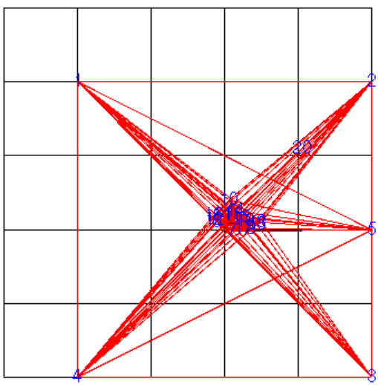

**CCT2:**

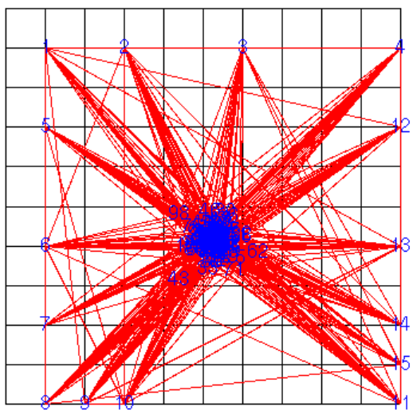

**CCT3:**

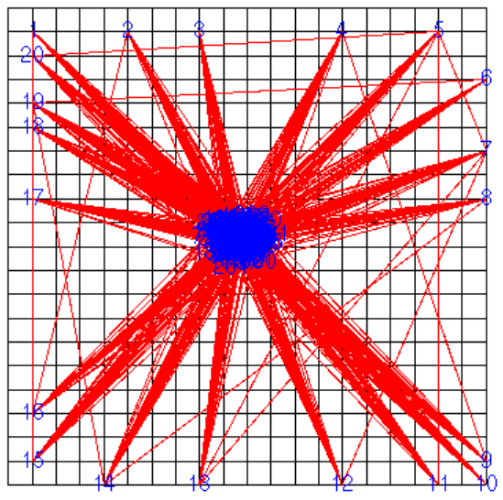

**CCT4:**

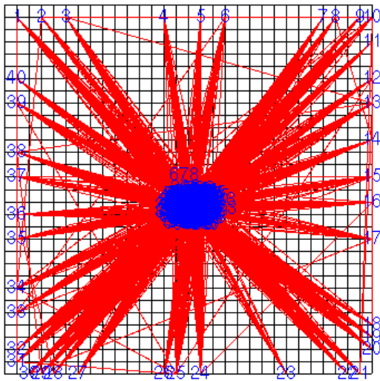

**Half-Perimeter Bounding Box Wire Length**

|  |  |
| --- | --- |
| **Circuit** | **HPBB WL [units]** |
| **CCT1** | 106.556 |
| **CCT2** | 693.167 |
| **CCT3** | 2390.31 |
| **CCT4** | 7099.67 |

**Part2:**

**Plots:**

**CCT2:**

**CCT3:**

**CCT4:**

**Bounding Box Wire Length**

|  |  |
| --- | --- |
| **Circuit** | **BB WL** |
| **CCT2** | 5 |
| **CCT3** | 8 |
| **CCT4** | 14 |

Describe how you partitioned the blocks This randomization is only called when the program has already taken a significant amount (adjustable) of attempts at routing. What happens to WL when the new fixed blocks are introduced? Experiment with

changing (increasing/decreasing) the weights of the artificial two-pin nets; comment on the WL results when different weights are used.

**Part3:**

**Plots:**

**CCT2:**

**CCT3:**

**CCT4:**

**Bounding Box Wire Length**

|  |  |
| --- | --- |
| **Circuit** | **BB WL** |
| **CCT2** | 5 |
| **CCT3** | 8 |
| **CCT4** | 14 |

**Part4:**

**Plots:**

**CCT2:**

**CCT3:**

**CCT4:**

**Bounding Box Wire Length**

|  |  |
| --- | --- |
| **Circuit** | **BB WL** |
| **CCT2** | 5 |
| **CCT3** | 8 |
| **CCT4** | 14 |

Compare with the results for step #3. How much did BB WL increase after snapping

**Software Flow:**

Your report should include a short description of the flow of your program, the main routines and what they do, assuming that I have basic knowledge of analytical placement

**References:**

* **[1]** C.Y. Lee, "An algorithm for path connections and its applications," *IRE Transactions on Electronic Computers,*vol. 10, pp. 346-365, Sept. 1961. ([PDF](http://janders.eecg.toronto.edu/1387_2017/readings/lee.pdf))  (Classic paper on maze routing)