PDepend Gambling Study

Start of Block: Disqualify



Q1 According to our servers, you are trying to complete this survey on a mobile device. This survey can only be completed on a desktop or laptop computer. Please try taking this survey again on a non-mobile device.



Q2 Timing

First Click (1)

Last Click (2)

Page Submit (3)

Click Count (4)

End of Block: Disqualify

Start of Block: Consent Form



Q3   
**Consent Form**
  
This research study is designed to examine how people make judgments and decisions. You will be asked to answer questions that will help us discover some of the systematic patterns of human judgment and decision making.
  
  
You will be asked questions about your attitudes, beliefs, and preferences. Some of the questions may involve sensitive topics, but there are no foreseeable risks to participating in this study.  
  
It should take you 2 minutes or less to complete this study. Participation in this study is voluntary. You can choose not to take part. You can choose not to finish the questionnaire or omit any question you prefer not to answer without penalty or loss of benefits.  
  
Your participation in this study will be confidential and purely voluntary. Your responses to these questions will remain anonymous, and the data will be analyzed in aggregate form.  
  
If you have any questions or complaints please contact David Tannenbaum, Department of Management, University of Utah, by email at david.tannenbaum@utah.edu. You can also contact the Institutional Review Board (IRB) if you have questions regarding your rights as a research participant, or if you have questions, complaints or concerns which you do not feel you can discuss with the investigator. The University of Utah IRB may be reached by phone at (801) 581-3655 or by e-mail at irb@hsc.utah.edu.  
  
By clicking the button below, you are providing consent to participate in this study

End of Block: Consent Form

Start of Block: Gamble



Q4 **On the next page you will see six gambles that vary in their degree of riskiness. You will choose the gamble you'd most prefer to play.  
  
Once the study is complete, we will random select 5 MTurkers and play their chosen gamble for real money. All payouts will be given as bonus payments.**

|  |  |
| --- | --- |
| Page Break |  |

Display This Question:

If risky options = unpacked

And grouped option = bottom

|  |
| --- |
|  |

Q5 **Below are descriptions of six different chance gambles, labeled A through F.  
  
Please indicate the gamble that you would most like to play for real money, by clicking on that gamble. Choose only one.**

|  |  |  |
| --- | --- | --- |
|  | Off (1) | On (2) |
| 1 (1) |  |  |
| 2 (2) |  |  |
| 3 (3) |  |  |
| 4 (4) |  |  |
| 5 (5) |  |  |
| 6 (6) |  |  |

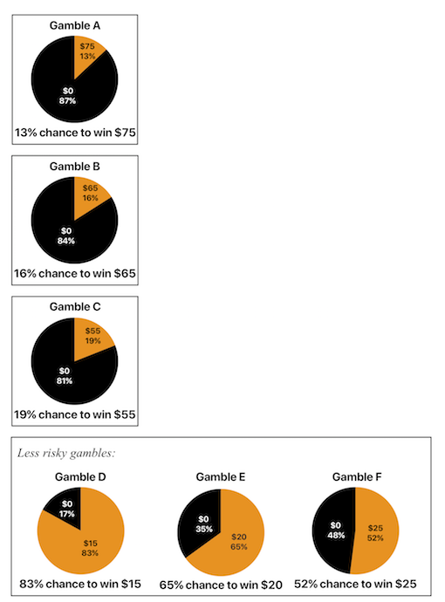

Display This Question:

If risky options = packed

And grouped option = bottom

|  |
| --- |
|  |

Q6 **Below are descriptions of six different chance gambles, labeled A through F.  
  
Please indicate the gamble that you would most like to play for real money, by clicking on that gamble. Choose only one.**

|  |  |  |
| --- | --- | --- |
|  | Off (1) | On (2) |
| 1 (1) |  |  |
| 2 (2) |  |  |
| 3 (3) |  |  |
| 4 (4) |  |  |
| 5 (5) |  |  |
| 6 (6) |  |  |

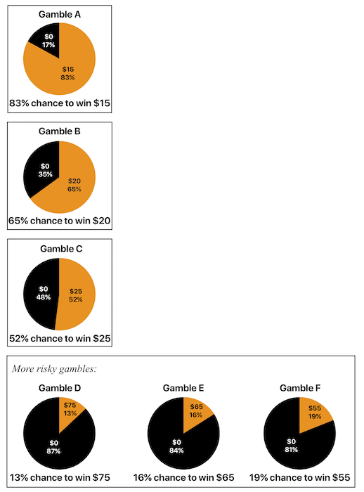

Display This Question:

If risky options = unpacked

And grouped option = top

|  |
| --- |
|  |

Q7 **Below are descriptions of six different chance gambles, labeled A through F.  
  
Please indicate the gamble that you would most like to play for real money, by clicking on that gamble. Choose only one.**

|  |  |  |
| --- | --- | --- |
|  | Off (1) | On (2) |
| 1 (1) |  |  |
| 2 (2) |  |  |
| 3 (3) |  |  |
| 4 (4) |  |  |
| 5 (5) |  |  |
| 6 (6) |  |  |

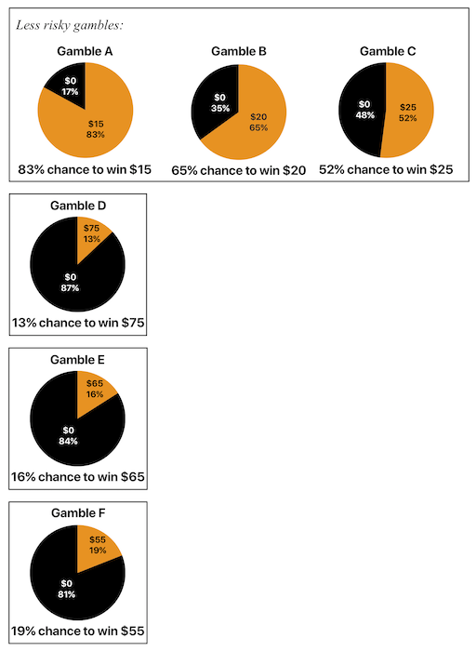

Display This Question:

If risky options = packed

And grouped option = top

|  |
| --- |
|  |

Q8 **Below are descriptions of six different chance gambles, labeled A through F.  
  
Please indicate the gamble that you would most like to play for real money, by clicking on that gamble. Choose only one.**

|  |  |  |
| --- | --- | --- |
|  | Off (1) | On (2) |
| 1 (1) |  |  |
| 2 (2) |  |  |
| 3 (3) |  |  |
| 4 (4) |  |  |
| 5 (5) |  |  |
| 6 (6) |  |  |

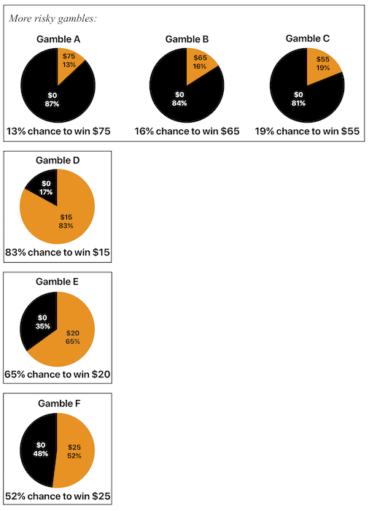

End of Block: Gamble

Start of Block: Demographics



Q9 **Very good. Some final questions before you complete the survey:**



Q10 Please indicate your gender:

* Male (1)
* Female (2)

|  |  |
| --- | --- |
|  |  |

Q11 How old are you?

_______ years old (1)



Q12 Any questions, comments, or suggestions for this study?

________________________________________________________________

________________________________________________________________

________________________________________________________________

________________________________________________________________

________________________________________________________________

End of Block: Demographics