Date: May 12th, 2021
From: David G Tassoni
To: Dr. Kaputa
Subject: ESD II Final Tech Memo

Introduction
The final project in Embedded Systems Design II was to develop an FPGA-based tennis ball tracker that accurately determines ball position within 3D space and determines if the ball is in or out. The required functionality and features to add were as follows:
- Camera calibration
- System Accuracy Analysis
- Coefficient of Restitution
- LED Visualization
- April Tag Table Tennis Tracker
- Camera Motion Errors
The below analysis investigates the methods as to which most of the above requirements were met, as well as the overall functionality of the system.

Analysis
With six major components to the system, each one took some time to develop and test. For camera calibration, twenty sets of images captured with the Snickerdoodle Black at varying angles were loaded into the MATLAB Stereo Calibrator application. Upon running the application, intrinsic data for each camera were determined, and then used in some MATLAB and Python code for April tag and ball detection. System accuracy analysis was another important criterion for the project, as the tracker would be nearly useless if it were not accurate. The intrinsic data was put into the Python file that is run on the snickerdoodle, including important camera analytics such as focal length, camera principal points, and radial distortion coefficients. It is important to use measurements that are specific to the system being used, since they directly effect things like the X, Y, Z camera coordinate of the April tag, the pose of the camera relative to the April tag, and the position of the ball. I calibrated my system cameras to be used in most of the project.
April tag detection and tracking was a very important part of the project. Dr. Kaputa provided some starter Python code to identify April tags, and this was an important start. The Python code, when ran, starts a server that can be connected to via local Wi-Fi, and the camera feed from the snickerdoodle black can be viewed. It shows the ball and April tag, identifies both with surrounding boxes or circles, and displays the coordinates. Upon obtaining the camera intrinsic information from the MATLAB calibrator, I was able to populate the Python file used with that unique data, which was successfully run to allow for April tag and ping pong ball detection.
A custom Graphical User Interface was used to allow for RGB slider manipulation (to better identify the ping pong ball if lighting conditions change), and to plot something. The below image is a screenshot from the GUI, with the RGB sliders located in the upper right of the image, the camera feeds in the lower half, and various buttons in the top left. The user can capture images, switch to a grayscale video mode, and display a plot of the X, Y, and Z values of the ball for system accuracy analysis.
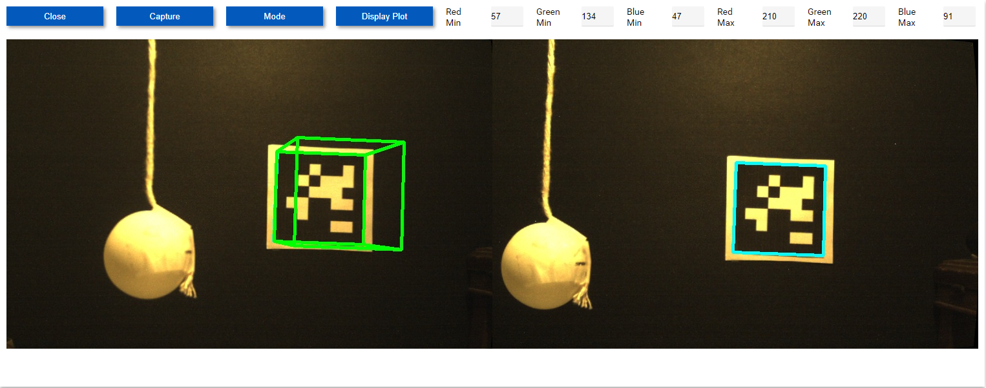
Figure 1 Graphical User Interface
As for camera motion errors, all testing was performed with the camera system on stable, flat surfaces. The plan for a real-world application is to use a gimble to ensure that the camera remains independent of the rotation of its support. This should minimize unwanted camera movement, which will in turn minimize blurry image feeds. The camera is placed on a flat and stable surface, and this mitigates motion errors at this scale. For the real-world application, the camera would be placed on a gimbal, so that the camera would remain independent of the rotation of its support, therefore minimizing any camera motion. Figure 2, shown on the following page, is my personal setup that was used for most of the testing and demonstration of the project.
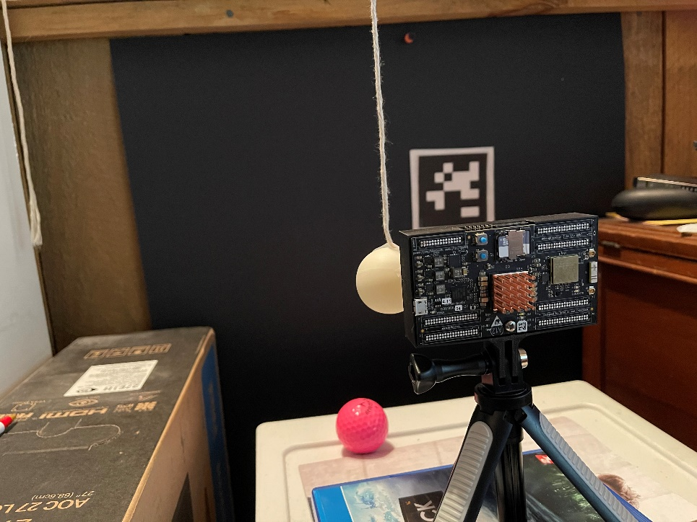
Figure 2 Snickerdoodle Black Test Setup
Unfortunately, the requirements of coefficient of restitution and LED visualization remain incomplete. With more time, a plan is in place to guarantee that they are finished and working correctly. For the LED visualization, Python would be used. By placing an April tag at each corner of the court, the system can be calibrated to recognize the border of the court. With this information, it will be possible to see if the ball is in or out of the court, and the address of the LED can be written to, using a modified version of the blink AXI code. For coefficient of restitution, the bounce height of the ball would need to be recorded for several bounces. The plan was to create an array to store the consecutive bounce heights. The data from this array could be used to calculate the coefficient of restitution. With this plan, not only would the data be available to access live, but the United States Tennis Association would be able to retrieve the data at any point for comparison purposes. The USTA could compare any changes in the coefficient of restitution on the same court over time, or to compare to other courts.
The final piece of the puzzle was to determine and display the ball within three-dimensional space, which was done using Unity. After starting the server on the Snickerdoodle, a second Python file can be run to send specific data to Unity. A server was also started in Unity, so that it could receive the sent ping pong ball data. The game scene in Unity then accurately tracks the ping pong ball, with a vertical wall acting as the April tag. I ran the Unity three-dimensional visualization on my personal computer, and captured video and images showing a working minimum viable product; an image of this is shown on the following page. The white ball represents the ping pong ball, and the orange vertical wall is representative of the April tag used in the camera setup, which is shown in both figures 1 and 2.
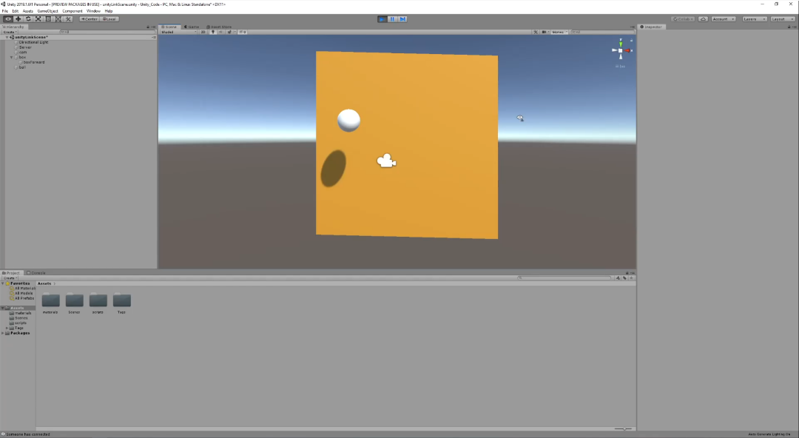
Figure 3 Screenshot of the Unity Interface

Conclusion
An FPGA-based table tennis ball tracker was successfully developed, that does accurately determine the ball position within three-dimensional space. The system has calibrated cameras, an April tag ping pong ball tracker, and any concerns with camera motion errors were addressed. As stated before, while the LED visualization and coefficient of restitution were not completed, plans are in place as to how to finish them. Give more time, a fully completed working system could be made, seeing as how two thirds of it is finished.

