Date: February 23rd, 2021
From: David G Tassoni
To: Dr. Kaputa
Subject: ESD II Lab 2 TIF Image Processing

Introduction
The purpose of this laboratory was to modify a given sample VHDL program to perform additional processing on TIF image files. The program by default that would read in TIF files, process them in multiple ways, and save off the processed TIF file. The required functionality to add was as follows:
- shall have 6 std_logic_vector(7 downto 0) inputs corresponding to min and max thresholds for red, green, blue.
- shall input red, green, and blue pixels.
- shall output modified red, green, and blue pixels based on the image thresholding.
- shall save off the resultant RGB filtered image.
The below analysis investigates the methods as to which the above requirements were met, as well as the overall functionality of the VHDL program.

Analysis
The lab source code consisted of six or seven VHDL files, and their functionality was part of the way to the end goal of the lab. The goal was to determine what needed to be changed or added to the existing solution.vhd and filter.vhd files to make them work as intended in the requirements. One other file, image_handler.vhd, contained a good number of procedures and processes, and studying this file, as well as the other two files, helped with completing the assignment. The first major change to make was adding in additional processing in the if/else statements; this added in green and blue pixel processing, as red was in by default. The image handler VHDL file had some code like this, so that was a helpful stepping point. Please see the image on the following page for a snippet of the pixel “grabbing” process.
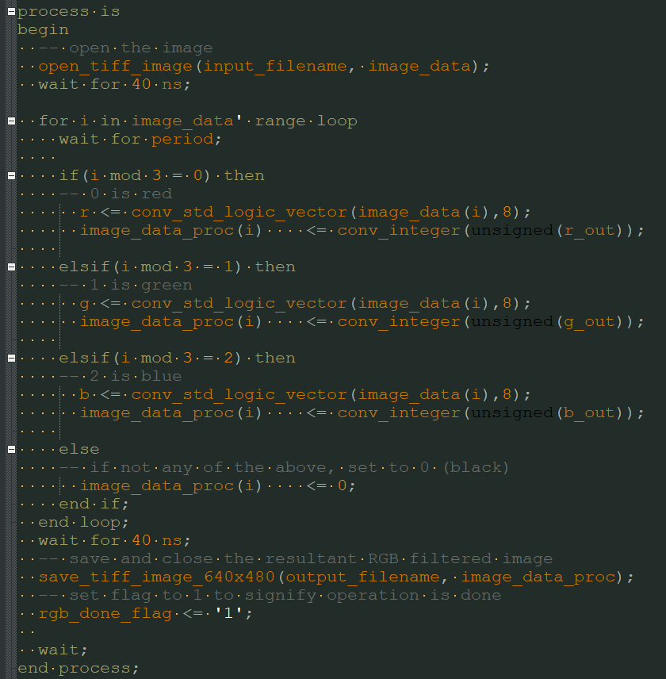

Figure 1 RGB pixel grabbing process
Once the pixels are “grabbed”, they are filtered in the filter VHDL file. That file checks to see if the values are between a certain threshold criterion (set in solution.vhd), and outputs them accordingly. The default values are set to 0 for the minimum, and 255 for the maximum, but they can be anything within that range to have different images output.
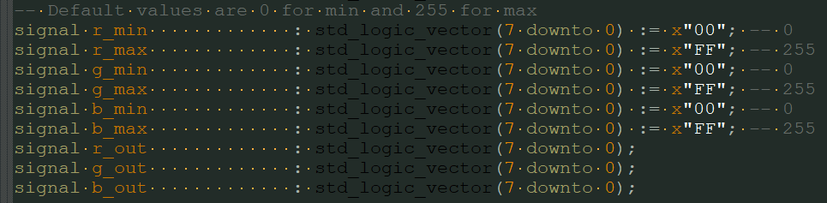
Figure 2 RGB Minimum & Maximum assignments
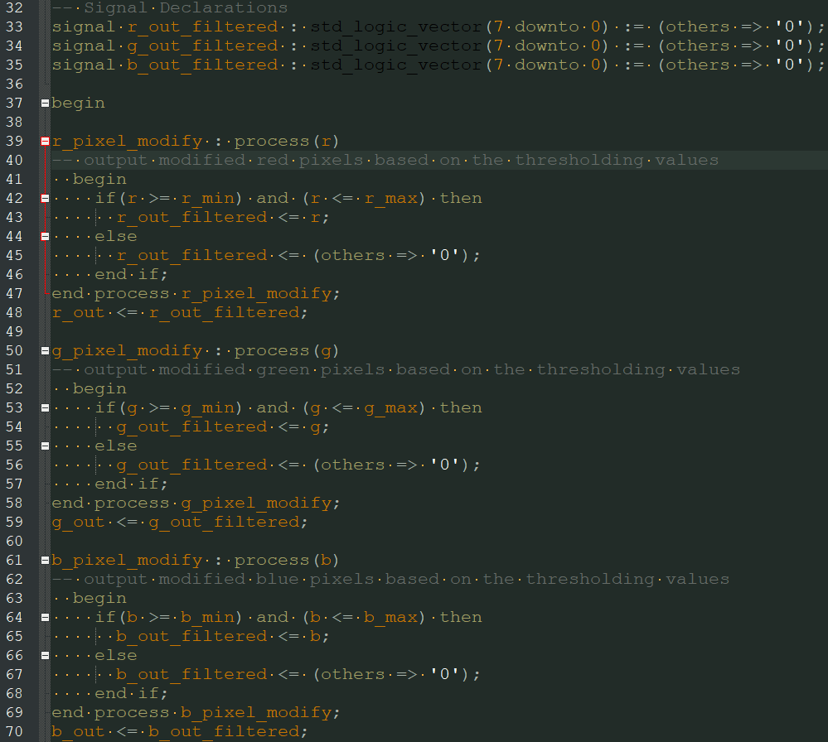
Figure 3 RGB pixel modification in filter.vhd
Using ModelSim, the files can be simulated to produce an output. The output is a single image with its RGB pixels modified according to the assigned thresholds; there are two sample outputs, one with the default thresholds (of 0 and 255), and one with modified thresholds chosen at random.
Unmodified RGB Thresholds | Modified RGB Thresholds
Table 1 RGB pixel modification comparison

Conclusion
The program can correctly filter images based on the minimum and maximum RGB threshold values set. This was achieved by adding additional standard logic vector signals corresponding to the minimum and maximum thresholds for red, green, and blue, and adding to the existing pixel grabbing process. The pixels are input, modified, and output to a
resultant RGB filtered image which is saved in the Results folder. The given sample code was a great foundation, and the additional functionality was relatively simple to implement. In the end, the threshold values can be set to any viable number, and the simulation outputs a modified filtered image of any TIF file of dimensions 640x480 pixels.

