Date: March 2nd, 2021
From: David G Tassoni
To: Dr. Kaputa
Subject: ESD II Lab 3 RGB/YCbCr Image Filtering

Introduction
The purpose of this laboratory was to modify a given Simulink demo program to filter out either RGB colors or YCbCr colors from the imported image. The required functionality to add was as follows:
- shall input all 6 RGB limits on a single port.
- shall input all 6 YCbCr limits on a single port.
- shall specify the RGB and YCbCr limits within a setup file.
- shall display the resultant image on a video output scope.
- shall have a manual switch in Simulink to select between RGB or YCbCr mode.
The below analysis investigates the methods as to which the above requirements were met, as well as the overall functionality of the Simulink program.

Analysis
The first changes to make were simple, create the color limits in the setup file. This was achieved by making 6 limits for each color space, and then an array for each one as well. The relevant code is shown below:
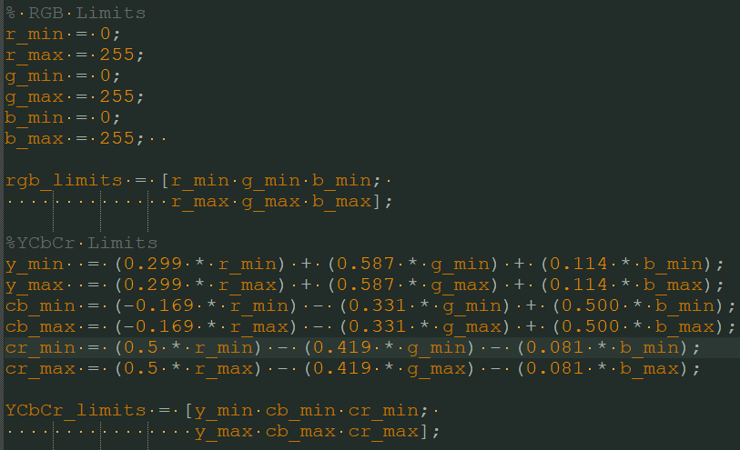
Figure 1 Color Limits in setup.m File
The idea to create arrays for the limits came from the given setup file, doing it this way made the import in Simulink much easier. Creating the rest of the functionality for the program was somewhat straightforward. Having not used Simulink before, thee learning curve was more significant than anticipated. By reviewing the given demo, some of the Simulink programming was given. Once it was determined how to separate the input arrays into their individual components, the rest of the program wrote itself. Using the six upper and lower limits for each color space, selecting only the relevant pixels was simple. The Simulink block “Relational Operator” was used two times for each color channel, with its inputs corresponding to the color limit, and the color signal (ex. r_min and R). The below configuration was duplicated six times, with the minimum limit and color input into the top Operator, and the maximum limit and color input into the bottom Operator.
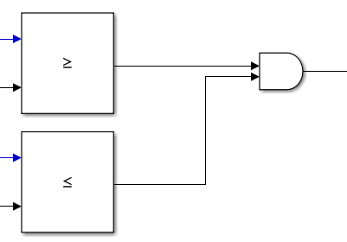
Figure 2 Relational Operator to AND Gate
The Relational Operator block outputs either a 1 or 0, so by using an AND gate immediately after, it is ensured that only the pixels that meet the criteria will output to the image. Incorporating the manual switch into the Simulink code was a bit difficult at first, but it was achieved. The original plan was to have the switch at the end, directly before the video viewer block. This idea was dropped after being unable to combine the individual RGB or YCbCr signals together before the switch, with either Add blocks or Concatenate blocks. The conclusion was to put the switch at the beginning, with 1 and 0 being the inputs to the switch. The output was fed to an AND gate placed after the AND gate shown above in Figure 2. This would guarantee that, like before, only outputs of 1 would pass, and therefore the proper image type would be displayed.
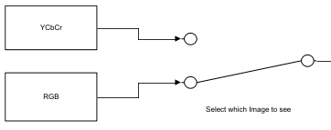
Figure 3 Filter Selection Switch
The YCbCr enable corresponds to 0, and RGB to 1. The YCbCr signal feeds into a NOT gate, so the number is changed to 1, guaranteeing that the AND gate outputs a 1 when in YCbCr mode, so the image display is active.

Conclusion
The program correctly filters out either the RGB or YCbCr colors from the input image. The limits are set in the setup file and imported into Simulink on a single port. The resultant images are output onto a video output scope, with a manual switch toggled by the user in order to select between RGB and YCbCr modes. The Simulink MATLAB program is fully functional and meets all outlined criteria.

