Date: April 6th, 2021
From: David G Tassoni
To: Dr. Kaputa
Subject: ESD II Lab 4 Simulink and REMI

Introduction
A Simulink program was developed that performs an RGB filter on an input image. The purpose of this laboratory was to modify this program to filter out either RGB colors or YCbCr colors from the imported image, with the below requirements.
- shall filter out between a minimum and maximum for R, G, B channels or Y, Cb, Cr channels.
- shall have a button that toggles between RGB and YCbCr modes.
- shall target the Simulink model to the fusion 2 hardware.
- shall visualize the filtering via a REMI GUI
The below analysis investigates the methods as to which the above requirements were met, as well as the overall functionality of the program.

Analysis
The first changes to make were simple, create three additional color limits in the setup file to correspond to the minimum values for R, G and B. The next step was to go into the RGB filter subsystem to add the new inputs to the existing comparison blocks, as shown below.
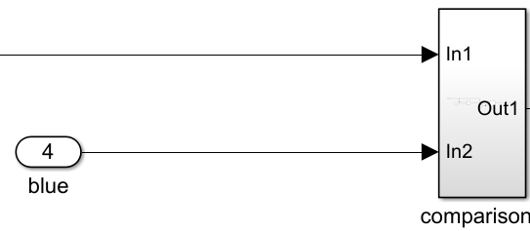 | 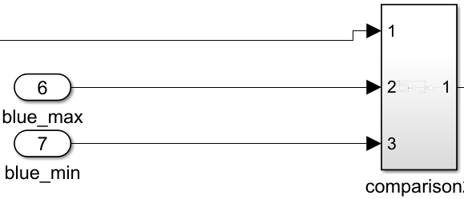
Table 1 Comparison Blocks
This change was made for each color channel, and then the remaining parts of the RGB filter needed to be looked at. The YCbCr color space conversion was performed inside the filter using the Simulink RGB to YCbCr block, and its outputs were routed to the existing outputs of valid_out and image_out. The major changes were to add in two switches to toggle between the two color spaces, and properly routing the control signal. The image located on the following page shows the new RGB filter system.
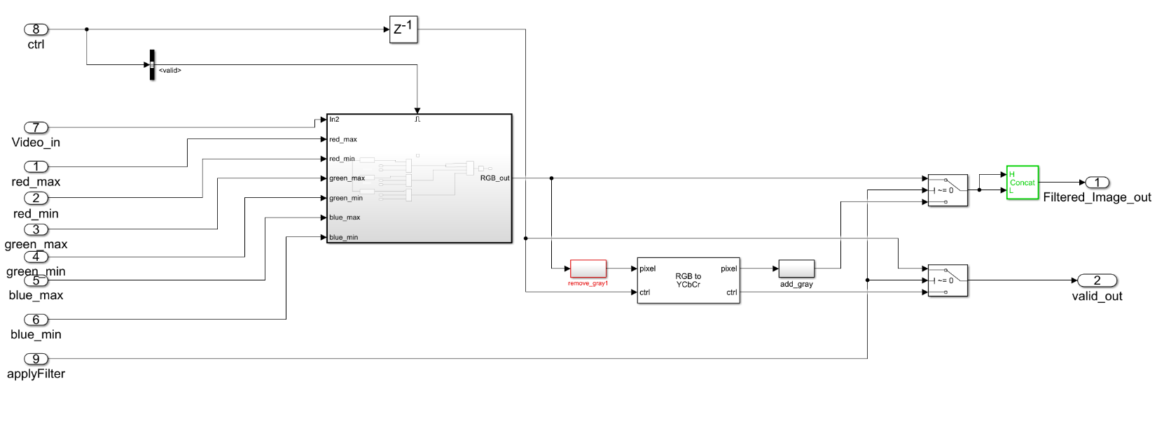
Figure 1 RGB filter Simulink System
On the left of the image, one can see the 6 inputs for the RGB limits, the “applyFilter” input for toggling between color spaces in Simulink (0 for YCbCr and 1 for RGB), and the video_in signal which houses the input image. On the right side lie the two switches as mentioned earlier, whose responsibility is switching the output between RGB and YCbCr.
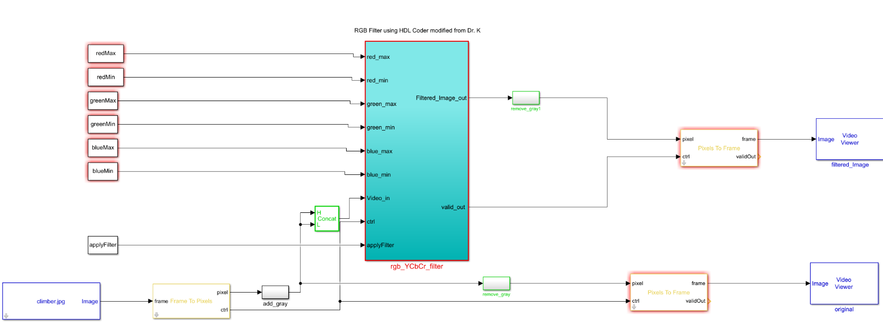
Figure 2 Overall Simulink File
Shown above, outside the RGB Filter lies the rest of the system, with its outputs of the original unmodified image, and the filtered image.
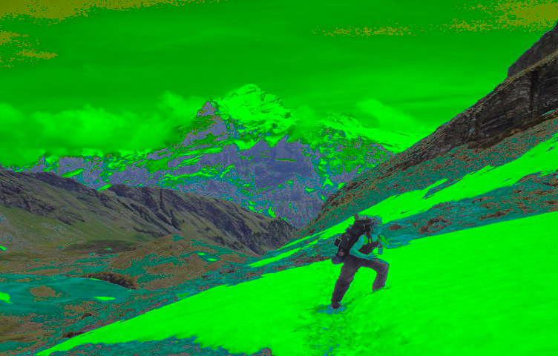 | 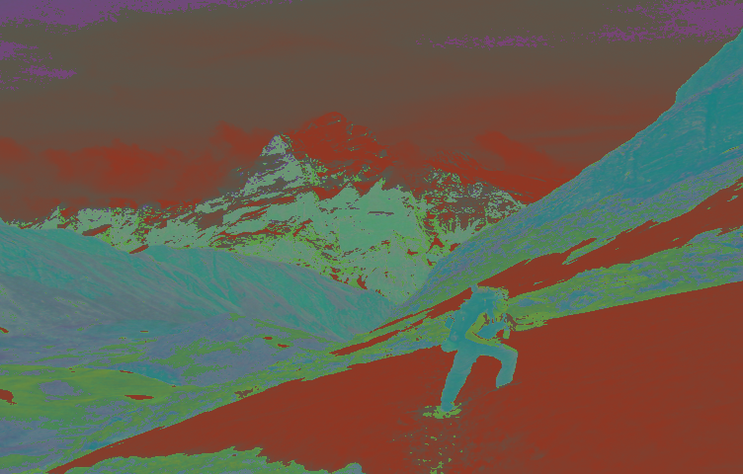
Table 2 RGB and YCbCr Simulink Outputs
The above table shows the input image with modified RGB and YCbCr values, thus verifying that the application is working as expected. The HDL code was compiled, and the resultant system.bit file was put onto the Snickerdoodle Black to check for REMI functionality. The system and REMI worked well together, yielding similar results to the above Simulink outputs.
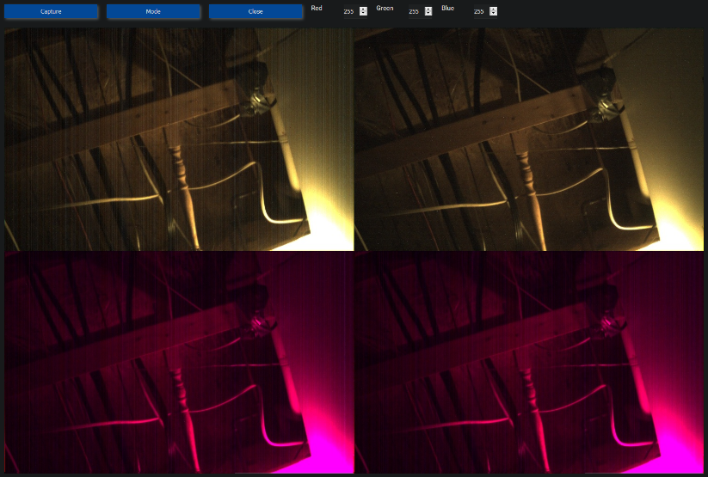 | 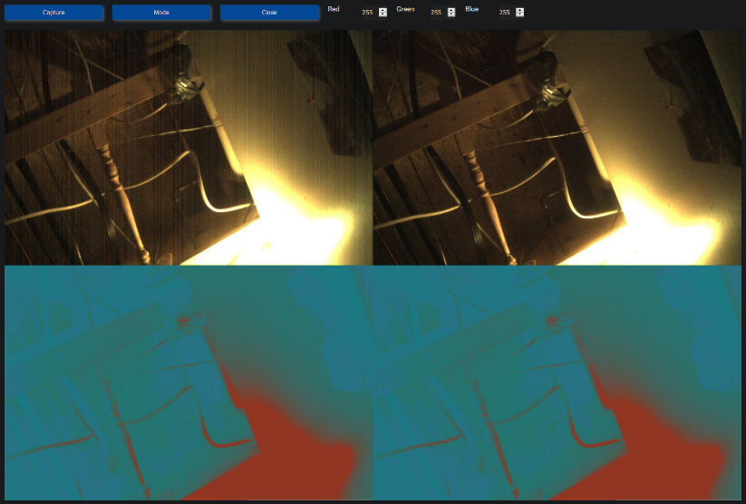
Table 3 RGB and YCbCr REMI camera captures
Shown in the table are a couple of captures from the REMI web interface. On the left, the system is in RGB mode, and right it is in YCbCr mode. Changing the values of the limits can be done by writing to their addresses.

Conclusion
The program correctly filters out either the RGB or YCbCr colors from the input image, in both Simulink and on the Snickerdoodle board. The Simulink model was targeted to the Fusion 2 hardware, and the filtering was also able to be visualized via a REMI gui. Overall, the program meets the functionalities as defined in the project requirements.

