EPR 05 - „Vier Gewinnt“
Authors: Nils Gandlau, David Jordan
Documentation:
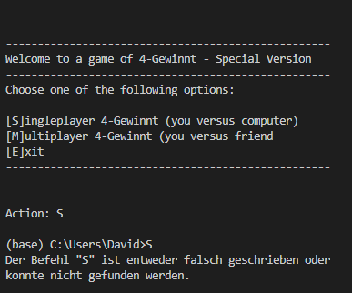
Testcase 1:
Here a feature was selected in the user interface, revealing it had not yet been properly implemented in the underlying code.

Testcase 2:
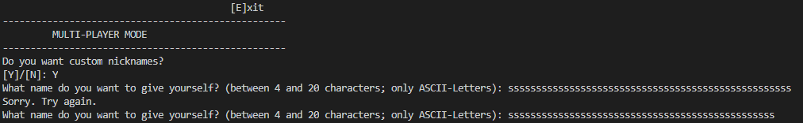
Here a user name was entered exceeding the prescribed number of 20 characters. Program correctly repeated its input prompt.

Testcase 3:
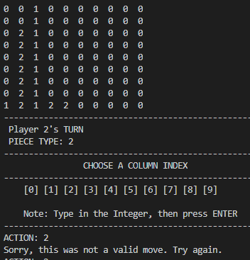
Here a column was filled completely with playerpieces and an attempt was made to select that column again, to see if the program accurately displays an invalid move and prompts another user input. Test was done to see if the erroneous user input is handled.

Testcase 4:
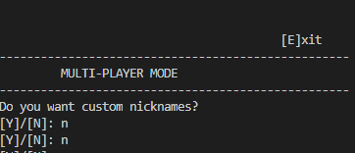
Here lower case letters were entered instead of the needed uppercase ones. The Program repeats the input prompt in a new line. Test was done to see if the erroneous user input is handled.

Testcase 5:
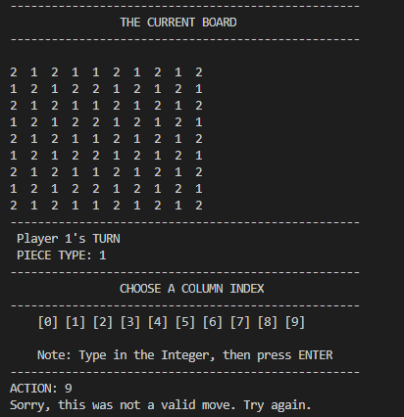
Here the board was completely filled with pieces, yet the program still asks for another move by the player. A method checking for a draw was not working yet.

Testcases 6 -9:
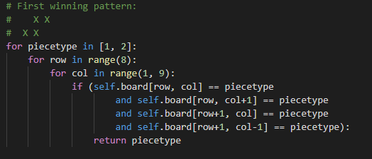
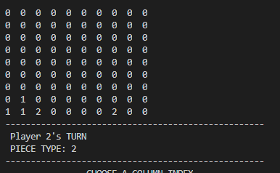
Here the first winning pattern was entered in the four outermost parts of the playing board, testing if the ranges in the underlying algorithm were working as intended. Both piecetypes were used twice.

Testcases 10-13:
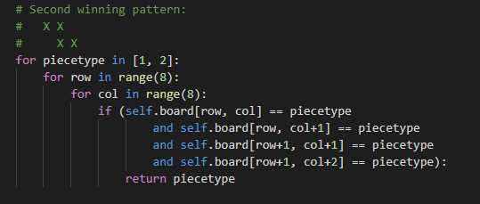
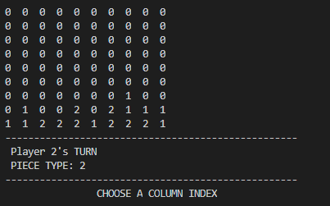
Here the second winning pattern was entered in the four outermost parts of the playing board, testing if the ranges in the underlying algorithm were working as intended. Both piecetypes were used twice.

Testcases 13-16:
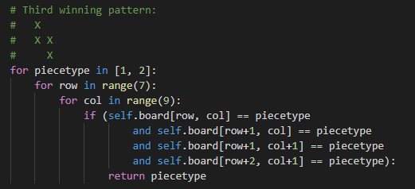
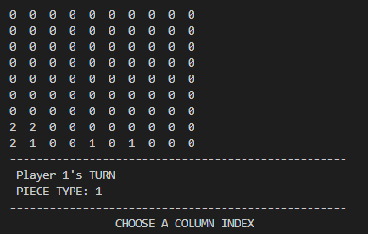
Here the third winning pattern was entered in the four outermost parts of the playing board, testing if the ranges in the underlying algorithm were working as intended. Both piecetypes were used twice.

Testcases 16-19:
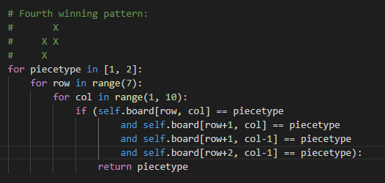
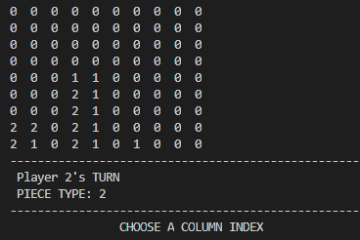
Here the fourth winning pattern was entered in the four outermost parts of the playing board, testing if the ranges in the underlying algorithm were working as intended. Both piecetypes were used twice.

