EPR 05: „Vier Gewinnt“
User Manual
Authors: David Jordan, Nils Gandlau

The popular board game “Vier Gewinnt” was implemented as a console-based game, with both multi player- and single player options, written exclusively in Python 3.7, keeping with the specified rules on the included “EPR 05” pdf. File. To sum up the rules relevant for players of the game:
The game is defined for two players. All user input is entered into the console and confirmed by pressing “Return”. The game “board” is simulated by a 9 x 10 matrix /array. The program lets the player(s) initially choose between a multi- player- or single player option, by pressing either (“SsMm”) of the initial letters to set the game mode. In singleplayer mode the player is then presented the option of choosing either a custom nickname or being addressed as “Player 1”. He will be playing against an AI opponent, in the game referred to as “Bot”, who will always be playing with “2” as default piece type. The human player will be playing with “1” as his default piece type. In multiplayer mode, two human players can play against each other, both being able to either choose custom nicknames, or remain “Players 1/2”.
The game is turn based and each player's objective is to reach one of the four below specified winning patterns, with their respective piece type, by selecting one of the 10 columns to drop their piece into, by entering the numbers 0 to 9 into the console. The individual player piece will drop into the selected player column and into the lowest unoccupied position. The four possible winning patterns are:
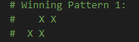
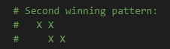
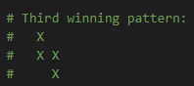
1. 2. 3.

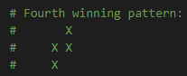
4.

The player has the option to exit the game by entering “E/e” into the console at all times during the game. If the entire board is filled and no winner could be determined, the game will be scored as a draw. The final result of each game is displayed in the console.

