EPR 05: “Vier Gewinnt”
Documentation
Authors: David Jordan, Nils Gandlau

Test case 20:
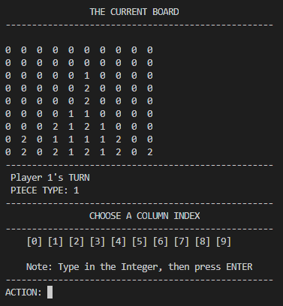
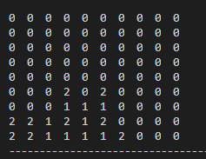
Here it was tested whether the Bot correctly identifies winning patterns 1, 2, 3 and 4. Bot successfully recognizes an impending win by Player 1 by searching for and identifying all four patterns. It then successfully thwarts a win by the human player.

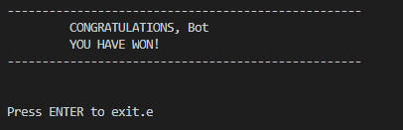
Test case 21:

Here it was tested whether the Bot algorithms were sophisticated enough to actually generate a win against an opponent who is not playing with a strategy where he is planning more than two moves ahead. Bot is consistently able to win against such an opponent.

Test case 22:
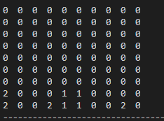

Here it was tested whether there is a definite way to win against the Bot. It always loses if the human player is able to generate a small square of four 1's in the center of the board. Because upon its completion four independent winning possibilities arise, of which the bot can only thwart one.

