**Tutorial 6**

N = 8

K = 1

L = 16

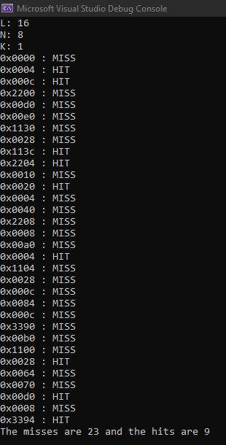

N = 4

K = 2

L = 16

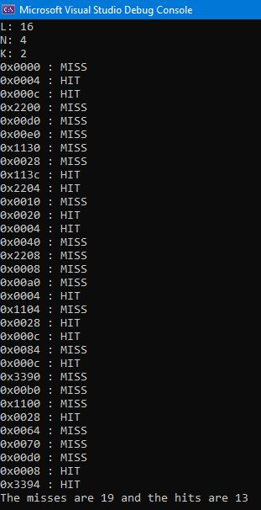

N = 2

K = 4

L = 16

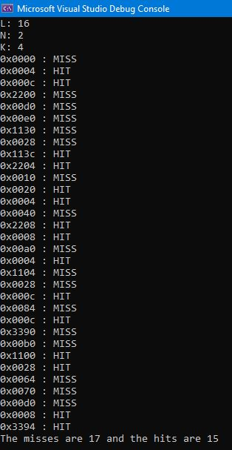

N = 1

K = 8

L = 16

