Python Programming Assignment
Setup, Scripting, and Execution Models in Python

Question 1: Install Python and VS Code
Task: Install the latest version of Python and Visual Studio Code (VS Code) on your computer, then take a screenshot of both the Python installation confirmation and the VS Code welcome screen.
Steps to install Python:
1. Go to python.org/downloads and download the latest stable release for your operating system.
2. Run the installer. On Windows, check the box "Add Python to PATH" before clicking Install Now.
3. Open a terminal (Command Prompt, PowerShell, or Terminal) and type: python --version
4. The terminal should print the installed version number, e.g. Python 3.13.1, confirming the installation.
Steps to install VS Code:
1. Go to code.visualstudio.com and download the installer for your operating system.
2. Run the installer and accept the default options.
3. Launch VS Code — the welcome screen appears automatically on first launch.
4. (Optional but recommended) Install the official "Python" extension from Microsoft inside VS Code's Extensions panel.
Note: Because this document is generated by an AI assistant and not run on your personal computer, the two images below are labeled mockups that show what each confirmation screen looks like. Please replace them with your own screenshots taken after installing Python and VS Code on your machine.
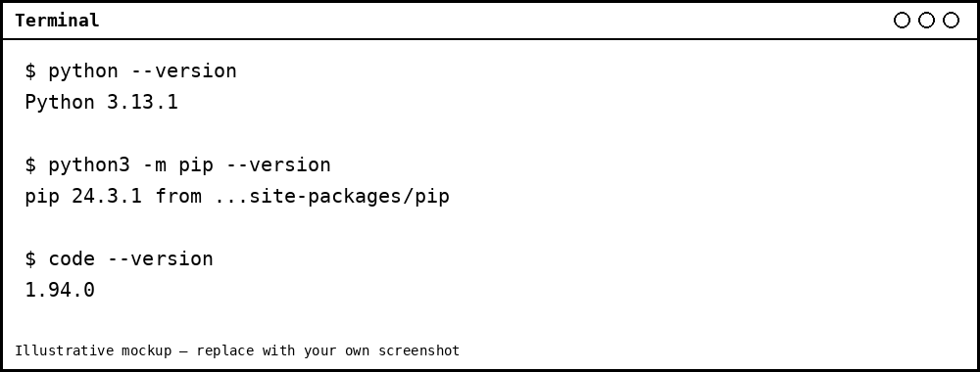
Figure 1 — Terminal output confirming a Python installation (mockup)
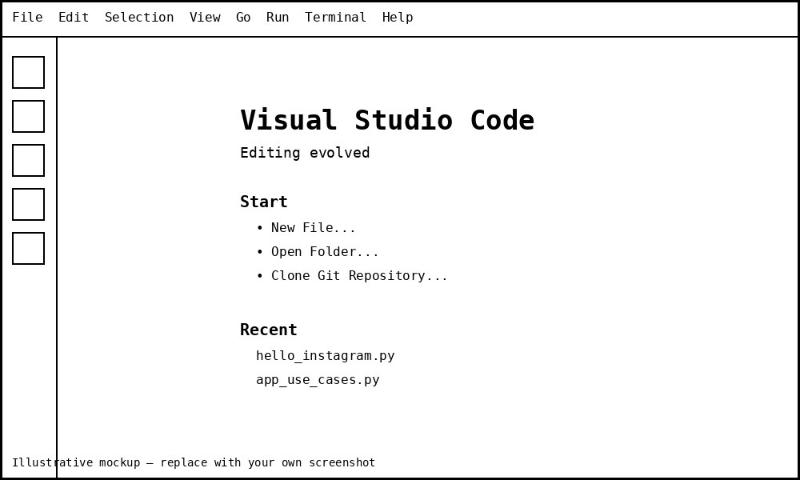
Figure 2 — VS Code welcome screen (mockup)

Question 2: hello_instagram.py
Task: Create a new Python file named hello_instagram.py in VS Code and write code to print 'Hello, Instagram World!' to the terminal.
Code (hello_instagram.py):
# hello_instagram.py
# Prints a greeting to the terminal

print("Hello, Instagram World!")
Expected terminal output:
Hello, Instagram World!

Question 3: app_use_cases.py
Task: Write a Python script called app_use_cases.py that prints three real-life apps you use daily and, for each, prints one way Python could be used in their backend or data analysis.
Code (app_use_cases.py):
# app_use_cases.py
# Lists three daily-use apps and one way Python could support
# their backend or data analysis

apps = {
"Instagram": "Python (Django) powers parts of the backend that
serve feeds, handle authentication, and manage
media uploads.",
"Spotify": "Python is used to analyze listening data and
power music recommendation algorithms.",
"YouTube": "Python is used for backend services and for
processing and analyzing video/viewership data.",
}

for app_name, python_use in apps.items():
print(f"App: {app_name}")
print(f" Python use case: {python_use}")
print()
Expected terminal output:
App: Instagram
Python use case: Python (Django) powers parts of the backend that
serve feeds, handle authentication, and manage
media uploads.

App: Spotify
Python use case: Python is used to analyze listening data and
power music recommendation algorithms.

App: YouTube
Python use case: Python is used for backend services and for
processing and analyzing video/viewership data.

Question 4: Modify hello_instagram.py to Print the Python Version
Task: Modify your hello_instagram.py script to print the Python version currently running your script. Hint: Use the sys module and sys.version.
Updated code (hello_instagram.py):
# hello_instagram.py
# Prints a greeting and the running Python version

import sys

print("Hello, Instagram World!")
print("Python version running this script:", sys.version)
Example terminal output:
Hello, Instagram World!
Python version running this script: 3.13.1 (main, Oct 7 2024, 05:02:14)
[GCC 13.2.0]

Question 5: Python Execution vs. C/Java Execution
Task: Explain the difference between how Python executes code versus how C or Java executes code, using your own words and a simple example for each.
Python is an interpreted language. When you run a Python script, the Python interpreter reads the source code and executes it line by line, translating each line into machine-level instructions at runtime. There is no separate compile step that the programmer has to run first — you simply run the file and the interpreter does the translation on the fly. This makes Python quick to test and debug, but generally slower to execute than a fully compiled language, since translation happens every time the program runs.
Example: If I write print("Hello, Instagram World!") in a file and run "python hello_instagram.py", the interpreter reads that single line and immediately prints the text — no separate build step is needed.
C, on the other hand, is a compiled language. The entire source code is translated ahead of time by a compiler (such as gcc) into machine code specific to the target CPU, producing an executable file. Only after compilation succeeds can the program be run, and at that point the CPU executes the machine code directly, with no translation happening during the run. This makes compiled C programs start up and run faster, but any change to the code requires re-compiling before it can be tested.
Example: A C program with #include <stdio.h> and int main() { printf("Hello, World!"); return 0; } must first be compiled with a command like "gcc hello.c -o hello", which creates an executable "hello". Running "./hello" then executes the already-compiled machine code.
Java sits in between the two. Java source code is first compiled by the Java compiler (javac) into an intermediate form called bytecode, not directly into machine code. That bytecode is then run by the Java Virtual Machine (JVM), which interprets it (and often uses just-in-time, or JIT, compilation to speed up frequently used code). This gives Java the "write once, run anywhere" property, since the same bytecode can run on any machine that has a JVM installed.
Example: A file Hello.java is compiled with "javac Hello.java" to produce Hello.class (bytecode). Running "java Hello" then starts the JVM, which reads and executes that bytecode.
In short: Python translates and runs code one line at a time at runtime (interpreted); C translates the whole program into machine code before it ever runs (compiled); and Java compiles to an intermediate bytecode that a virtual machine then interprets or JIT-compiles (a hybrid approach).
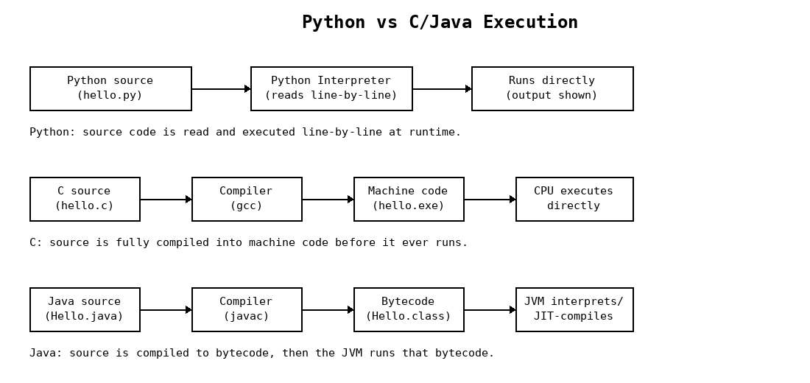
Figure 3 — Python (interpreted) vs C (compiled) vs Java (compiled to bytecode, run by JVM)

