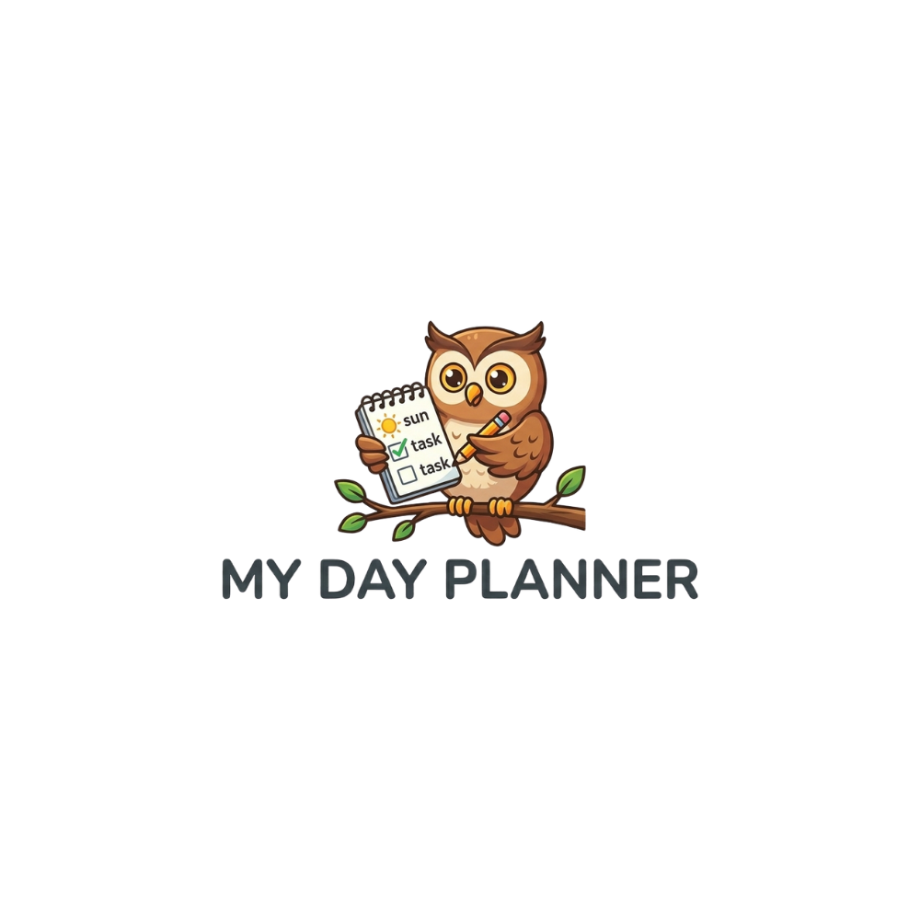
Brand Style Guide
Visual design specifications for web, iOS, and Android
March 2026 — Internal Document

1. Logo & Mascot
The My Day Planner brand identity centers on a friendly owl mascot. The owl represents wisdom, planning, and attention to detail.
Full Logo

Use in headers, marketing materials, and splash screens. Includes mascot and wordmark.
File: owl-logo.png
App Icon
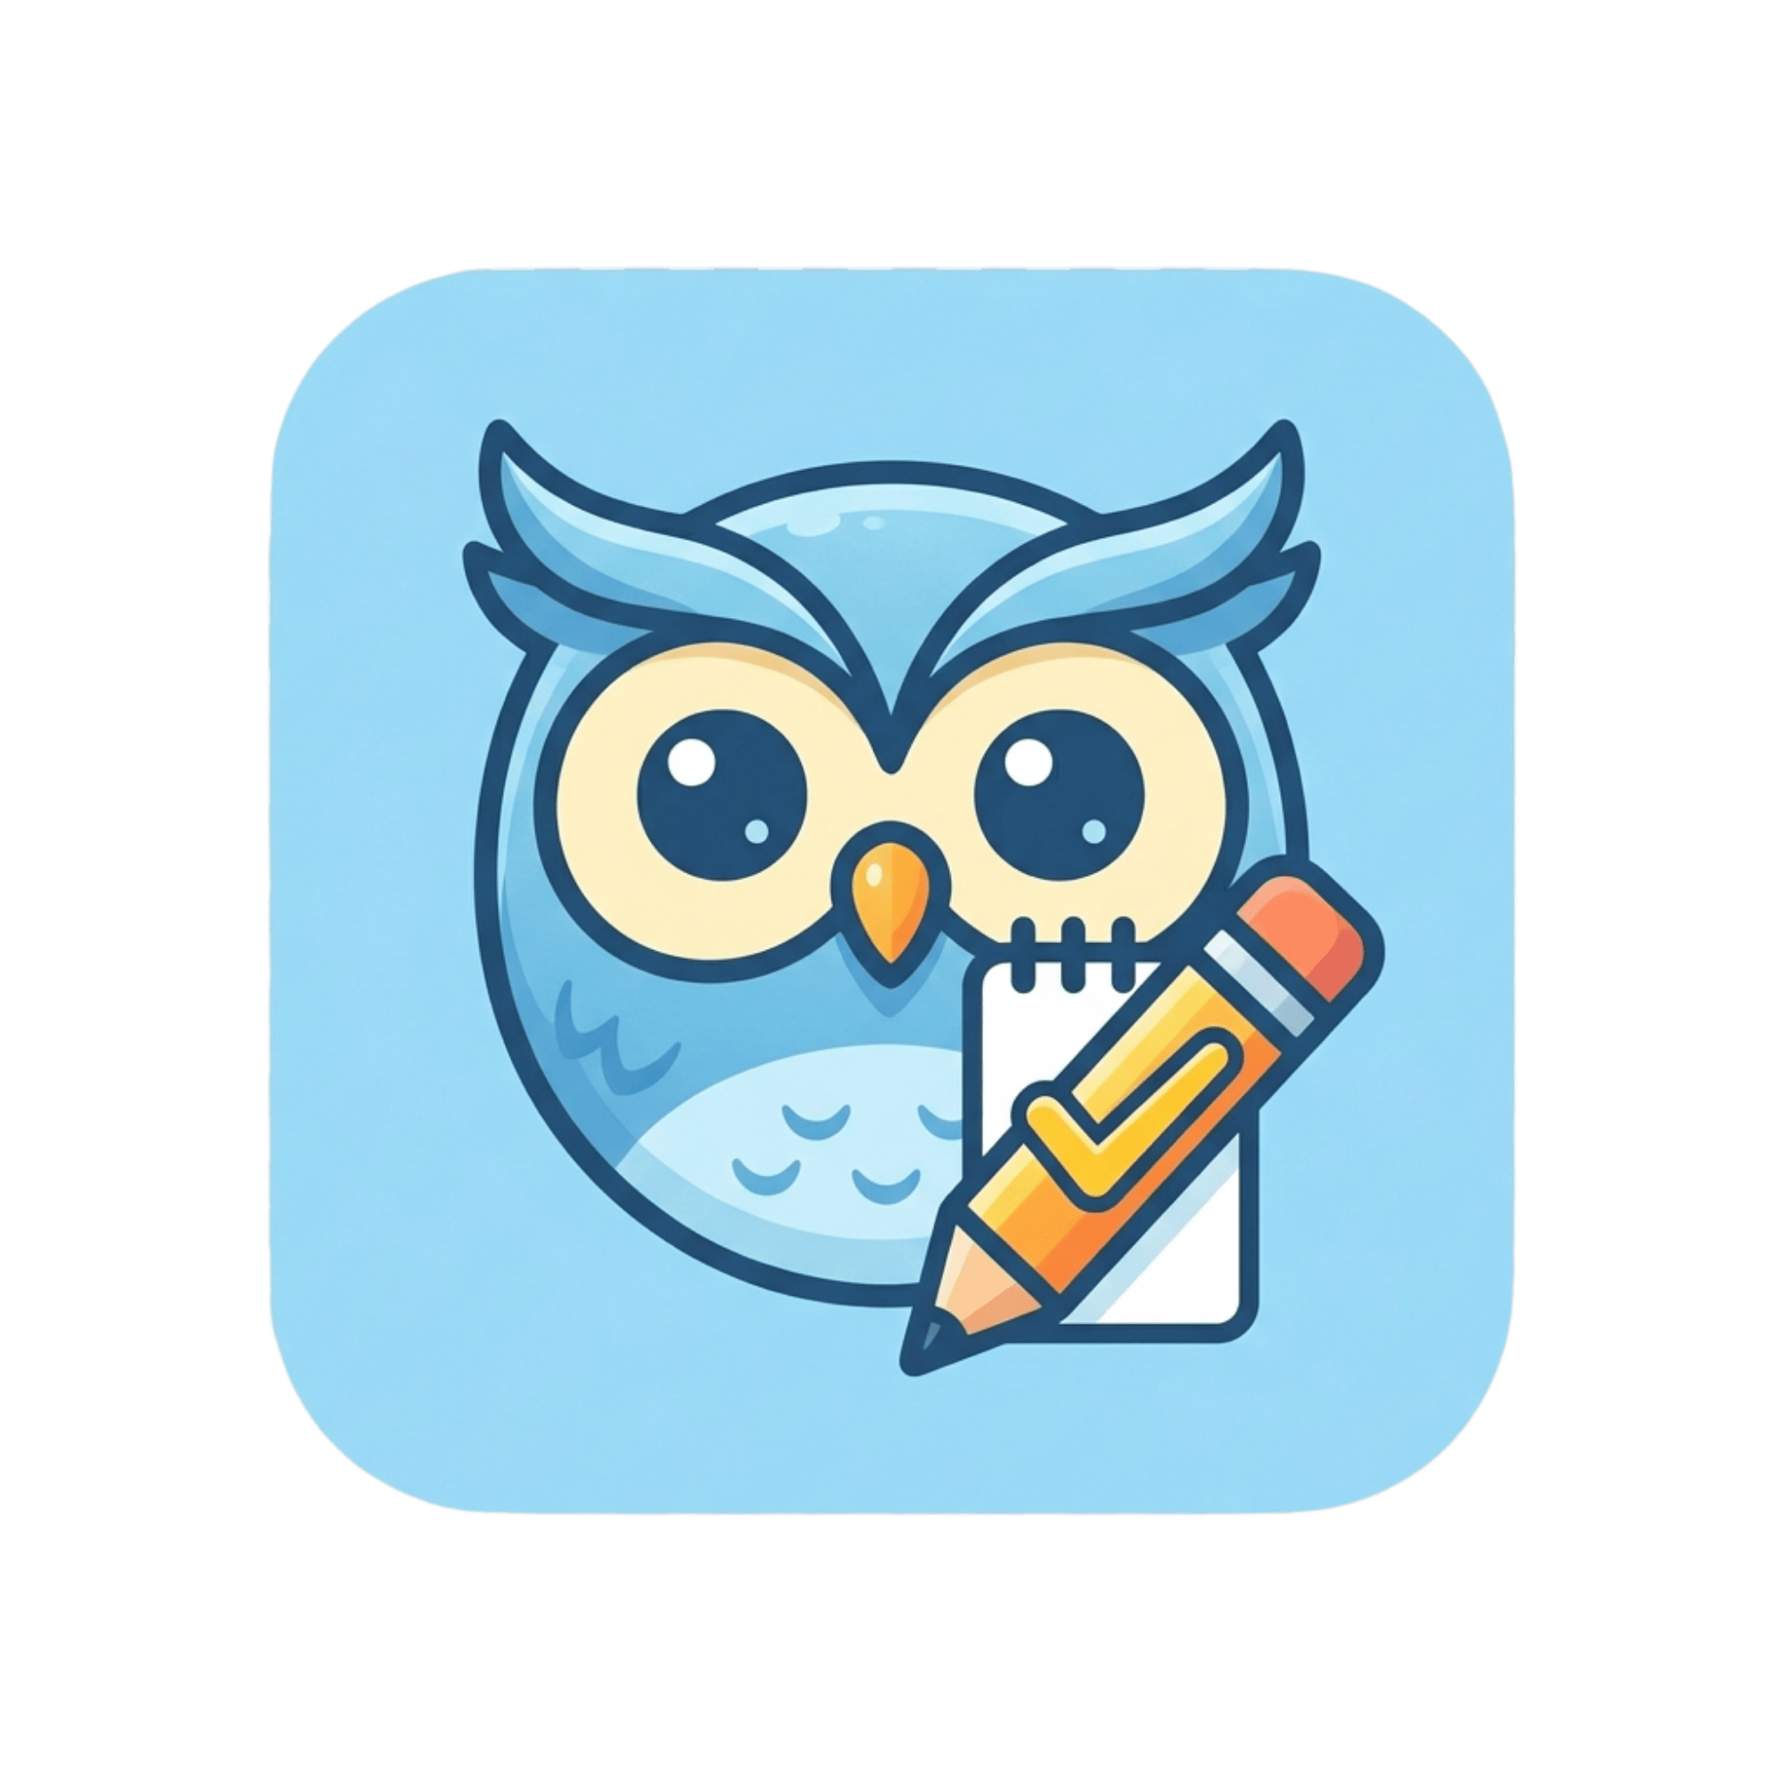
Use as app icon, favicon, and compact brand mark. Sky blue background with rounded corners.
File: owl-icon.png
Checkmark Icon

Decorative element for task completion, success states, and illustrations.
File: checkmark.png
Favicon & App Icon Files
- favicon.ico — Multi-size ICO for browsers
- favicon-16x16.png — 16px PNG favicon
- favicon-32x32.png — 32px PNG favicon
- apple-touch-icon.png — 180px Apple touch icon
- android-chrome-192x192.png — 192px Android icon
- android-chrome-512x512.png — 512px Android icon (splash/PWA)
Logo Usage Rules
- Always maintain clear space around the logo equal to the height of the owl’s head.
- Never stretch, rotate, recolor, or place on busy backgrounds.
- On dark backgrounds, use the full logo as-is (it has a transparent background).
- Minimum size: 120px wide for digital, 1 inch for print.

2. Color Palette

Primary — Sky Blue
The core brand color. Use for primary actions, links, active states, and key UI elements.
 | Sky 50 | #F0F9FF
 | Sky 100 | #E0F2FE
 | Sky 200 | #BAE6FD
 | Sky 300 | #7DD3FC
 | Sky 400 | #38BDF8
 | Sky 500 (Primary) | #0EA5E9
 | Sky 600 (Hover) | #0284C7
 | Sky 700 | #0369A1
 | Sky 800 | #075985
 | Sky 900 | #0C4A6E

Accent Colors
Used for secondary actions, status indicators, categories, and visual variety. Drawn from the owl illustration.
Swatch | Name | Hex | Usage
 | Amber | #F59E0B | Stars, highlights, warnings, calendar events
 | Yellow | #FBBF24 | Checkmarks, sunny accents, pending states
 | Green | #22C55E | Success, completed tasks, positive states
 | Orange | #F97316 | Urgency, overdue, important badges

Semantic / Status Colors
State | Color | Hex | Usage
Success | Green | #22C55E | Task complete, save confirmation, positive feedback
Warning | Amber | #F59E0B | Due soon, approaching deadline
Error | Red | #EF4444 | Validation errors, overdue, destructive actions
Info | Sky | #0EA5E9 | Tips, informational banners, help text

3. Typography

Font Family
System font stack (platform native). Uses the native font of each platform for optimal readability and performance.
ui-sans-serif, system-ui, -apple-system, BlinkMacSystemFont, "Segoe UI", Roboto, "Helvetica Neue", Arial, sans-serif

Type Scale
Element | Size | Weight | Color
Display / H1 | 36-48px | 800 (extrabold) | gray-900 #111827
H2 | 30px | 700 (bold) | gray-900 #111827
H3 | 20px | 600 (semibold) | gray-900 #111827
Body | 16px | 400 (normal) | gray-700 #374151
Body secondary | 16px | 400 (normal) | gray-600 #4B5563
Small / Label | 14px | 500 (medium) | gray-600 #4B5563
Caption / XS | 12px | 400 (normal) | gray-500 #6B7280

4. Buttons
All buttons use the pill shape (fully rounded corners) for a friendly, approachable feel.
Primary Button
Background: sky-500 #0EA5E9 | Hover: sky-600 #0284C7 | Text: white
Border radius: full (pill) | Shadow: sky-200 | Font weight: 600 (semibold)
Secondary Button
Background: gray-900 #111827 | Hover: gray-800 | Text: white
Outline / Ghost Button
Background: white | Border: 2px sky-200, hover sky-400 | Text: sky-600 #0284C7
Success / Complete Button
Background: green-500 #22C55E | Hover: green-600 | Text: white
Danger / Destructive Button
Solid: red-500 #EF4444 | Hover: red-600 | Text: white
Outline: border red-200 | Text: red-600

5. Cards
Feature cards use a color-coded system with four accent colors.
Property | Value
Border radius | 16px (rounded-2xl)
Padding | 24px (p-6)
Border | 1px solid, matching color-100
Hover shadow | 0 10px 15px -3px, matching color-100
Icon container | 48x48px, rounded-xl (12px)
Background | color-50 (sky-50, amber-50, green-50, orange-50)

6. Spacing & Layout
Element | Value | Notes
Max content width | 1152px | max-w-6xl
Max text width | 768px | max-w-3xl (legal pages)
Side padding | 16px / 24px | px-4 mobile, px-6 desktop
Section padding | 80px / 112px | py-20 mobile, py-28 desktop
Card gap | 32px | gap-8
Base unit | 4px | Tailwind spacing scale

Border Radius Scale
Name | Value | Usage
rounded | 4px | Subtle rounding
rounded-lg | 8px | Inputs, small elements
rounded-xl | 12px | Icon containers
rounded-2xl | 16px | Cards, panels
rounded-3xl | 24px | Hero images, large panels
rounded-full | 9999px | Buttons, pills, avatars

7. Shadows
Use colored shadows matching the element’s accent color for a softer, more cohesive look.
- Sky elements: shadow-lg shadow-sky-200
- Amber elements: shadow-lg shadow-amber-200
- Green elements: shadow-lg shadow-green-200
- Dark elements: shadow-lg shadow-gray-300

8. Design Principles
Friendly & Approachable
Use rounded shapes, warm colors, and the owl mascot to create a welcoming feel. Avoid sharp corners and harsh contrasts.
Clean & Uncluttered
Generous whitespace, clear hierarchy, and minimal decoration. Let content breathe. Every element should earn its place.
Cheerful Color Coding
Use the four accent colors (sky, amber, green, orange) to differentiate features, categories, and states. Never use more than two accent colors in the same view.
Consistent Across Platforms
The same palette, typography scale, and spacing system should be used on web, iOS, and Android. Platform-specific patterns are acceptable but colors must match.

9. CSS Variables Reference
Copy these into your web app or design system for consistent colors.
/* Primary - Sky Blue */
--color-primary-50: #f0f9ff;
--color-primary-100: #e0f2fe;
--color-primary-200: #bae6fd;
--color-primary-300: #7dd3fc;
--color-primary-400: #38bdf8;
--color-primary-500: #0ea5e9; /* Main brand color */
--color-primary-600: #0284c7; /* Hover / links */
--color-primary-700: #0369a1;
--color-primary-800: #075985;
--color-primary-900: #0c4a6e;

/* Accent */
--color-amber: #f59e0b;
--color-yellow: #fbbf24;
--color-green: #22c55e;
--color-orange: #f97316;

/* Semantic */
--color-success: #22c55e;
--color-warning: #f59e0b;
--color-error: #ef4444;
--color-info: #0ea5e9;

10. Mobile App Implementation
iOS (Swift / SwiftUI)
- Use system font (SF Pro) — matches the system stack approach
- Map Tailwind colors to SwiftUI Color assets in the asset catalog
- Use .clipShape(RoundedRectangle(cornerRadius: 16)) for cards
- Use Capsule() for pill buttons
Android (Jetpack Compose / Material)
- Use system font (Roboto) — matches the system stack approach
- Map colors to Material 3 color scheme with sky-500 as primary
- Use RoundedCornerShape(16.dp) for cards
- Use CircleShape or large corner radius for pill buttons
React Native / Flutter
Use the CSS variables above, translated to your framework’s token system. Match border radius values: 4, 8, 12, 16, 24, 9999 (full). Shadow color should match the accent color at 20% opacity.

© 2026 My Day Planner. Internal style guide — not for public distribution.

