Physical Anthropology
2nd Paper

Orangutans: Earth's Intelligent Red Apes

David Dawson
March 04, 2026

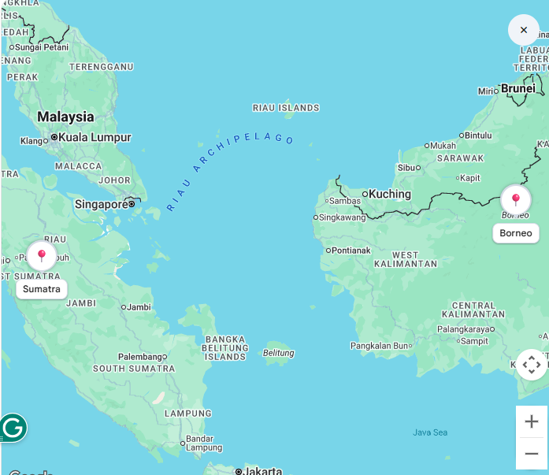
Orangutan Geographic Range
Borneo and Sumatra

Orangutans: Earth's Intelligent Red Apes
Deep in the rainforests of Southeast Asia live some of our planet's most intelligent and fascinating creatures orangutans. The name orangutan comes from two Malay words: orang meaning person and hutan meaning forest. Together, they mean person of the forest, which perfectly describes these amazing animals. Orangutans are large, red-haired apes that share many similarities with humans. Scientists have discovered that orangutans share approximately 97 percent of their DNA with people (National Geographic 2024). These incredible animals are found only in a few places on Earth, and they are in serious trouble. Understanding orangutans helps us appreciate nature's diversity and the importance of protecting wild animals.
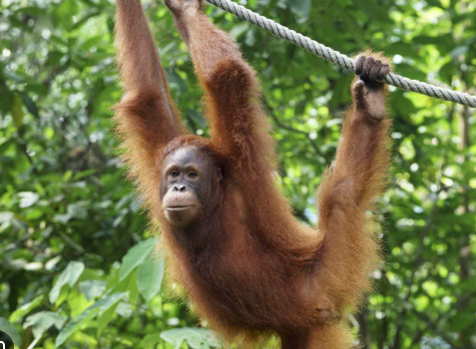
Orangutan in Rainforest Canopy
The scientific name for orangutans tells us something important about them. There are three species of orangutans: Pongo pygmaeus (Borneo orangutan), Pongo abelii (Sumatran orangutan), and Pongo tapanuliensis (Tapanuli orangutan) (IUCN Red List 2024). Orangutans live only on two large islands in Southeast Asia: Borneo and Sumatra (World Wildlife Fund 2024). These islands are located near the equator with warm, wet climates perfect for rainforests Orangutans are the largest tree-dwelling animals on Earth (National Geographic 2024). Adult males weigh 75 to 150 kilograms while females weigh 30 to 50 kilograms. Their most distinctive feature is their long, reddish-brown hair. Orangutans have extremely long arms reaching up to 2.25 meters, which helps them move through trees with ease (BBC Earth 2024). They live exclusively in rainforests (Orangutan Foundation International 2024), preferring tropical lowland and swamp forests. These forests provide everything orangutans need to survive, and the animals spend most of their time in the canopy, semi-arboreal and adapted to tree life with powerful arms and gripping feet.
Orangutans are primarily frugivores, with about 90 percent of their diet consisting of fruit (Orangutan Foundation International 2024). They are highly intelligent animals displaying problem-solving abilities and cultural behaviors passed down through generations (National Geographic 2024). They are famous for their tool use, using sticks to test water depth and extracting insects from trees. Unlike gorillas and chimpanzees that live in social groups, orangutans are mostly solitary animals (National Geographic 2024). Young orangutans remain with their mothers for about six to seven years, during which mothers teach essential survival skills. All three species of orangutans are endangered or critically endangered (IUCN Red List 2024). The greatest danger today is habitat loss due to deforestation (World Wildlife Fund 2024). Population estimates are alarming: Borneo orangutans approximately 45,000-69,000 individuals, Sumatran orangutans approximately 7,500 individuals, and Tapanuli orangutans approximately 800 individuals (IUCN Red List 2024).
Over the past 20 years, populations have dropped more than half due to habitat loss and poaching. Orangutans are remarkable creatures that deserve our respect, understanding, and protection. From their incredible intelligence to their crucial role in rainforest ecosystems, these people of the forest face uncertain futures due to human activity. However, through dedicated conservation efforts, legal protection, and changing human behavior, there is hope. By learning about orangutans and sharing that knowledge with others, we can help ensure that these amazing apes continue to swing through rainforest canopies for generations to come. Their survival is not just about saving one species but about preserving the entire rainforest ecosystem and maintaining Earth's biodiversity for future generations.
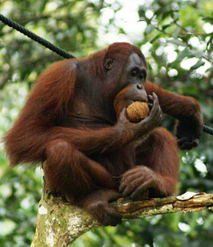
Adult Orangutan
in Natural Habitat
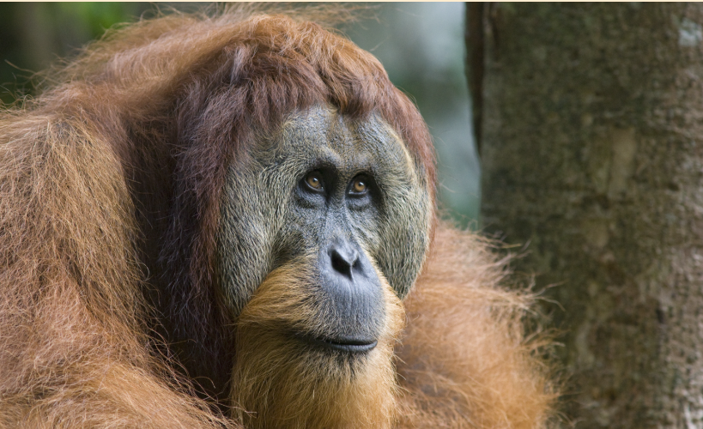
Orangutan: Adult Male

Works Cited

BBC Earth. "Orangutan Facts and Information." BBC Wildlife, 2024, www.bbcearth.com/news/things-you-need-to-know-about-orangutans
IUCN Red List. "Orangutans (Pongo)." International Union for Conservation of Nature, 2024, www.iucnredlist.org/species/17975/259043172
National Geographic. "Orangutan." National Geographic Kids, 2024, kids.nationalgeographic.com/animals/mammals/facts/orangutan
Orangutan Foundation International. "Orangutan Facts and Conservation." Orangutan Foundation, 2024, www.orangutan.org/orangutans/orangutan-facts
World Wildlife Fund. "Orangutan Conservation Efforts." WWF, 2024, www.worldwildlife.org/species/orangutan.
Nater, Alexander, et al. “Morphometric, Behavioral, and Genomic Evidence for a New Orangutan Species.” Current Biology, vol. 27, no. 22, Nov. 2017, pp. 3487-3498.e10, https://doi.org/10.1016/j.cub.2017.09.047
video:
https://ars.els-cdn.com/content/image/1-s2.0-S0960982217312459-mmc3.mp4

