**Name:** Suggestions, for Destiny 2

**Description:** This app is designed for the game “Destiny 2”, focused on endgame PvE. The main features are the app are:

* Give suggestions for weapon loadouts in endgame PvE, based on the activity/encounter and what other fireteam members are using, using roles I have defined and “the meta” for each role in each encounter.
* Give suggestions for what you may want to do today based on a curated set of endgame PvE activities.
  + When using this, also tell them which bounties are related to those activities and weapons.
* Use PGCR data to visually display data about the player that is generally hidden away

**Competitive Analysis:** There are actually a decent number of apps created that give you the information (basically the profiles that I am creating in the background), but there are very few apps (if any) that actually give suggestions about what an indecisive person should do today in Destiny.

Applications such as TodayInDestiny.com and Braytech.org tell that these things exists and that you CAN do them. Other apps such as Charlemagne and Destiny Item Manager give you information about your character. And other apps such as Trials Report and Guardian Report give you information about your fireteam, such as exactly what gear they are using.

My app is designed to give the indecisive Destiny 2 player suggestions for what activities they could play and what bounties to get, or when preparing for PvE endgame content, what sort of weapons and subclass to bring. Experienced players can do the 2nd part, but newer players may need extra help in deciding, which is what this app is for. It will also display stats and other data points that are generally hidden from the player, since the game does not have an in-game method of viewing these statistics.

**Structural Plan:** Functions will be split up depending on what they need to do, and each function won’t do a ton of stuff (aka LOTS of helper functions).

Some functions will use requests.get or requests.post methods to get any data they need, and then parse the data inside the function to extract the useful (raw) information and return it.

Other functions will then take the raw information obtained from the API, and then convert that into something that actually means something.

Files will be split up in a way so that the functions that are similar to each other or rely on each other will be together. For example, all functions pertaining to weapon information specific to the player will be stored in playerWeaponInfo.py. All functions and data pertaining to the authorization of the app by the user will be stored in authorization.py

Most data will be stored in dictionaries, with the account having a dictionary containing basic data about the account, and each character containing dictionaries with their own character-specific information.

**Algorithmic Plan:** Recommended loadouts for activities/encounters will take some time, but not many algorithms. Most likely, I’ll create some sort of ranking system, and give weapon classes and archetypes a ranking when it comes to each role in the activity. Once it passes some sort of threshold, it’ll pass and you’ll be categorized into the role. We can use the Garden of Salvation, Sanctified Mind encounter as an example. If your score is 7/10 or better, your loadout is good for that role. DPS weapons are not factored in.

|  |  |  |  |  |  |  |  |
| --- | --- | --- | --- | --- | --- | --- | --- |
| Primary Weapon | SMG | Auto Rifle | Sidearm | Pulse Rifle | Hand Cannon | Scout Rifle | Bow |
| Motes | 5/5 | 5/5 | 5/5 | 3/5 | 3/5 | 1/5 | 1/5 |
| Build | 3/5 | 4/5 | 2/5 | 5/5 | 5/5 | 3/5 | 2/5 |

|  |  |  |  |  |
| --- | --- | --- | --- | --- |
| Special Weapon | Shotgun | Sniper Rifle | Fusion Rifle | Grenade Launcher |
| Motes | 5/5 | 5/5 | 5/5 | 3/5 |
| Build | 1/5 | 5/5 | 2/5 | 3/5 |

|  |  |  |  |  |  |  |  |
| --- | --- | --- | --- | --- | --- | --- | --- |
| Heavy Weapon | Grenade Launcher | Rocket Launcher | Machine Gun | Linear Fusion Rifle | Whisper of the Worm | 1000 Voices | Xenophage |
| DPS | 3/5 | 3/5 | 1/5 | 2/5 | 4/5 | 5/5 | 5/5 |

~~The main complicated sections will probably be the creation of profiles, and using the profiles in suggestions for what to play. First, I need to create a profile. This will be done by scraping every single Post-Game Carnage Report for the selected character, and throwing into a dictionary the data about what activities they play the most (number of completions, time spent in activity) as well as their most favorite weapons for that activity.~~

~~For example, if I were to ask my app what dungeon I should play today on my Titan, it would tell me that I should play the Prophecy Dungeon, since by looking at the dictionary full of my data, it would see that I have done the Prophecy Dungeon the most (and therefore probably like it). Then, if I were to ask it what weapons I should use in the Prophecy Dungeon, it would take my favorite weapons from that dungeon (in this case, a grenade launcher, bow, and sword) as well as the current meta into consideration, and spit out a recommendation. For people with clear favorites (ex. one weapon class has much more kills than others), the app will recommend their favorite weapons. For people who don’t have a clear favorite, it will recommend the current meta: an AR, SMG, HC, or sidearm, a shotgun/grenade launcher, and either a sword or the Anarchy Heavy Grenade Launcher.~~

This app is designed to help people succeed, not try quirky loadouts. Weapon recommendations are designed for the highest chance of success, so these recommendations will only be what is currently considered “the meta” by the community.

**Timeline Plan:** Get the meta weapon suggestions working for activities/encounters, figure out how to get all of the PGCRs and parse them, and get the bounty suggestions done by TP1.

~~Figure out how to create profiles (using PGCRs), use the profiles to influence weapon suggestions, and use the profiles to suggest things to play today in Destiny by TP2.~~

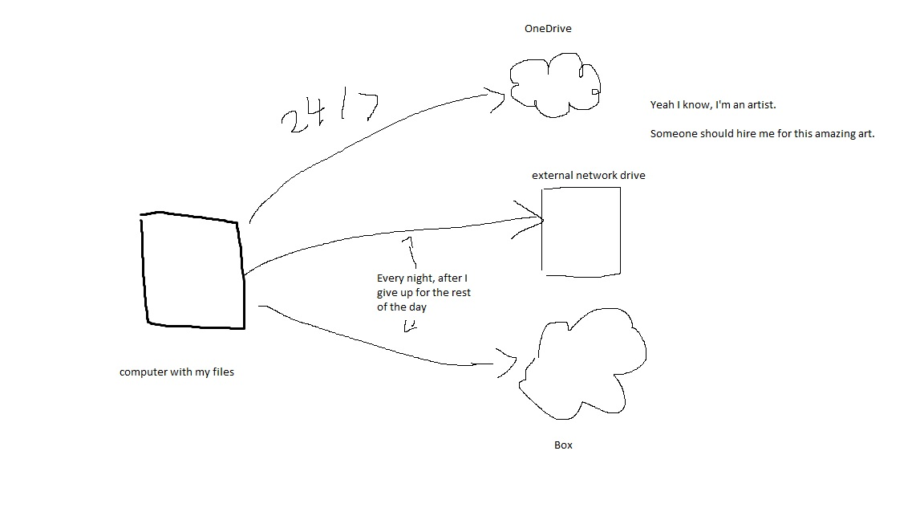**Version Control Plan:** I am saving a backup of my files to my external network drive and Box every night (after working on my code), as well as having an automatic backup synced to OneDrive. Also, my files are saved on my hard drive, not my SSD (which is my boot drive). My *absolutely amazing* drawing is below.

**Module List:** requests

**TP2 Update:** 1st part of section B: recommendations based on time/activity and PGCRs is not coming along well. Probably gonna scrap the recommendations based on time/activity (profiles), and focus on PGCRs: generating graphs and stuff based on PGCRs; probably have them split up by the same activities already used for the weapon recommendations/roles. We’ll see if I can figure out how to do profiles before Monday. If not, I’m just gonna give up on it and try to get some points another way.

**TP3 Update:** Graphs were implemented in, and some minor UI tweaks to make it more user-friendly and intuitive. No real design modifications were made.