**Final Project – Design your own website**

**(Due Date: July 26, 2018)**

**Total Points: 100**

**(Classmates’ evaluation: 40%, Instructor Evaluation: 60%)**

**Important Notices:**

* **The file structures, coding styles, and documentation are required (as the same as you did in your projects).**
* **Html and css files should pass validator test**
* **The website will be presented and evaluated on 7/26/2018**

In the project, you will use what you learn in this course to design a website.

You should follow the **Phases below to complete your website development:**

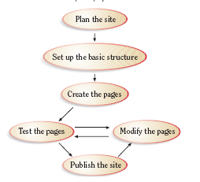

**Extra Points: 10**

**Phase 1: Plan your web site**

Answer all Questions below:

* Who is the target audience?
* How can I tailor the site to reach that audience?
* What are the goals for the website?
* How will I gather the information?
* What is my budget?
* What is the timeline?
* Who is on my project team?
* How often should the site be updated?
* Who will update the site?

**Create Wireframes**

You need create at least 5 web pages based on the wireframe below

Web Page 2 and Web Page 3 should be named based on what your website is designed for.

* Design webpage layout

Your web page layout and design should be consistent throughout the site

**Requirements**:

* + Use HTML/CSS to create a “**template**” page to present the Webpage layout.
  + Create the all WebPages based on the “**template**” page.

**Phase 2: Set up the basic structures**

In your website, the following basic elements **MUST** be included:

* Contents
* Images and background images
* Menu bar (navigation bar)
* Header (Banner and/or logo)
* Footer (address and/or copyright)
* List
* Table
* Form
* audio
* <class> and <id>

The following **HTML5** **Structural Elements** should be included**. You can design a layout that matches your website’s needs.**

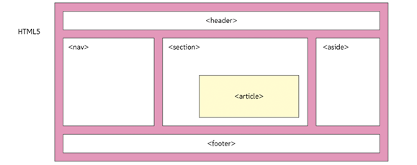

**Phase 3: Create Web Pages**

Create your website/WebPages.

**Requirements:**

* Researching websites on internet, and see what should be included in the “**Index.html**” and “**aboutUs.html**” pages.
* Using Microsoft Word to create contents for each page.
* Preparing images and banner/logo that meet the needs of your webpage.
* Creating a template page (**template.html**)
  + Creating a **main.css** file to define CSS rules for predefined tags **<p>, <h1>, <h2>, <nav>** etc and for “**class**” and/or “**id**” defined by you.
  + Using HTML code and **main.css** to create a “**template.html**” that includes “header (logo)”, “menu bar (navigation bar)”, “section (dummy)”, and “footer” parts.
  + Creating “empty” WebPages based on the **template.html and wireframe**
  + Adding and testing hyperlinks of WebPages
* Adding required contents and elements to each webpage. If necessary, add extra external CSS files for formatting them properly

**Note:**

**Special requirements** for “**ContactUs.html**” Page (see the following figure as reference)

* Creating interface to gather visitor info in “**ContactUs.html**”. The “**First Name**”, “**Last Name**”, “**Phone Number**”, “**Emai**l”, and “**Comments**” are **required** input info.
* The pattern strings are needed to validate “**phone number**” and **email**.
* “**Please send me monthly newsletter**” is a checkbox
* Add **JavaScript** code to implement buttons “**Send**” and “**Reset**”
  1. When “Send” button is hit, a Summary page that shows “First Name”, “Last Name”, “Phone Number”, and “email” will be pup-up.
  2. When “Reset” button is hit, all input entered in current page will be cleared.

**Note: Using the following figure as a reference**.

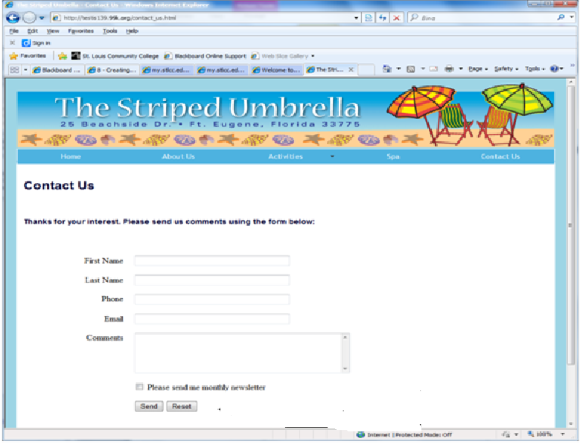

**Phase 4: Test your website in two different Browsers (Internet Explorer and Firefox)**

**Phase 5: Modify your website and fix any bugs found during test phase.**

**Phase 6: Publish the website to internet (optional: Extra Points: 10) – It is a self-learn part. You can Google to find a web server, which can FREE publish your website, and follow the instructions described on this site to upload your files to the web server.**