National College of Ireland

Advanced Rich Internet Applications

Go Wild!!!!!!!

Technical Report
http://morning-atoll-1018.herokuapp.com/home/index
https://github.com/daveyw/Rich-internet-application-final-project
https://github.com/Tomasomahony/go_wild
May 2nd 2014
Submitted By:
David Winters – x12110396
Enda Lyons – x00097135
Tomas O Mahoney – x12118672

Table of Contents

Page

Motivation 3
Project Scope 3
Area of Contribution 3
State of the art review 4
Frameworks, Toolkits & Solution Architecture 8
Site main features 8
Asynchronous JavaScript and XML (AJAX) 8
Canvas 8
3D Image Slider 9
Memory Card Game 11
Lightbox 13
Drag and Drop 14
AngularJS – Newsfeed 15
Videos 16
Existing Examples of RIA in Education 17

User Interface Design 19
Application Architecture 20
Development and Analysis Methods 20
Software Process 21
Security 23
Testing 24
Summary 25
References 26
Motivation

Project Scope
Go Wild was designed and developed as a resource for providing primary school children with the opportunity to learn about wildlife in an engaging and entertaining manner. Traditionally, children have learned about such topics from schoolbooks in the classroom. This approach has always been considered a little boring for most. While there is still a need for this approach, it is clear that teaching techniques are now progressing, with most schools embracing digital technology.

Area of Contribution
The Department of Education and Skills has recently initiated a public consultation phase on how best to use technology in the classroom. In a press release published by the Department, it is stated that “The public consultations phase will feed into the development of a new strategy on the use of ICT in teaching and learning in primary and post primary schools”.¹ Furthermore, the minister for Education and Skills, Ruairí Quinn T.D. added that “In this consultation phase, we are particularly interested in hearing from schools, parents, industry and academics on how we can genuinely use technology to improve teaching and learning in our classrooms....... We already have some excellent examples of schools who are using technology to innovate in the classroom. Our challenge now is to ensure that every child in every school has the same opportunities to engage with technology across all aspects of the curriculum”.²
Clearly, the use of information technology in education has grown rapidly in recent years, partly because most children are already very comfortable using computers and see I.T. as an enjoyable way to learn. With the use of I.T in the classroom now in the process of becoming government policy, we see the Go Wild application as being a fun and useful learning resource for younger primary school children (ages 5 to 8). Also, because of the Department's public consultation phase mention above, we believe that this is an opportune time to introduce such a product to the market.

State of the Art Review
The benefits offered by Rich Internet Application's (RIA's) over standard web pages are now widely accepted and well documented. A Rich Internet Application can be described as “a Web application with many of the same features and appearances as a desktop application. A RIA requires a browser, browser plug-in or virtual machine to deliver a user application. Data manipulation is handled by the server, and user interface and related object manipulation are handled by the client machine”.³
Additionally, many Rich Internet Application's share some key characteristics that further differentiate them from traditional web application's. These include:⁴
- Direct Interaction – Traditional web application's were very limited in the level of user interaction that was possible. This interaction was largely restricted to basic form field input controls, such as clicking on radio buttons and checkboxes. These days, with the use of Rich Internet application's, users can become much more engaged with web application's by using features such as the drag and drop capabilities used in Go Wild! (Russell Kay, 2009)

- Partial-Page Updating – Previously, html pages were loaded as requested. Every time a user wanted to update the data on screen, the application had to send a request to the server for an entire new page to be sent back. However, these days, Rich Internet Application's are able to “speed things up” in this regard through the use of RIA techniques such as AJAX. An example of this technology has been used in Go Wild and will be discussed further in this section of the document. (Russell Kay, 2009)

As with establishing the main characteristics of modern RIA's, defining modern best practices are also important in order to maximise the benefits of what is possible. On this occasion, our group began by selecting an appropriate Integrated Development Environment (IDE). The IDE of choice was IntelliJ IDEA Community Edition, as it was seen as providing the team with a comprehensive set of developer supports, such as code hinting and file management support without having to invest in a software licence. Using the community edition of this IDE was also seen as an effective way of familiarising ourselves with a leading development environment that is widely used in industry.
While selecting an appropriate IDE is an essential first step, consideration must also then be given to the features that would be built into the application, and any potential limitations that the application could encounter. According to a white paper report by Dean Jeannings and Steve Wyman at TandemSeven.com, “To achieve the sophistication of a desktop application, the RIA UI must offer intensive code/processing capabilities such as 'drag and drop,' event processing and heavy DOM manipulation. Even though browsers offer JavaScript support to allow these types of interactions to take place, the browser’s original capability was designed to display static content in large 'page size' gulps. Other than some expanded JavaScript support, little has changed on the browser side of the equation. Add to this the differences in each browser’s implementation of 'standards' and the browser is hardly the environment to offer a rich user experience”.⁵
While this statement could almost be regarded as discouraging, the while paper does go on to make certain recommendations that are very much in line with current best practice. These recommendations include the following:
- Optimizing Performance – Many RIA application's offer a wide range of features that, while impressive, can also impact on the performance of the application. This is especially true for people who are accessing content via small mobile devices or for people who do not have a good internet connection. Common best practices that have been proven to overcome these issues include:
- Reference External Resources – The order in which external resources are referenced will have an impact on the performance of the application. Go Wild has been developed with this in mind, will all style sheets been referenced as external files from the application.html.erb file. While these external style sheets would typically be referenced from the head section of static html pages, this application has been built using Ruby on Rails. Therefore, referencing from the application.html.erb file is considered the proper convention.

Similarly, the Go Wild application is heavily dependent on JavaScript functionality. As with our CSS files, our JavaScript files are also referenced with optimization in mind and once again follow the Rails convention. However, its worth noting that while this works perfectly well using Ruby on Rails, in a static application, it is now more typical for JavaScript files to be referenced at the bottom of the html document. “This defers the extensive parsing/processing of JavaScript until the basic loading and rendering of the HTML document is complete”.⁶
Image loading is another aspect of developing Rich Internet Application's that now has a set of best practices for developers to follow. Again, following best practice, all of our graphics have been optimized for the web, and are loaded in a “just in time” fashion. (Tandem Seven, 2014)
While a lot of consideration has been given to following current best practice, especially with regards to optimization, collectively, we have purposely decided to stop short of providing full optimization. This is most notable in terms of our decision not to minimize our style sheets and JavaScript files. The reason for this is to allow for easier ongoing development and allow for simpler code examination.
- Achieving Maintainability – achieving maintainability is a definite best practice for modern Rich Internet Application's. Even with just three developers making a contribution to Go Wild, it was difficult to agree on a consistent set of coding standards. If the application was to grow further, or more so, if new developers were to join the team at a later stage, defining a set of coding standards would become imperative.

- Responsive Framework – with more and more people now consuming internet content via a range of different devices, providing a responsive layout is now considered essential in terms of best practice. Therefore, Go Wild was built using Twitter Bootstrap, a popular mobile first, twelve column responsive framework. Furthermore, for added convenience, this framework is also made available for Rails in the form of an installable gem....

gem 'twitter-bootstrap-rails', '~> 2.2.8'

While many responsive frameworks are now available for developers to use, we chose bootstrap, mainly due to the fact that it integrates easily with Ruby on Rails, and for the fact that it is considered a “light weight” framework. Other frameworks that were up for consideration, such as the Zurb Foundation framework, were considered too heavy in terms of the added functionality and components that are offered. For example, such frameworks are sometimes pre-packaged with sliders, lightboxes and so forth. For the purposes of this assignment, the team felt it was better to choose our own plugins.

Frameworks, Toolkits & Solution Architecture
Site main features
Asynchronous JavaScript and XML (AJAX)
One of the most exciting features that can be considered to make internet applications rich, is the ability to load data asynchronously. In web technologies, asynchronous typically means “happening in the background”.
As mentioned a little earlier, according to modern best practice, it is advisable for developers to build their sites in a way that allows for the greatest level of optimization. One way to achieve this is to reduce the number of http requests necessary. Integrating AJAX into an application is an ideal way of achieving this. In the case of Go Wild, a page was created called “Habitats”. The idea of this page was to display three images of three different habitats. Once the user clicks on an image, new data is loaded asynchronously from a Json file, describing that particular habitat. The great benefit of using this method is that only the text information relevant to the image that the person has clicked on needs to be updated. Therefore, other page elements do not need to be reloaded every time an onClick action occurs. As a result, page content is updated in a very seamless manner, making for an enhanced user experience.

Canvas Js
CanvasJS is a HTML5 & JavaScript Charting library constructed on Canvas element. Graphs can be displayed across multiple devices such as iPhone, iPad, Android, Windows Phone, Desktops. This Js library allows developers to create rich consoles that will work on all devices, and does not compromise when it comes to with maintainability or functionality of your web application. The Charts have several decent looking themes and the Canavsjs is over 10x faster than Flash and SVG Charts.
We chose to use canvas js to display data in a chart like format. The data was gathered from the animals of Africa fauna. The Fauna of Africa, is a broader sense, of all the different species of animals living on the African continent and its surrounding seas and islands.to display this data we took full advantage of the new features of hmtl5.
The feature we used to achieve our goal was the HTML5 <canvas> element is used to draw graphics, on the fly, via scripting (usually using JavaScript). The <canvas> element works as only a container for graphics. It is essential use a script to a draw the graphics parts .Canvas has quite a few different methods for drawing paths, boxes, circles, text, and adding images.
Features
• To display data gathered data
• Display data in a pie chart
• Movable pie segment’s to for better visual effects
• Learning animal facts for children
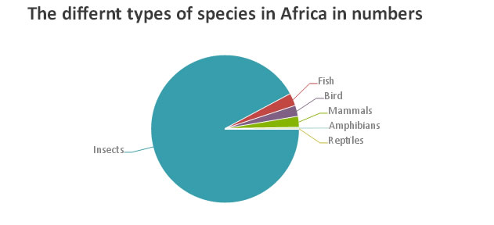
3D Image Slider
This 3d image slider was built using Html5 and Css3 and JQuery in this application.Css3 added new features such as the transforms. “CSS3 transforms allows elements styled with CSS to be transformed in two-dimensional or three-dimensional space”.
The CSS visual formatting model describes a coordinate system within each element is positioned. The positions and sizes in this coordinate space would be calculated in pixels, this starts in the origin of point with positive values proceeding to the right and down.
The coordinate space can be modified using the transform property. Using this property, elements will be translated, rotated and scaled in either a two or three dimensional space.
Additional properties make working with transforms easier, and allow the author to control how nested three-dimensional transforms interact.
The transform-origin property provides a convenient way to control the origin about which transforms on an element are applied.
The following property elements form the 3D transformed state
“ The perspective property allows the author to make child elements with three-dimensional transforms appear as if they live in a common three-dimensional space. The perspective-origin property provides control over the origin at which perspective is applied, effectively changing the location of the "vanishing point".
(transform-style ) this property allows 3D-transformed elements and their 3D-transformed descendants to use the same common 3d space, thus allowing the creation of hierarchies of three-dimensional objects.
(backface-visibility) this property is called on “ when an element is flipped around via three-dimensional transforms such that its reverse side is visible to the viewer. In some situations it is desirable to hide the element in this situation, which is possible using the value of hidden for this property”.
The transform property’s in Css3 allow us to make an element to be transformed in a three-dimensional coordinate system, the elements themselves are not three-dimensional objects. they really exist on a two-dimensional plane eg (a flat surface) and have no depth.

Features
- Displays animal pictures
- Fun and easy to use
- Spins images around
- Toggle between transparency
- Transforms 2d images into a 3d rotating box
http://dev.w3.org/csswg/css-transforms/#rendering-3d
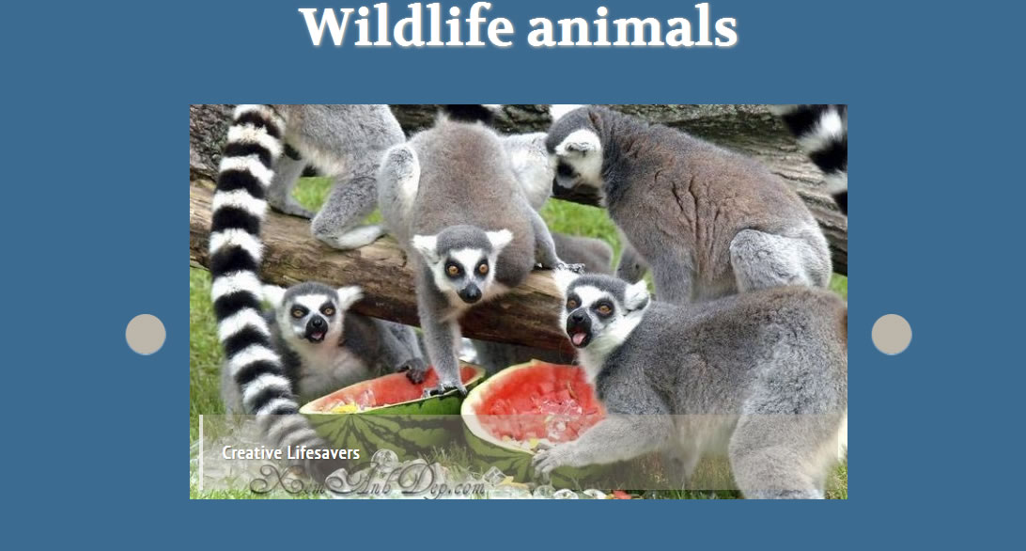

Memory Card Game
This game was created using The QuizY Memory Card Game plugin is a jQuery plugin, which allows the creation of memory games examples . Pelmanism, Shinkei-suijaku, Pexeso, Concentration, Pairs) in your web browser. The plugin provides several of settings in order to enhance its usability. When using this plugin a nice feature is that it allows you to add any type of content on the back side of the card, not only images. In our project we match animal’s images the animal names for learning purposes.
Properties can be changed to suit your web application features.
- itemWidth: The width of the card in pixels. The default is 156. If you want to change it, you should also change the background picture for the backside of the card (quizy-mg-item-top.jpg).
- itemHeight: The width of the card in pixels. The default is 156. If you want to change it, you should also change the background picture for the backside of the card (quizy-mg-item-top.jpg).
- itemsMargin: The right and bottom margin of the element defining the margin between the cards. The default is 10 pixels.
- colCount: In how many columns the plugin should arrange the cards. the default is set at 4.
- animType: The type of animation used when a card is clicked. Can be 'flip', 'fade' and 'scroll'.
- flipAnim: The direction of the flip animation (inherited from the flip! plugin), if chosen in the previous property.Possible values: 'tb', 'bt', 'lr', 'rl'. Default is:'tb')
  - animSpeed: How fast the card turning animation should be (in milliseconds), the default is 250ms.

Features
- Displays animal pictures and names
- Helps memory
- Helps learning curve
- Fun and simple to use
http://memorygame.quizyplugin.com/

Css3 lightbox
The traditional Lightbox feature is a JavaScript technique that is used to display mainly images and other content using modal dialogs where the image is shown up center filling most of the screen, and the rest of the window is dimmed out.”Lightbox was originally the name of a specific JavaScript plugin, written by Lokesh Dhakar”.

With the Css3 lightbox the user clicks an anchor link with a hash value equal to that of an ID. Once this happens, the :target pseudo-class kicks in and the properties it contains take effect. The transition property on the ID then takes effect
The close button isn’t really a “close” button. It’s an anchor link that contains a different hash value to the value in the in the URL. Once this “close” button is clicked, the previously :targeted id is not targeted any more. Therefore it loses the z-index and opacity properties that were applied to it. Once this happens the transition property takes affect again and this creates the “fade out” effect.
Features
- Modal Style pop up
- Information box on animals
- Names featured on :hover
- Displays animal pictures
- Fun and easy to use
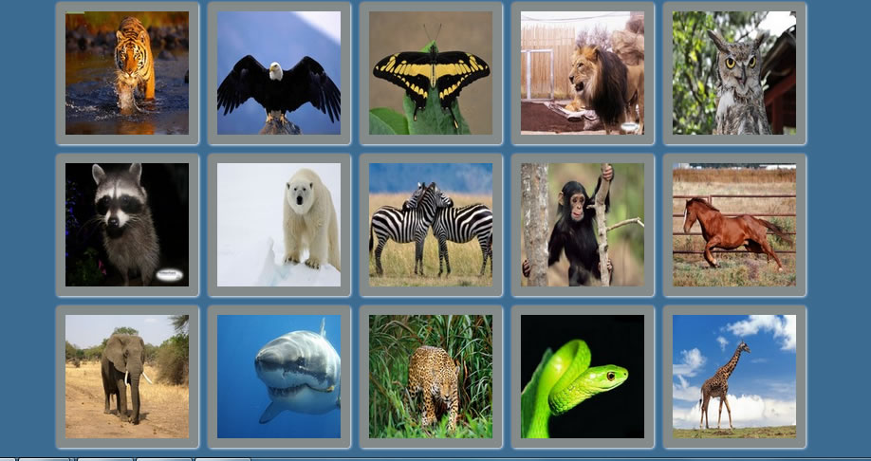

Drag and Drop Game
A new feature of the HTML5 standard over earlier versions is the ability to Drag and Drop elements on a page. While Drag and Drop was previously possible using JavaScript and jQuery, the process has been greatly simplified using HTML5. As with all of the other features used in the Go Wild application, Drag and Drop was used not only as a means of providing education, but also, to do so in a fun and engaging manner for young children.
As such, the “Who Eats What” game was developed, where children are required to drag an image and attempt to drop it over another image. If the child attempts to drag a lion and drop it on top of a wildebeest, the images will swap places and a message will appear saying “Lion eats Wildebeest”. On the other hand, if the child tries to drag the image of the lion on top of the image of leafs, the images will fail to swap places and a message will appear saying “Lion does not eat leafs”. While this is not the most challenging of games, it is a simple way of teaching children about herbivores and carnivores using HTML5.
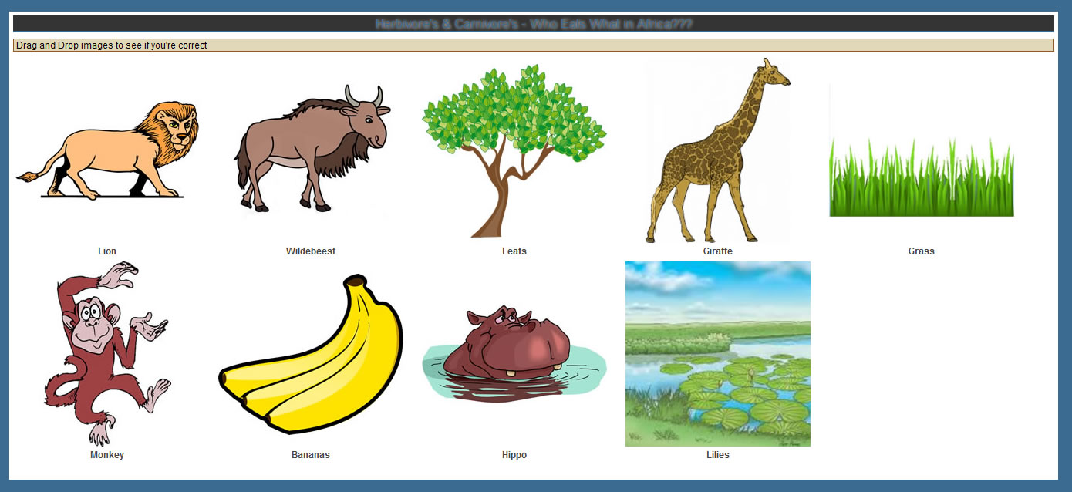

Responsiveness and UI
UI is built using twitter bootstap with built in responsiveness.
This uses a fluid grid system. This can be seen in action on the Navigation Bar and in the Games section.

AngularJs – NewsFeed

We use the AngularJs-rails gem which is a simple wrapper for angularjs.
Declare the angular app in the appropriate HTML file “Dashboard.html.erb”.

The main angular js file is app.js. This includes the dependencies i.e. controllers and services.
In accordance with AngularJS best practices, to create a HomeController, we need to create a new JavaScript file and a new Angular module - this is in controllers.js.

We’re building an app that will show articles loaded by the front end.
To fetch our articles on the front end, we’ll build an articles service that loads the latest articles.
In this service, we’re going to load articles from the TED Talks latest RSS feed. We wished to load from a wildlife channel on youtube or BBC but ran into to difficulties so TED service will suffice to showcase the feature.
We create a services.js file. This uses the google feed service to pull the RSS data from TED talks. Then in our controller we can call this service to get the latest newsfeed. The controller saves the data in scope and call be called in the HTML file as “articles”.

Videos

We first created a table to store the video data such as URL, desrcipiton etc…
The we created a rake task to import the data and persist in the table using Feedjira gem:

screencast_importer.rb

This will use Angularjs as a frontend and will use JSON api calls to the server for the data.

We are going to only use two calls to the API:
- /screencasts.json – returns a full list of episodes
- /screencasts/ID.json – returns data for a specified screencast (where ID is the unique ID of the screencast in our db)
Because we used the resource generator, we already have our controller and routes.

scope :api do
get "/screencasts(.:format)" => "screencasts#index"
get "/screencasts/:id(.:format)" => "screencasts#show"
end

This sets up the routes for the corresponding controller actions which will spit out the JSON - so that’s basically how to do a simple rails API setup.

Now on to the front end for the angular app to use this API.

We set it up similarly we one folder for controllers, one for directives and one for services.
The main module is declared in app.js.coffee and dependencies declared i.e. ngResource which provides simple REST client functionality.

Our Angular controller is going to access the data from our API using ngResource. ngResource enables interaction with RESTful server-side data sources.
Angular services are singletons that carry out specific tasks common to web apps. Services are commonly used to perform the XHR interaction with the server.

We then tell the controller to use this service.

$scope.screencasts = Screencast.query()

Then in the HTML file videos.html.erb we call the controller and can make calls to controller using the Screencast scope.

We use the ng-show directive which only displays the div if selectedScreencast exists.

We add an ng-click directive that when clicked will call the showScreencast function in the controller.
We use FlowPlayerjs to play the videos and create a directive to call this which requires flowplayer() to show the video and then we call this directive in the view.

Existing Examples of RIA in Education
Earlier in this document, it was clear that while using Rich Internet Application's and the internet in general are yet to be fully embraced by the education system, the trend is undoubtedly heading in that direction. This is evident from the government's initiation of a public consultation on the use of technology in the classroom. However, unlike many national education systems, the private sector has embraced the internet enthusiastically in terms of providing Rich Internet Application's for children's learning. For example, it would appear that there are an infinite amount of applications available for download from sites such as the Google Play Store and the Apple App Store related to Children's Educational Games. Other websites, such as Primary Games, Fun Brain, Cookie and many others, all provide a wide range of educational services (maths, reading skills etc.) via Rich Internet Applications.
In a more formal sense, other not – for – profit organisations such as e-LearningForKids and Khan Academy also provide impressive services through the use of Rich Internet Applications.
Therefore, in order for Go Wild to make any type of impression in such a competitive market, the site would need to be marketed carefully as a particular niche product.

User Interface Design
As with all effective web applications, it was important to give a great deal of consideration to providing an effective User Interface Design. In fact, the first Rails gem that was installed in the application related to this issue. As mentioned earlier, Twitter Bootstrap allowed for a twelve grid, mobile first responsive layout. This approach was seen as being of great importance, as it is likely that children will use the application not only on school desktop PC's, but also on their parents smart phones and tablet computers.
Similarly, as with any effective website, it was important for the application to be presented with a clearly labelled navigation bar. Again, Twitter Bootstrap provided a proven layout in this regard, for varying screen resolution's.
In terms of the application content, it was first necessary to examine the approaches taken by similar, competing applications. First of all, because of the intended target market, it became clear that applications targeting younger users are presented in a very “uncluttered” manner. As such, all of the content on the Go Wild application is clearly laid out, without any need for detailed text or explanations. Simple, one line instructions for children were the aim.
Keeping in mind the target market, a lot of consideration was also given to the type of imagery that would be used. Finding a balance between accurate, educational wildlife imagery and fun, entertaining imagery was considered desirable. Therefore, throughout the application, the imagery changes from realistic animal photographs to playful, cartoon type imagery in the educational games. This approach was intended to provide the best of both worlds with regards to the user interface.
Again, with the application being targeted at a very young audience, it was deemed necessary to avoid large areas of text when possible. Adhering to this standard, the application has been built with a variety of Rich Internet toolkits and techniques. Theses include the use of a Lightbox plugin, HTML5 chart, links to videos, amongst others. By creating such an interactive user interface, the application is much more engaging and visually pleasing for young children.
Finally, to ensure maximum market penetration, the application has been built and tested to perform in a consistent manner across a range of modern browsers and devices. This partly relates to the issue of screen resolution mentioned above, but also due to the fact that the era of Internet Explorer domination in the browser marketplace has thankfully long past.

Application Architecture:
Our server side application was developed with Ruby on Rails. After much debate We chose the rails framework over C#.net framework, this choice boiled down to the framework we were most comfortable with which was rails at the time which would help us concentrate on more client side functionality rather than wasting time learning a new server side technology.

Development and Analysis Methods
In devolpment of this application we combined our knowledge of frontend and server side technologies. The client side aspect of the site has been built with HTML5, CSS3, JavaScript, jQuery, JSON, Ajax and APIs. On the server side part, we made the most of the Rails application framework with Ruby as our main serverside programming language. This framework employs the ( Mvc)Model-View-Controller pattern.
The entire application was built on a windows operating system with Rubymine and Apptana Interactive Development Environment.
We used the (RAD) rapid application development and Prototyping methodologies to ensure the our application was developed quickly and then we could make appropriate changes made after each iteration cycle.

Software Process
We took a agile approach when developing this application this method ensures that the prototype and beta versions have small pieces of functionality to start off with at the very least.
Rapid Application Development splits the development process in to small iterative steps.
During the requirements gathering stage we had a comprehensive understanding of the Childrens’ needs and what we needed to build, with these requirements we expect many changes to the application along the way. With deadlines set there was a limited amount of time in which to construct the application. RAD involves iterative development and the construction of prototypes, this allows the developers to do some analysis, design and implementation before receiving vaulable feedback. When the cycle repeats it helps the human learning fase and enhances the accuracy of the developers’ perception of what people and users expect. Rapid Application Development works best with small-scale projects ,these projects would have a narrow focus, which would have a small amount of staff operating a small number of business practices.

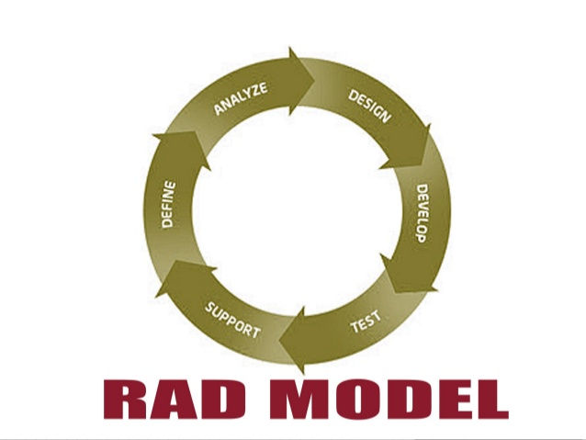

Security:
Security is handled using the Devise rails gem.
This is the gold standard authentication system for rails apps. You install the gem and then:

rails generate devise:install
and

rails generate devise User.

This will generate initializers, routes, views etc for user login.

Then in your main app template “application.html.erb” you set up the links for login, sign out, register.

In your controllers add:

before_action :authenticate_user!

This will filter users for any actions in that controller. If they are not logged in they will be routed to the login page.
This ensures access to features/pages only for logged in users.

Toolkits and Frameworks:
- Css3
- Modernizr/html shiv
- CoffeeScript
- Angular.js
- Html5
- Javascript
- jQuery

Testing
We used Google's pagespeed tool to get detailed information on the sites speed performance. We used this tool analyze our web pages and help to identify the main areas where we could improve our site.

“PageSpeed Insights is available as an open-source browser extension for Google Chrome and Firefox. Webmasters and web developers can use PageSpeed Insights to evaluate the performance of their web pages and to get suggestions on how to improve them”.
https://developers.google.com/speed/pagespeed/insights_extensions
We used the “Jasminerice” gem for rails which has good support for rails and has Jasmine-jquery built in.

We created a spec.js.coffee file. This will be the central file and here we can require any other JavaScript files that we want to use in our specs.

#= require jquery
#= require jquery.ui.all
#= require countries
#= require_tree .

We run the specs by using the /jasmine path.

Summary
The initial goal when planning for the Go Wild application was to build a visually pleasing website for children that would encourage learning about wildlife in a fun and engaging way. To do so, modern Rich Internet features were used, such as HTML5 Canvas, jQuery plugins, videos links and AJAX, along with other client side techniques. To achieve all this, the application was initially developed using Ruby on Rails.
On reflection, the group feels that while most of the emphasis was placed on providing a very rich, client-side user experience, most of the difficulties experienced in the development process came from trying to run the Rails application on different operating systems. As a result, much of the time that should have been spent adding new features to the application and fine tuning existing features was taken up with trying to solve Rails incompatibility issues. Therefore, in order to proceed with developing this application, a further period of exposure to Rails would be required. If the application was to be rebuilt from scratch, it is now more likely that the team would opt for ASP.NET.
Finally, in order for the application to remain interesting and encourage return visits, it will be necessary for new games and educational pages to be added to the site on an ongoing basis. While the application currently has sufficient content to keep a child's attention for the first few visits, it would quickly become repetitive. Therefore, ongoing development will be essential for Go Wild!

References

1 December, 2013 - Minister Quinn seeks views on how best to use technology in the classroom - Department of Education and Skills . 2014. 02 December, 2013 - Minister Quinn seeks views on how best to use technology in the classroom - Department of Education and Skills . [ONLINE] Available at: http://www.education.ie/en/Press-Events/Press-Releases/2013-Press-Releases/PR13-12-02.html. [Accessed 01 May 2014].

2 December, 2013 - Minister Quinn seeks views on how best to use technology in the classroom - Department of Education and Skills . 2014. 02 December, 2013 - Minister Quinn seeks views on how best to use technology in the classroom - Department of Education and Skills . [ONLINE] Available at: http://www.education.ie/en/Press-Events/Press-Releases/2013-Press-Releases/PR13-12-02.html. [Accessed 01 May 2014].

3 What is a Rich Internet Application (RIA)? - Definition from Techopedia . 2014. What is a Rich Internet Application (RIA)? - Definition from Techopedia . [ONLINE] Available at: http://www.techopedia.com/definition/2531/rich-internet-application-ria. [Accessed 01 May 2014].

4 Rich Internet Applications - Computerworld. 2014. Rich Internet Applications - Computerworld. [ONLINE] Available at: http://www.computerworld.com/s/article/335519/Rich_Internet_Applications. [Accessed 01 May 2014].

5 Rich Internet Application UI Development Best Practices | Tandem Seven. 2014. Rich Internet Application UI Development Best Practices | Tandem Seven. [ONLINE] Available at: http://www.tandemseven.com/rich-internet-application-ui-development-best-practices/. [Accessed 01 May 2014].

6 Rich Internet Application UI Development Best Practices | Tandem Seven. 2014. Rich Internet Application UI Development Best Practices | Tandem Seven. [ONLINE] Available at: http://www.tandemseven.com/rich-internet-application-ui-development-best-practices/. [Accessed 01 May 2014].

