Currently in the state of Michigan, employers are discriminating against their female employees by paying them less than their male employees at the same level. The Michigan Senate Bill #298 was introduced to the Michigan Senate on April 10, 2013. This bill was written in order to prohibit the discrimination against women in the work place. Currently in Michigan, women are making on average about seventy-four cents to every dollar a man makes on average. This is even less than the national average of seventy-seven cents to every dollar made by a man (Fisher, 2013). The bill proposes making an amendment to the Elliott-Larsen Civil Rights Act, which was supposed to make it illegal for employers to discriminate against employees based on sex, religion, race, color, or national origin. This new amendment includes not only protecting wages, but also compensation such as added benefits. The current legislation addressing discrimination against women needs to be strengthened and made more efficient. Wage discrimination against women has long-term effects on women and their families such as fewer saving for retirement. Women make up nearly half of the work force; therefore, families are dependent on women’s salaries (The White House, 2014). Women are currently making up about 57% of student classes’ graduating with bachelor degrees (Weiner, 2013). The new amendment also proposes allowing all gender discrimination cases as far back as June 1992 to continue to be eligible to be prosecuted in court. It also prohibits employers from failing to offer equal work compensation on the basis of sex or marital status. I recommended to the Senators that they also add in consequences for employers that discriminate against their female employees’ wages. I also suggested that an agency is created to monitor the wages that citizens are being paid, and assess for any discrimination.

References

Elliott-Larsen Civil Rights Act, S0298 (2013). Retrieved from: http://www.legislature.mi.gov/(S(k3ck3u45jgx3bl45qfa1mz2f))/mileg.aspx?page=getobject&objectname=2013-SB-0298&query=on

Fisher, M. (2012, May 3). Pay equality needs to move forward in michigan. *The Ann Arbor News.* Retrieved from: http://www.annarbor.com/news/opinion/pay-equity-needs-to-move-forward-in-michigan/

The White House (2014). Did you know that women are still paid less than men?. Retrieved from: http://www.whitehouse.gov/equal-pay/career

Weiner, J. (2013, August, 13). Why women still earn less than men: It’s the kids’ fault. *The Washington Post.* Retrieved from: http://www.washingtonpost.com/blogs/she-the-people/wp/2013/08/13/why-women-still-earn-less-than-men-its-the-kids-fault/

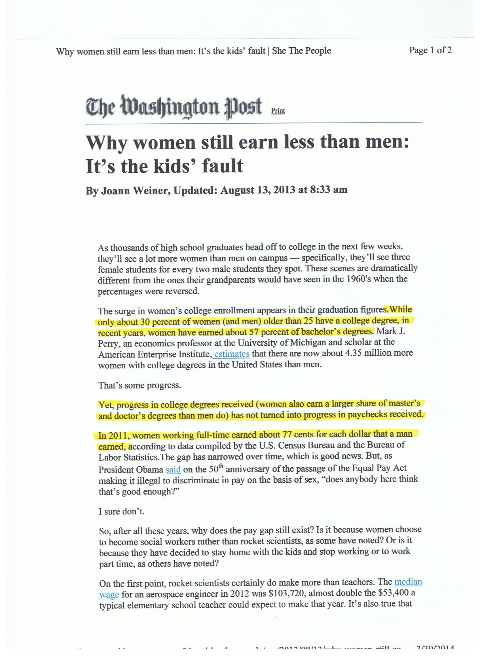

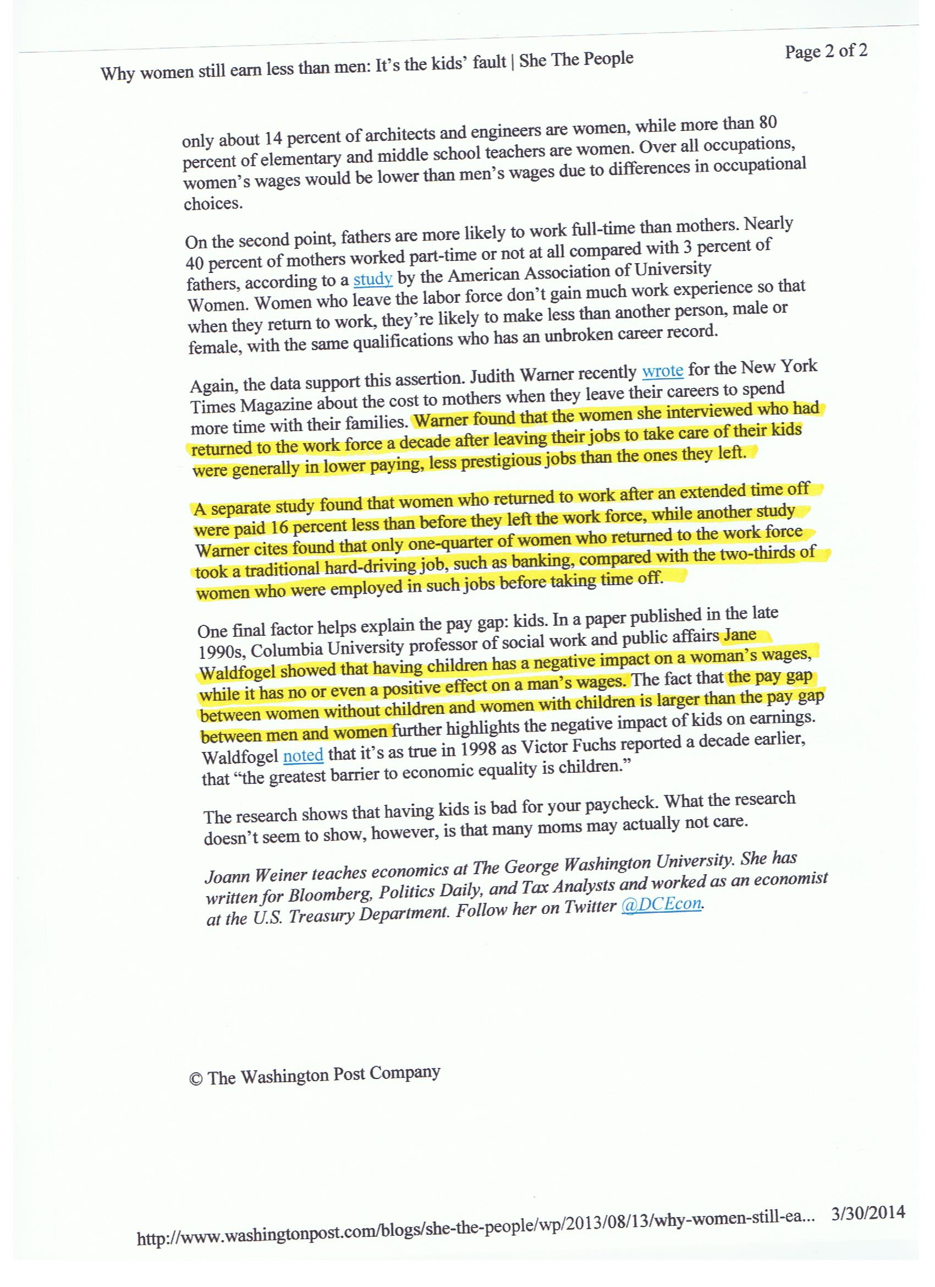

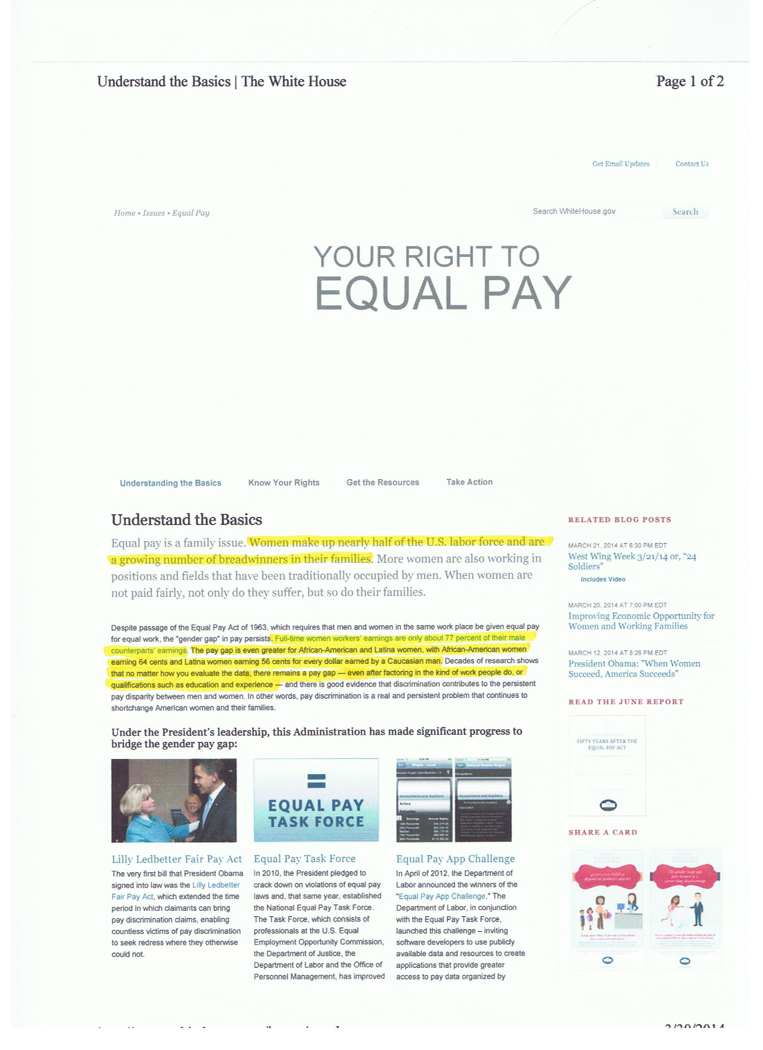

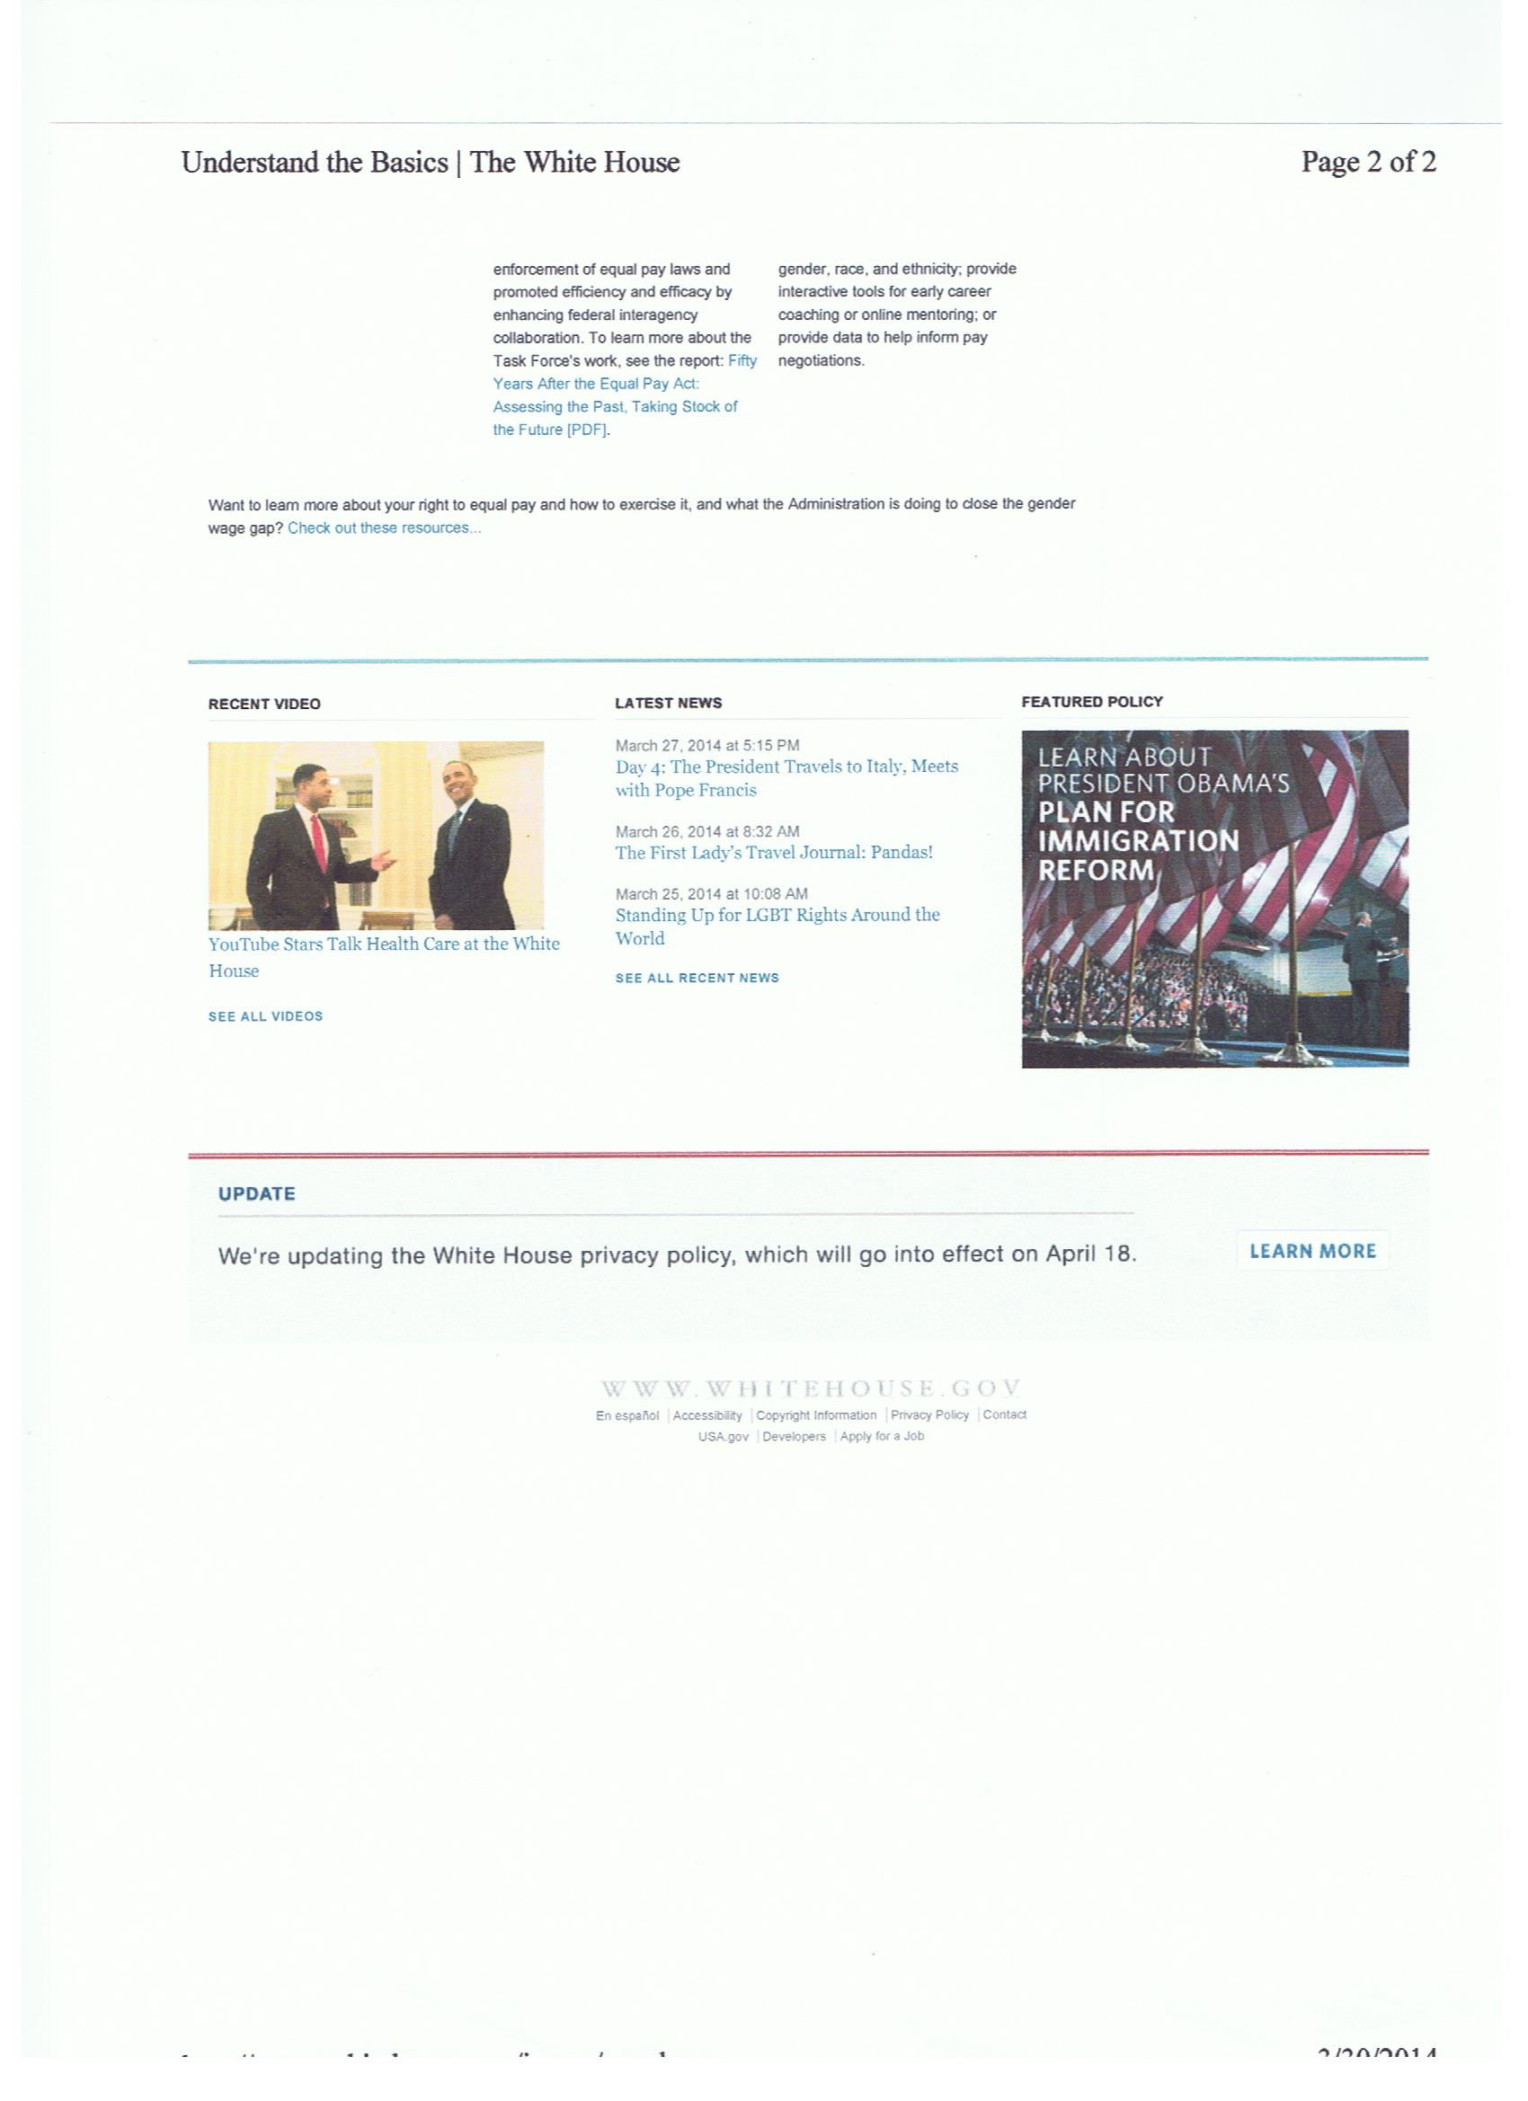

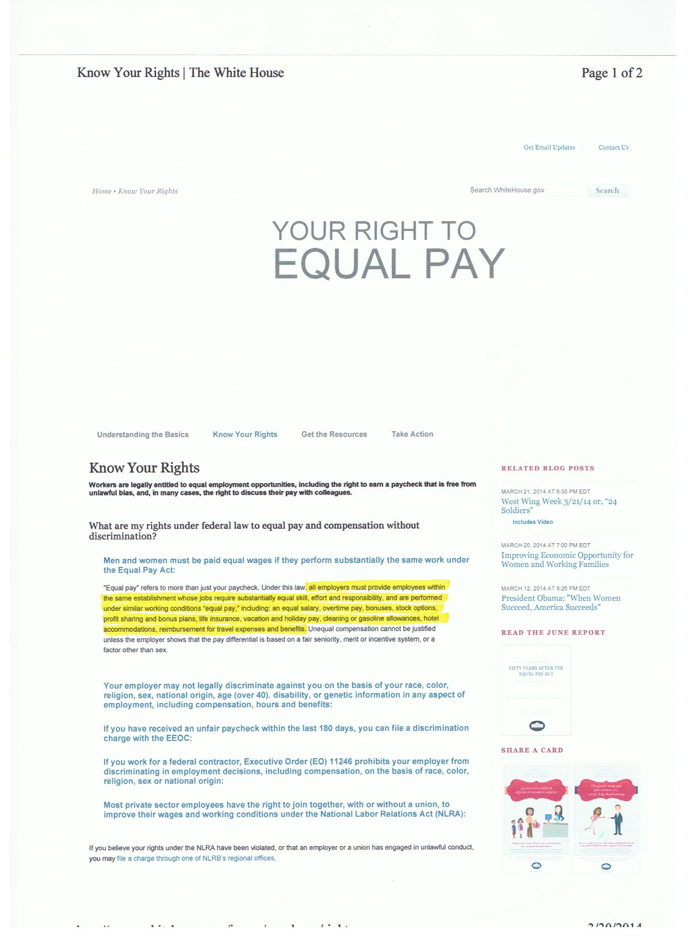

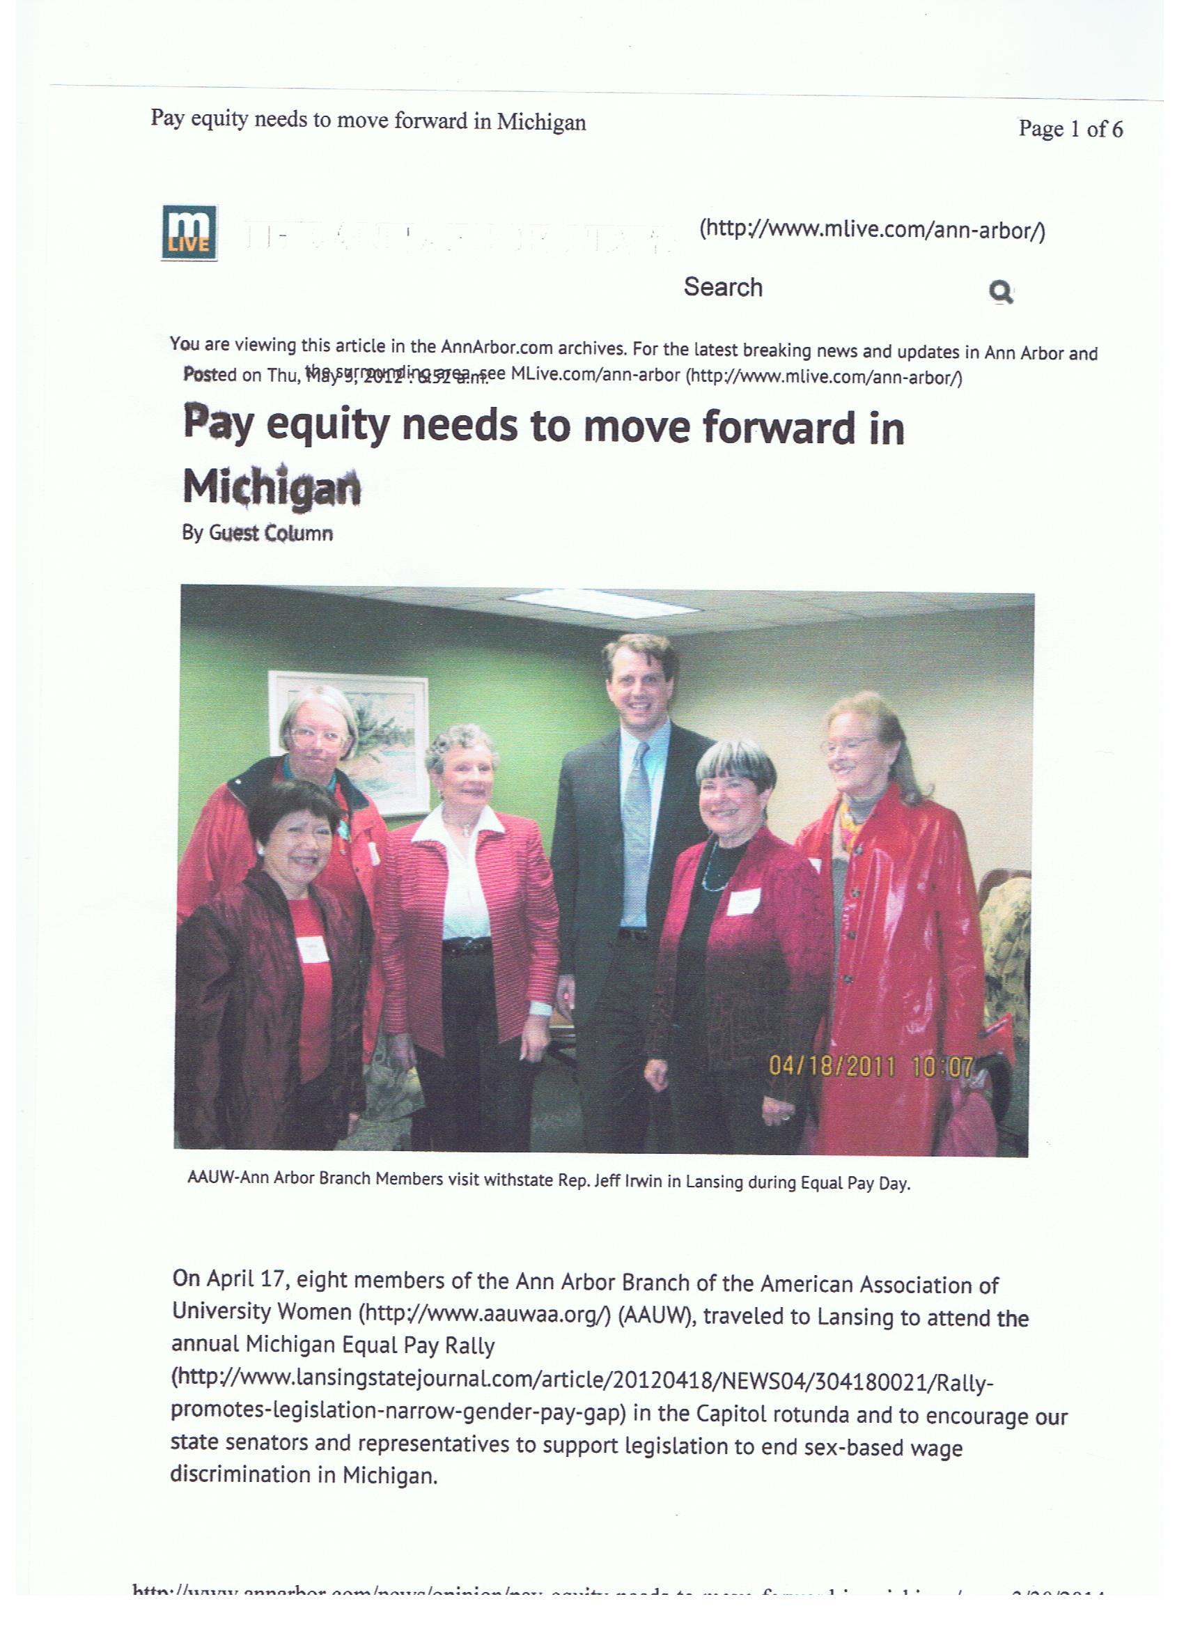

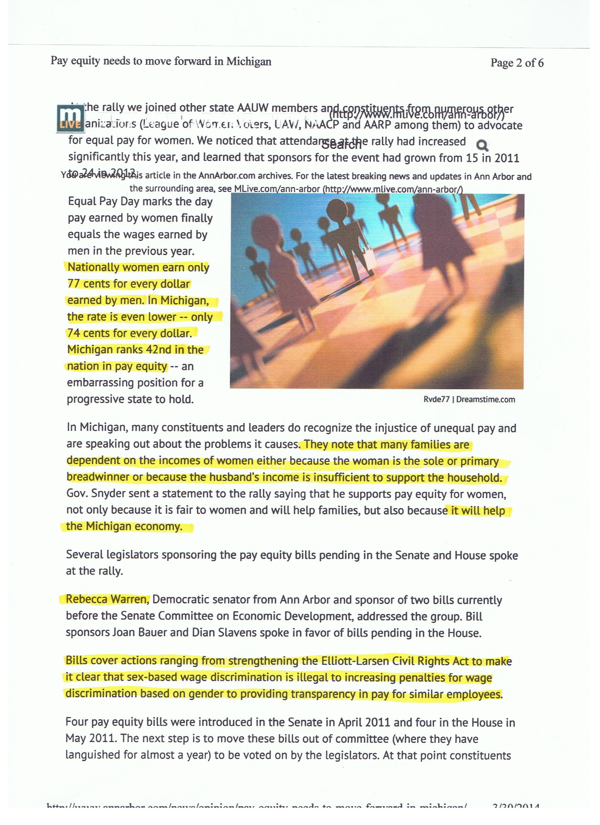

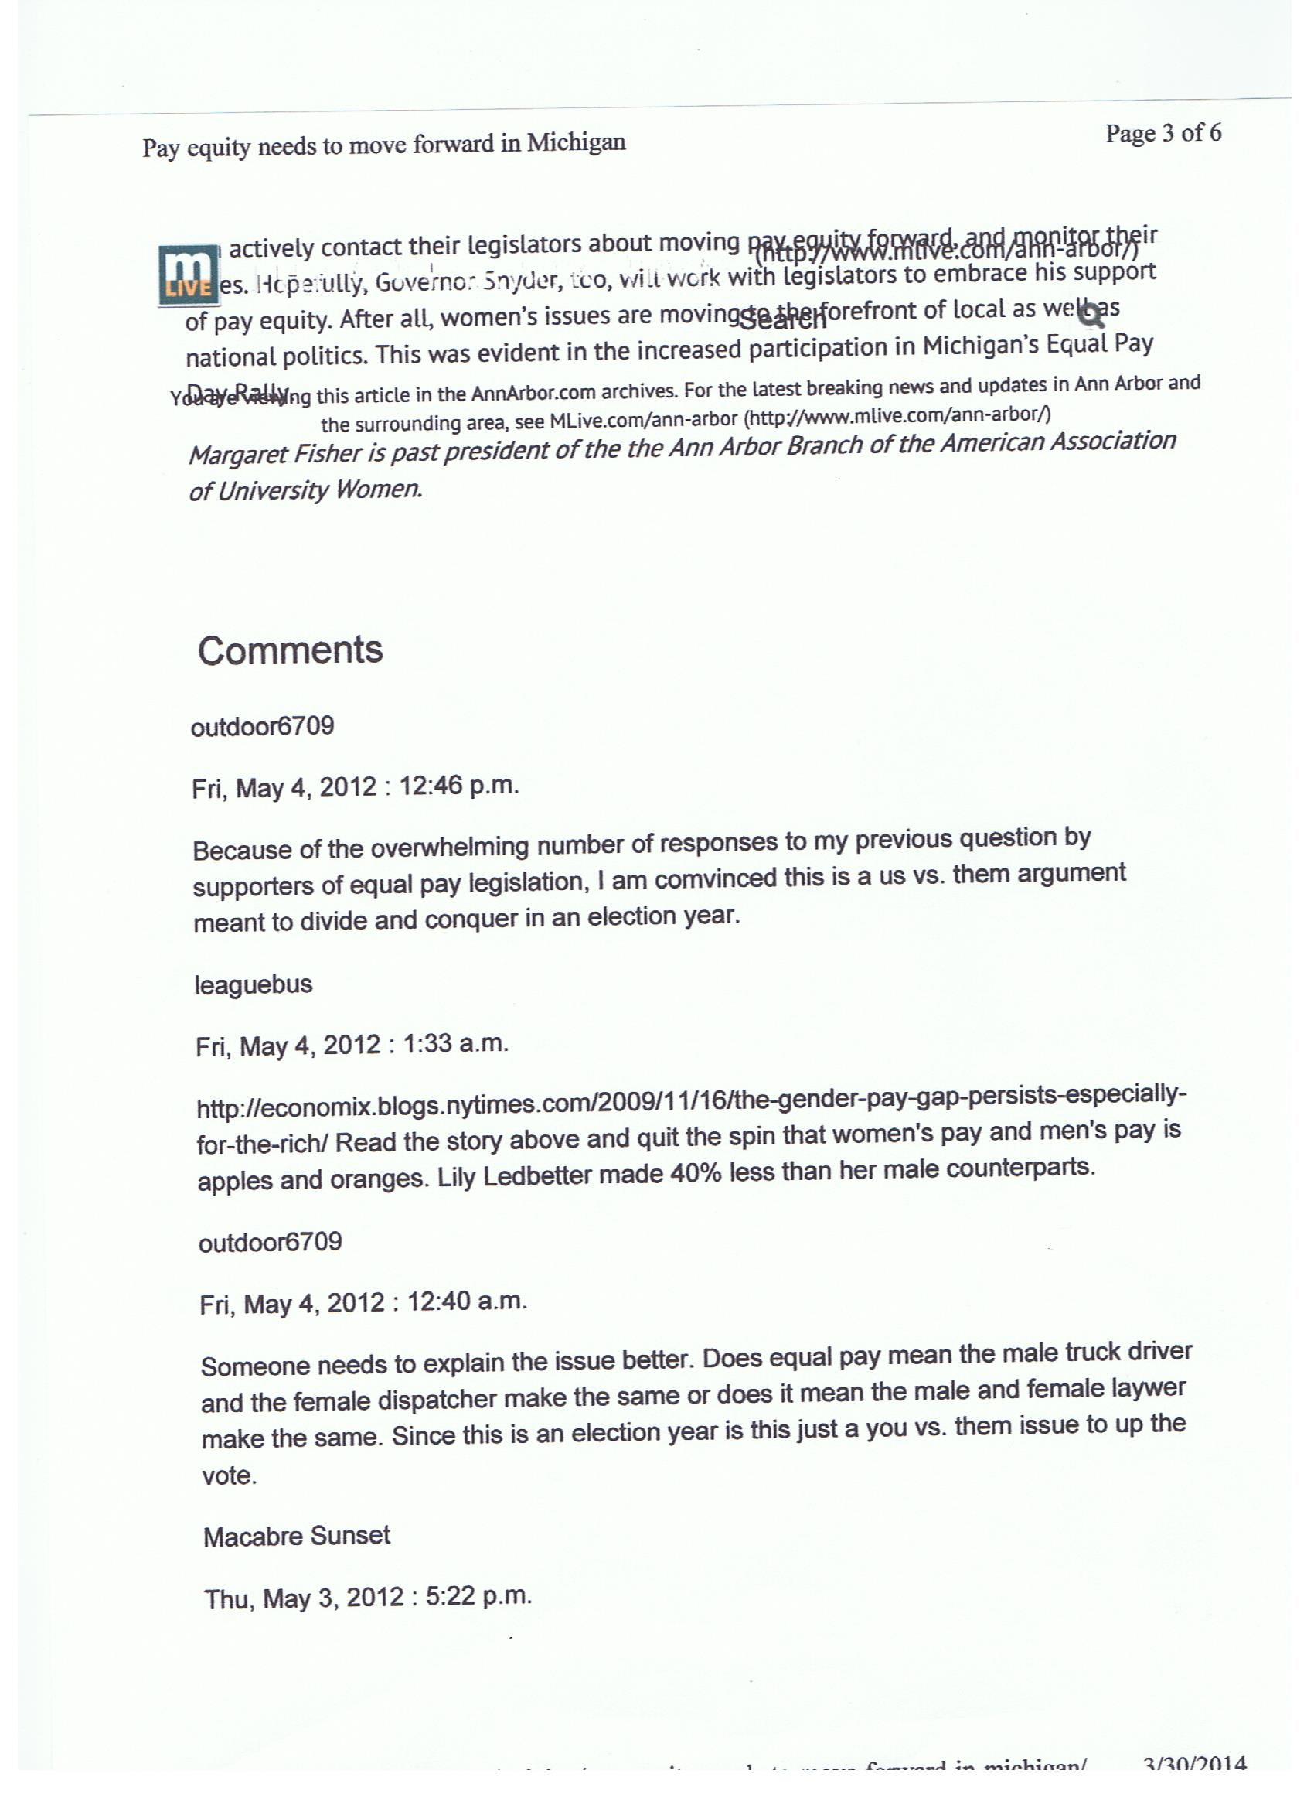

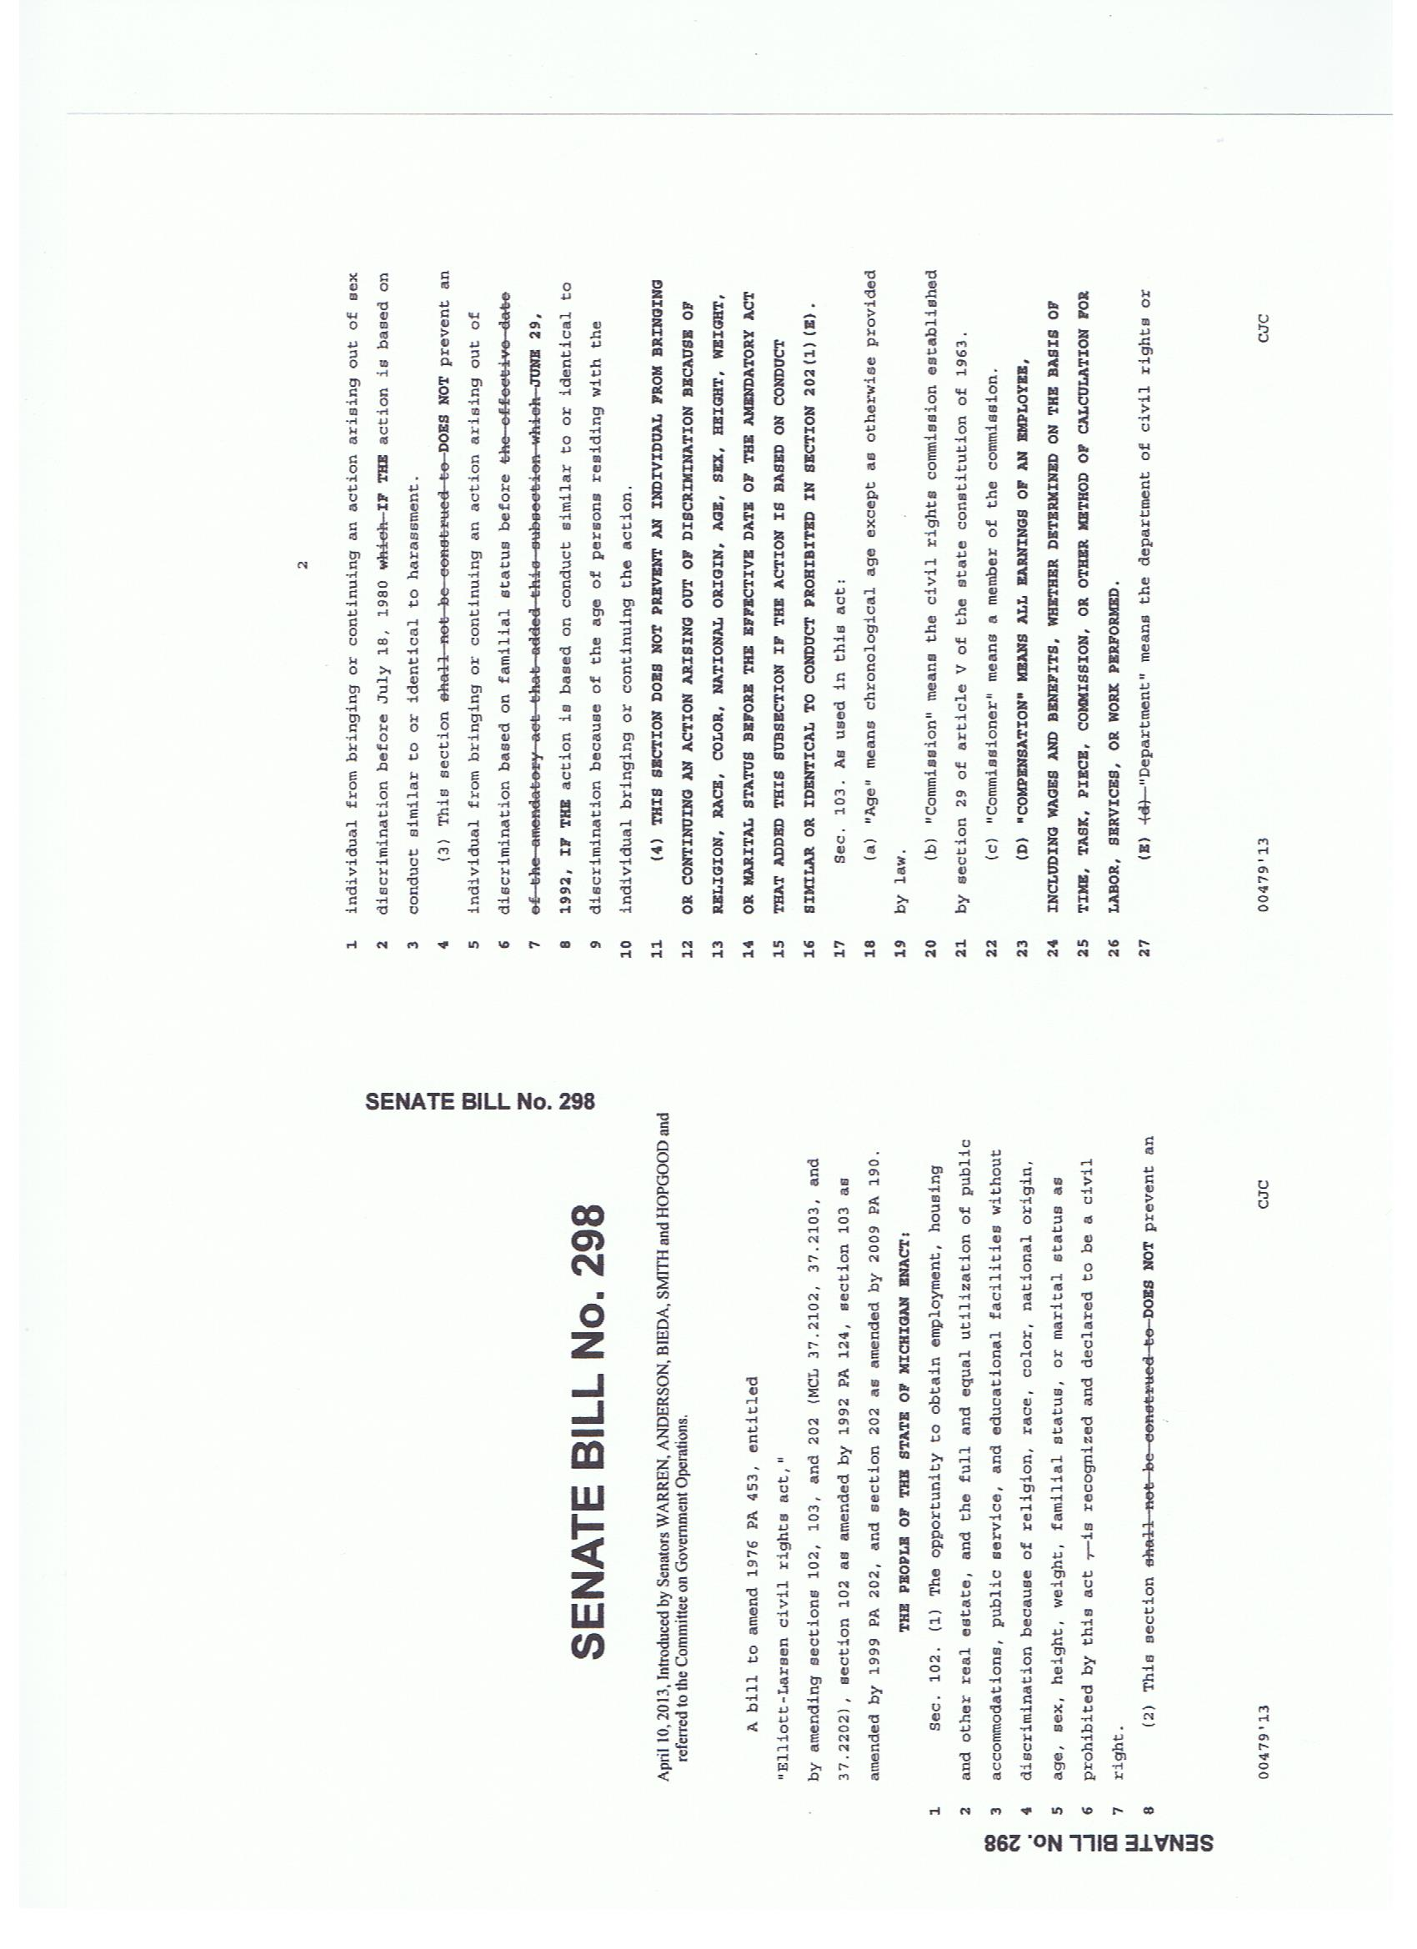

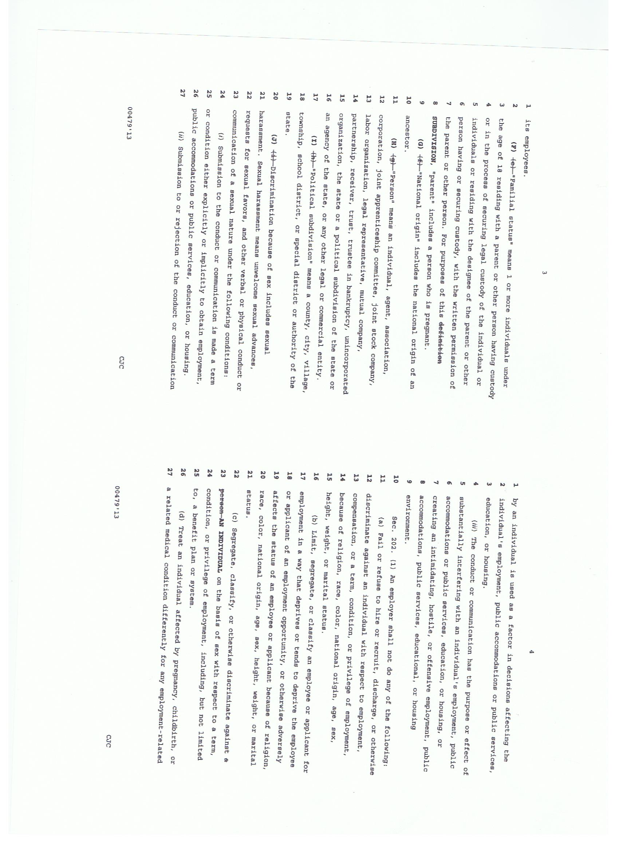

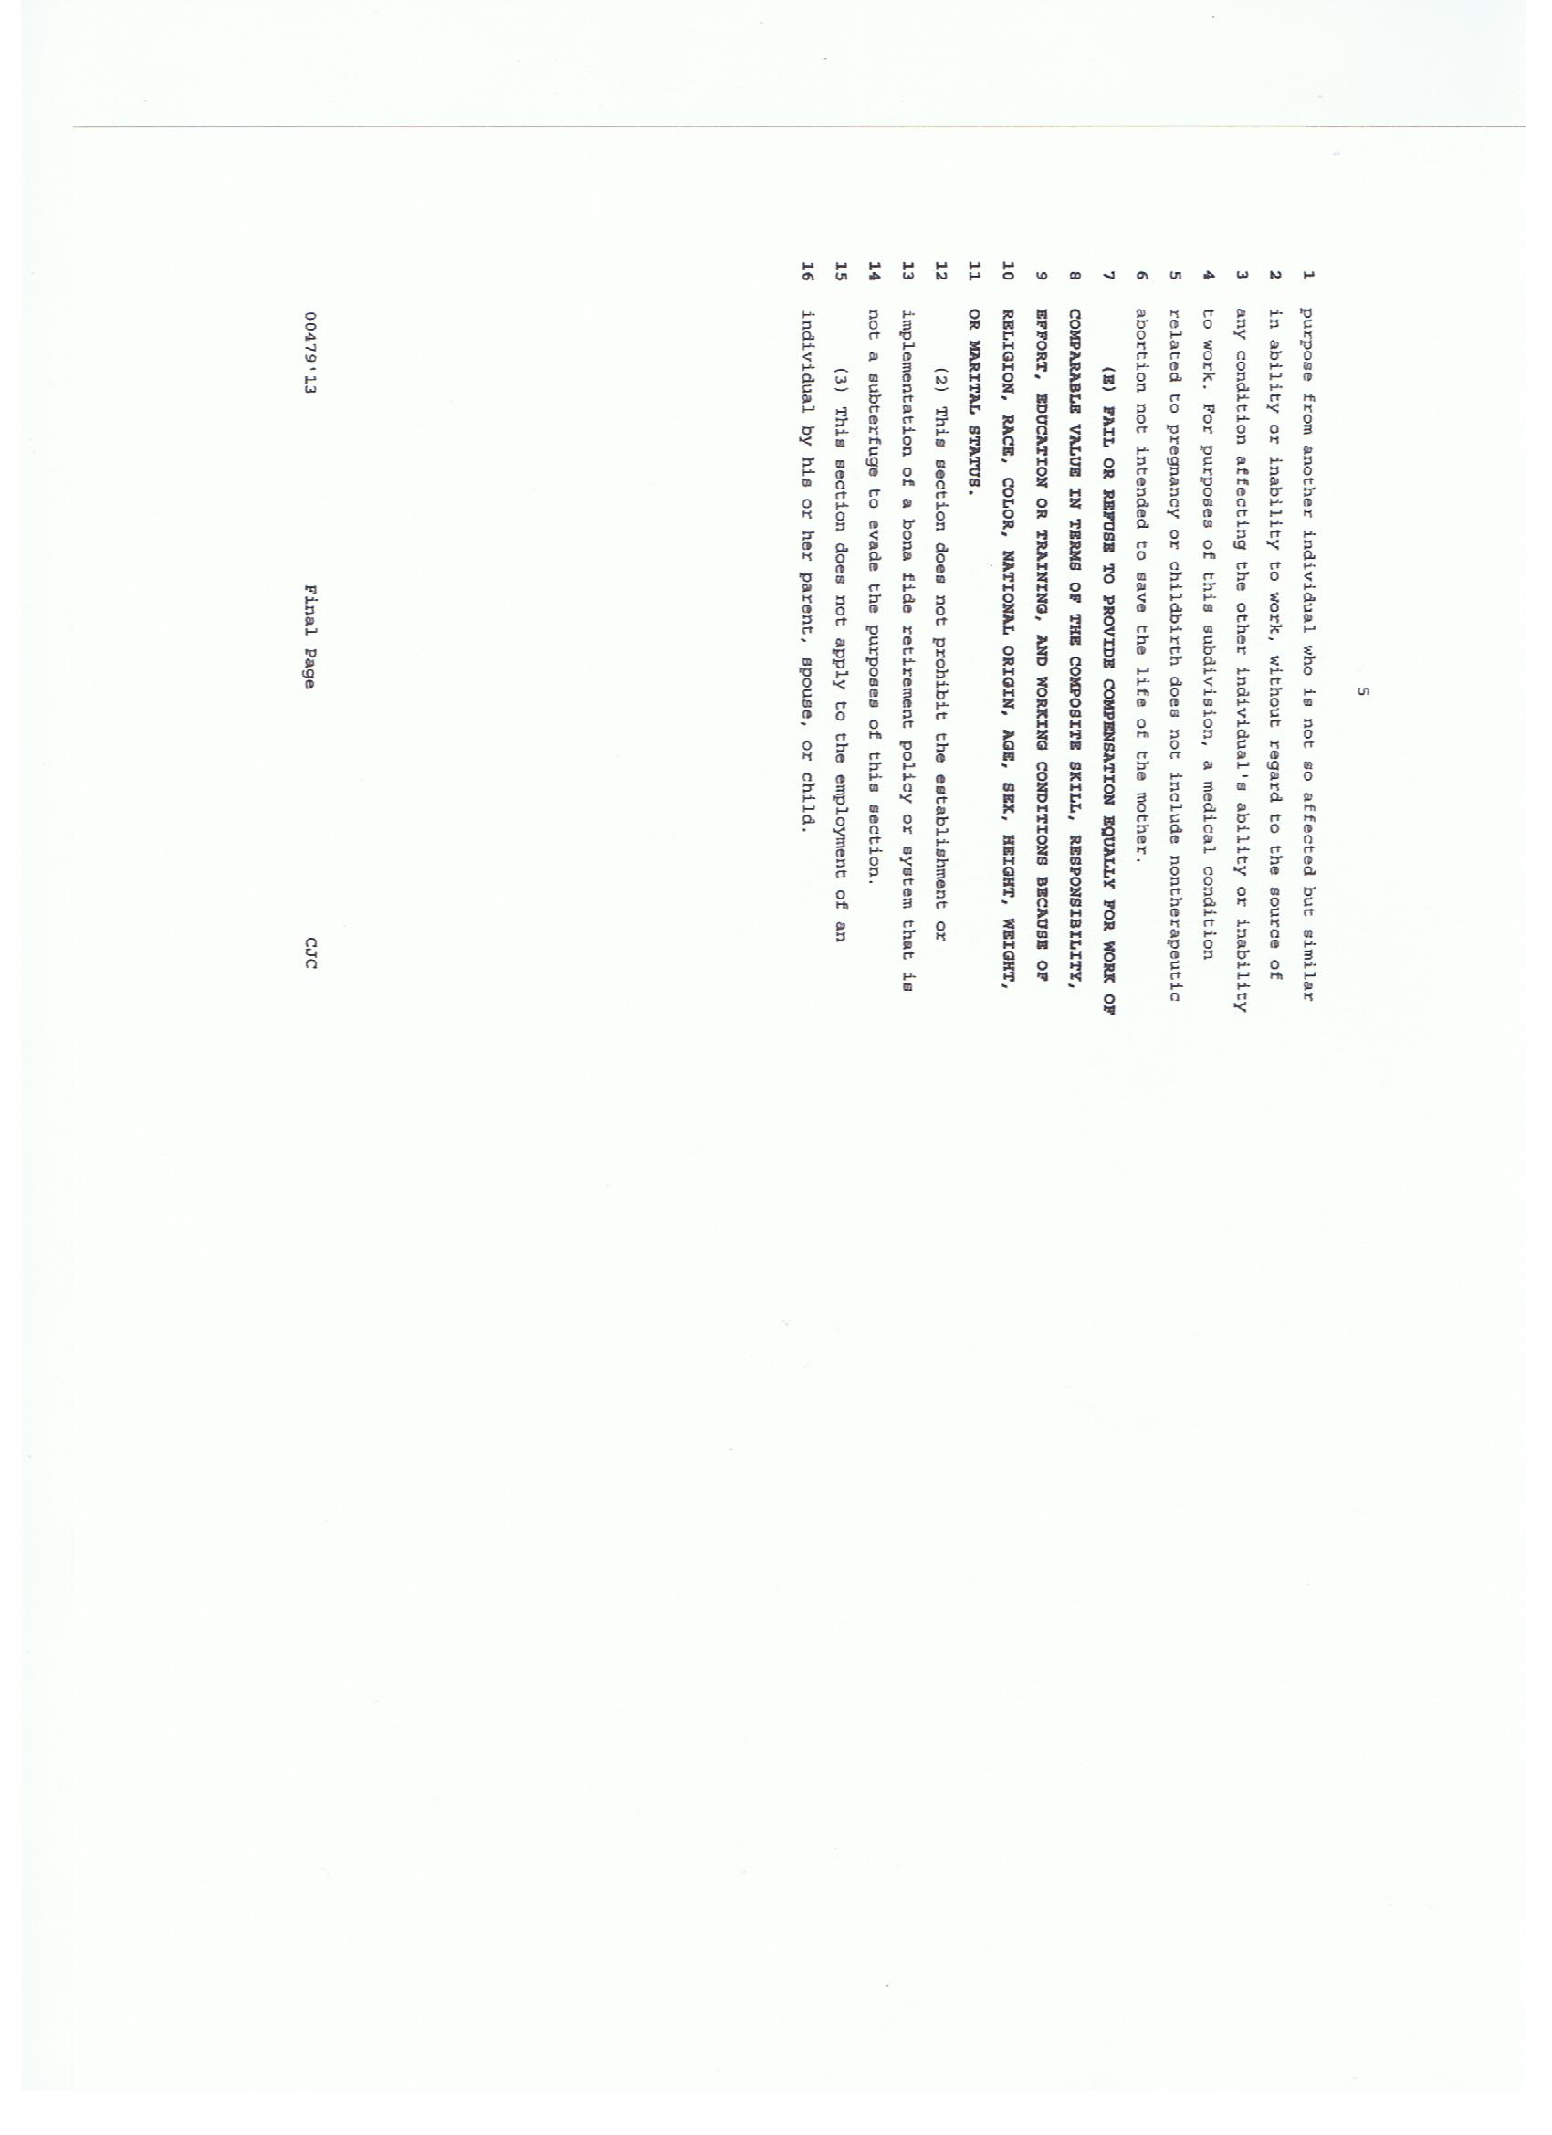

March 25, 2014

55960 Parkview

Shelby Township, MI. 48316

The Honorable Jack Brandenburg

Michigan Senate

P.O. Box 30036  
Lansing, MI 48909-7536

Dear Senator Brandenburg,

A bill to amend the Elliott-Larsen Civil Rights Act of 1976 (S. 298) is currently pending in the Committee of Government Operations. As a supporter of the proposed amendment to this act, I am concerned and upset that the legislation has not yet moved forward in the Senate. This bill was introduced on April 10, 2013 and has yet to make progress.

The Elliot-Larson Civil Rights Act prohibits employers from discriminating against employees on the basis of sex. The proposed amendment was created to eliminate the gender wage gap that exists in Michigan. Currently in Michigan, women are making seventy-four cents for every dollar that a man makes.

Please do whatever is in your control to move this bill onward and ensure women are being paid equal to men in the workforce. Women make up nearly half of the workforce; therefore, it is hurting the Michigan economy by lowering the household incomes.

It is important that this amendment is passed because women are a vulnerable population that is often discriminated against in the workforce. I recommend that the amendment should include stricter consequences for employers that do pay women less than a man at the same level. Also, there should be an agency that monitors the wages that employees are being paid. This would decrease the amount of discrimination against women in the workforce and better the economy.

As your constituent, I urge you to support the amendment to the Elliott-Larsen Civil Rights Act and look forward to your response.

Sincerely,

Jacqueline Kutcher

(248) 303-6942

jmkutche@oakland.edu

March 25, 2014

55960 Parkview

Shelby Township, MI. 48316

The Honorable Randy Richardville

Michigan Senate

P.O. Box 30036  
Lansing, MI 48909-7536

Dear Senator Richardville,

A bill to amend the Elliott-Larsen Civil Rights Act of 1976 (S. 298) is currently pending in the Committee of Government Operations. As a supporter of the proposed amendment to this act, I am concerned and upset that the legislation has not yet moved forward in the Senate. This bill was introduced on April 10, 2013 and has not advanced.

The Elliot-Larson Civil Rights Act prohibits employers from discriminating against employees on the basis of sex. The proposed amendment was created to eliminate the gender wage gap that exists in Michigan. Currently in Michigan, women are making seventy-four cents for every dollar that a man makes.

Please do whatever is in your control to move this bill onward and ensure women are being paid equal to men in the workforce. Women make up nearly half of the workforce; therefore, it is hurting the Michigan economy by lower the household incomes.

It is important that this amendment is passed because women are a vulnerable population that is often discriminated against in the workforce. I recommend that the amendment should include stricter consequences for employers that do pay women less than then a man at the same level. Also, there should be an agency that monitors the wages that employees are being paid. This would decrease the amount of discrimination against women in the workforce and better the economy.

As a concerned Michigan citizen, I urge you, the committee chair, to support the amendment to the Elliott-Larsen Civil Rights Act.

Sincerely,

Jacqueline Kutcher

(248) 303-6942

jmkutche@oakland.edu

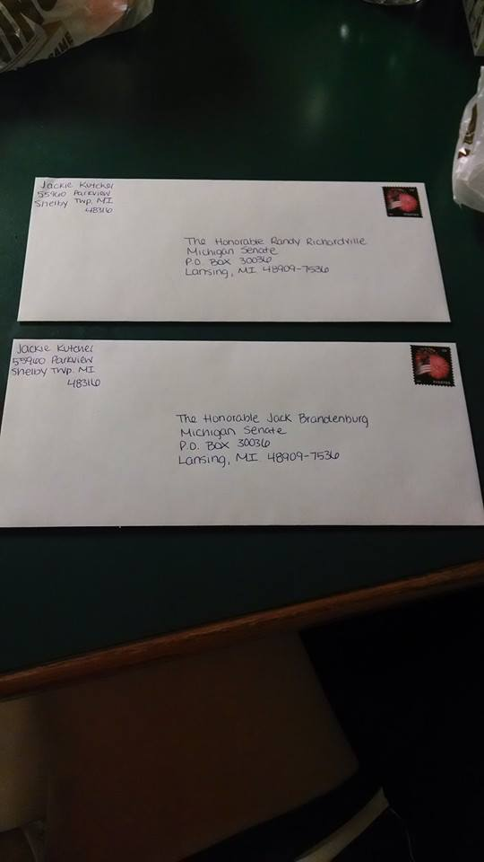

Link to Video for presentation:

<http://www.ksdk.com/video/2924340626001/1/Wage-gap-narrows-for-young-women--YoungMoney>