System Design Document

FR1
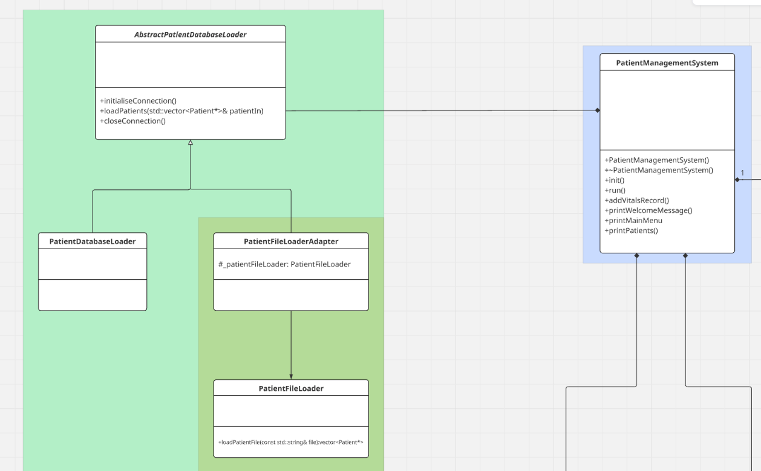
Figure 1 Adapter Design Pattern

The system must load patients’ data from a file. AbstractPatientDatabaseLoader interface facilitates extensibility for new loaders, but the existing design requires further improvements to add file loader. So, Figure 1 represents Adapter pattern to enable system load patients’ data from file.
How it works:
- The PatientManagementSystem will initialise the PatientDatabaseLoader by calling initialiseConnection() – this handshake with the database.
- The PatientDatabaseLoader will call loadPatient(…) passing in a vector which will be loaded with patients.
- The concrete PatientFileLoaderAdapter delegates PatientFileLoader to load the patients’ data from file by calling PatientFileLoader.loadPatientFile() and gets vector of patients.
- PatientFileLoader retrieves the patient details and construct patient objects which are added to the vector.
- The PatientManagementSystem is then responsible for release Patient memory allocated by the PatientDatabaseLoader.
- Finally, the PatientManagementSystem must explicitly call closeConnection() to close the database connection.
Git commits:
- First completed code in PatientFileLoader to load data from file 79e1a21c5acc4298c953e539644fa3718ee5cdc6
- Then I refactored code and added the PatientFileLoaderAdapter 0967db0770a2fdb8a81cad2d261c9f93191fe510
- Another commit: e31a84a187d2649515700b452f2434614b669eb1

