The attentive online reading: do eye movement modeling examples enhance navigation and evaluation of multiple documents in English (L2)?

Table of Contents

# Preliminary Analyses

## Outliers Detection and Replacement

Individual fixations that lasted two standart deviations above or below each participant fixation duration mean were considered outliers and were replaced by the participant fixation duration median(see SALMERÓN; DELGADO; MASON, 2020, p. 1045). Outliers represented 4.56% of the durations.

## Tests of Normality and Data Transformation

Figure 1 shows the frequency distributions of the time variables used in the study. Apart from mean fixation duration on reliable pages, all distributions have skewness values higher than 0.5, being right-skewed, as it is commonly observed with time variables. The variables were log-transformed to be better approximated to a normal distribution. The log-transformed variables are shown in Figure 2 with their theoretical probability distributions. Transformation resulted in improved skewness values for two of the four variables, namely, total fixation duration on serp and total fixation duration on source features. Thus, log-transformed variables were used for these two variables.

(see SALMERÓN; DELGADO; MASON, 2020, p. 1047)

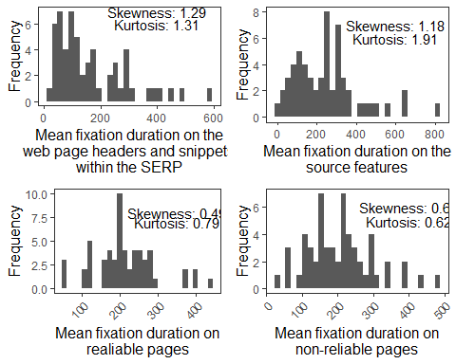

*Figure 1*. Histograms of time variables

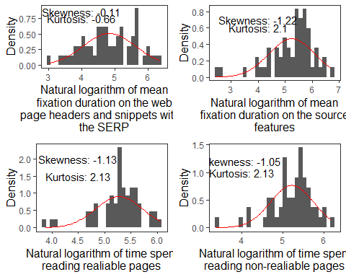

*Figure 2*. Histograms of transformed time variables with theoretical probability distributions

# Main Analysis

## Descriptive statistics

# Adicionar tabela com resumo das variáveis:  
# Média, desvio padrão, simetria, kurtose, mínimo, máximo (por grupo)

## Research Questions 1a and 1b

### RQ1a

“RQ1a: Do EMMEs affect navigation across the results of a search engine research page (SERP) in English (L2), measured by fixation duration on the webpage headers and snippets of each result within the SERP? Do L2 level and self-perceived strategic behavior mediate this interaction between EMMEs and navigation in L2?”

To answer these research questions a mediation analysis was conducted. First, a simple linear regression model was fit with fixation duration on SERP (log transformed) as response and Group (two levels: Control and Experimental) as predictor. This model show a statistically significant effect of Group (). Then, the effects of Group on L2 level and Self-reported behaviour were analyzed to verify possible mediation effects with two linear models, both with Group as predictor and each one with a mediator as response. The models show that there is no effect of Group on L2 level () nor on Self-reported behaviour (). So, the effect of Group is not mediated by these factors.

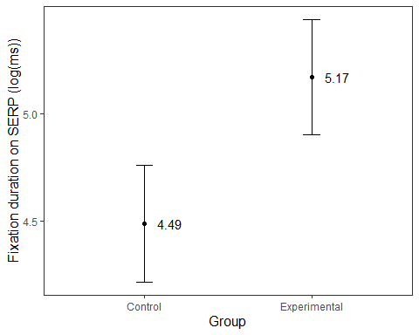

### RQ1b

“Do EMMEs affect source evaluation of multiple online documents in English (L2) that either endorse or refute the Learning Styles (LS) misconception, to be analyzed by the contrast between fixation duration on reliable versus non-reliable pages, and on total fixation duration on the source features (author’s name and occupation)? Do L2 level and self-perceived strategic behavior mediate this interaction between EMMEs and evaluation of sources in L2?”

To answer these questions a mediation analysis was performed. First, a multiple linear mixed-effects model was fit with Fixation duration on reliable and non-reliable pages as response, reliability (two levels: Reliable and Non-reliable), Group (two levels: Control and Experimental) and their interaction as predictors and random intercepts for participants. The model shows a statistically significant effect of Group () but not of Reliability (). It also shows a statistically significant interaction between Group and Reliability (). Since there are no effects of Group on L2 level nor Self-perceived behaviour, no additional steps were conducted. No mediation effects were observed with this model. Then, a linear model was fit with Fixation duration on source features as response and Group predictor. The model shows no statistically significant effects of Group () and, thus, no additional steps were necessary.

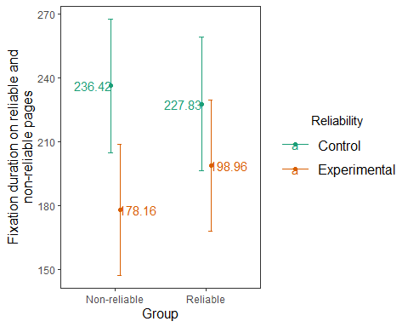

## Research Questions 2a, 2b and 2c

### RQ2a

“RQ2a Do EMMEs enhance argumentative reasoning, i.e., identification of opposing perspectives about the Learning styles theory, as measured by an essay writing task? Do English level, navigation and evaluation behavior mediate the effect of EMMEs on argumentation score?”

To answer these questions a mediation analysis was performed. A linear model with Argumentation scores on an essay writing task as response and Group as predictor. No effect of Group was observed . Since there was no effect of Group, the additional steps were not performed.

### RQ2b

“RQ2b Do EMMEs increase memory for the sources when reading multiple documents? Do English level, navigation and evaluation behavior mediate the effect of EMMEs on source memory?”

To answer these questions a mediation analysis was performed. A linear model with Source memory task scores as response and Group as predictor. No effect of Group was observed . Since there was no effect of Group, the additional steps were not performed.

### RQ2c

“RQ 2c Are EMMEs linked with updating of misconceptions about Learning Styles, to be measured in a pre/posttest? Do English level, navigation, and evaluation behavior (including memory for the sources) mediate the effect of EMMEs on misconception change?”

To answer these questions a mediation analysis was performed. A linear model with Scores on a pre and post-test of misconceptions about learning styles as response and Group as predictor. No effect of Group was observed . Since there was no effect of Group, the additional steps were not performed.

SALMERÓN, L.; DELGADO, P.; MASON, L. Using eye-movement modelling examples to improve critical reading of multiple webpages on a conflicting topic. **Journal of Computer Assisted Learning**, vol. 36, no. 6, p. 1038–1051, 2020. <https://doi.org/10.1111/jcal.12458>.