|  |
| --- |
|  |

Title

Davi Bicudo Guggisberg

Xiao Sun

ABMT Report

January 2019

Course Report, ABMT 2018 HS

Title

Davi Bicudo Guggisberg, Xiao Sun

IVT ETH Zurich

Stefano-Franscini-Platz 5, 8093 Zurich, Switzerland

E-Mail: davig@student.ethz.ch

E-Mail: sunxi@student.ethz.ch

January 2019

Keywords

MATSim; Traffic Simulation; Transport Policy; Paris; Route Choice, Vehicle Behavior

Preferred citation style

Guggisberg, Davi Bicudo, Xiao, Sun (2019) Title, *Course Report*, **ABMT 2018HS**, IVT, ETH Zurich, Zurich.

Table of contents

1 Modified Network 3

2 Simulation Description 3

3 Limitation and Future Work 3

3.1 Subheading 4

3.2 Subheading 4

4 Reference list 5

A Appendix Heading 6

A.1 Appendix Subheading 6

# Modified Network

Road closure (links that need to be closed as a dead end):

432525-432552 (378901-219082, 215563-432524(77417))

77414

529627

383318-514882

240395

319528 (179601-204222)

525852

496522

496523 (209518 (247139, 334430))

563213 (563209, 563210, 563230)

563214

563215 (79963 (563230, 79960), 79960 (563221-563212, 563218), 563231, 563205 (563206 (563231, 563221-563212), 563225))

199-608079 (450308)

346923

240977 (327433-437443-389258, 240122)

499496-226050

250643

240276

240277 (247122-3887)

240278

240279

448845 (589946)

448844

496526 (589952)

448846-589949

448843

455368-236178-602113

287613

287614 (416986)

287615

287616

159385

159386

272529

272530

159387

159388 (512036 (600093))

159389

159390

272531

272532 (306474 (600092, 527253 (527254, 600097)), 600104)

236003

236004 (79429 (460880-556287, 79427-79428))

402812

6931

6932

6933 (600119)

6934

6935

6936

# Simulation Description

Route Choice Change Analysis (using VIA)

Departure Time Change Analysis (using VIA)

# Limitation and Future Work

Figure 1: Label

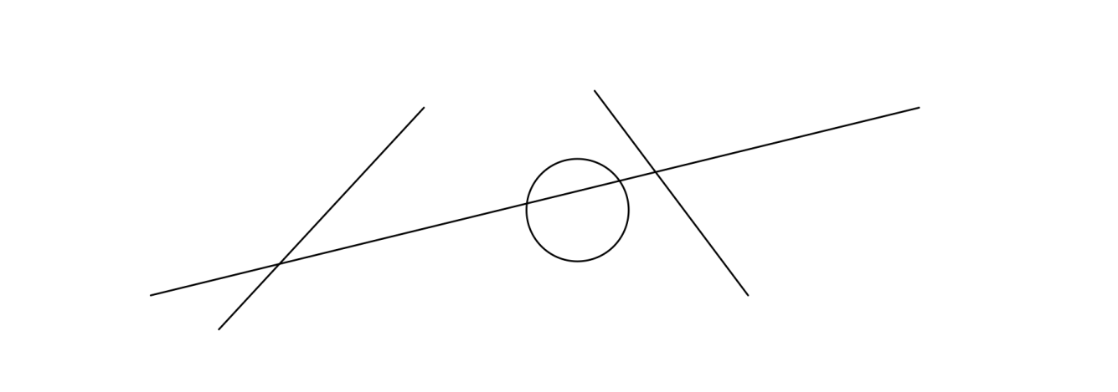

Table 1: Label

|  |  |  |  |  |
| --- | --- | --- | --- | --- |
| Table heading | Table heading | Table heading | Table heading | Table heading |
| Table content | Table content | Table content | Table content | Table content |
|  |  |  |  |  |
|  |  |  |  |  |
| Source or notes. | | | | |

## Subheading

Paragraph[1]

### Subsubheading

Paragraph

## Subheading

* list item
* list item

# Reference list

Arthur, P. and R. Passini (1992) *Wayfinding: People, Signs and Architecture*, McGraw Hill, New York.

Backhaus, N. and M. Steinemann (2002) Leitfaden für wissenschaftl. Arbeiten, *Schriftenreihe Anthropogeographie*, Geographisches Institut, Zurich University UZH, Zurich.

Chapman, M and C. Wykes (1996) *Plain Figures*, HMSO, London.

Cleveland, W.S. (1994) *The Elements of Graphing Data*, Hobart Press, Summit.

Dudenredaktion (Hrsg.) (2014) *Duden: Die deutsche Rechtschreibung*, Dudenverlag, Mannheim.

ETHZ CC (2016) Corporate design, https://www.ethz.ch/services/en/service/communication/corporate-design.html, ETH Zurich Corporate Communications, Zurich, May 2016.

Gowers, E. (1986) *The Complete Plain Words*, revised by S. Greenbaum and J. Whitcut, HMSO, London.

RSETHZ (2004a) Procedure to address allegations of research misconduct at the ETH Zurich (RSETHZ 415), Rechtsdienst ETH Zurich, Zurich.

RSETHZ (2004b) Disciplinary code of the Swiss Federal Institute of Technology Zurich (RSETHZ 361.1), Rechtsdienst ETH Zurich, Zurich.

RSETHZ (2007) Guidelines for Research Integrity and Good Scientific Practice at the ETH Zurich (RSETHZ 414), Rechtsdienst ETH Zurich, Zurich.

Schweizerische Bundeskanzlei (1996) *Leitfaden zur sprachlichen Gleichbehandlung*, EDMZ, Bern.

Schweizerische Bundeskanzlei (1998) *Leitfaden zur Neuregelung der deutschen* Rechtschreibung, EDMZ, Bern.

Tufte, E. (1983) *The Visual Display of Quantitative Information*, Graphics Press, Cheshire.

Wilkinson, L. (1999) *The Grammar of Graphics*, Springer, Heidelberg.

# Appendix Heading

## Appendix Subheading

### Appendix Subsubheading

1. Footnote.