**LAB 2 – EE 352**

Davi Rodrigues Chaves

1. Memory Map:

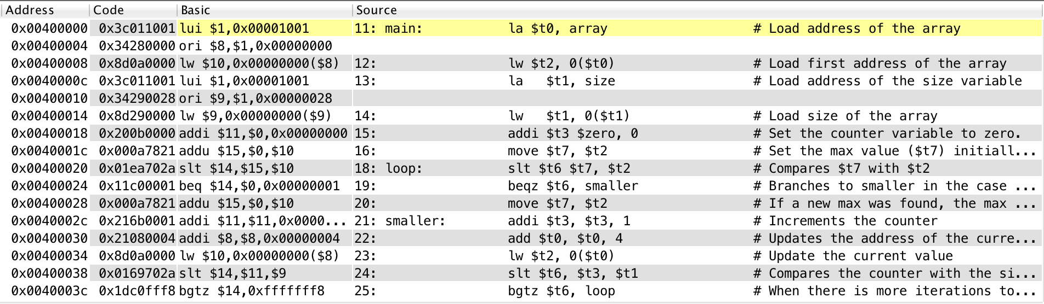Main Program:

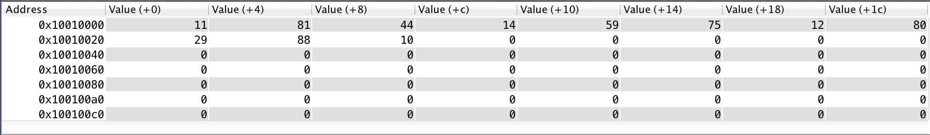Array and size data:

Array: 11, 81, 44, 14, 59, 75, 12, 80, 29, 88.

Size: 10.

1. Content of the registers for each iteration
   1. Iteration 0:

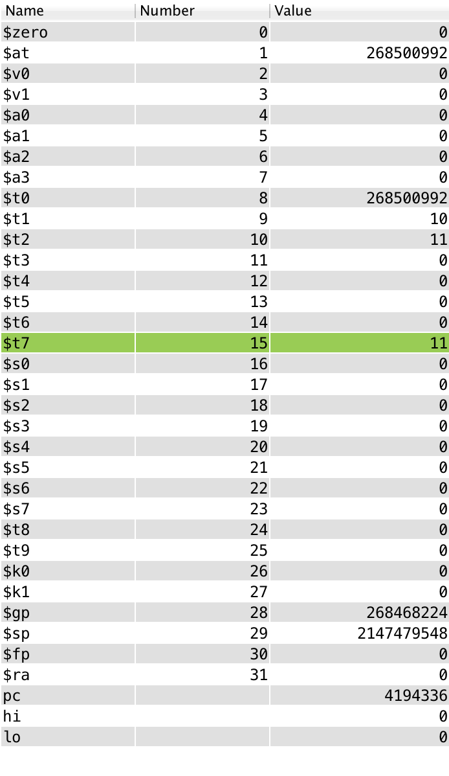

* 1. Iteration 1:

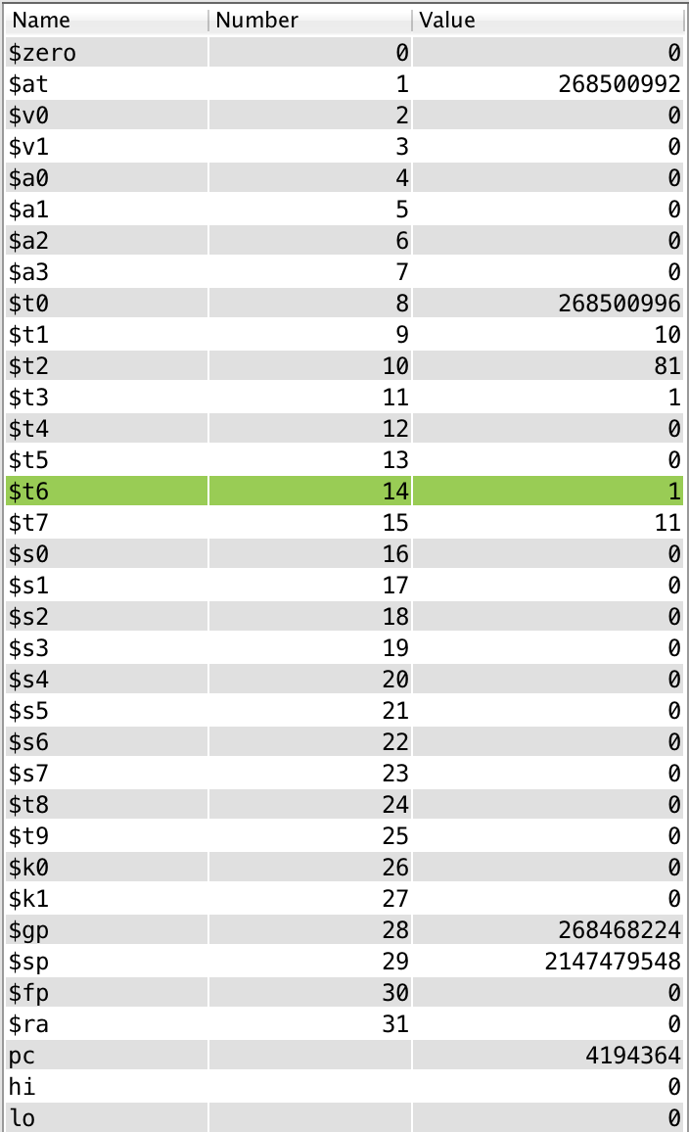

* 1. Iteration 2:

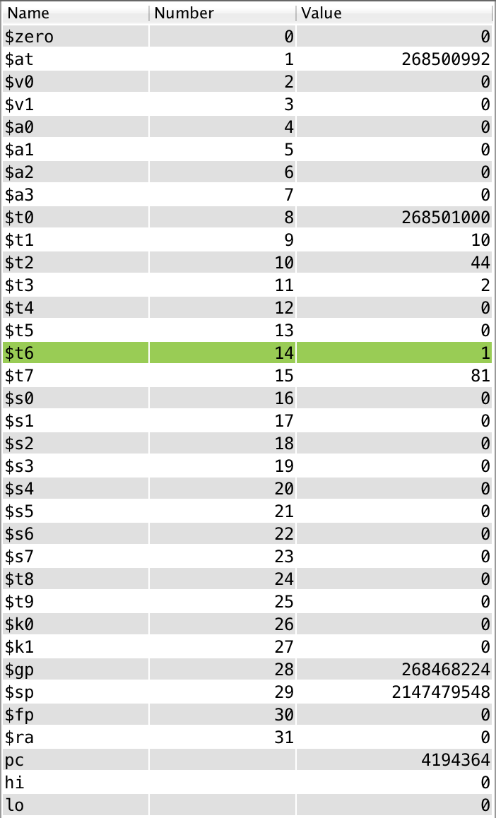

* 1. Iteration 3:

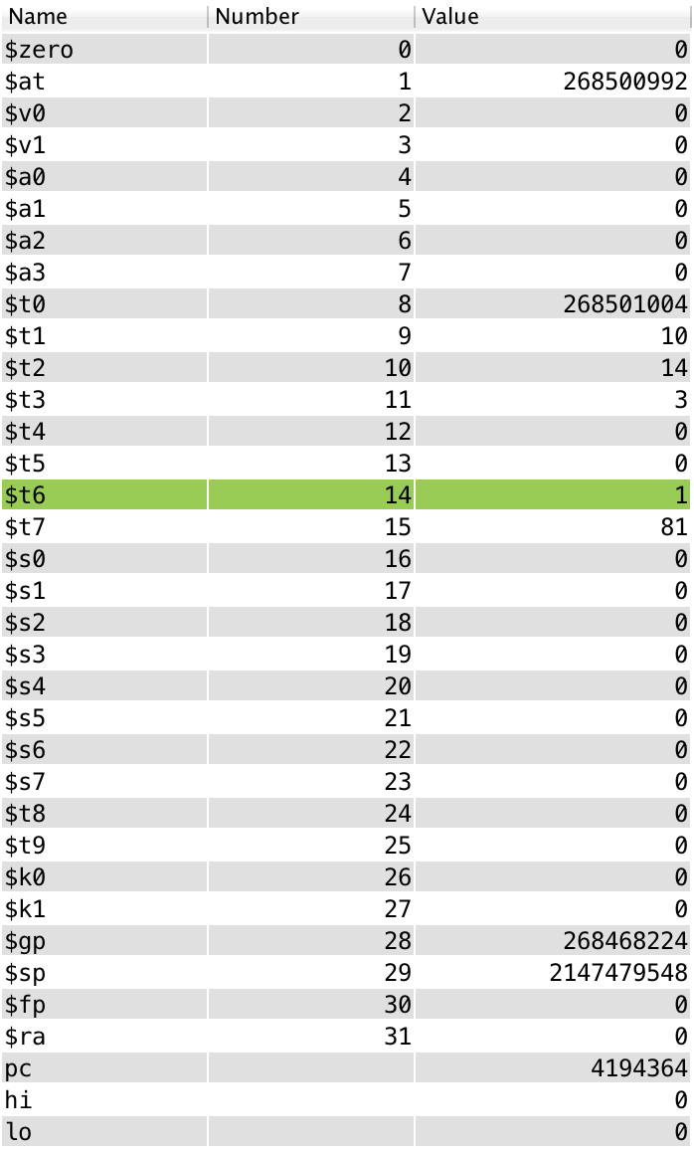

* 1. Iteration 4:

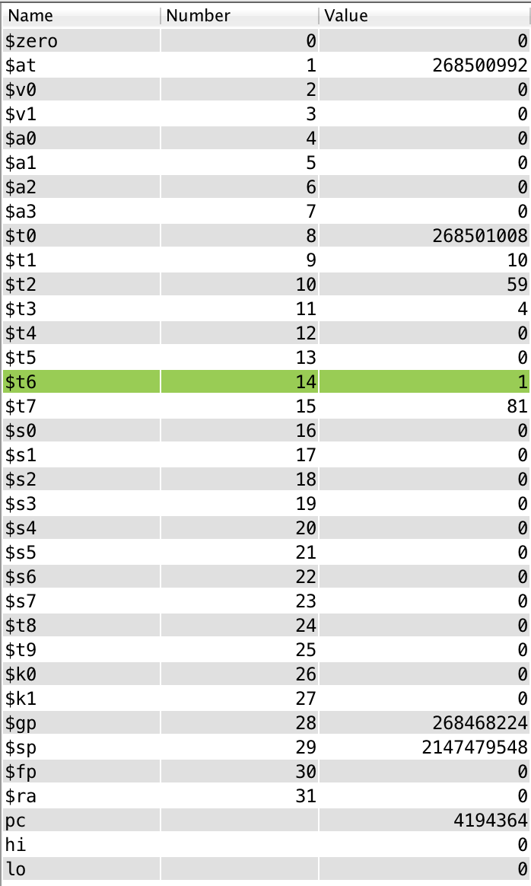

* 1. Iteration 5:

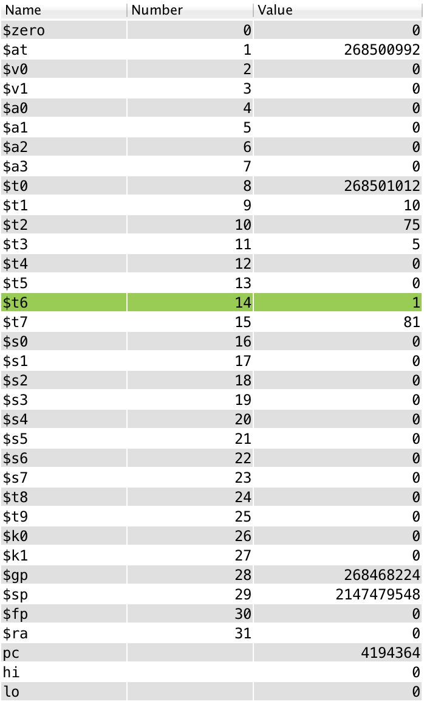

* 1. Iteration 6:

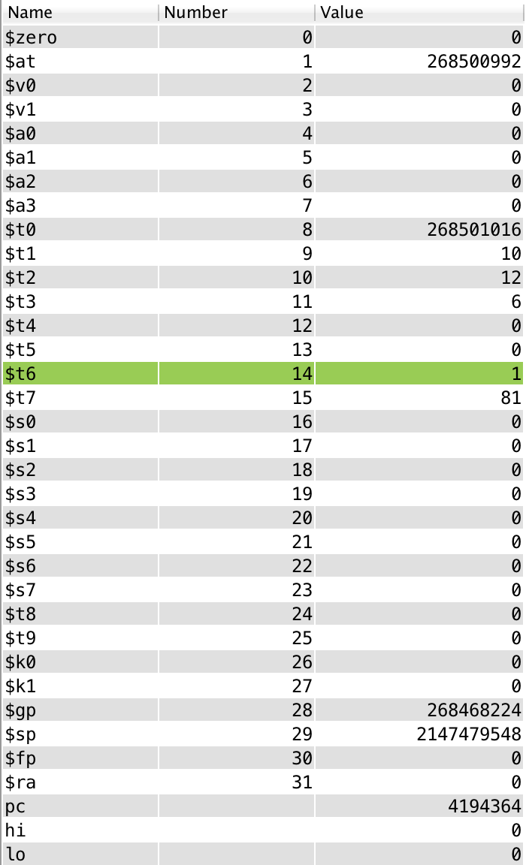

* 1. Iteration 7:

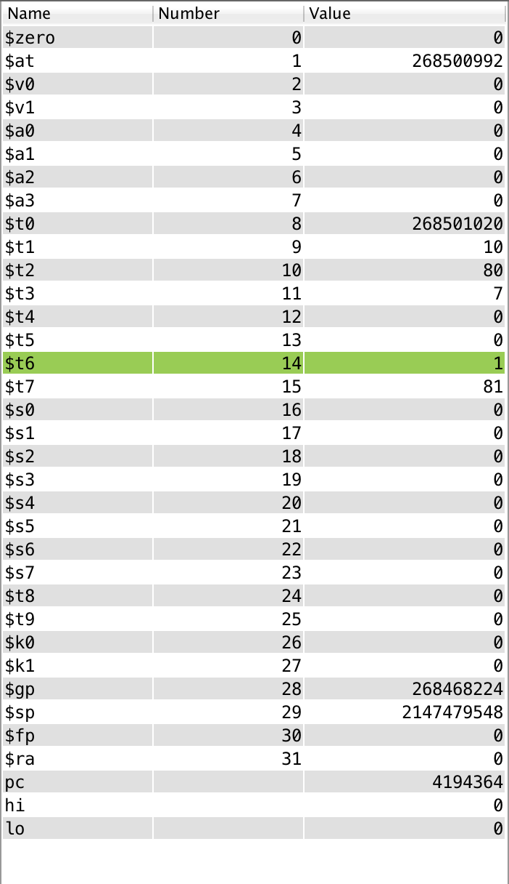

* 1. Iteration 8:

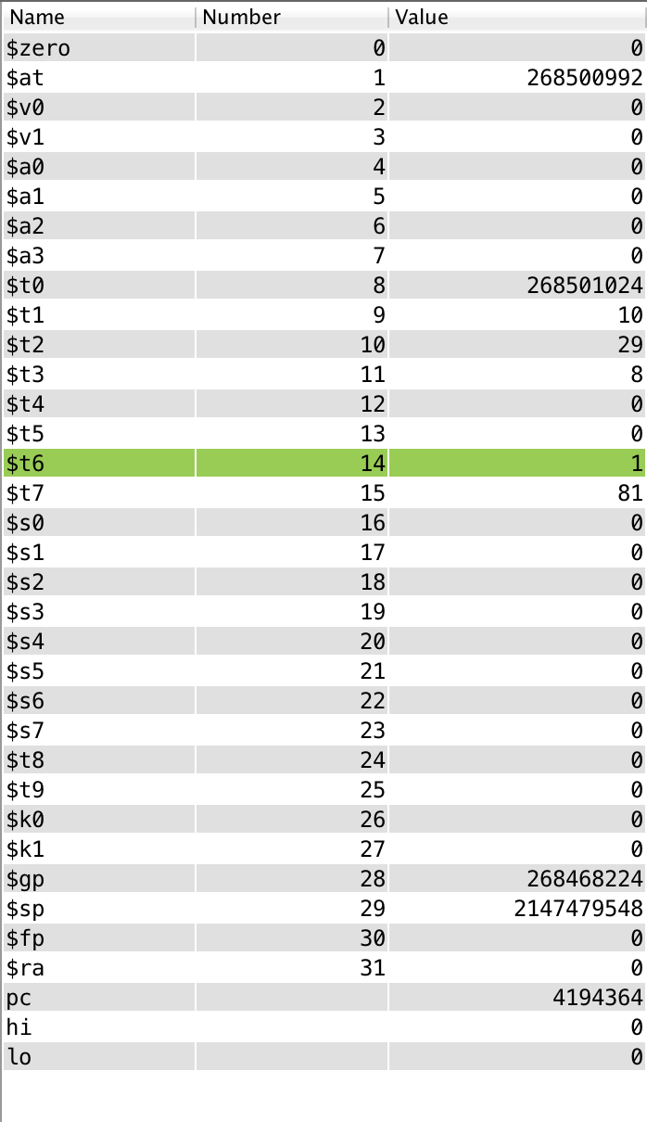

* 1. Iteration 9:

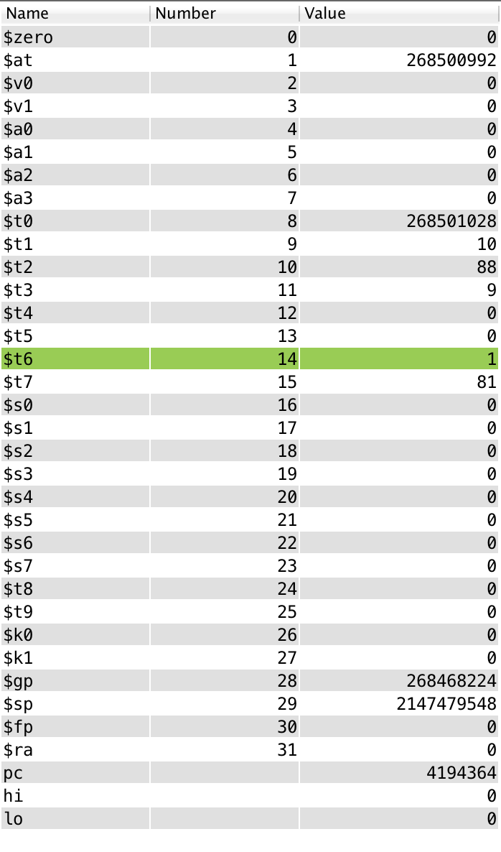

* 1. Iteration 10:

