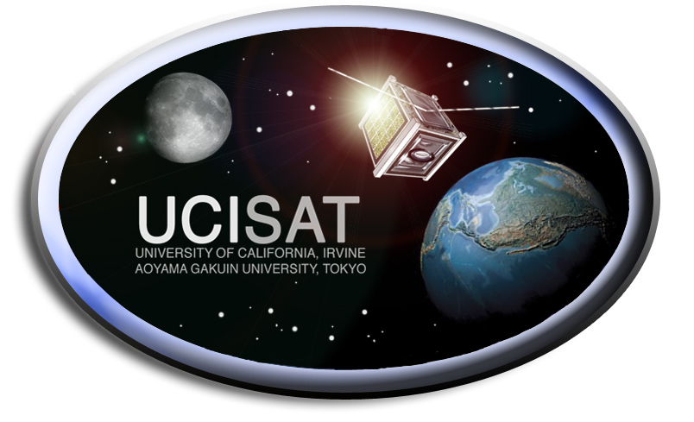
Communications
Team Members: David Sasaki, Sheena Shokoohi

Overview:

This system is responsible for establishing a link between the satellite and ground station in order to retrieve measurements from the onboard sensors as well as downloading pictures. There are three major design components, the antenna, radio, and TNC (interfaces between radio and onboard computer). The design focus for this year is the antenna deployment circuit and balun circuit. Additional progress has been made on the TNC.

Completed Tasks:

- Antenna deployment sequence
  - Antenna is secured prior to launch with fishing wire which is then released using nichrome wire to melt the fishing wire
  - Minimize nichrome wire length
    - Current needed to melt fishing wire is proportional to length of nichrome wire
- Balun and antenna deployment circuit
  - The balun is used for impedance matching between the radio and antenna to maximize the radiated signal
  - Variable LC circuit added for fine tuned impedance matching
  - The deployment circuit uses an NMOS as a switch to deliver current to the nichrome wire
- Balun and antenna circuit implemented on PCB
  - design constraints
    - Limited board size due to location on satellite
    - Minimize distance between balun and antenna connector
    - Part selection
      - Operating temperature range
      - Size Vs. Performance of NMOS
- TNC implemented and configured
  - Firmware configured for designated baud rate
  - Tested interface between onboard computer and ground station
    - Debugging of ground station software code

Scheduled for Completion:

- PCB manufacture and assembled
  - Currently waiting for other subsystems’ PCB before order is sent out
  - Locating vendor to do assembly work
- Testing (dependent on fully assembled satellite)
  - Integrated
    - Antenna deployment sequence timing with onboard computer
  - Field
    - Ground station testing with completed satellite
  - Radiation Pattern
    - Antenna performance data to compare for future satellite antenna designs
    - Perform impedance tuning with LC circuit for optimized performance
  - Radiated Spurious Emissions (RSE)
    - Detect and isolate harmonic noise from satellite prior to launch
      - Results may require circuit design modifications

Summary:
The design phase has been completed and scheduled for manufacture. The satellite is moving onto testing phase of the project. A future point of interest will be the results from the RSE testing which will delay the project if board level redesigns are required.

