David Amos

4/2/2024

3.2 Assignment

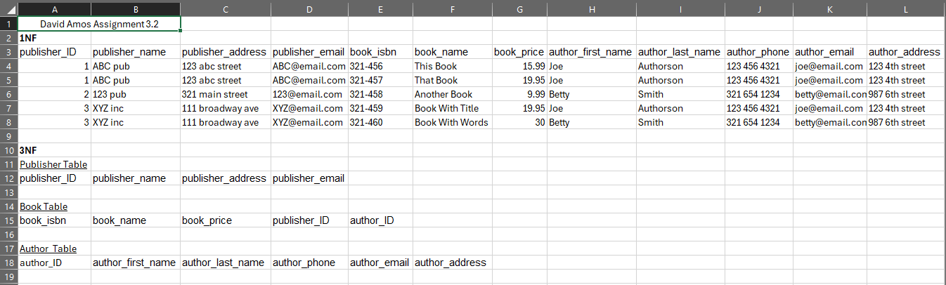

Assumptions made:

I assumed that the author table should be given a new surrogate key. The email would possibly be a unique key but that may not be a guarantee and other tables would then need to store that for reference when they otherwise would not have needed to.

Another assumption I made was that a book can only have 1 publisher and 1 author. If either of those were not true, I would have made new tables to present those relations. For multiple authors I would have a “Book Author” table which would store isbn and author id to represent the relationship between them.

I also assumed that publishers and authors can only have 1 address. If that was not true, then I would have made an address table with a composite key of author id and sequence number to uniquely identify each address.