Table of Contents

Mount drive if you are working on Google Colab else skip this cell 1

Segmentations Data set 1

Run 1

Requirements 1

Libraries 1

Training the model 2

Run 2

Requirements 2

Libraries 2

# Mount drive if you are working on Google Colab else skip this cell

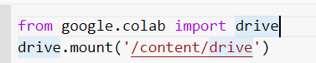

You would need to upload dataset on google drive

# Segmentations Data set

## Run

* File= Extracted_features.ipynb
* Change the working directory where the dataset is placed, within inverted commas 
* Folder name of the dataset folder within inverted commas
* Segmented pictures saving folder within in inverted commas with forward slash / at the end of the name.



* Run All other cells It will create a folder name segmented or you decided with segmented pictures.

## Requirements

Files “Duagman.py” and “Duagman_visuail_explaination.py” should be in the working directory.

### Libraries

* matplotlib
* tqdm
* cv2 (OpenCV)
* numpy
* random
* os
* Itertools
* typing
* keras

# Training the model

## Run

* File= train.ipynb
* Change the working directory where the dataset is placed, within inverted commas



* Path for the segmented dataset with forward slash with in it.

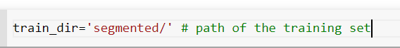

* Set model name with extension ‘h5’ as format below. It will save model with same name.
* Run other all cells It will save model everytime when validation loss would be detected lower than current in training mode. It will overwrite the model.

## Requirements

### Libraries

* tensorflow
* keras
* matplotlib
* numpy
* sklearn