# Raspberry Pi 3b

# 

# Buttons

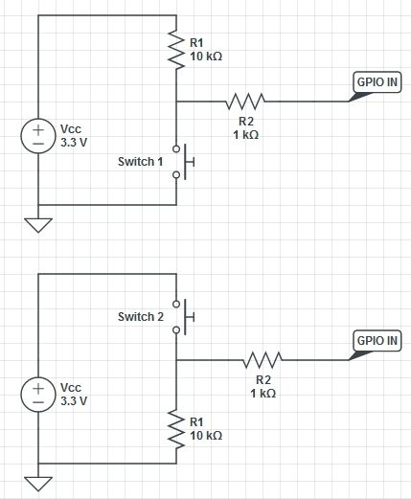A GPIO pin is set as an input is “floating” and has no defined voltage level. To be able to reliably detect whether the input is high or low it needs to be tied it so that it is always connected and either reads high or low. To tie the pin connect either a Pull Up or Pull Down resistor.

A Pull down resistor connects the pin to ground through a large resistor, this means that when the switch is open there is a path to ground and so it will read low. When the switch is pressed (with the other side connected to 3.3V) there is a lower resistance path to high and so the pin will read high. The large (10kΩ) resistor ensures that too much current is not drawn when the switch is pressed.

Damage is still possible if the GPIO pins are accidentally set to an output. If they are driven low the output would then be connected directly to ground. Pushing the button will then create a short circuit between 3.3V and ground. To prevent this a current limiting resistor (1kΩ) to make sure the Pi can handle the current drawn.

# LEDs

Wire up the LED through the 220Ω current-limiting resistor to a pin of your choice, observing the polarity of the LED. (The flat side of the LED should be connected to the ground pin, and the other side should be connected to the GPIO pin.) Larger LEDs require more power and will require a transistor to drive them to prevent damage to the Pi’s pin.

# Relay Boards

## Sainsmart 8 Channel 5V Solid State Relay Module

Input control signal voltage

* 0V - 0.5V Low stage (SSR is OFF),
* 0.5V – 2.5V (unknown state).
* 2.5V - 20V High state (SSR is ON).

## SainSmart 8 Channel DC 5V Relay Module