Olivan Online-store Functionality List
Inspired by Bunnings and Wilcon Depot
Key:
Core Functionality | Unsure? |Stretch Goal

Product Catalog & Browsing
Product Listing & Categories: Browse products organized by category (Appliances, Building Materials, Electrical, Furniture, Hardware, Plumbing, Tiles, Tools, etc.) with hierarchical navigation and subcategories
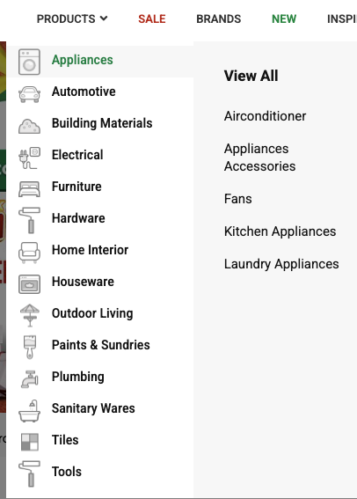
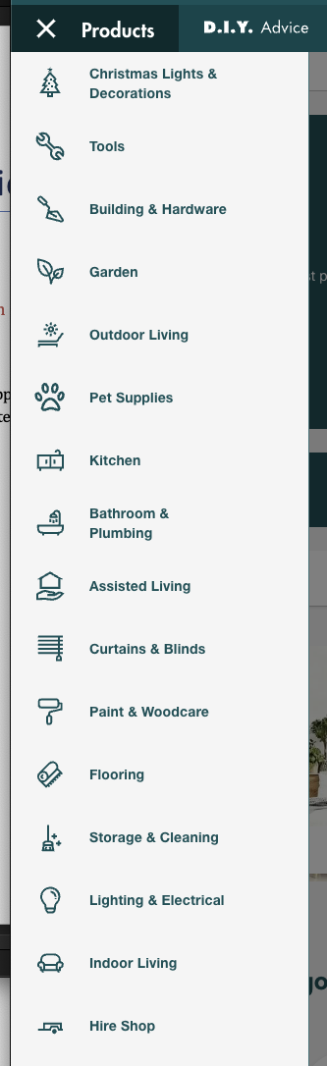
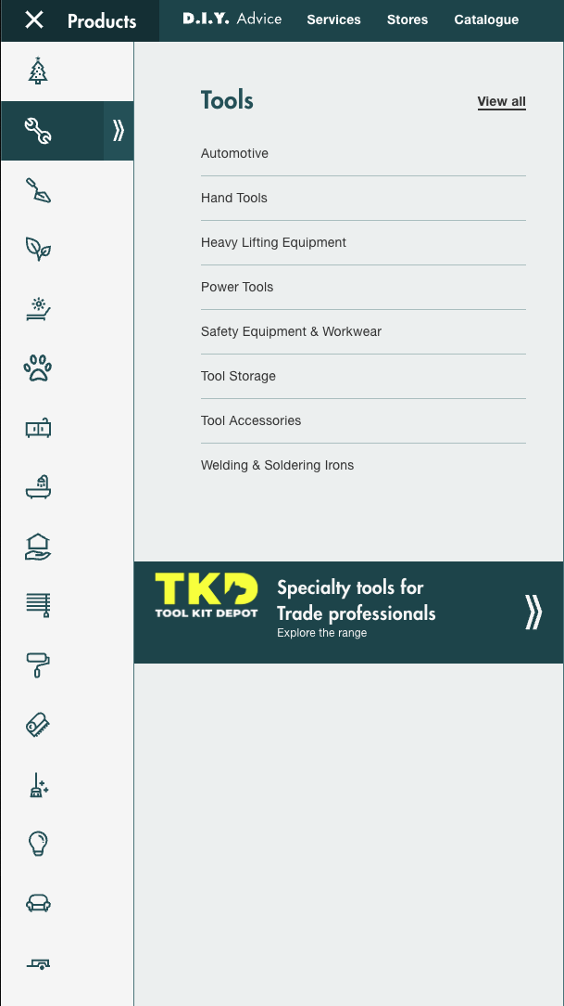
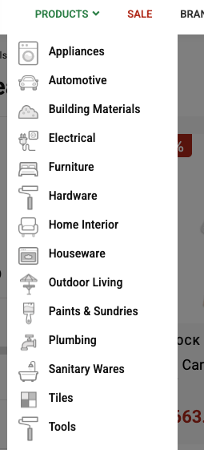
Wilcon Depot Shop Bunnings

Product Detail Pages: Individual product pages with high-quality images, detailed descriptions, specifications, pricing, availability status, customer reviews/ratings, and related product suggestionsfi
Product Search: Advanced search functionality allowing users to search by product name, SKU, category, or brand with autocomplete suggestions
Advanced Filtering & Sorting: Filter products by price range, brand, availability, customer ratings, and features.
Sort by:
- Item Category
- Price (low to high, high to low)
- Popularity
- Newest Arrivals
- Customer Ratings
- Tile Size
- Colour
- Material
- Sale Status
Brand Pages: Dedicated pages for each brand showcasing brand information, product listings, and brand-specific promotions
New Arrivals: Showcase of newly added products to help customers discover latest inventory
Sale & Promotions: Dedicated sale section highlighting discounted items, special offers, promotional banners, and limited-time deals; MAIN PAGE Promotional Paginated Carousel/Slideshow
Product Comparison: Side-by-side comparison tool allowing users to compare multiple products on features, specifications, and pricing

Shopping & E-commerce
Shopping Cart: Add/remove items, update quantities, save items for later, view cart summary with subtotal, taxes, and shipping costs
Wishlist/Favorites: Save products to wishlist for future purchase, share wishlist with others, and get notifications when wishlist items go on sale
Checkout Process: Multi-step checkout process including shipping address selection, shipping method selection, payment method selection, order review, and confirmation page
Multiple Payment Options: Support for various payment methods including credit/debit cards, digital wallets (GCash, PayPal), bank transfers, and cash on delivery
Order Management: View complete order history, track order status in real-time, view detailed order information, reorder previous purchases, and submit cancel/return requests
Inventory Management: Real-time stock status display (In Stock, Out of Stock, Low Stock), check availability at specific store locations, and delivery time estimates

Store & Location Services
Store Locator: Find nearby stores with complete information including addresses, contact details, operating hours, map integration, and directions
Store-Specific Inventory: Check product availability at specific store locations before visiting
Click & Collect: Order online and pick up in-store with order ready notifications and pickup scheduling
Store Services: Information about in-store services such as cutting services, custom orders, and in-person consultations

Account & User Management
User Registration & Login: Account creation with email/password, social media login options (Google), password recovery, and account verification
User Dashboard: Comprehensive account overview showing recent orders, saved addresses, payment methods, wishlist items, and account preferences
Profile Management: Edit personal information, manage multiple shipping addresses, update contact details, and set communication preferences
Order Tracking: Real-time order status updates, shipping tracking integration, delivery notifications, and estimated delivery dates

Content & Inspiration
Project Inspirations: DIY project ideas, room makeovers, before/after galleries, and step-by-step project guides with material lists
DIY Guides & Tutorials: Comprehensive step-by-step guides, video tutorials, material lists, tool requirements, and difficulty ratings for various projects
Blog/Articles: Regular content including home improvement tips, product guides, maintenance advice, seasonal content, and expert advice

Services
Design Hub Service: Interior design consultation services, room planning tools, color scheme suggestions, and personalized product recommendations
Tile Cutting Service: Custom tile cutting services, measurement assistance, installation advice, and professional cutting for specific project needs
Delivery Service: Home delivery options with scheduling, delivery fee calculator, delivery tracking, and multiple delivery time slots
Installation Services: Professional installation booking for various products including scheduling, pricing information, and service area coverage
After-Sale Service: Warranty claims processing, repair services, maintenance services, and ongoing customer support

Customer Support
Live Chat: Real-time chat support with customer service agents available during business hours (typically 8AM-10PM based on Wilcon model)
Phone Support: Customer service phone line with operating hours, call-back options, and multi-language support
FAQ Section: Comprehensive frequently asked questions organized by category with search functionality
Contact Forms: Email contact forms for general inquiries, product questions, feedback, and complaint submission
Help Center: Extensive help articles, troubleshooting guides, video tutorials, and self-service resources

Promotions & Marketing
Newsletter Subscription: Email signup for promotional offers, new product announcements, special deals, and seasonal campaigns
Special Deals: Featured promotions, flash sales, seasonal sales, clearance items, and member-exclusive offers
Loyalty Program: Points system, rewards program, member-exclusive deals, and tiered membership benefits (if applicable)
Product Recommendations: Personalized product recommendations based on browsing history, purchase history, and similar customer preferences

Product Information
Product Reviews & Ratings: Customer reviews and ratings system, Q&A sections, verified purchase badges, and helpful review voting
Product Specifications: Detailed technical specifications, dimensions, materials, compatibility information, and installation requirements
Product Images & Videos: Multiple high-quality product images, zoom functionality, 360° product views, and video demonstrations
Product Availability: Real-time stock status, estimated restock dates, alternative product suggestions, and backorder options

Legal & Policy Pages
Privacy Policy: Comprehensive data protection information, cookie policy, user rights, and GDPR compliance details
Terms of Use: Website terms and conditions, user agreements, acceptable use policies, and intellectual property information
Product Warranty: Detailed warranty information, claim process, terms and conditions, and warranty registration
Returns & Exchanges: Clear return policy, exchange process, refund information, return shipping instructions, and return timeframes
Pricing Policy: Price matching policy, price guarantee information, pricing transparency, and price change notifications

Additional Features
Mobile Responsiveness: Fully responsive design optimized for mobile devices, tablets, and desktops with touch-friendly interfaces
Recently Viewed: Track and display recently viewed products for easy access and continued shopping
Product Authenticity Guarantee: Guarantee of genuine products from authorized suppliers with authenticity verification
Accessibility Features: Screen reader support, keyboard navigation, high contrast mode, text size adjustment, and WCAG compliance
Compare Products: Side-by-side product comparison tool with feature highlighting and difference indicators
Quick View: Quick product preview modal without leaving the product listing page for faster browsing

Technical Features
Fast Search: Instant search suggestions, autocomplete functionality, search history, and search result highlighting
Image Optimization: High-quality product images with lazy loading, image zoom, gallery views, and optimized file sizes
Performance Optimization: Fast page load times, optimized images and assets, efficient caching, and CDN integration
SEO Optimization: Search engine optimized pages, proper meta tags, structured data markup, and sitemap generation

FOR DEVELOPER

Tech Stack
Front-end
Framework: NEXTJS
Styling: Tailwind CSS
Backend
Framework: Java Spring Boot
Database: PostgreSQL
Auth/Token: JWT

