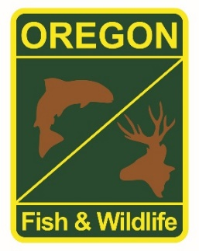

**State Fisheries Genomics Lab Tissue Sample Intake Form**

Please complete the top part of this form and send to: [kathleen.omalley@oregonstate.edu](mailto:kathleen.omalley@oregonstate.edu)

Make arrangements with us prior to dropping off the tissue samples and include a copy of this form with your samples.

**Project dropping off samples:**

ODFW Fish Propagation

2020 Willamette Hatcheries Adult Salmon/Steelhead Genetic Samples

**Person dropping off samples:** Ryan Couture

**Phone:** 541-757-5228  **Email:** ryan.b.couture@state.or.us

**Description of samples (e.g. species, collection locations, collection dates, collection methods, number of samples, life stage; may attach spreadsheet):**

ADULT STW for the North Santiam released above Minto

ADULT STW for the South Santiam released above Foster

ADULT CHS for the Mckenzie, hatchery broodstock and outplants

ADULT CHS for the North Santiam for outplanting above Detroit (HOR) and release above Minto (NOR). *Missing spawned/broodstock samples

ADULT CHS for the South Santiam for broodstock (HOR) and release above Foster (NOR)

**If applicable, known origin (e.g. natural or hatchery):**

Both NOR and HOR

**Sample type (e.g. fin tissue, scale, muscle, etc):**

Fin tissue

**Storage method (e.g. dry, 95% ethanol, RNA later, etc):**

95% ethanol