**North and South Umpqua Chinook salmon**

In 2020 and 2021, tissue samples were collected from spring Chinook salmon in the North and South Umpqua Rivers. DNA was extracted from 103 North Umpqua samples and 69 South Umpqua samples (Table 1).

**Table 1.** Summary of spring Chinook salmon samples collected from the North Umpqua River (NUMP) in 2020 and from the South Umpqua River (SUMP) in 2021.

|  |  |  |  |  |
| --- | --- | --- | --- | --- |
| **River** | **Sample location** | **Sample type** | **Origin** | **n** |
| NUMP | Boulder to Copeland | Carcass | NOR | 7 |
| NUMP | Full Flow Reach | Carcass | NOR | 7 |
| NUMP | Lower Fish Creek | Carcass | NOR | 11 |
| NUMP | Slide Creek Bypass reach | Carcass | NOR | 2 |
| NUMP | Soda Springs to Boulder Creek | Carcass | NOR | 22 |
| NUMP | Upstream of Soda Springs | Carcass | NOR | 1 |
| NUMP | Winchester Dam or Rock Creek Hatchery | Live | NOR | 53 |
|  |  |  |  |  |
| SUMP | 2823 Bridge | Carcass | NOR | 1 |
| SUMP | Bedrock Gorge | Carcass | NOR | 2 |
| SUMP | NA | Carcass | NOR | 3 |
| SUMP | Narrows | Carcass | NOR | 1 |
| SUMP | Skillet Creek Campground | Carcass | NOR | 3 |
| SUMP | South Umpqua Falls | Live | 57 NOR, 2 HOR | 59 |

Using the Genotyping-in-Thousands by sequencing method (GT-seq; Campbell *et al.* 2015), all samples were genotyped at 353 single nucleotide polymorphisms (SNPs) (Hess *et al.* 2016) including a sex marker and two adult run timing SNPs (Ots37124_12277401 and Ots37124_12310649) that are ~33 kb apart on the Otsh_v1.0 (GCA_002872995.1) genome assembly and located in the intergenic region between *greb1l* and *rock1*. After filtering both samples and SNPs that genotyped poorly, the final dataset consisted of 57 North Umpqua samples and 66 South Umpqua samples genotyped at 324 SNPs (Table 2).

**Table 2.** Summary of the final dataset which consisted of 57 North Umpqua and 66 South Umpqua Chinook salmon samples genotyped at 324 SNPs.

|  |  |  |  |  |
| --- | --- | --- | --- | --- |
| **River** | **Sample location** | **Sample type** | **Origin** | **n** |
| NUMP | Boulder to Copeland | Carcass | NOR | 2 |
| NUMP | Full flow reach | Carcass | NOR | 1 |
| NUMP | Lower Fish Creek | Carcass | NOR | 2 |
| NUMP | Soda Springs to Boulder Creek | Carcass | NOR | 2 |
| NUMP | Upstream of Soda Springs | Carcass | NOR | 1 |
| NUMP | Winchester Dam or Rock Creek Hatchery | Live | NOR | 49 |
|  |  |  |  |  |
| SUMP | 2823 Bridge | Carcass | NOR | 1 |
| SUMP | Bedrock Gorge | Carcass | NOR | 2 |
| SUMP | NA | Carcass | NOR | 2 |
| SUMP | Narrows | Carcass | NOR | 1 |
| SUMP | Skillet Creek Campground | Carcass | NOR | 2 |
| SUMP | South Umpqua Falls | Live | HOR | 2 |
| SUMP | South Umpqua Falls | Live | NOR | 56 |

Based on the genetic sex marker, the North Umpqua dataset consists of 20 females and 37 males while the South Umpqua dataset consists of 36 females, 30 males. Most of the North Umpqua Chinook salmon genotyped homozygous spring at the two adult run timing SNPs while three individuals were heterozygous (i.e., one copy of the “early” run allele and one copy of the “late” run allele). All the South Umpqua samples genotyped homozygous spring at the two adult run timing SNPs.

Genetic variation among the 123 Chinook salmon samples was explored using principal components analysis (PCA) (Figure 1). Most North and South Umpqua samples clustered together. We identified four North Umpqua and three South Umpqua outlier samples (Table 3).

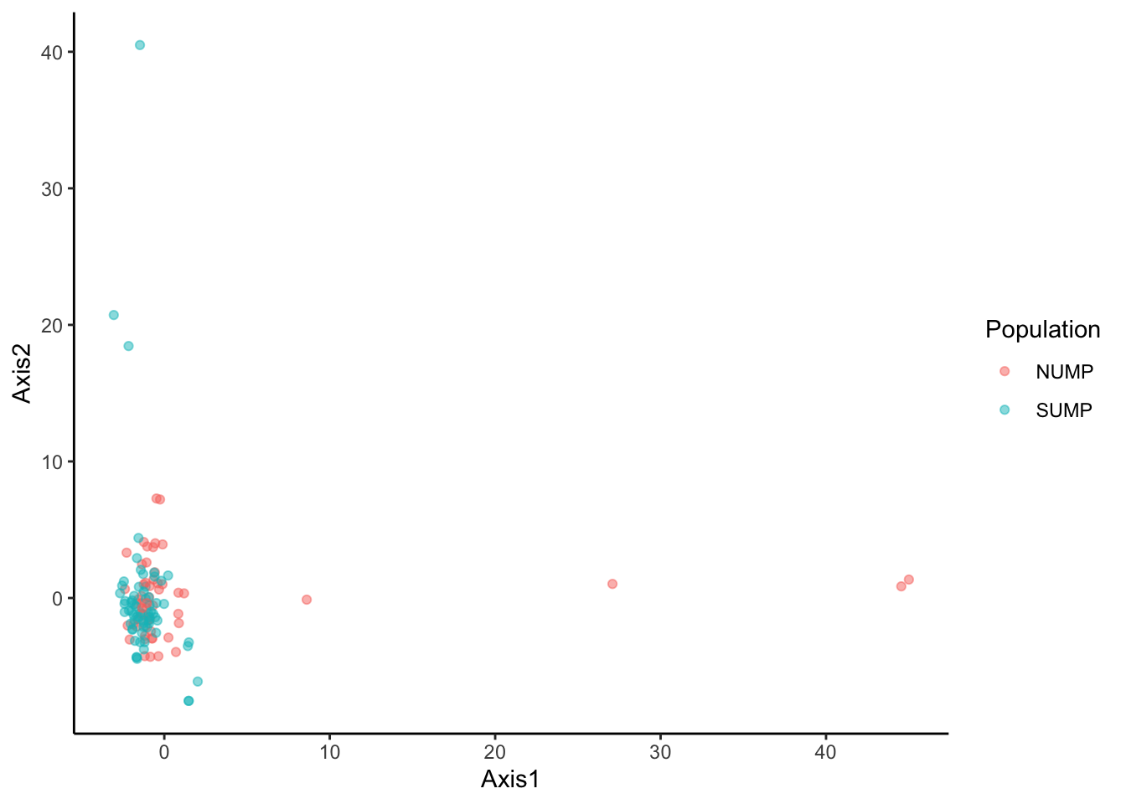

**Figure 1.** Principal components analysis (PCA) results for 57 North Umpqua (red) and 66 South Umpqua (blue) Chinook salmon samples genotyped at 324 SNPs.

**Table 3.** Seven outlier samples identified in the PCA.

|  |  |  |  |  |  |  |
| --- | --- | --- | --- | --- | --- | --- |
| **River** | **Sample name** | **Sample date** | **Sample location** | **Sample type** | **Sex** | **Origin** |
| NUMP | OtsCC20NUMP_0020 | 10/6/20 | Lower Fish Creek | Carcass | F | NOR |
| NUMP | OtsAC20NUMP_0017 | NA | Winchester Dam or Rock Creek Hatchery | Live | M | NOR |
| NUMP | OtsAC20NUMP_0023 | NA | Winchester Dam or Rock Creek Hatchery | Live | M | NOR |
| NUMP | OtsAC20NUMP_0032 | NA | Winchester Dam or Rock Creek Hatchery | Live | M | NOR |
| SUMP | OtsCC20SUMP_0002 | 10/19/20 | Bedrock Gorge | Carcass | F | NOR |
| SUMP | OtsAC21SUMP_0026 | 5/19/21 | South Umpqua Falls | Live | M | NOR |
| SUMP | OtsAC21SUMP_0059 | 5/28/21 | South Umpqua Falls | Live | M | HOR |

We removed the seven outlier samples and reexamined genetic variation among samples using PCA (Figure 2). There was no clear pattern of separation between the North and South Umpqua Chinook salmon samples.

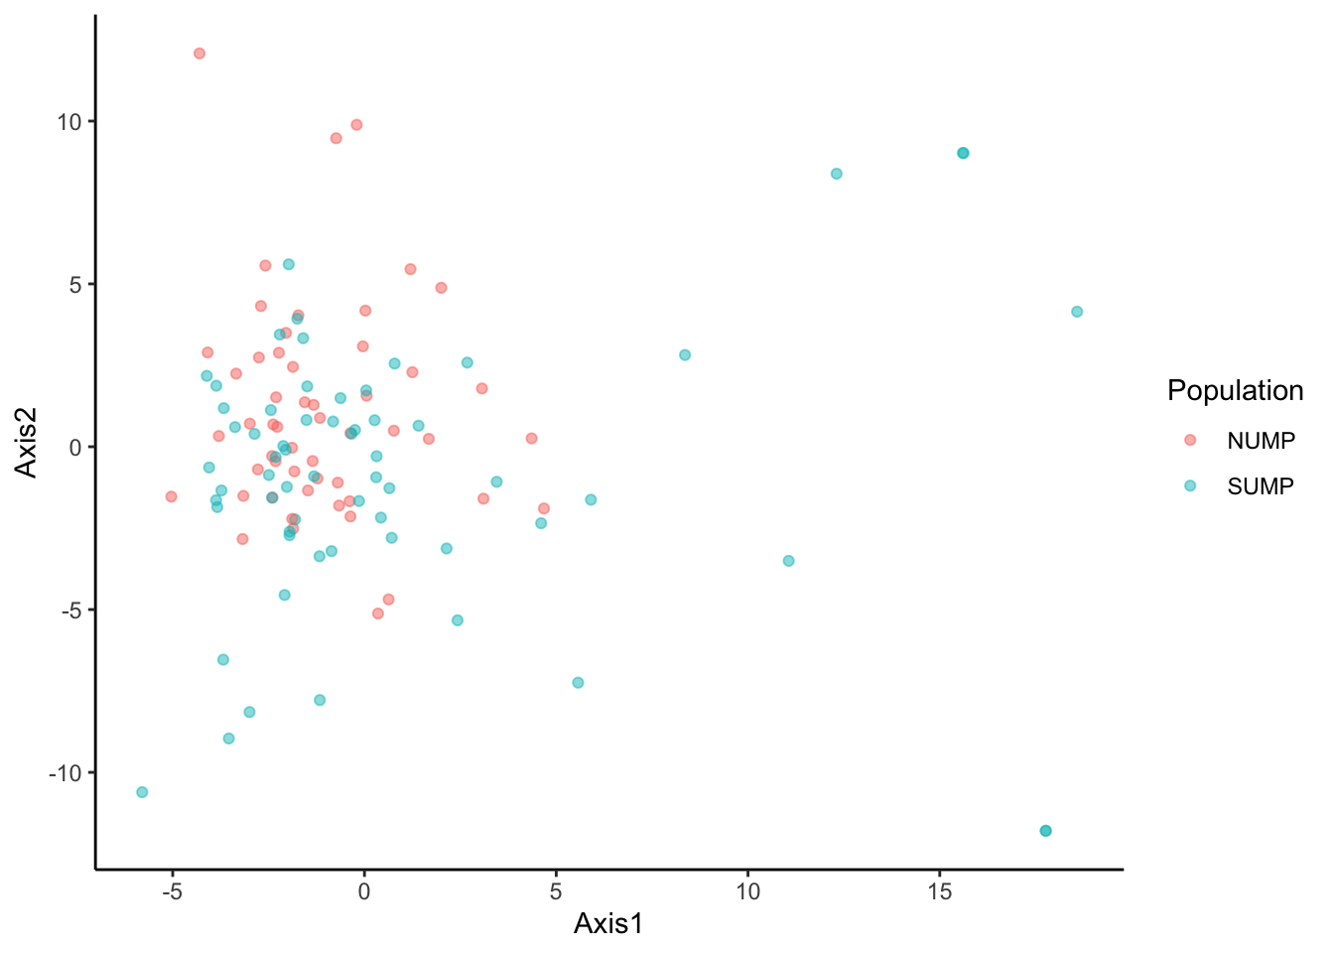

**Figure 2.** Principal components analysis (PCA) results for 53 North Umpqua (red) and 63 South Umpqua (blue) Chinook salmon samples genotyped at 324 SNPs. Four North Umpqua and three South Umpqua outliers were removed from this analysis.

We estimated differentiation using FST and as anticipated based on the PCA results it was low (FST = 0.008). Overall, our PCA and FST results suggest there are no strong genetic differences between our North Umpqua and South Umpqua Chinook salmon samples. It is important to acknowledge that our GT-seq SNP panel only provides a small snapshot of the genetic variation within and among the North and South Umpqua Chinook salmon samples and other adaptive differences may still exist.