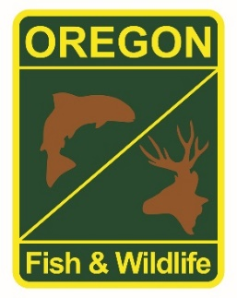

**State Fisheries Genomics Lab Tissue Sample Intake Form**

Please complete the top part of this form and send to: [kathleen.omalley@oregonstate.edu](mailto:kathleen.omalley@oregonstate.edu)

Make arrangements with us prior to dropping off the tissue samples and include a copy of this form with your samples.

**Project dropping off samples:**

Oregon Adult Salmonid Inventory and Sampling (OASIS)

Corvallis Research Office

**Person dropping off samples:** Ryan Emig  
 Sara Hart

**Phone:** (541)760-7746 **Email:** Ryan.Emig@oregonstate.edu

(503)708-1525 Sara. Hart@oregonstate.edu

**Description of samples (e.g. species, collection locations, collection dates, collection methods, number of samples, life stage; may attach spreadsheet):**

Fall Chinook, Coast Range, Collected October through December 2020 during Spawning Ground Surveys (adults), 296 total samples.

**If applicable, known origin (e.g. natural or hatchery):**

Both hatchery and natural origin fish.

**Sample type (e.g. fin tissue, scale, muscle, etc):**

Fin Tissue

**Storage method (e.g. dry, 95% ethanol, RNA later, etc):**

95% ethanol