Common Snook
Centropomus undecimalis

- Snook are protandric hermaphrodites, meaning that they begin life as males and eventually mature into females. This life style is one of the reasons why the Common Snook, Centropomus undecimalis, is a species of special concern in Florida State laws.

- Snook are capable opportunistic, or “ambush,” predators that wait for prey to come to them before devouring them with a powerful suction created by the long jaw. They also have the ability to tolerate massive salinity ranges, a euryhaline species.

- Snook are a coveted in-shore Florida gamefish due to their unique fighting prowess and their wonderful flavor.

- There are actually four species of Snook in Florida: common snook, fat snook, swordspine snook, and tarpon snook.

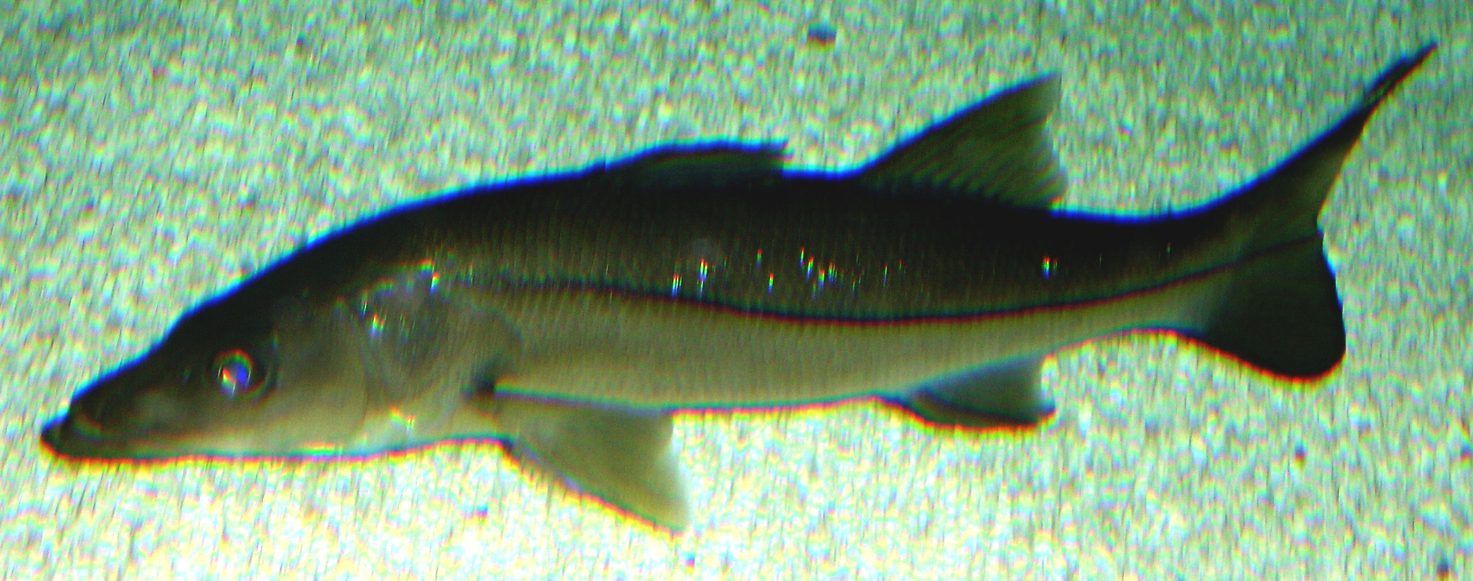

Horse-eye Jack
Caranx latus

- In the Jack family, the Carangidae. They can be differentiated from the Jack Crevalle by their large, darkly pigmented eye and the more rounded shape of the head.

- Horse-eye Jack are a pelagic species and common reef dweller found across most of the Atlantic Ocean.

- As juveniles, they are found along sandy beaches and even brackish waters.

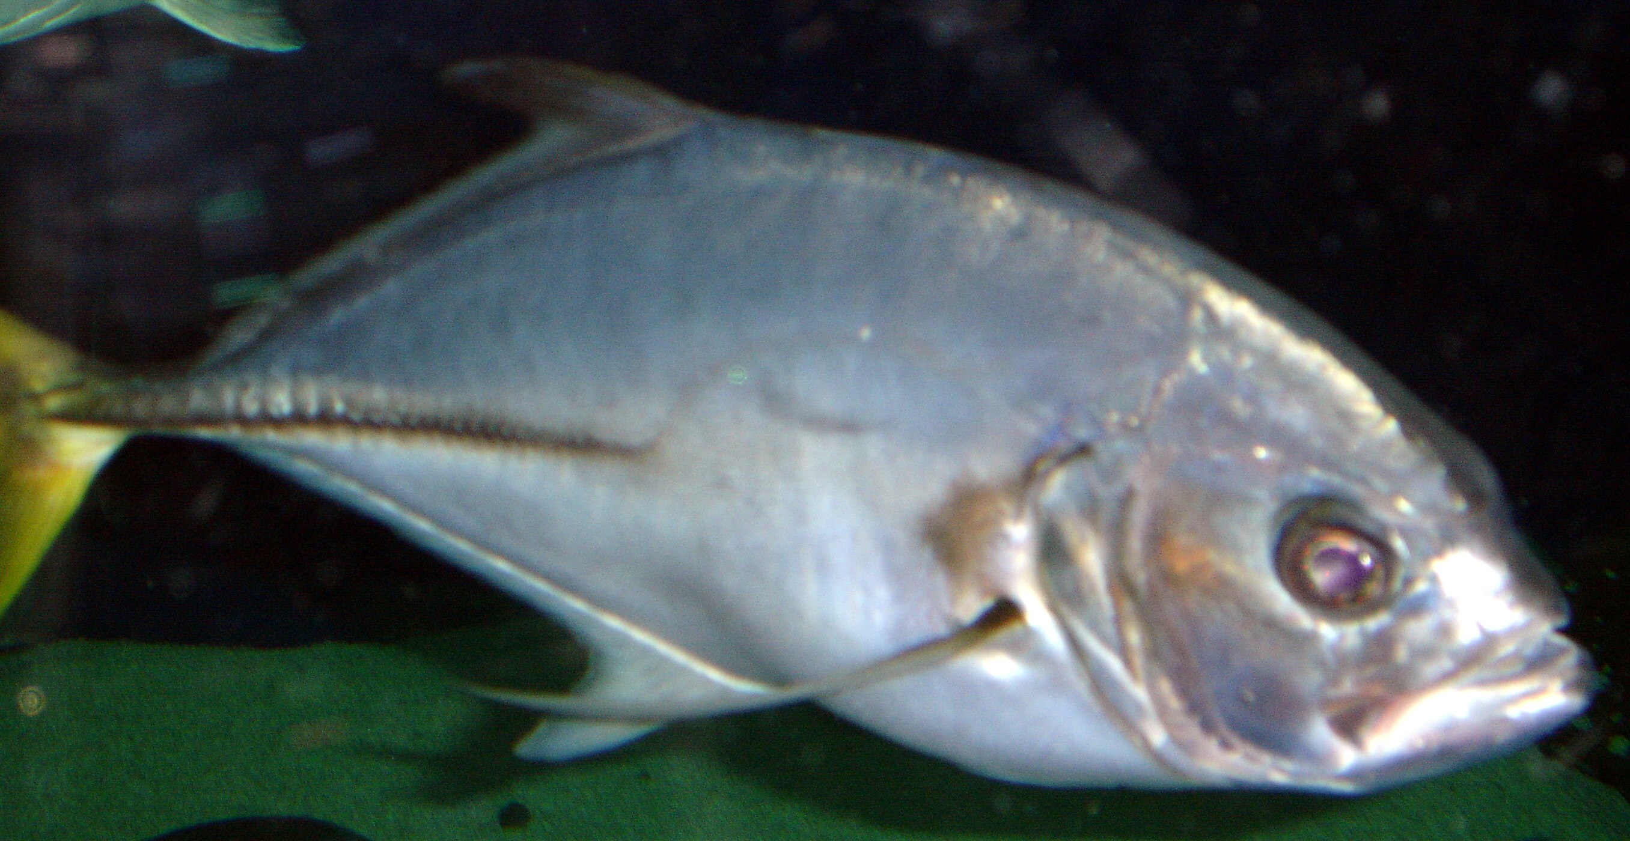

Southern Puffer
Sphoeroides nephelus

- As a member of the puffer family, Tetraodontidae, the Southern Puffer can quickly inflate its stomach, erecting small spines as a defense mechanism. The Southern Puffer can inflate itself to a nearly spherical shape.

- The Southern Puffer has a common range limited to the southern Gulf of Mexico, although it has been found in the Bahamas and throughout the Caribbean.

- Unlike many fish species, they are solitary and usually found surrounding hard structure.

- The puffers strong fused teeth are a family wide characteristic and are used for crushing strong mollusk and crustacean shells.

- Adult males can display vibrant orange colorations.

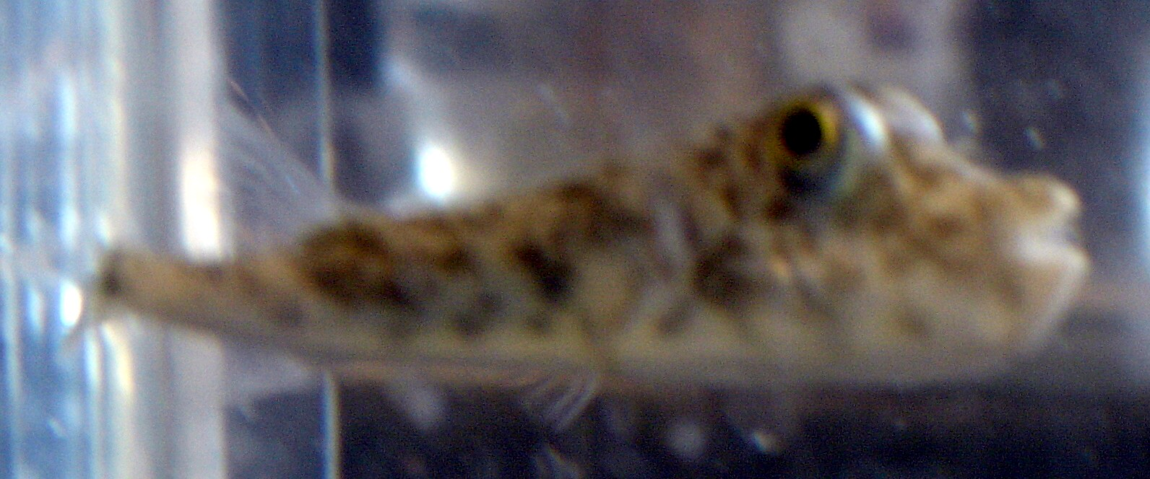

Pinfish
Lagodon rhomboides

- Pinfish are a keystone species. They are extremely abundant throughout their geographical range and have extremely important positions in multiple food webs.

- They are members of many different marine communities: grass beds, salt marshes and mangrove estuaries, near shore, and offshore reefs. Also, they have an extremely large geographic range as they are found throughout the North Atlantic.

- Pinfish only grow to 4 or 5 inches. The fish in this tank represent an extreme condition.
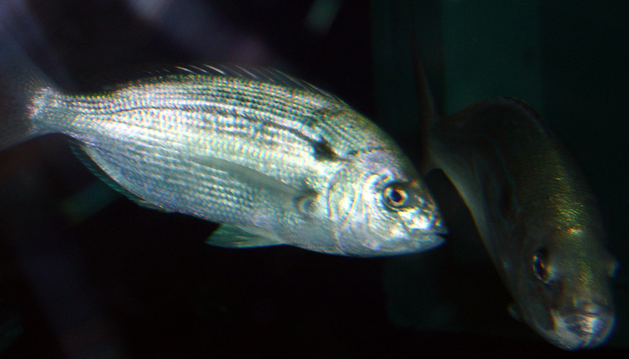

Jack Crevalle
Caranx hippos

- Jack Crevalle are well-kown for their voracious feeding behavior. Jack Crevalle commonly feed in large schools so aggressively that the water appears to boil from hundreds of feet away.

- Jacks in general are extremely fast and powerful swimmers. This is due to their robust musculature and fin arrangement. The lunate, or crescent-moon-like, tail is found in rapid swimming fishes such as the Jacks and Tunas. This strength makes the Jack Crevalle a commonly targeted game fish.

- The Jack Crevalle’s range extends through the Gulf of Mexico and the subtopical and tropical Western Atlantic.

