STAT202 Assignment 4: Variable selection

David Ewing

Due on 1 pm 21st August

# Introduction

This document contains the analysis for Assignment 3. It explores the aquatic_toxicity dataset using multiple linear regression to understand the relationships between various predictors and the response variable LC50.

# Step 0: setup

loading libraries:

# repository and seed  
options(repos = c(CRAN = "https://cloud.r-project.org"))  
set.seed(82171165)  
  
# libraries  
suppressPackageStartupMessages({  
 library(conflicted)  
 library(tidyverse)  
 library(performance)  
 library(GGally)  
 library(flextable)  
 library(broom)  
 library(skimr)  
 library(data.table)  
 library(lmtest)  
 library(leaps)  
 library(caret)  
 library(caTools)  
 library(Metrics)  
 library(car)  
   
library(patchwork)  
})  
  
# conflicts  
conflict_prefer("filter", "dplyr")

## [conflicted] Will prefer dplyr::filter over any other package.

conflict_prefer("select", "dplyr")

## [conflicted] Will prefer dplyr::select over any other package.

# Step 1: Load dataset

local <- "../data/kungsan_full_local.csv"  
url <- "http://stats.apiolaza.net/data/kungsan_full.csv"  
  
  
if (file.exists(local)) { #check   
 kungsan <- read.csv(local) #read  
} else {  
 kungsan <- read.csv(url) #fetch  
 write.csv(kungsan, file = local, row.names = FALSE) #write  
}  
  
skim_kungsan <- skim(kungsan) |>  
 select(skim_variable, n_missing)  
  
skim_kungsan

## # A tibble: 4 × 2  
## skim_variable n_missing  
## <chr> <int>  
## 1 sex 0  
## 2 height 0  
## 3 weight 0  
## 4 age 0

head(kungsan)

## height weight age sex  
## 1 151.765 47.82561 63 male  
## 2 139.700 36.48581 63 female  
## 3 136.525 31.86484 65 female  
## 4 156.845 53.04191 41 male  
## 5 145.415 41.27687 51 female  
## 6 163.830 62.99259 35 male

# Step 2: Examine the Dataset

set.seed(82171165) # reproducibility  
  
kungsan <- kungsan |>  
 mutate(weight2 = weight^2) |> # mutate weight2  
 mutate(sex = factor(sex)) |> # mutate sex factor  
 filter(age >= 12) # Filter 12 years or older  
  
 my_kungsan <- kungsan |> sample_n(100) #sample

Purpose of the transformations:

* Filtering (age >= 12): Excludes individuals younger than 12, focusing on an adult or older age group for more meaningful relationships between height, weight, and other variables.
* Transformation (weight2): The square of weight was created to allow for testing of potential quadratic relationships between weight and the response variable (height) in later modelling steps.
* Random Sampling (sample_n(100)): A random subset of 100 observations (my_kungsan) was selected to simplify visualisation and analysis while ensuring representativeness.

summary(kungsan)

## height weight age sex weight2   
## Min. :118.0 Min. :18.26 Min. :12.00 female:221 Min. : 333.3   
## 1st Qu.:146.1 1st Qu.:37.93 1st Qu.:23.00 male :192 1st Qu.:1438.8   
## Median :152.4 Median :43.40 Median :35.00 Median :1883.8   
## Mean :152.0 Mean :42.59 Mean :37.18 Mean :1889.1   
## 3rd Qu.:159.4 3rd Qu.:48.48 3rd Qu.:49.00 3rd Qu.:2350.1   
## Max. :179.1 Max. :62.99 Max. :88.00 Max. :3968.1

summary(my_kungsan)

## height weight age sex weight2   
## Min. :118.0 Min. :19.62 Min. :12.00 female:58 Min. : 384.9   
## 1st Qu.:147.3 1st Qu.:37.92 1st Qu.:23.75 male :42 1st Qu.:1438.3   
## Median :153.0 Median :43.98 Median :33.50 Median :1934.6   
## Mean :152.7 Mean :42.81 Mean :37.25 Mean :1894.1   
## 3rd Qu.:160.0 3rd Qu.:48.12 3rd Qu.:49.12 3rd Qu.:2315.2   
## Max. :171.1 Max. :58.46 Max. :75.90 Max. :3417.2

# Step 3: Scatterplot Matrix

# function = add regression line and confidence interval  
add_rlci <- function(data, mapping, ...) {  
 ggplot(data = data, mapping = mapping) +  
 geom_point(alpha = 0.5) + # Scatterplot points  
 geom_smooth(method = "lm", se = TRUE, colour = "blue", ...) + # rl ci  
 theme_minimal()  
}  
  
add_contour <- function(data, mapping, ...) {  
 ggplot(data = data, mapping = mapping) +  
 geom_density2d(aes(colour = ..level..), ...) +  
 theme_minimal()  
}  
upper = list(continuous = add_contour)  
  
  
# Scatterplot   
kung_splot1 <- ggpairs(  
 my_kungsan,  
 columns = c("weight", "weight2", "sex", "height"),  
 lower = list(continuous = add_rlci), #lwoer triangle  
 diag = list(continuous = wrap("barDiag", bins = 20)),   
# upper = list(continuous = add_contour),  
 upper = list(continuous = "cor"),   
 aes(colour = sex, alpha = 0.7)  
) +   
 labs(title = "Scatterplot Matrix with RL and CI")

kung_splot1

## `geom_smooth()` using formula = 'y ~ x'  
## `stat_bin()` using `bins = 30`. Pick better value with `binwidth`.  
## `stat_bin()` using `bins = 30`. Pick better value with `binwidth`.  
## `geom_smooth()` using formula = 'y ~ x'  
## `geom_smooth()` using formula = 'y ~ x'  
## `stat_bin()` using `bins = 30`. Pick better value with `binwidth`.

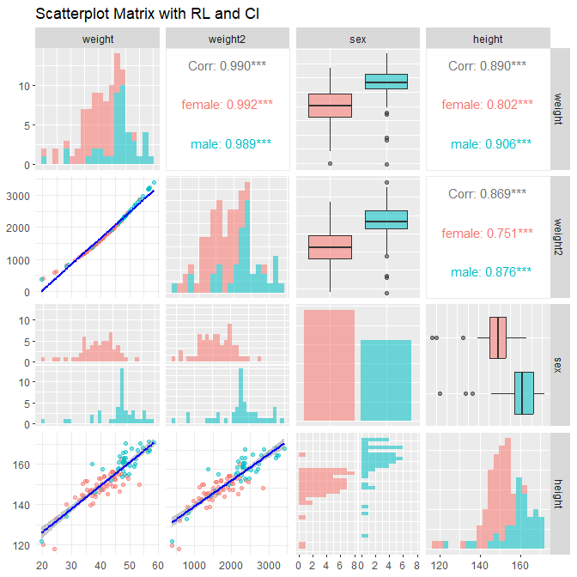

: Purpose: The scatterplot matrix was created to explore the relationships between variables (height, weight, weight2, and sex) before modelling:

* Lower Triangle: Scatterplots with regression lines and confidence intervals (add_rlci) allowed visualisation of potential linear or non-linear relationships.
* Diagonal: Histograms showed the distributions of variables, confirming normality or identifying skewness.
* Upper Triangle: Left blank (“blank”) to focus was on the lower triangle.

As this visual does not provide any satisfying conclusion to the model, additional investigation is required, which I have performed below.

# Load necessary libraries  
  
  
# args  
  
myk1 <- as.formula("height ~ weight")  
myk2 <- as.formula("height ~ weight + I(weight^2)")  
myk3 <- as.formula("height ~ weight + sex")  
myk4 <- as.formula("height ~ weight + I(weight^2) + sex")  
args <- list(myk1,myk2,myk3,myk4)  
n_args <- length(args)  
  
models <- vector("list", n_args) # Pre-define as a list  
for (i in seq_along(args)){  
 models[[i]] <- lm(args[[i]], data = my_kungsan)  
}  
  
# VIF for models with more than 1 predictor  
calc_vif <- function(model) {  
 if (length(coef(model)) > 2) { # More than one predictor (Bo + B1 + 1)  
 return(round(max(vif(model)),6)) # max VIF  
 } else {  
 return("--NA--") # NA for 1 predictor  
 }  
}  
  
#RMSE simplification  
  
calc_rmse <- function(args,numbr) {  
 train(args, data = my_kungsan, method = "lm",  
 trControl = trainControl(method = "cv", number = numbr))$results$RMSE  
}  
# metrics  
  
adj_r2 <- numeric(n_args) # Adjusted R^2  
bp_p <- numeric(n_args) # Breusch-Pagan p-values  
shapiro_p <- numeric(n_args) # Shapiro-Wilk p-values  
cooks_max <- numeric(n_args) # Maximum Cook's Distance  
vif_vals <- numeric(n_args) #   
rmse <- numeric(n_args) #  
  
set.seed(82171165)  
for (i in seq_along(args)) {  
 adj_r2[i] <- summary(models[[i]])$adj.r.squared #Adjusted R^2   
 bp_p[i] <- bptest(models[[i]])$p.value #Homoscedasticity  
 shapiro_p <- shapiro.test(models[[i]]$residuals)$p.value #Res Normality  
 cooks_max[i] <- max(cooks.distance(models[[i]])) #Cook's Distance  
 vif_vals[i] <- calc_vif(models[[i]]) #VIF  
 rmse[i] <- calc_rmse(args[[i]],10) #Posterior Predictive Performance  
}  
  
  
# Cross-Validation for RMSE (Posterior Predictive Performance)  
  
# Create a summary table  
comparison_table <- data.frame(  
 Model = c("Model 1\n(Weight)", "Model 2\n(+Weight^2)",  
 "Model 3\n(Weight\n+Sex)", "Model 4\n(Weight\n+Weight^2\n+Sex)"),  
 Adj_R2 = adj_r2,  
 BP_p = bp_p,  
 Shapiro_p = shapiro_p,  
 Max_Cooks_D = cooks_max,  
 Max_VIF = vif_vals,  
 RMSE = rmse  
)  
  
comparison_table_transposed <- as.data.frame(t(comparison_table))  
colnames(comparison_table_transposed) <- comparison_table$Model # Use Model names as column headers  
comparison_table_transposed <- comparison_table_transposed[-1, ] # Remove the row with model names  
comparison_table_transposed <- cbind(Metric = rownames(comparison_table_transposed), comparison_table_transposed) # Add row labels  
rownames(comparison_table_transposed) <- NULL # Clear rownames for better formatting  
  
# Generate a flextable for the transposed metrics  
comparison_table_flex <- flextable(comparison_table_transposed) %>%  
 colformat_double(digits = 3) %>%  
 bg(part = "header", bg = "#D3D3D3") %>% # Grey background for the top header row  
 bg(i = NULL, j = 1, bg = "#D3D3D3", part = "body") %>% # Grey background for the left column  
 theme_box() %>%  
 align(j = 1, align = "left", part = "all") %>% # Left-align the left column  
 autofit()  
  
# Display the table  
comparison_table_flex

| **Metric** | **Model 1 (Weight)** | **Model 2 (+Weight^2)** | **Model 3 (Weight +Sex)** | **Model 4 (Weight +Weight^2 +Sex)** |
| --- | --- | --- | --- | --- |
| Adj_R2 | 0.7892028 | 0.7950624 | 0.8047912 | 0.8266101 |
| BP_p | 0.6365383 | 0.8362766 | 0.1286418 | 0.7063236 |
| Shapiro_p | 0.8381626 | 0.8381626 | 0.8381626 | 0.8381626 |
| Max_Cooks_D | 0.3045838 | 0.2969302 | 0.2741246 | 0.2189285 |
| Max_VIF | --NA-- | 52.120366 | 1.268628 | 61.434462 |
| RMSE | 4.472237 | 4.673119 | 4.533823 | 4.378760 |

Model 4 is the best overall choice as it balances high Adjusted R-square, prediction accuracy (RMSE), and residual diagnostics, but it does have a high VIF which can suggest multicollinearity, and may require further investigation.

# Step4 : Check Collinearity

# Load necessary library for collinearity check  
  
# Fit the models  
m1 <- lm(height ~ weight, data = my_kungsan)  
m2 <- lm(height ~ weight + I(weight^2), data = my_kungsan)  
m3 <- lm(height ~ weight + I(weight^2) + sex, data = my_kungsan)  
  
# Check variance inflation for m2 and m3  
vif_m2 <- check_collinearity(m2)  
vif_m3 <- check_collinearity(m3)

print(vif_m2)

## # Check for Multicollinearity  
##   
## High Correlation  
##   
## Term VIF VIF 95% CI Increased SE Tolerance Tolerance 95% CI  
## weight 52.12 [36.15, 75.34] 7.22 0.02 [0.01, 0.03]  
## I(weight^2) 52.12 [36.15, 75.34] 7.22 0.02 [0.01, 0.03]

print(vif_m3)

## # Check for Multicollinearity  
##   
## Low Correlation  
##   
## Term VIF VIF 95% CI Increased SE Tolerance Tolerance 95% CI  
## sex 1.50 [ 1.24, 2.04] 1.22 0.67 [0.49, 0.81]  
##   
## High Correlation  
##   
## Term VIF VIF 95% CI Increased SE Tolerance Tolerance 95% CI  
## weight 58.17 [40.48, 83.78] 7.63 0.02 [0.01, 0.02]  
## I(weight^2) 61.43 [42.74, 88.49] 7.84 0.02 [0.01, 0.02]

Multicollinearity exists between weight and I(weight^2), as indicated by the high VIF values. The variable sex does not contribute to collinearity. Adjustments to the model are required to address this issue.

# Step5: Examine Residual Plots and Normality of Residuals

# Residual Plots: Residuals vs Fitted Values and Q-Q Plots  
  
mmodels <- list(m1,m3)  
par(mfrow = c(2, 2)) # Set up a 2x2 grid for plots  
  
for (i in seq_along(mmodels)) {  
 model <- mmodels[[i]] # Extract the i-th model  
   
 # Residuals vs Fitted Plot  
 plot(model$fitted.values, model$residuals,  
 main = paste("Residuals vs Fitted: Model", i),  
 xlab = "Fitted Values", ylab = "Residuals",  
 pch = 19, col = "blue")  
 abline(h = 0, col = "red") # Add a horizontal line at 0  
   
 qqnorm(model$residuals, main = paste("Q-Q Plot: Model", i))  
 qqline(model$residuals, col = "red") # Add reference line  
}

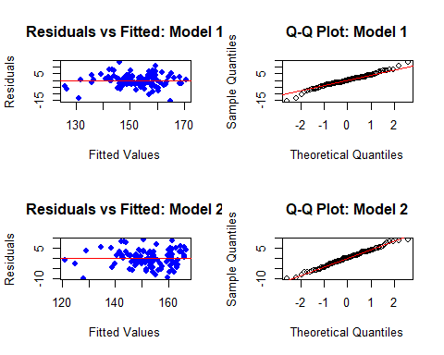

par(mfrow = c(1, 1)) # Reset plot layout to single plot

Purpose:

* Residuals vs Fitted Plot: Checks for homoscedasticity (equal variance of residuals) and non-linear patterns.
* Q-Q Plot: Assesses whether residuals follow a normal distribution, critical for reliable statistical inference.

Insights:

* Residuals centred around zero, but some heteroscedasticity was observed in the residuals vs fitted plots, suggesting potential issues with variance stability.
* Q-Q plots indicated that residuals were approximately normally distributed, meeting this key assumption.

# Step 6: Centring weight and creating weight_c2

# Centre the weight variable  
my_kungsan <- my_kungsan %>%  
 mutate(weight_c = weight - mean(weight)) %>% # Centre weight  
 mutate(weight_c2 = weight_c^2) # centred weight squared  
  
  
# Scatterplot   
kung_splot2 <- ggpairs(  
 my_kungsan,  
 columns = c("weight_c", "weight_c2", "sex", "height"),  
 lower = list(continuous = add_rlci), #lwoer triangle  
 diag = list(continuous = wrap("barDiag", bins = 20)),   
# upper = list(continuous = add_contour),  
 upper = list(continuous = "cor"),   
 aes(colour = sex, alpha = 0.7)  
) +   
 labs(title = "Scatterplot2 Matrix with RL and CI")  
  
  
kung_splot2

## `geom_smooth()` using formula = 'y ~ x'  
## `stat_bin()` using `bins = 30`. Pick better value with `binwidth`.  
## `stat_bin()` using `bins = 30`. Pick better value with `binwidth`.  
## `geom_smooth()` using formula = 'y ~ x'  
## `geom_smooth()` using formula = 'y ~ x'  
## `stat_bin()` using `bins = 30`. Pick better value with `binwidth`.

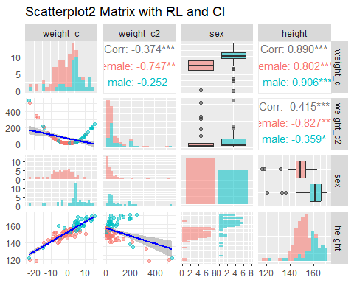

# Access specific panels in a `ggpairs` plot using indexing  
plot_weight_height_3 <- kung_splot1[4, 1] # Step 3: weight vs height  
plot_weight2_height_3 <- kung_splot1[4, 2] # Step 3: weight2 vs height  
# plot_sex_height_3 <- kung_splot1[4, 3] # Step 3: sex vs height  
  
plot_weight_height_6 <- kung_splot2[4, 1] # Step 6: weight_c vs height  
plot_weight2_height_6 <- kung_splot2[4, 2] # Step 6: weight_c2 vs height  
# plot_sex_height_6 <- kung_splot2[4, 3] # Step 6: sex vs height  
  
  
comparison_plot <- (kung_splot1[4, 1] + kung_splot2[4, 1]) / # Row 1  
 (kung_splot1[4, 2] + kung_splot2[4, 2]) # / # Row 2  
 # (kung_splot[4, 3] + kung_splot2[4, 3]) # Row 3

comparison_plot

## `geom_smooth()` using formula = 'y ~ x'  
## `geom_smooth()` using formula = 'y ~ x'  
## `geom_smooth()` using formula = 'y ~ x'  
## `geom_smooth()` using formula = 'y ~ x'

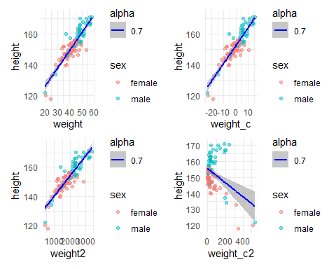

Centring variables (weight_c and weight_c2) improve symmetry, reduce extreme ranges, enhance visuals, and address multicollinearity. The opposite slopes for height vs weight2 and height vs weight_c2 are because centring changes the reference point of the quadratic term to the mean. This reduces the dependency between the linear (weight_c) and quadratic (weight_c2) terms, providing better scaling and stability in the regression models. Centring appears to be necessary when exploring the introduction of a quadratic term.