**The 960 grid has been used which split the page in 12 columns (the same on all pages)**

**Rules of third has been used (the same on all pages)**

**Font Colour is always Black unless stated otherwise.**

**Font style is always Sans unless stated otherwise.**

**Window frame -**

Width: 963

Height: 835

(The same for all pages)

1. **Home Screen**

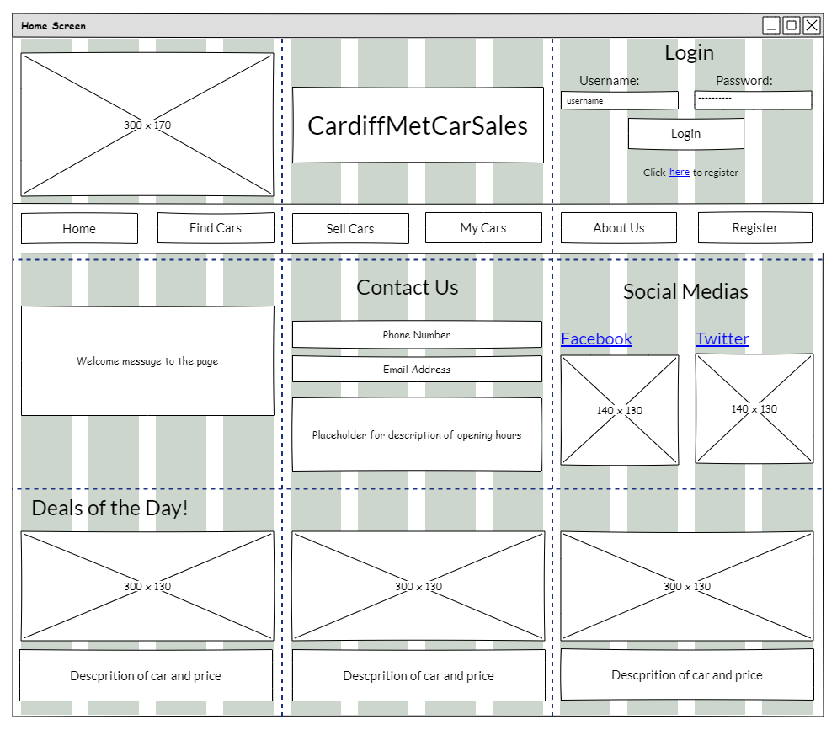

**Placeholder image of logo -**

Width: 300

Height: 170

(the same on every single page)

Placeholder description of the car and its price –

Font size: 15

Placeholder for car picture –

Width: 300

Height: 130

**Deals of the Day Section -**

Deals of the Day! label:

Font size: 25

**Contact Us Section -**

Contact Us Label –

Font size: 25

Phone number label:

Font size: 15

Email Address label:

Font size: 15

Opening hours label:

Font size: 15

**Navigation Bar -**

Width: 963

Height: 60

Buttons in the bar –

Width: 140

Height: 35

Font size: 15

Content: Home, Find Cars, Sell Cars, My Cars, About Us and Register

(the same on all pages)

**Login Section –**

Login Label:

Font size: 25

Username and Password Label -

Font size: 15

Username and password box –

Font size: 10

Width: 140

Height: 20

Login button –

Font size: 15

Width: 140

Height: 35

Click here to register label –

Font size: 12

The here word is a link to the register screen.

**Header –**

Font Size: 30

Width: 300

Height: 90

Content: CardiffMetCarSales

**Welcome message to the page -**

Width: 300

Height: 130

Font size: 15

**Social Medias Section -**

Social media label –

Font size: 25

Links:

Font Size: 20

Font colour: Blue

Content: Facebook and Twitter

Image placeholder of Facebook and twitter logo:

Width: 140

Height: 130

**The 960 grid has been used which split the page in 12 columns (the same on all pages)**

**Rules of third has been used (the same on all pages)**

1. **Register Screen**

**Header –**

Font Size: 30

Width: 620

Height: 90

Content: CardiffMetCarSales

(The same on every page except the home screen)

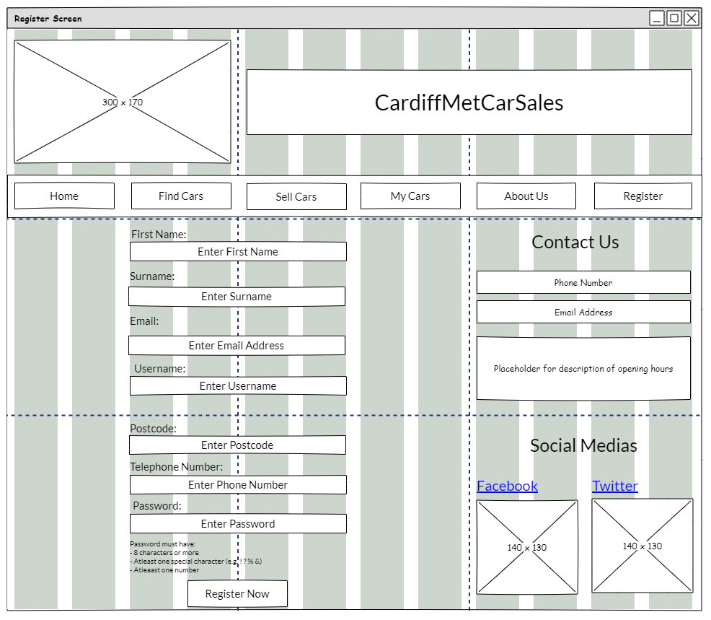

**Register Section (outlined in red just to be easily visible, the red line is not in the actual design) –**

First Name, Surname, Email, Username, Postcode, Telephone Number and Password labels –

Font size: 15

First Name, Surname, Email, Username, Postcode, Telephone Number and Password boxes –

Font size: 15

Width: 300

Height: 25

Password must have label –

Font size: 10

Register Now button –

Font size: 15

Width: 140

Height: 35

**Contact Us Section -**

Contact Us Label –

Font size: 25

Phone number label:

Font size: 15

Email Address label:

Font size: 15

Opening hours label:

Font size: 15

**Social Medias Section -**

Social media label –

Font size: 25

Links:

Font Size: 20

Font colour: Blue

Content: Facebook and Twitter

Image placeholder of Facebook and twitter logo:

Width: 140

Height: 130

**The 960 grid has been used which split the page in 12 columns (the same on all pages)**

**Rules of third has been used (the same on all pages)**

1. **Find Cars Screen**

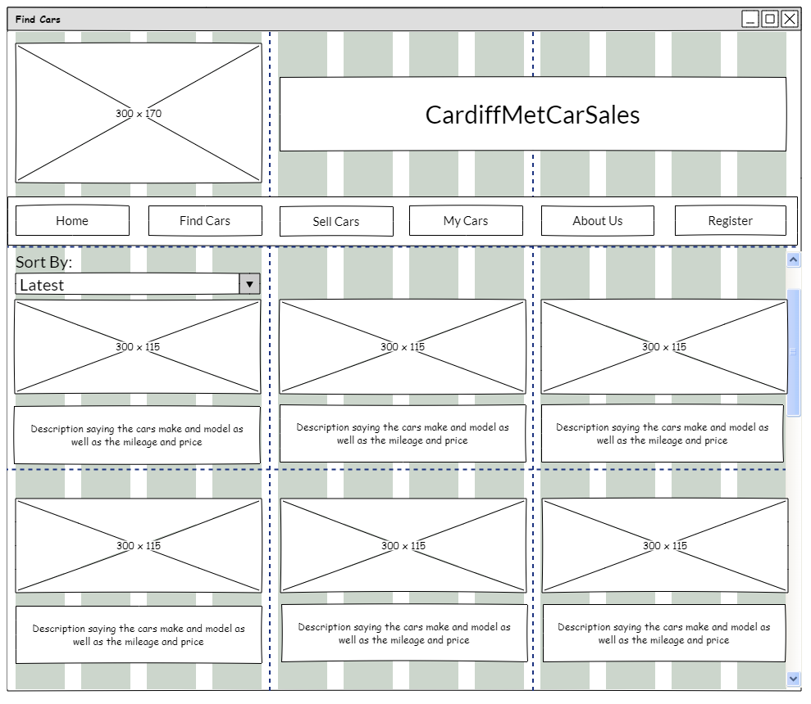

**Sort By Section -**

Sort by label -

Font Size: 20

Drop down box –

Font size: 20

Width: 300

Height: 25

Content: Latest, Oldest, Price (Low to High) and Price (High to Low)

**Scroll Bar-**

Width: 20

Height: 535

Scroll bar only works when there are more than 6 cars listed in which then the user can scroll down to see them all.

**Car Displaying -**

Placeholder for the image of the car –

Width: 300

Height: 115

**Description of the car -**

Font size – 15

Content: Cars make, model, price, mileage

**The 960 grid has been used which split the page in 12 columns (the same on all pages)**

**Rules of third has been used (the same on all pages)**

1. **Sell Cars Screen**

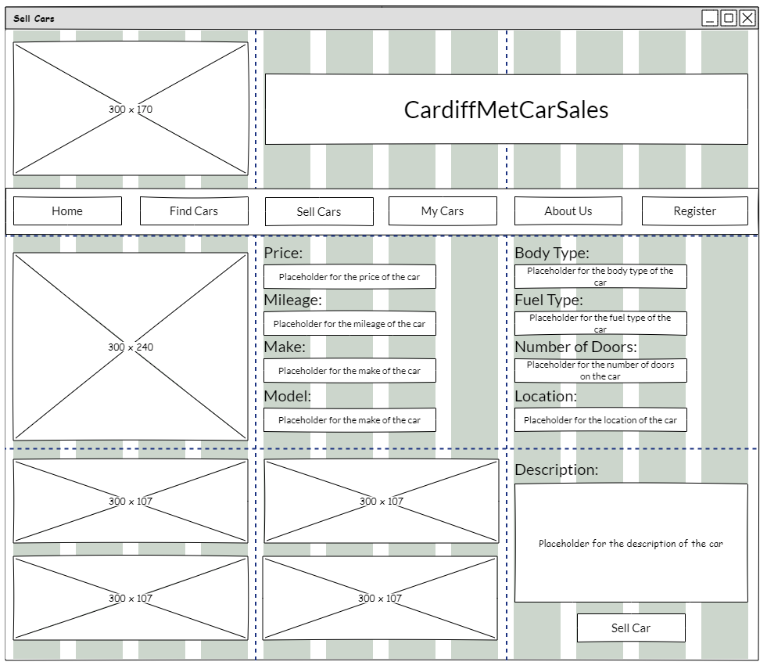

**Insert Car Details Section (outlined in red just to be easily visible, the red line is not in the actual design) –**

Price, Mileage, Make, Model, Body Type, Fuel Type, Number of Doors and Location labels –

Font size: 20

Price, Mileage, Make, Model, Body Type, Fuel Type, Number of Doors and Location boxes –

Font size: 15

Width: 220

Height: 30

All field must be filled in other wise an error message appears.

**Displaying of the car -**

Placeholder of the main image of the car you wish to sell –

Width: 300

Height: 240

The picture box is blank until the user clicks on the blank spot and inserts the image.

**Displaying of the car -**

Placeholder of the multimedia images of the car you wish to sell (where the other images of the car goes) –

Width: 300

Height: 107

The picture box is blank until the user clicks on the blank spot and inserts the image.

**Description of Car –**

Description Label –

Font size: 20

Placeholder for the description of the car –

Font Size - 15

The description must be filled in other wise an error message appears.

Vehicle will only be allowed to be sold if all the fields have a valid input in it.

**Sell Car Button –**

Description Label –

Font size: 20

Width: 140

Height: 35

1. **My Cars Screen**

**Rules of third has been used (the same on all pages)**

**The 960 grid has been used which split the page in 12 columns (the same on all pages)**

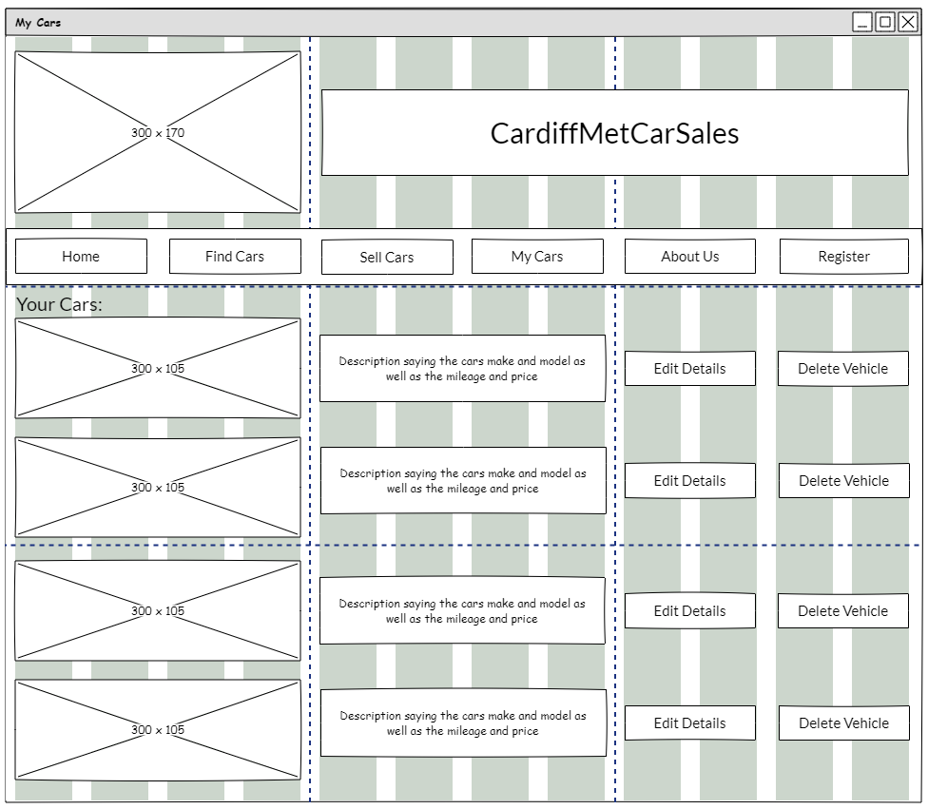

**Edit Details Button –**

Font size: 15

Width: 135

Height: 35

When pressed takes you to a page to edit that vehicle.

**Your Cars label–**

Font size: 20

**Your Cars Images placeholder –**

Width: 300

Height: 105

**Delete Vehicle Button –**

Font size: 15

Width: 135

Height: 35

When pressed it asks if you sure you want to delete the vehicle and if yes is pressed then the car is deleted from the page.

**Your Cars Description placeholder –**

Font Size: 15

Content: Cars Make, model, mileage, and price

1. **About Us Screen**

**Rules of third has been used (the same on all pages)**

**The 960 grid has been used which split the page in 12 columns (the same on all pages)**

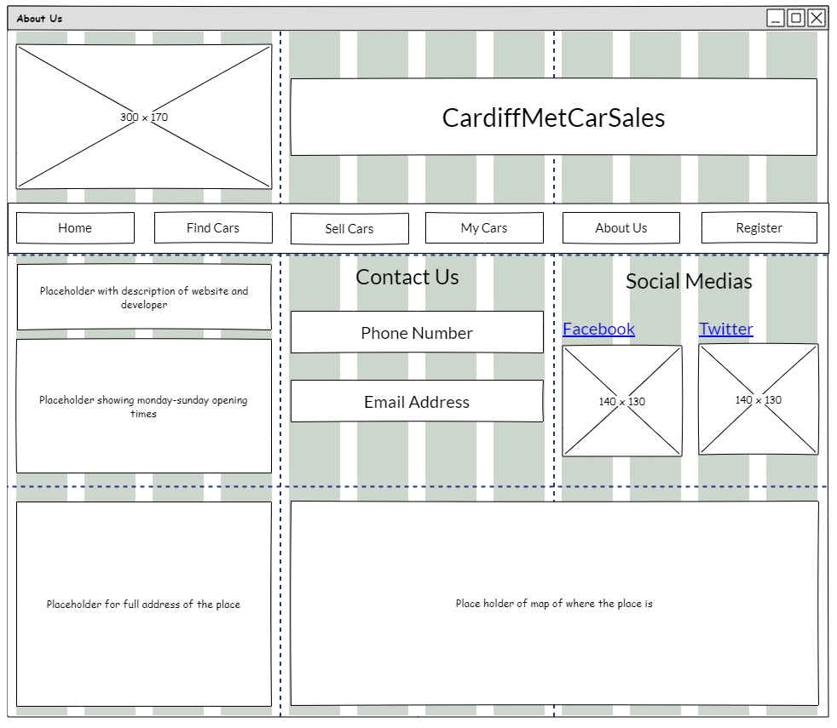

**Contact Us Section -**

Contact Us Label –

Font size: 25

Phone number label:

Font size: 15

Email Address label:

Font size: 15

**Placeholder for Description –**

Font Size: 15

Content: A description about the website as well as the developer.

**Social Medias Section -**

Social media label –

Font size: 25

Links:

Font Size: 20

Font colour: Blue

Content: Facebook and Twitter

Image placeholder of Facebook and twitter logo:

Width: 140

Height: 130

**Placeholder for Opening times of CardiffMetCarSales –**

Font Size: 15

Content: Monday – Sunday times of opening

**Placeholder for the address of CardiffMetCarSales –**

Font Size: 15

Content: Address of the place

**Placeholder for the map showing where the place is –**

Width: 620

Height: 240

1. **Vehicle Summary Screen**

**Rules of third has been used (the same on all pages)**

**The 960 grid has been used which split the page in 12 columns (the same on all pages)**

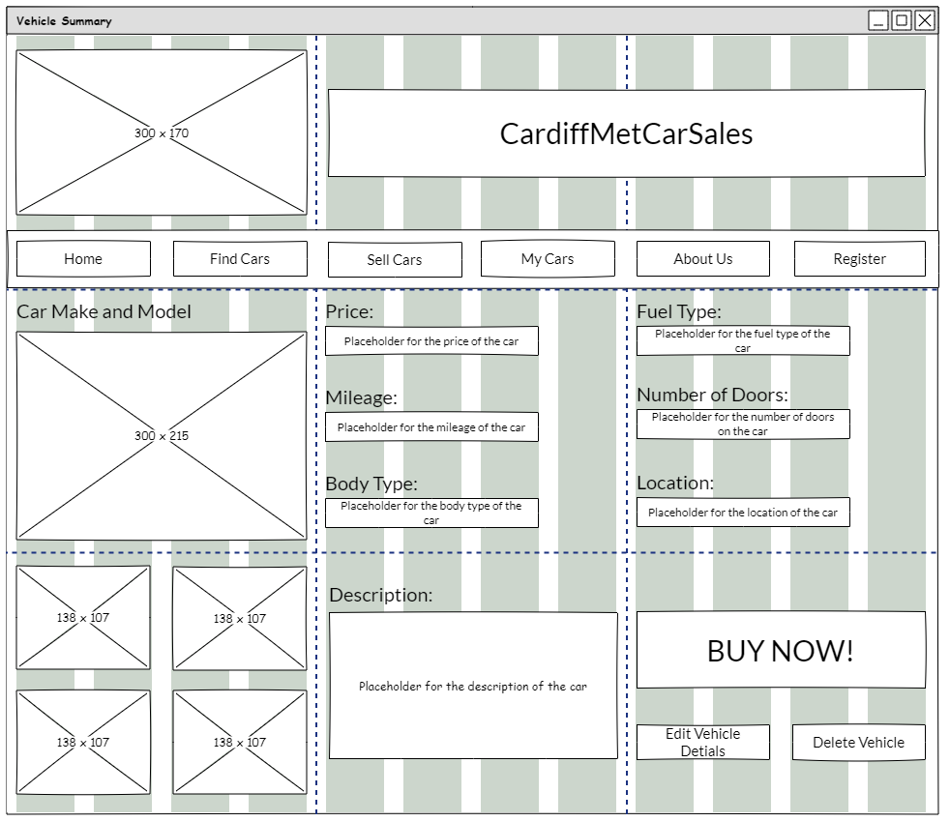

**View Car Details Section (outlined in red just to be easily visible, the red line is not in the actual design) –**

Price, Mileage, Body Type, Fuel Type, Number of Doors and Location labels –

Font size: 20

Price, Mileage, Body Type, Fuel Type, Number of Doors and Location boxes –

Font size: 15

Width: 220

Height: 30

**Car Make and Model label–**

Font size: 20

**Displaying of the car -**

Placeholder of the main image of the car –

Width: 300

Height: 215

**BUY NOW! Button –**

Font size: 30

**Displaying of the car -**

Placeholder of the multimedia images of the car –

Width: 138

Height: 107

**Edit Vehicle Details and Delete Vehicles Button –**

Font size: 15

Width: 135

Height: 35

The buttons are only visible if the user on this page owns and uploaded this car.

**Description of Car –**

Description Label –

Font size: 20

Placeholder for the description of the car –

Font Size - 15

1. **Edit Car Screen**

**The 960 grid has been used which split the page in 12 columns (the same on all pages)**

**Rules of third has been used (the same on all pages)**

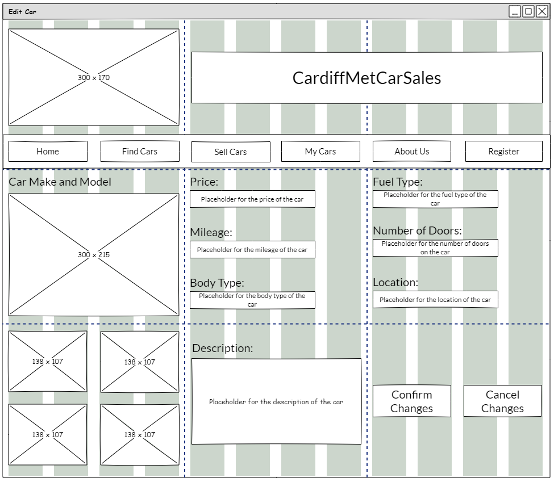

**Edit Car Details Section (outlined in red just to be easily visible, the red line is not in the actual design) –**

Price, Mileage, Body Type, Fuel Type, Number of Doors and Location labels –

Font size: 20

Price, Mileage, Body Type, Fuel Type, Number of Doors and Location boxes –

Font size: 15

Width: 220

Height: 30

The details can be Changed but they cannot be empty and must be valid inputs.

**Car Make and Model label–**

Font size: 20

Can be edited but cannot be empty.

**Description of Car –**

Description Label –

Font size: 20

Placeholder for the description of the car –

Font Size - 15

**Displaying of the car -**

Placeholder of the main image of the car –

Width: 300

Height: 215

Can be Changed but cannot be empty.

**Confirm Changes and Cancel Changes–**

Font size: 20

Width: 135

Height: 55

Confirm Changes –

If all the fields contain a valid input, then details are changed and saved.

Cancel Changes –

Cancels anything changed and goes back to how it was.

**Displaying of the car -**

Placeholder of the multimedia images of the car –

Width: 138

Height: 107

Can be Changed but cannot be empty.

Can be edited but cannot be empty.