Name: Mohau Menyatsoe

Student Number: ST10335992

Module Code: CLDV 6212

Assessment: POE

GitHub link: <https://github.com/VCPTA/bca2-cldv6212-poe-submission-An0nXm0us.git>

**Question A**

**Creating and uploading database**

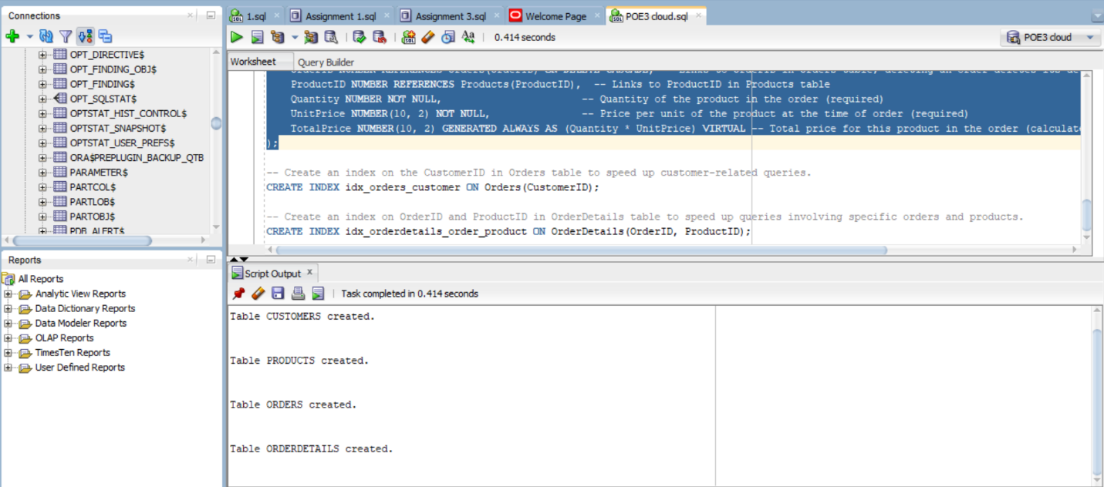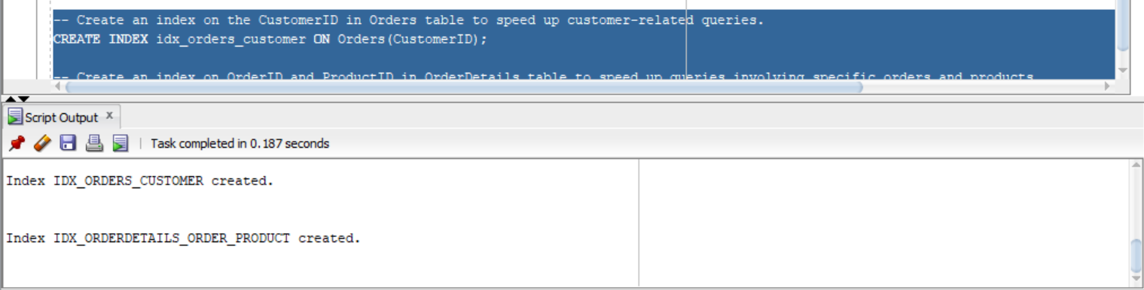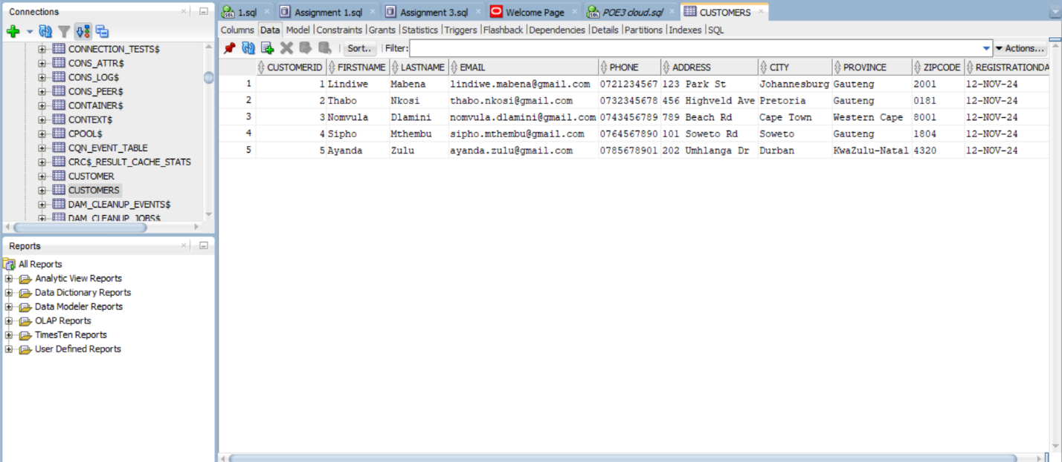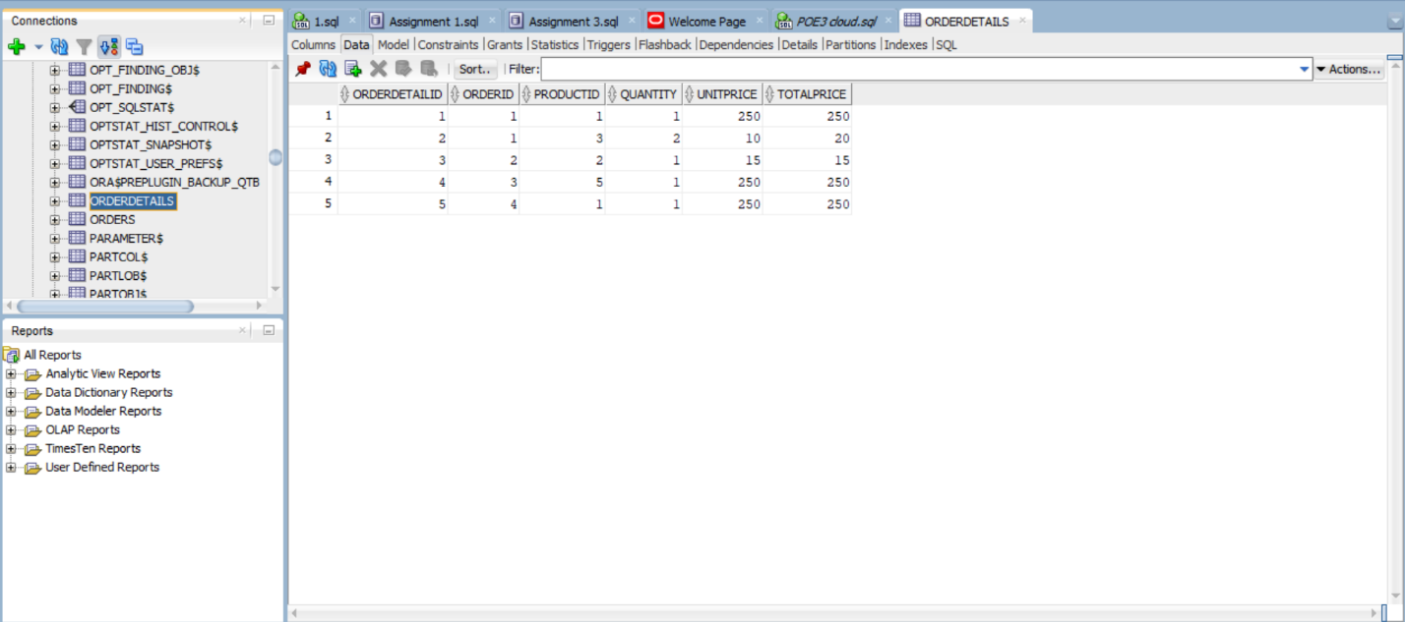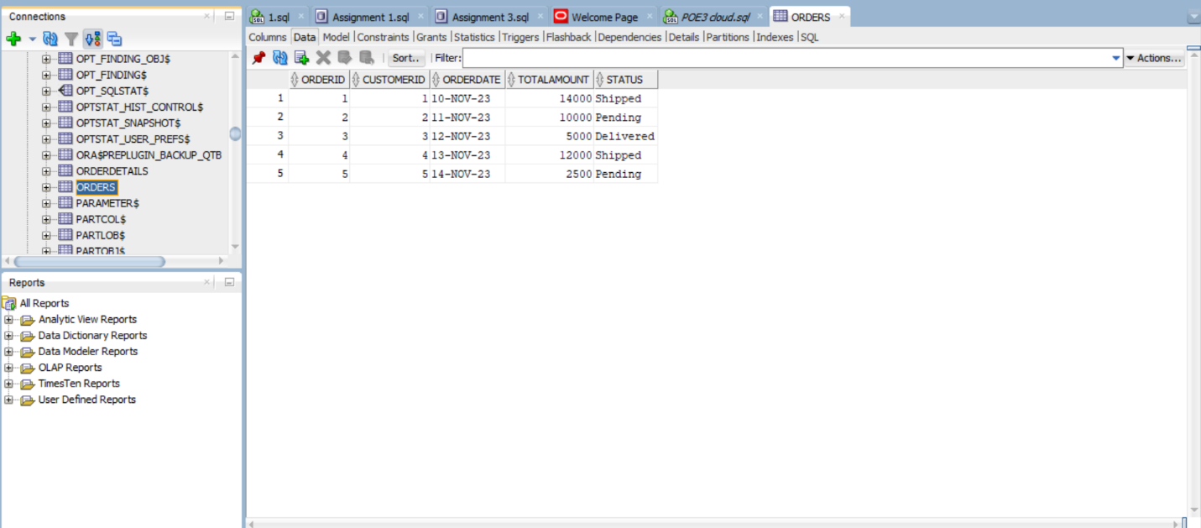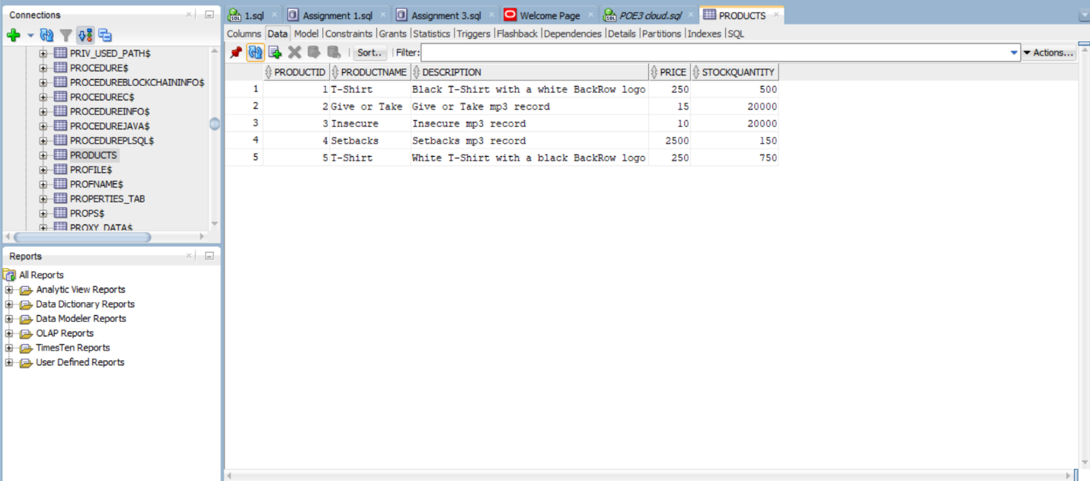

Created the db locally using ORACLE SQL ( The Independent Institute of Education , 2024).

When trying to create it on Azure ran into subscription errors:

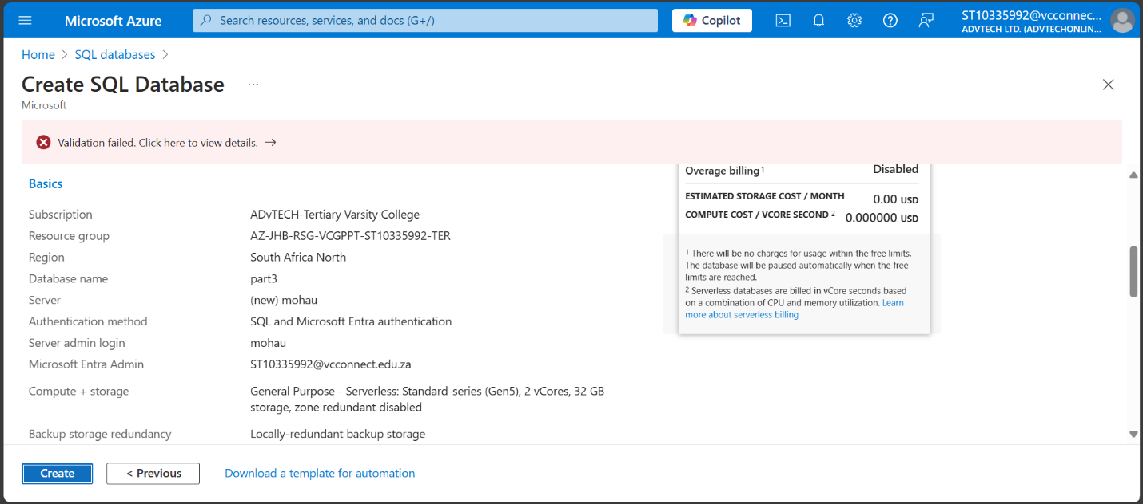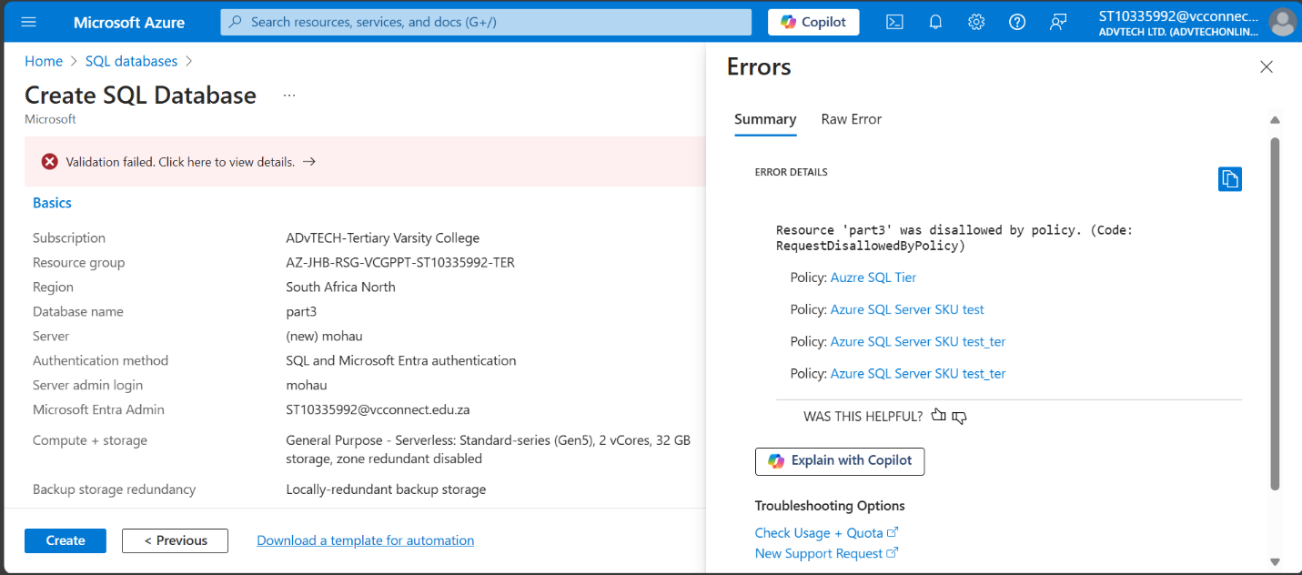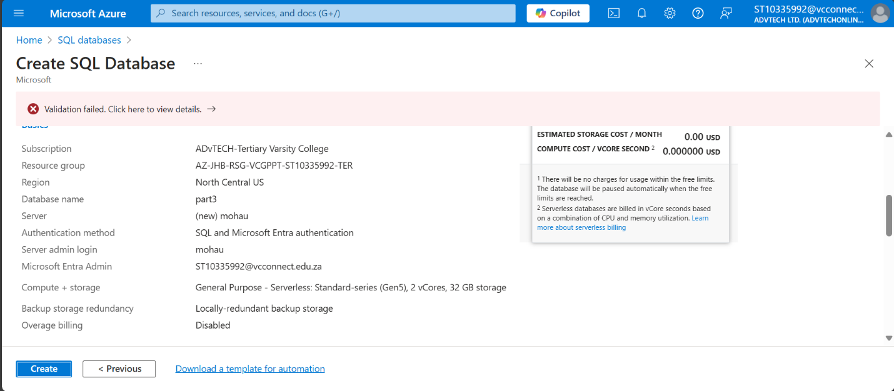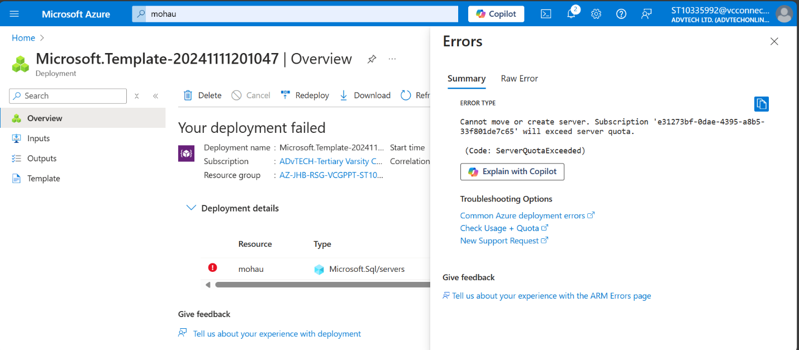

Screenshots for evidence.

Managed to create an SQL server:

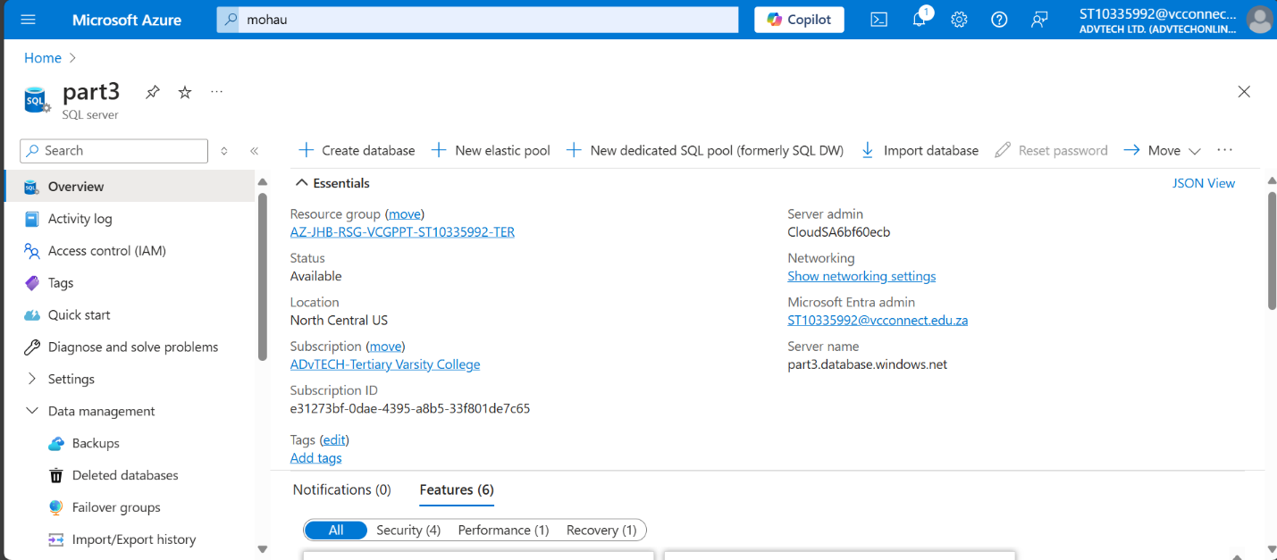

But ran into more errors due to subscription quotas when trying to import my database

For the replica, I uploaded the database to a blob storage

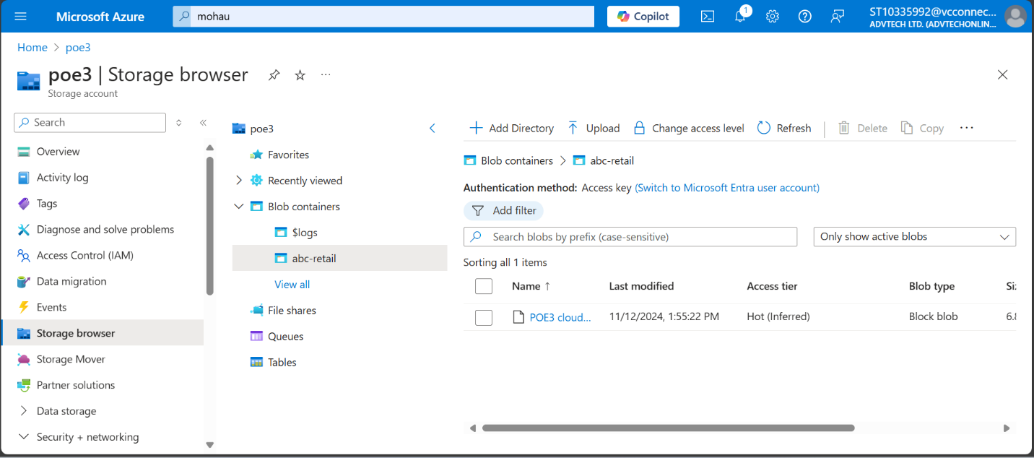

**Importance of having a replica database**

1. **Improved availability and data recovery** (Marget, 2021)

A replica database can be used as a backup which remains on stand-by in case the main database fails. During disasters such as hardware failure or natural events, switching to the replica reduces the amount data loss and downtime. For critical applications, replicas also allow for data access even during maintenance on the main database.

1. **Improved performance** (Marget, 2021)

Replicas can handle read operations, easing the load on the main database. This can be very useful for read-heavy applications such as report creation (Mitchell, 2023). By handling reads on replicas, the main database can focus on other duties i.e., writing essentially improving the system performance.

1. **Data Redundancy and Fault Tolerance** (Mitchell, 2023)

With replicas, the presence of a backup allows for improved reliability and maintaining data integrity in case one database fails. This redundancy allows for continuous data access even if the main database encounters issues.

1. **Support for Geographically Distributed Applications (Mitchell, 2023)**

The distribution of replicas across different locations worldwide, allows for faster data access for users in various regions. This reduces network delays and lightens the load on the main database.

1. **Real-Time Analytics and Reporting (Marget, 2021)**

For applications that utilize real-time analytics, a replica database can handle these tasks separately, preventing slowdowns in the main transactional database. This way, heavy read queries won’t have much impact the main database’s performance.

**B. Technology Choices Documentation**

|  |  |  |  |  |
| --- | --- | --- | --- | --- |
| **Component** | **Technology Choice** | **Service Type** | **Hosting Model** | **Description** |
| Azure SQL Database | Data Storage | Database | PaaS | Stores customer, product, and order data as well as providing relational database features like improved scalability, and high availability with integrated backup solutions. |
| Azure App Service | Compute | Web Hosting | PaaS | Hosting our web application, allowing for scalability and easy maintenance for consistent user access. |
| Azure Blob Storage | Data Storage | Storage | PaaS | Storing large files like images, audio and documents, accessible by users when needed within the web application (Microsoft, 2022). |
| Azure Service Bus | Messaging | Queue | PaaS | Ensures parts of our web app can send messages concurrently without waiting or with minimal waiting time, allowing background tasks and reduced delays (Microsoft, 2022). |
| Azure Event Hubs | Streaming | Event Streaming | PaaS | Responsible tracking real-time user actions and our web-application analytics, such the amount of people using our website, how often they use it and how the interact with the different services we provide (Microsoft, 2024). |

**C. Motivation for Azure Services Used**

|  |  |  |
| --- | --- | --- |
| **Application Requirement** | **Azure Service Used** | **Motivation for Service Choice** |
| Storing customer, order and product information | Azure SQL database | Azure SQL Database was chosen because it's good for storing relational data, like customer, order and product records. It works well with other Azure tools, allows for complex searches, and ensures data is always available with automatic backups and easy scaling. |
| File Storage and Access | Azure Blob Storage | Its ability to store large files allows for efficient, scalable storage for user-uploaded files, accessible through our web app and suited to growing storage needs. In our project we were able to store product images, documentation e.g. contracts as well audio. |
| Web Application Hosting | Azure App Service | Allows for easy web application deployment and scaling of the app, ensuring high availability and a consistent experience for all users including customers and admin. As such we used it to deploy our ABC retail web app. |
| Real-Time Data Processing | Azure Event Hubs | Its ability to support fast data processing of real-time events like user actions or sensor data, enhancing interactive app features allowed us to integrate it to our project in order to track online activity from our customers. These analytics will be used later to improve the system. |
| Reliable App Component Communication | Azure Service Bus | Its ability to provide reliable message delivery pathway between different parts of the app and its importance for handling complex workflows without data loss is why it was implemented in our system. This allows different pages to communicate without losing updated data. E.g., after adding things to cart, switching between pages such as registering or logging in, won’t affect your cart items. |
| Background Task Execution | Azure Functions | Allows efficient, on-demand processing of background tasks like notifications or message queueing without a constant server load. An example includes providing updates on product shipping statuses. |

**D. Alternative Azure Technologies**

|  |  |  |  |
| --- | --- | --- | --- |
| **Application Requirement** | **Original Azure Service Used** | **Alternative Azure Service** | **Motivation for Alternative Service** |
| Storing customer, order and product information | Azure SQL database | Azure Cosmos DB | Cosmos DB offers flexibility such NoSQL database with multiple data models and global distribution which is useful for global scalability (Sensei, 2020). |
| Web Application Hosting and Deployment | Azure App Service | Azure Kubernetes Service | Provides container orchestration, allowing for a microservices-based deployment with greater control (Sahid, 2022). |
| File Storage and Access | Azure Blob Storage | Azure Data Lake Storage | It is more suitable for high-volume data analytics, offering a hierarchical namespace for large-scale data solutions (Velusamy, 2024). |
| Reliable App Component Communication | Azure Service Bus | Azure Queue Storage | Even though we already used it, what’s different about the Azure Queue Storage is its cost effective for simple messaging scenarios with a reliable message delivery and basic queuing system (spelluru, n.d.). |

**Conclusion**

Our solution at ABC Retail uses a combination of Azure services, each chosen for a specific purpose. Azure SQL Database stores relational data, while Azure App Service provides a scalable environment to host the app. Blob storage on the other hand stores user files and documents while the Event Hubs processes data in real-time. The Azure Service Bus is responsible for keeping parts of our application in sync, while Azure Functions handles background tasks and other CRUD functionalities. Other options like Cosmos DB, Azure Kubernetes Service, Data Lake Storage, and Queue Storage may be implemented if needed for more advanced data handling, growth, or different app setups, making the solution adaptable as business needs change in the future.

**References**

Marget, A. (2021). *Data Replication: Benefits & How It Works*. [online] Unitrends. Available at: <https://www.unitrends.com/blog/data-replication> [Accessed 11 Nov. 2024].

Rivery. (n.d.). *What is Database Replication: Definition, Benefits & Tools*. [online] Available at: <https://rivery.io/data-learning-center/complete-guide-to-data-replication/> [Accessed 11 Nov. 2024].

Mitchell, T. (2023). *Data Replication: Advantages & Disadvantages*. [online] The Couchbase Blog. Available at: <https://www.couchbase.com/blog/data-replication-advantages/> [Accessed 11 Nov. 2024].

Microsoft (2024). *What is Azure Event Hubs? - a Big Data ingestion service - Azure Event Hubs*. [online] learn.microsoft.com. Available at: <https://learn.microsoft.com/en-us/azure/event-hubs/event-hubs-about>

[Accessed 11 Nov. 2024].

Microsoft (2022). *Azure Service Bus messaging overview - Azure Service Bus*. *Microsoft*. Available at: <https://learn.microsoft.com/en-us/azure/service-bus-messaging/service-bus-messaging-overview> [Accessed 11 Nov. 2024].

Microsoft (2022). *Introduction to Blob (object) storage - Azure Storage*. [online] learn.microsoft.com. Available at: <https://learn.microsoft.com/en-us/azure/storage/blobs/storage-blobs-introduction> [Accessed 11 Nov. 2024].

spelluru (n.d.). *Compare Azure Storage queues and Service Bus queues - Azure Service Bus*. [online] learn.microsoft.com. Available at: <https://learn.microsoft.com/en-us/azure/service-bus-messaging/service-bus-azure-and-service-bus-queues-compared-contrasted> [Accessed 12 Nov. 2024].

Velusamy, K. (2024). *Azure Blob Storage vs Data Lake: Complete Comparative Study*. [online] Available at: <https://www.whizlabs.com/blog/azure-blob-storage-vs-data-lake/> [Accessed 12 Nov. 2024].

Sensei (2020). *Azure SQL Database vs Cosmos DB*. [online] Tutorials Dojo. Available at: <https://tutorialsdojo.com/azure-sql-database-vs-cosmos-db/> [Accessed 12 Nov. 2024].

Sahid (2022). *Azure AppService vs Kubernetes (AKS)*. [online] Cloud Training Program. [Available at: https://k21academy.com/docker-kubernetes/aks-vs-azure-app-service/](Available%20at:%20https:/k21academy.com/docker-kubernetes/aks-vs-azure-app-service/) [Accessed 12 Nov. 2024].

# The Independent Institute of Education , 2024. *ADVANCED DATABASES MODULE MANUAL.* s.l.:IIE.