CEA CURIE – 20 months (2011/2012) – about 770 000 jobs and 722 users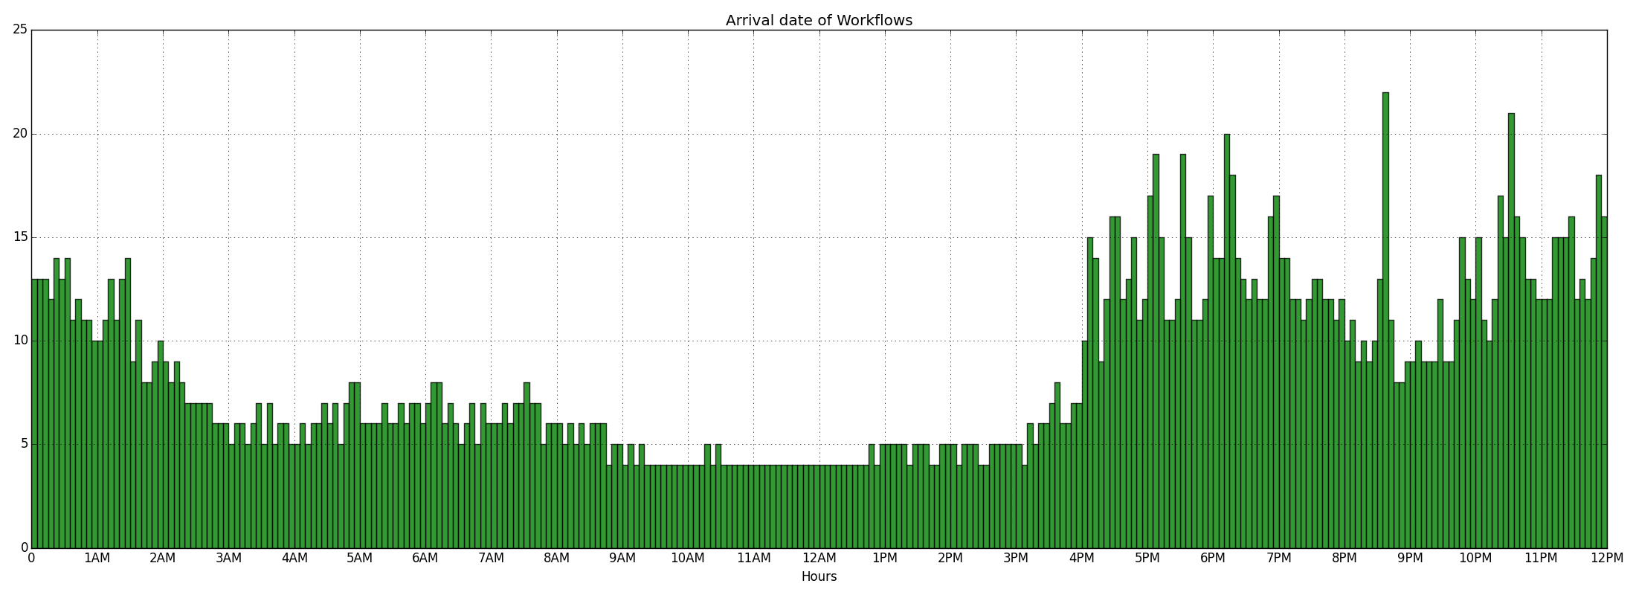
MetaCentrum2 – 28 months (2013/2015) – about 5 700 000 jobs and 880 users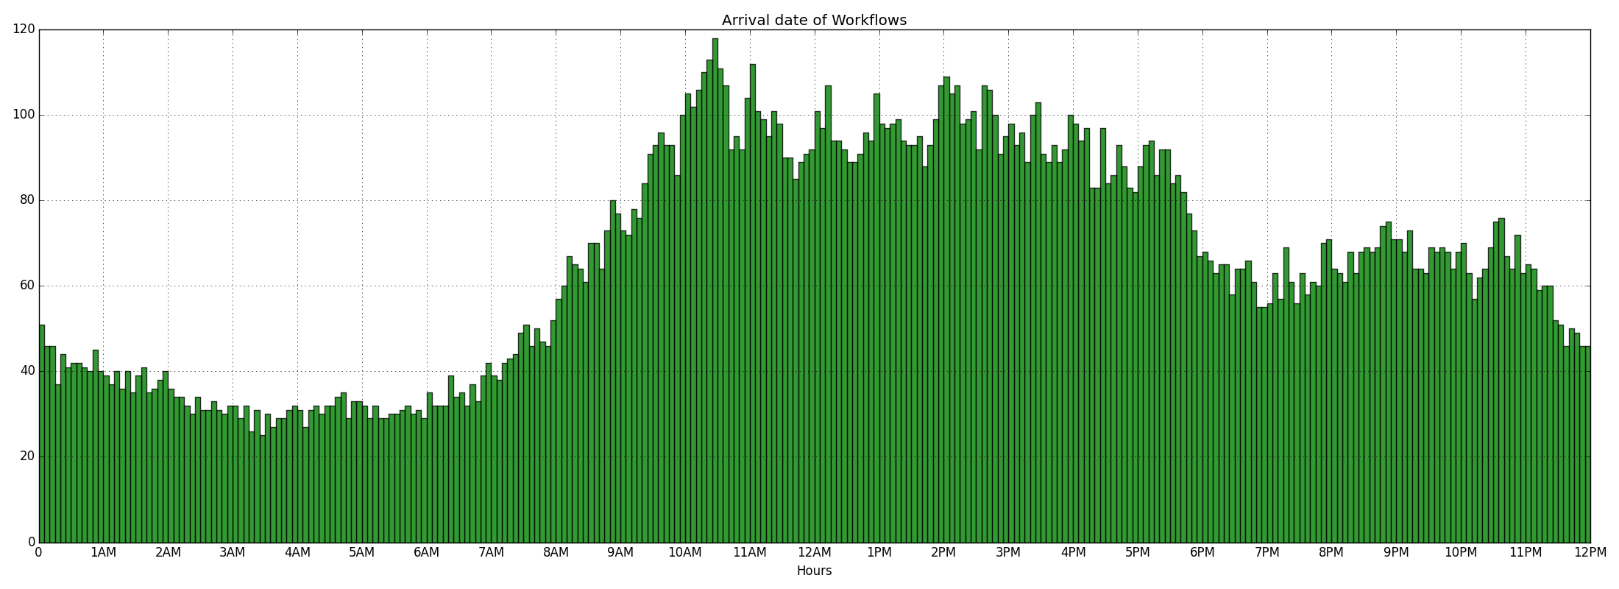
PIK IPLEX – 40 months (2009/2012) – about 740 000 jobs and 225 users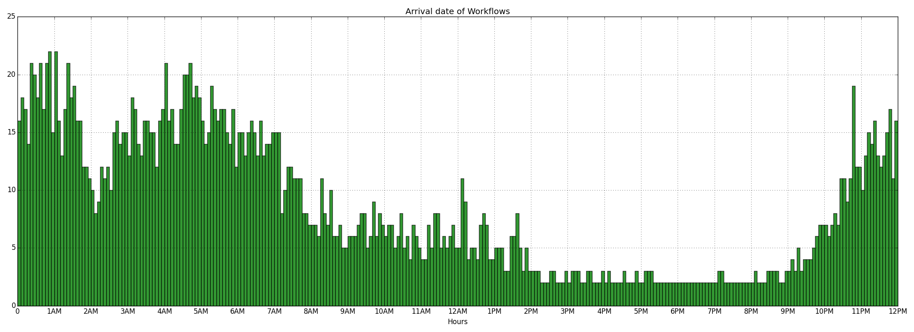
Intel NB pool A – 1 month (2012) – about 13 370 000 jobs and 1 100 users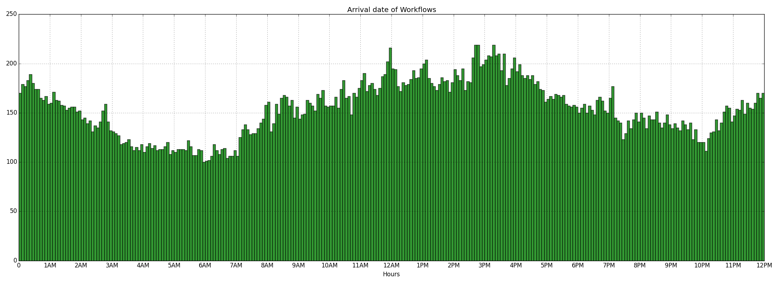
Intel NB pool B – 1 month (2012) – about 13 080 000 jobs and 1 600 users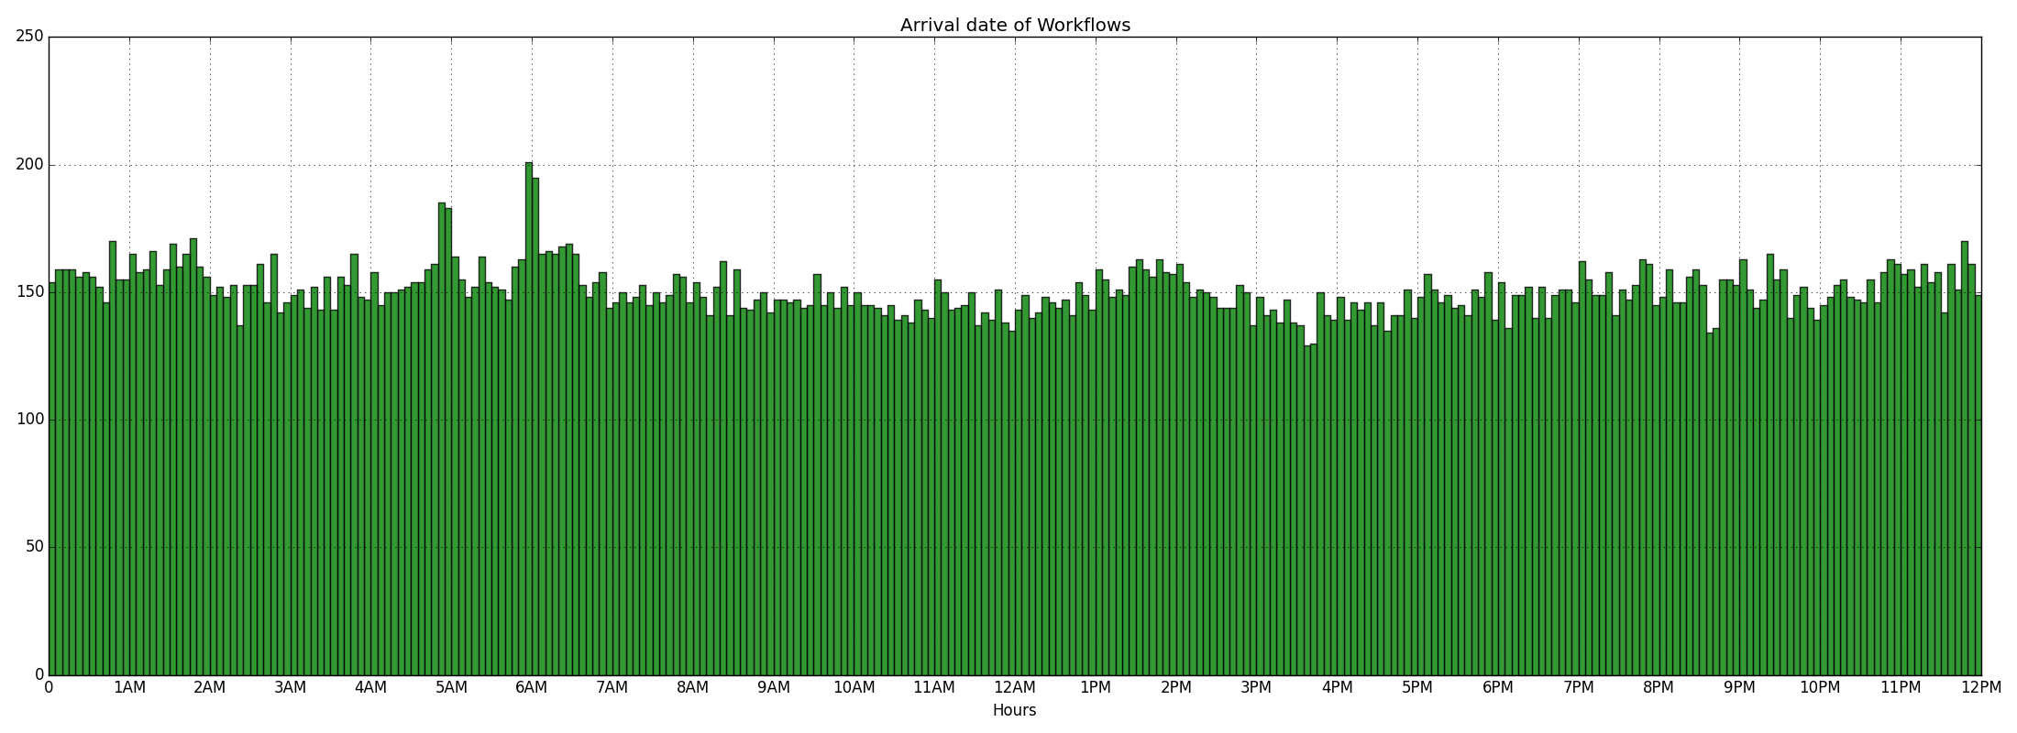
Intel NB pool C – 1 month (2012) – about 13 300 000 jobs and 1 150 users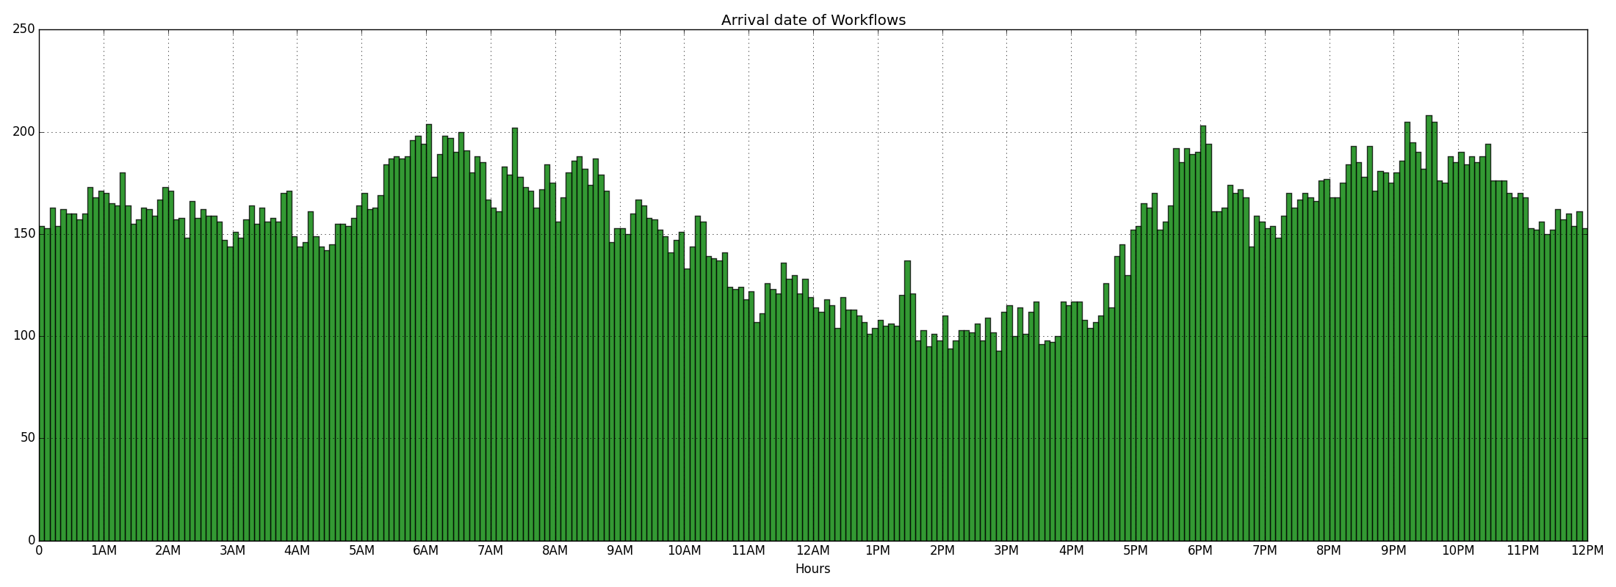
Intel NB pool D – 1 month (2012) – about 9 050 000 jobs and 860 users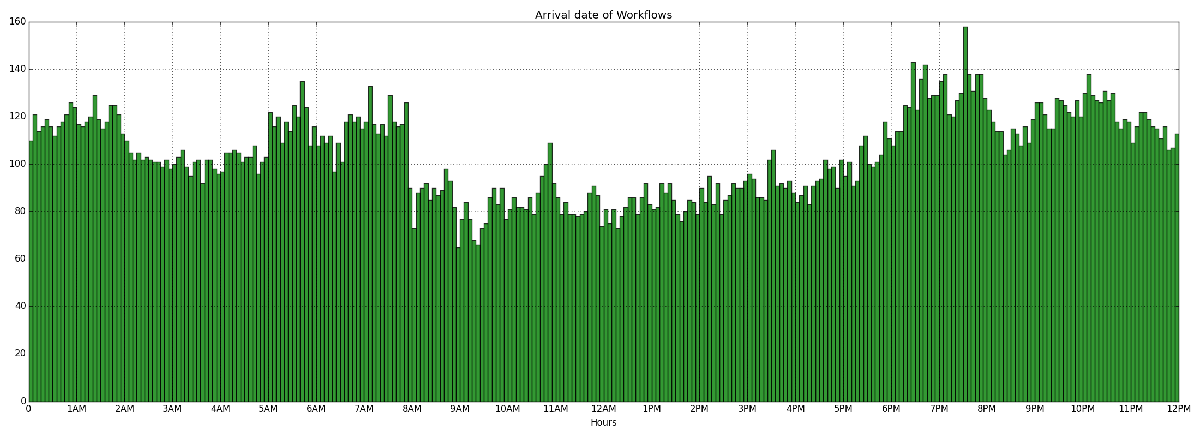
UniLu Gaia – 3 months (2014) – about 52 000 jobs and 84 users