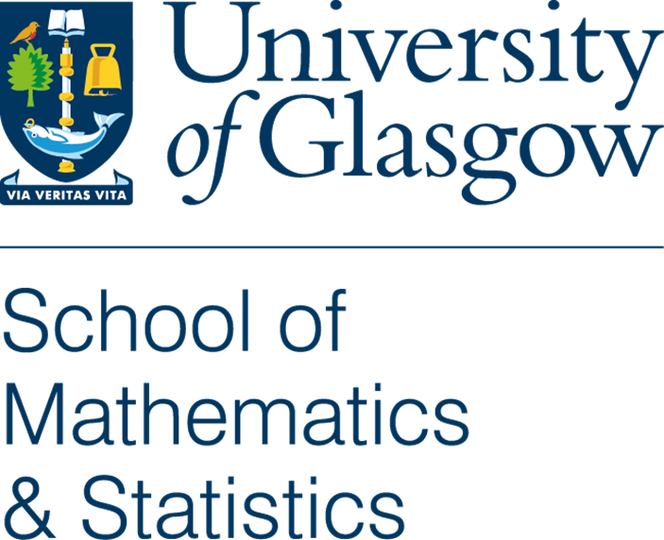
Course Name Here – Course Handbook
STATS1234 (Level M)

Course description
Delete this line – you may also re-order the sections (reasonably)

Introduction and summary
Welcome to … [insert introduction to course here]
This is the course catalogue entry for STATS1234.

Course Aims
This course aims to
- bullet
- point
- course
- aims

Intended Learning Outcomes (ILOs)
By the end of this course you will be able to:
- bullet
- point
- learning
- outcomes

Timetable information
- Total lectures: 10 hours (Weeks 1 to 10)
- Total computer labs: 20 hours (2 hours Weeks 1 to 10)

Lectures
- Mondays at 9am-10am in Building XYZ Room 123 (Room Name)

Labs sessions
- Tuesdays at 10am-Midday in Building ABC Rooms 123 & 456

Course format
This course is provided through … lectures and computer labs.
All materials (documents, videos, labs, etc.) will be made available on the course Moodle page together with communications via the Announcements Forum and the Student Q&A Forum.

Syllabus / Weekly breakdown
Detailed below is a provisional timetable for the on-campus sessions of the course (which is subject to change).
Sample table, you may just put a syllabus summary as paragraphs or bullets
Week (w/b) | Lectures (Monday 09:00-10:00) | Labs (Tuesday 10:00-12:00)
1 (12/01) | Placeholder Topic | Placeholder Topic
2 (19/01) | Placeholder Topic | Placeholder Topic
3 (26/01) | Placeholder Topic | Placeholder Topic
4 (02/02) | Placeholder Topic | Placeholder Topic
5 (09/02) | Placeholder Topic | Placeholder Topic
6 (16/02) | Placeholder Topic | Placeholder Topic
7 (23/02) | Placeholder Topic | Placeholder Topic
8 (02/03) | Placeholder Topic | Placeholder Topic
9 (09/03) | Placeholder Topic | Placeholder Topic
10 (16/03) | Placeholder Topic | Placeholder Topic
11 (23/03) | Placeholder Topic | Placeholder Topic

Learning and Teaching Methods
Optional - taken from PIP
Method | Formal Contact Hours | Notional Learning Hours (informal contact hours)
Seminar | 10 | 10
Practical Classes and Workshops | 20 | 20
Guided Independent Study | Not Applicable | 64

Lecturing staff

Lecturer 1
Office: Room 123, Maths & Stats
Email: abc.def@glasgow.ac.uk

Lecturer 2
Office: Room 456, Maths & Stats
Email: ghi.jkl@glasgow.ac.uk

Assessment

Summary
- 100% continuous assessment;

Overview of components
Due to the applied nature of the course there is no final exam and instead the course consists of 100% coursework. The course assessment takes the following structure and weighting.
Assessment | Weight
Sample Assessment 1 | 15%
Sample Assessment 2 | 25%
Sample Assessment 3 | 25%
Sample Assessment 4 | 35%

More detailed breakdown – Assessment and Feedback Calendar
Optional section if you want to provide deadline details
Assessment | Weight | Available from… | Due in by… | Feedback by…
Sample Assessment 1 | XX% | Placeholder Date | Placeholder Date | Placeholder Date
Sample Assessment 2 | XX% | Placeholder Date | Placeholder Date | Placeholder Date
Sample Assessment 3 | XX% | Placeholder Date | Placeholder Date | Placeholder Date
Sample Assessment 4 | XX% | Placeholder Date | Placeholder Date | Placeholder Date

Methods
Optional for further assessment description
Further details could go here about assessment methodology if required.

Re-assessment
Please consult the official reassessment rules applicable to all courses. See Assessment Guide Website
Put here any special comments specific to this course – maybe some element’s reassessment is different somewhow

