Figure 1. Phase transitions in choice behavior.

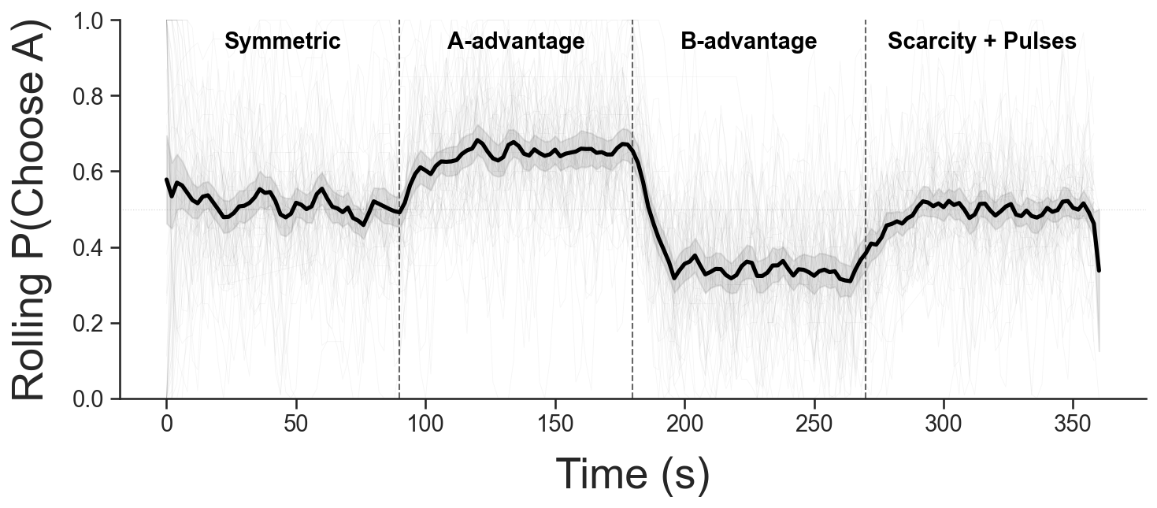
Note. Average rolling choice proportion (black line) with 95% confidence intervals (shaded band) across the four experimental phases (separated by vertical dashed lines). Lighter and thinner line paths represent individual participants.

Figure 2. Model comparison.
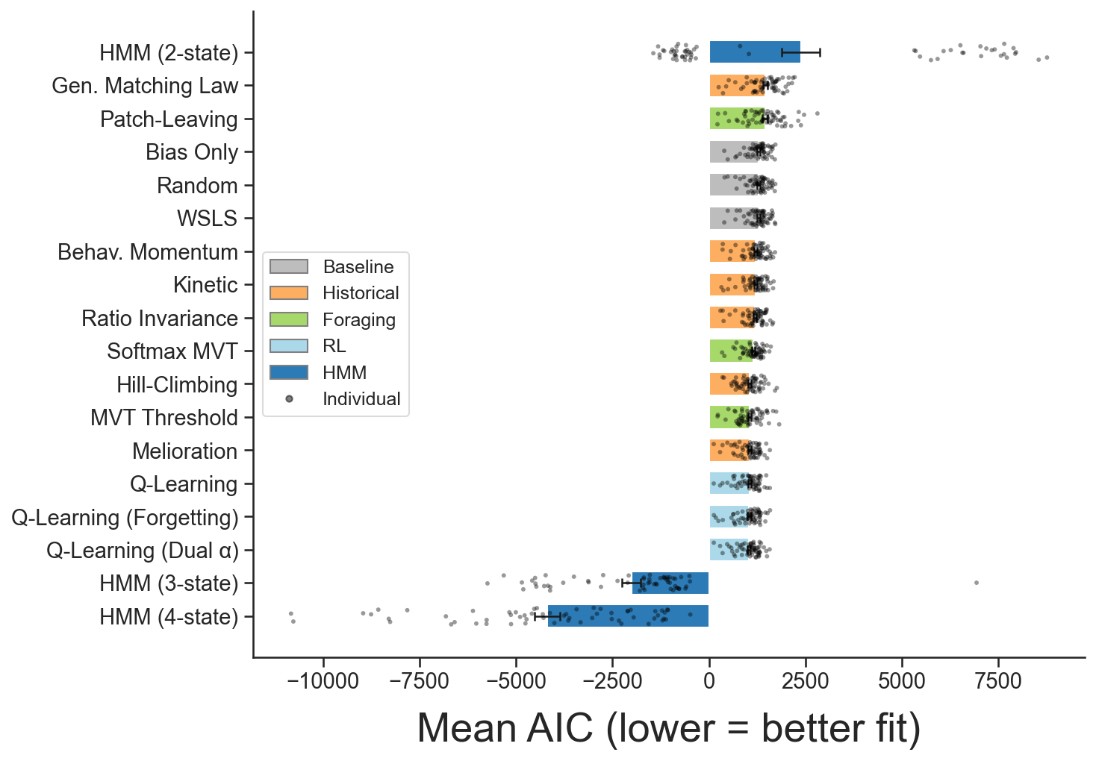

Note. Mean AIC across 60 sessions for all 18 models, organized by model family. Lower AIC indicates better fit. Note the discontinuous y-axis: HMM models (negative AIC) are separated from process models (positive AIC) by more than 3,000 units.

Figure 3. Phase-transition dynamics.

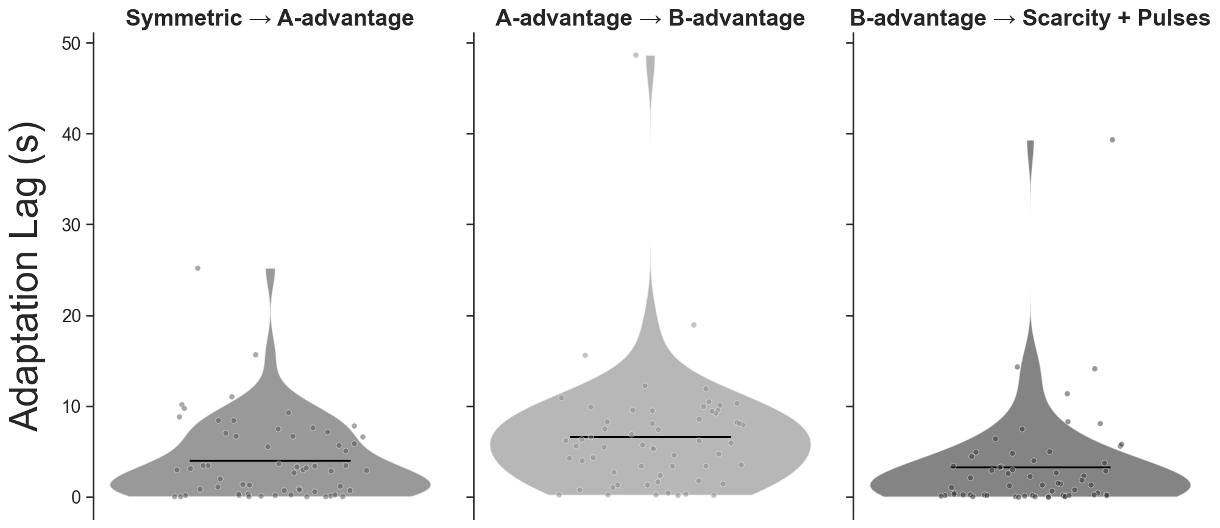

Note. Adaptation lags at each phase boundary, showing the distribution of time (in seconds) between the contingency change and the point at which choice allocation crossed the criterion threshold.

Figure 4. Hysteresis analysis of group average choice allocation as a function of latent response value (top panels) and contacted reinforcement (bottom panels) using 10 s rolling windows (each beginning and end of an arrow). Arrow directions show the temporal direction within each phase.

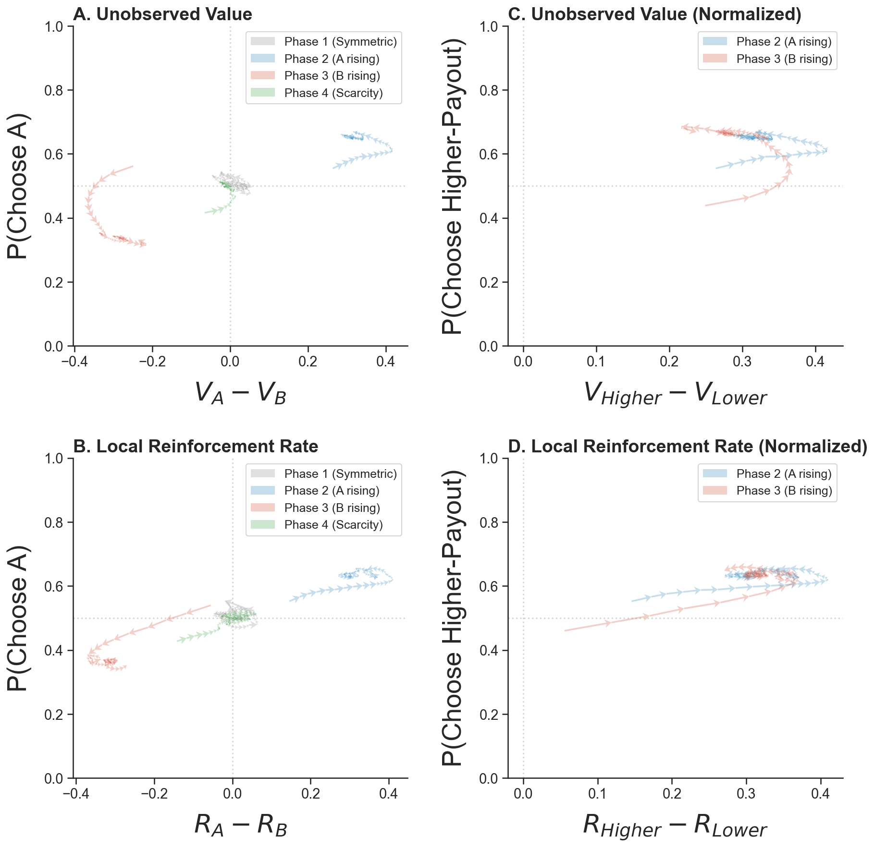
Figure 5. Observed proportion of responses to advantaged option (y-axis) relative to optimal proportion of responses to the advantaged option (x-axis) for each participant (marker) calculated from their individual average inter-click interval. The gray band shows ±5% around optimality.

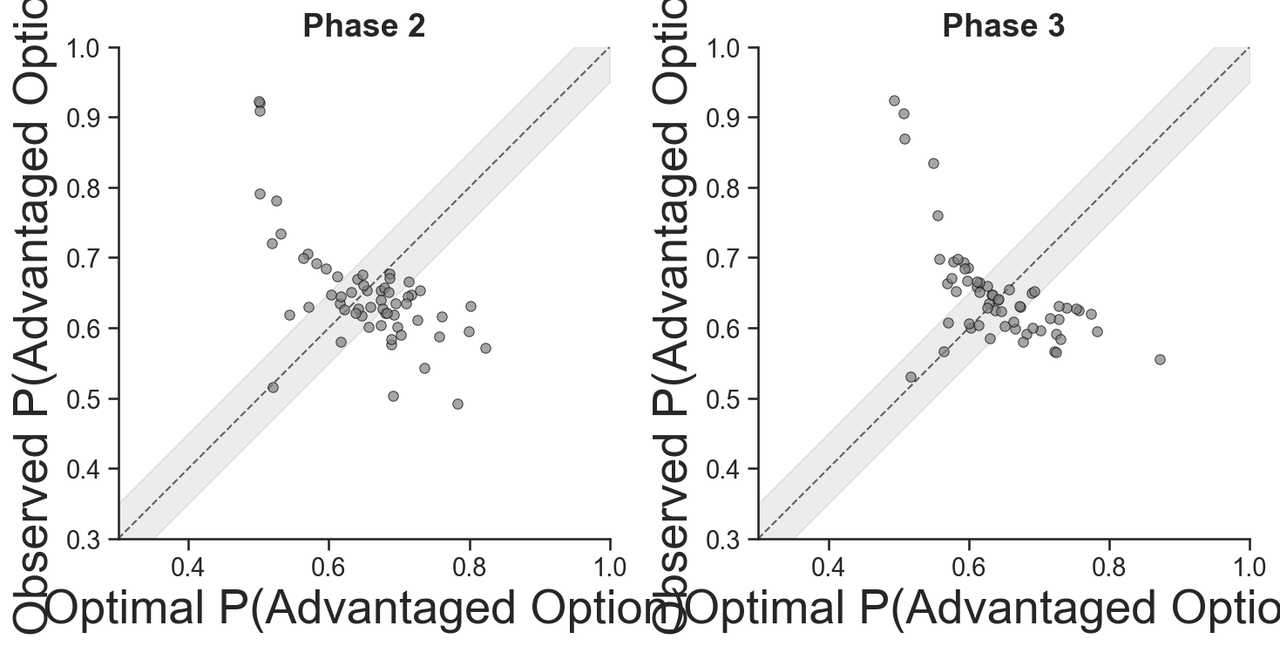
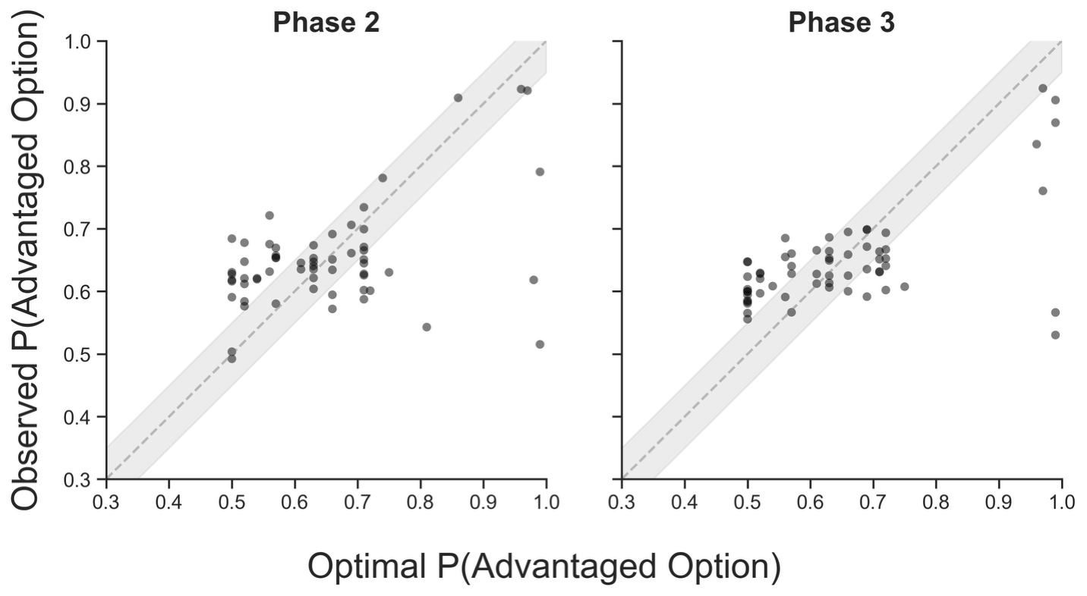
Figure 6. HMM analysis identifying state-space characteristics relative to response patterns (top and middle panels) and contact with reinforcement (bottom panel).

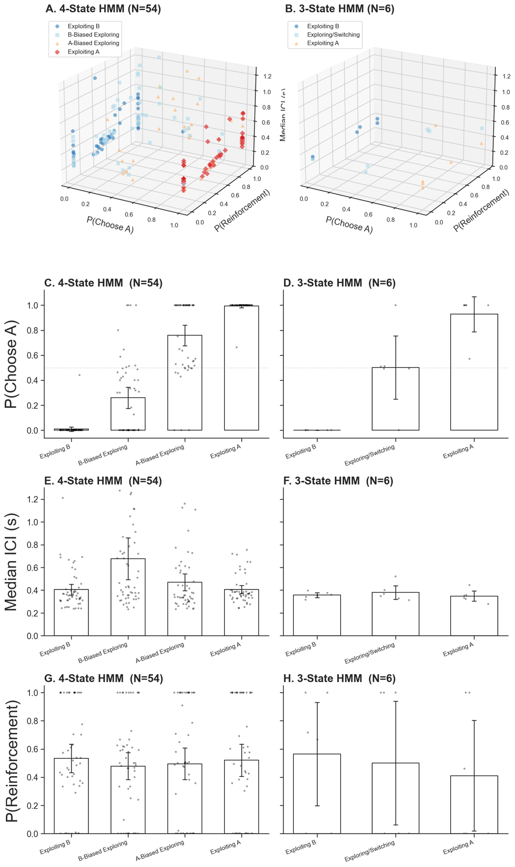
Figure 7. Convergent cross-mapping.

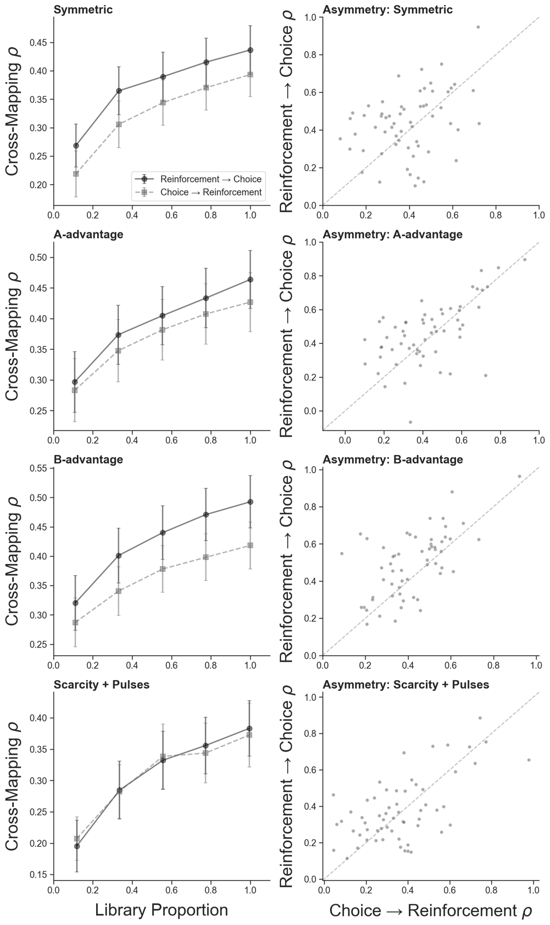

Note. CCM convergence plots showing increasing prediction skill with library size for the reward $to$ choice direction (stronger) and choice $to$ reward direction (weaker), confirming asymmetric causal coupling.
Figure 8. Recurrence plots of click rate per 3 s bins across the experiment for participants 1-31.
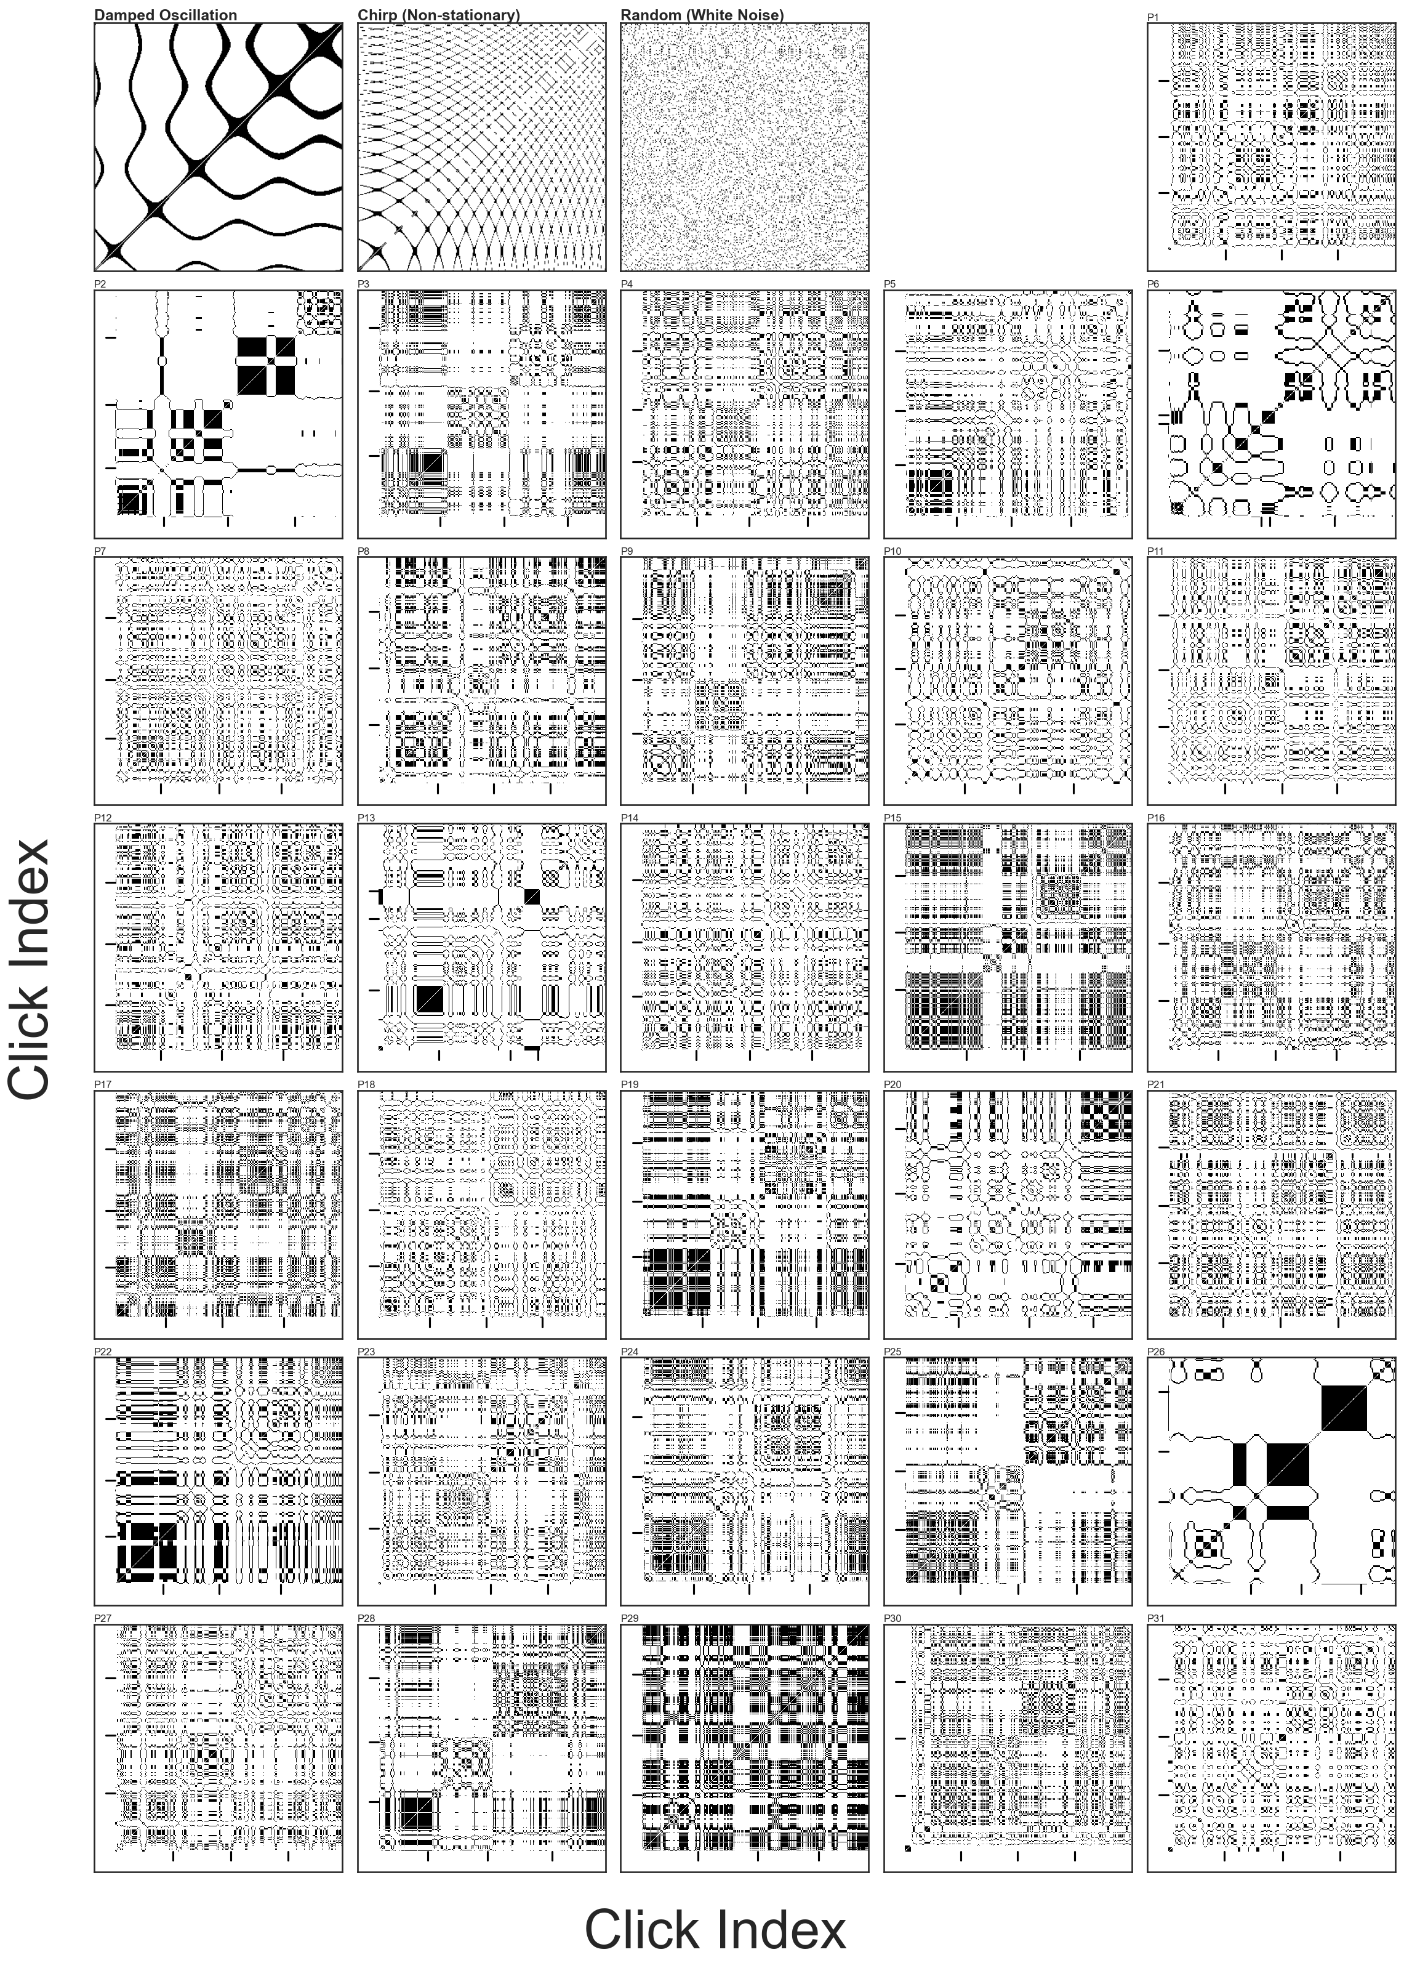
Figure 9. Recurrence plots of click rate per 3 s bins across the experiment for participants 32-60.
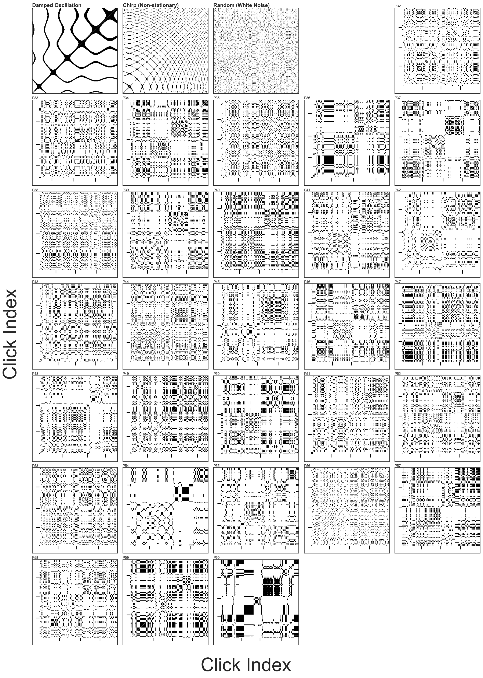

Figure 10. RQA metrics (x-axis) for each participant (markers) by experimental phase.

