**Module 8- Reviewing the Business Analytics Culture of Walmart**

David Reese

Colorado State University Global Campus

MIS 542: Business Analytics

Eric Straw Ph.D.

10/29/2020

**Module 8- Reviewing the Business Analytics Culture of Walmart**

For this week’s project I found a quote from Charles Darwin which fit perfectly. “It is not the strongest of the species that survives, not the most intelligent…it is the one that is the most adaptable to change” (inspirationfeed.com, 2020). If retail stores were a species, then Walmart would be the most adaptable to change. The ability to adapt has come from the use of data and gaining an understanding of it so that it can be used to make the company stronger.

To understand how this company has thrived while others have failed, you need to understand how Walmart has used data, as well as business analytics to make decisions and guide changes in how the company operates. In the book “The Analytic Lifecycle Toolkit,” the author, Gregory Nelson, lays out a diagram which focuses on five distinct areas.

**Figure 1**

*Analytics Culture (Nelson 2018, pg 76)*

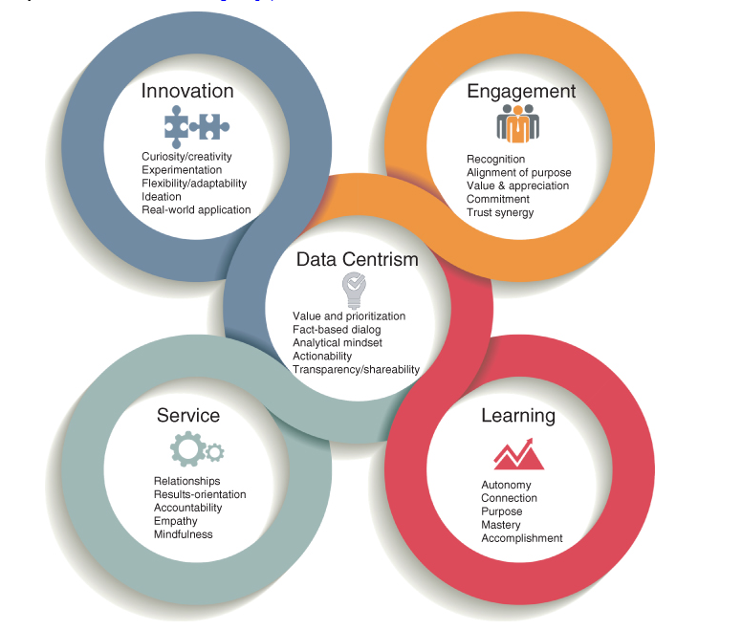

In keeping with the analogy of a species it makes sense to start any discussion with the central nervous system. For Walmart it is the central nervous system is data, as it drives every move the company makes.

**Data Centrism**

Walmart has a history of being innovative and data centric. The company was founded in 1962, and in 1975 began investing in dedicated computer systems for the purposes of maintaining control over both store inventory and distribution center inventory. For a company with sales of $236 million across 104 stores, this was a significant investment.

In 1980 Walmart created the VMI system. “Under a Walmart’s supply chain initiative – called [Vendor Managed Inventory](https://www.tradegecko.com/learning-center/what-is-vendor-managed-inventory?_ga=2.80005527.1462940200.1585734433-1340665190.1585734433) (VMI) – manufacturers became responsible for managing their products in Walmart’s warehouses. As a result, Walmart was able to expect close to 100% order fulfillment on merchandise.”(Lu, 2018 ¶ 7 ) Other benefits to Walmart with this system were that the order, shipping, and receiving processes were streamlined, saving the company money.

In 1983 the company began using barcodes across the entire 551 store operation to capture sales data on point of sale terminals. This gave the company an edge over other competitors and kept inventory costs down across all of the stores.

In 1987 the company took a bold step by launching what was at the time the largest private satellite system. This linked the entire company for data, phone and video conferences. More importantly, the company could now share data across the entire organization in real time.

In 1990 Walmart rolled out retail link. Retail Link is “a mammoth database. Through a global satellite system, Retail Link is connected to analysts who [forecast supplier demands](https://www.tradegecko.com/blog/smarter-demand-forecasting-using-smoothed-moving-average?_ga=2.248948999.1462940200.1585734433-1340665190.1585734433) to the supplier network, which displays real-time sales data from cash registers and to Walmart’s distribution centers” (Lu 2018 ¶ 19 ). By this time the company nearly 4,000 stores including Sam’s Club warehouse stores and over 1,000 international stores employing over 1.1 million people.

Fast forward to the creation of the Data Café. This will be the world largest private cloud system, and the ‘brain’ controlling the central nervous system of logistics and store operations. The data café be where all of the data Walmart creates will be analyzed and worked with. Walmart will be able to handle 2.5 petabytes of transactional data an hour, as well as integrate data from 200 other sources, mostly unstructured data. Managers and employees across the entire company will be able to get answers based on real time data in minutes.

Nelson defines data centrism as “using fact-based processes and data-derived insights for both decision making and business solutions. Analytic maturity is recognized to mean placing data products in the hands of frontline staff and business partners to drive decisions” (Nelson, 2018 pg. 76). Walmart meets every bit of that definition, and it allows for the company to move like a start up that is staying on top of trends.

**Innovation**

Walmart has been able to do what some other large retailers were not. They have been able to turn their data into real solutions and applications. Examples of this is the Walmart pay app that allows for seamless payments when checking out, and Shopycat.

Walmart pay is a part of the Walmart app. “We set out to marry our physical and digital assets to create a more seamless shopping experience for customers” (Eckert 2016, ¶ 3). Better experience = more loyal customer. A report by Bain and Company showed that a “superior experience earns stronger loyalty, turning customers into promoters with a lifetime value 6 to 14 percent times that of detractors” (Bain, 2015 ¶ 2). Walmart has devoted billions to the study of customer experience and creating innovations that will help them stay at the cutting edge in terms of big data and business analytics.

One way the company has stayed at the forefront of innovations is in acquisitions of startups and strategic partnerships. Shopycat is an example of how the company is looking to grow its web presence in the face of competitors. “The app, which suggests gifts for friends based on their Facebook use, was built with technology Walmart [acquired](https://beta.techcrunch.com/2011/04/18/walmart-ventures-into-the-social-media-space-with-acquisition-of-kosmix/) from social media startup Kosmix (now @WalmartLabs) earlier this year” (Perez, 2011¶ 1)

Shopycat is based on Kosmix’s Social Genome software platform, a semantic technology platform that was originally used to power social media discovery. The service was built primarily on top of Twitter. The growth of unstructured data has changed what retailers need to know in real time, and social media posts and ‘likes’ are the gold standard for unstructured data. Walmart’s purchase of Kosmix’s platform will help the company capture the unstructured data and convert that information into targeted ads, which will lead to sales.

Walmart has also created Walmart labs. Walmart labs is the 15,000 employee ‘lab’ where new apps and improvements to existing apps get created and tested. The lab has offices located around the world dedicated to creating the best possible experience for Walmart shoppers. Walmart has also created store #8. This is what the company calls its incubator. Ideas that have merit get tested in an actual 50,000 square foot store called Intelligent Retail Lab, the IRL. Customer input is gathered, changes are made until the innovation is set to be rolled out into the stores.

**Learning**

When Walmart launched the satellite system in 1987, part of what it was designed to do was to train new employees and managers. Walmart could save on training costs, and get consistent message delivery this way. In 2015, the company made a $ 2.7 billion dollar investment in the U.S. workforce. The investment was in the form of higher wages and training. Walmart Academy is a fixed location classroom training center, usually at a distribution center. The training centers have trained nearly ten percent of the two million employees at the 200 centers now operating.

From the standpoint of business analytics, Walmart has made acquisitions and rolled out programs that have been unsuccessful. However, in each case a piece of what the rollout included has ended up being adapted. Jetblack.com is one example of Walmart trying an approach and when it was not successful, closing down the project. Jetblack was a monthly fee service, similar in some way to Amazon prime that allowed for customers to text orders into a store for pick up later. The cost, $50 per month, never found any traction with existing Walmart customers or the customer base that can afford $50 a month for the ability to simply text an order to a store. Changes were made and the unlimited delivery service for a monthly fee was created, and is in the process of being rolled out to all Walmart stores.

**Engagement**

Going back to the central nervous system analogy, when something at Walmart itches, it gets scratched -quickly. Engagement is stretched companywide thanks to the network that was born back in the 1980’s. Since data is real time, any anomaly can be corrected in minutes instead of days. Analysts inside the data café can see into a store and give team members at the store level advice and guidance on how best to fix a particular issue the store. This give Walmart an edge over other competitors because they can make real time decisions on prices and base it on real time data. They can also track impacts of things like weather, gas prices or as we have seen in 2020, pandemics.

**Service**

Analytic teams at Walmart are working for a single goal- making the customer experience the best it can be. Success of an analytic project is based on whether or not it creates a better shopping experience for the customer. If it does, then everyone is happy. From Walmart labs, to the IRL, to the data café all of the analytic functions are designed to create a better experience for the shopper and generate information for the company.

**Going Forward**

I read more than one account of a product not selling and the analytics teams being able to figure out why it was not selling in minutes, which is great, for the company. However, an event took place in 1994 that is going to have a huge impact on Walmart if not addressed. Amazon.com ‘opened’ on July 5th, 1994.

For Walmart to grow and survive, the company must begin to aggressively grow its online sales arm. Improvements and new apps like Walmart voice order will help, but the challenge is not making a great customer experience. The company seems to have a great handle on the in-store experience. For Walmart.com the challenge is getting the chance to compete in online sales against Amazon.

The analytic teams need to work to break the strangle hold Amazon has on product search. According to a study by emarketer, Amazon is now the starting point for searches. “A number of consumer surveys have shown that more US digital shoppers now start their searches on Amazon. Nearly half (46.7%) of US internet users started product searches on Amazon compared with 34.6% who went to Google first” (Garcia, 2018 ¶ 2).

Amazon is in danger of becoming a habit, the way going to the store was before e-commerce. Amazon has “emerged as the primary destination for product searches when users are looking for specific items. Wide product selection, easy checkout and available ratings and reviews create a positive feedback loop that only encourages more product searching over time” (Koch, 2019, ¶ 3). Why, if the person is looking for a specific product, are they not looking at Walmart.com ?

For Walmart the target client is easily identified. “Just 19% of Walmart in-store shoppers shop at Walmart.com, compared to 53% of those who also buy at Amazon.com, according to a UBS report, citing Kantar Retail data” (Cheng, 2014 ¶ 2). Chipping off even as little as 3 percent of existing *Walmart store* clients from Amazon.com could mean millions for the company. What this tells me is that after they find it at Walmart, the customer goes on line to buy it from a different company. This is a huge issue for any business.

One area where Walmart.com still has an advantage is in online grocery sales. “A recent survey from The Retail Feedback Group found that 37% of shoppers chose Walmart for their most recent online grocery order, besting Amazon (29%) and also traditional supermarkets,” (Digitalcommerce, 2020 ¶ 3). Attention needs to be paid to how the stores can be used to compete against Amazon in terms of delivery time, and add onto the grocery order. The data is available, and it should not be that difficult to target messages based on shopping activity.

A new app called Walmart Voice order will help compete with Amazon when ordering groceries, and there is a monthly delivery service called Delivery Unlimited that will deliver groceries for an annual fee of $98, or $12.95 a month. The unlimited delivery service has been successful and will be rolled out to half the country this year. That needs to expand to cover non grocery items as well to make Walmart.com a destination site for other things beyond just food.

If delivery speed matters, then Walmart needs to leverage what they do best: use the experience they have in logistics to turn the stores into micro-fulfillment centers so that orders can be processed the same day. “In the United States 90 percent of the population resides within ten miles of a Walmart store” (Lewis 2018. ¶ 2), it seems this could be a way to compete against Amazon Prime and its free two-day delivery.

**References**

Bain and Company. (2015, April 8). *Are you experienced?* Bain.Com; Bain and Company. https://www.bain.com/insights/are-you-experienced-infographic/

Cheng, A. (2014, April 4). *Wal-Mart’s in-store shoppers prefer Amazon.com — not Walmart.com*. MarketWatch; Marketwatch.com. https://www.marketwatch.com/story/wal-mart-s-in-store-shoppers-prefer-amazon-com-not-walmart-com-1396634008

Eckert, D. (2016, May 17). *Open, Scan, Done: The Case for Walmart Pay*. Corporate.Walmart.Com; Walmart. https://corporate.walmart.com/newsroom/innovation/20160517/open-scan-done-the-case-for-walmart-pay

Garcia, K. (2018, September 7). *More Product Searches Start on Amazon*. EMarketer.Com; Emarketer. https://www.emarketer.com/content/more-product-searches-start-on-amazon

Inspirationfeed. (2020, July 16). *35 Charles Darwin Quotes And Sayings about Life, Survival, and Change*. Inspirationfeed; Inspirationfeed. https://inspirationfeed.com/charles-darwin-quotes/

Koch, L. (2019, March 31). Looking for a New Product? You Probably Searched Amazon. *Looking for a New Product? You Probably Searched Amazon*. https://www.emarketer.com/content/looking-for-a-new-product-you-probably-searched-amazon

Lewis, R. (2018, February 22). *Walmart’s “Last Ten Miles” - Quicker and Cheaper Than Amazon*. The Robin Report; therobinreport.com. https://www.therobinreport.com/walmarts-last-ten-miles-quicker-and-cheaper-than-amazon/

Lu, C. (2018, October 4). Walmart’s successful supply chain management. *Walmart’s Successful Supply Chain Management*. https://www.tradegecko.com/blog/supply-chain-management/incredibly-successful-supply-chain-management-walmart

Nelson, G. S. (2018). *The analytics lifecycle toolkit : a practical guide for an effective analytics capability* (p. 76). Wiley. https://platform.virdocs.com/r/s/0/doc/505037/sp/21805868/mi/75743097?cfi=%2F4%2F2%2F8%2F6%5Bc03-para-0034%5D%2C%2F1%3A0%2C%2F1%3A0&menu=search&q=figure%203.4

Perez, S. (2011, November 30). *Walmart Launches Shopycat, A Social Gift Finder Built On Top Of Facebook*. TechCrunch.Com; TechCrunch. https://techcrunch.com/2011/11/30/walmart-launches-shopycat-a-social-gift-finder-built-on-top-of-facebook/

‌