David Nguyen

Doina Bein

CPSC 479-01

19/02/2020

Homework 2

**NOTE: ALL EXECUTION TIMES ARE AN AVERAGE OF 10x RUNS DUE TO THE VARIABILITY OF PROCESSING. SEE PAGE 2 FOR DETAILED DATA.**

**Exercise 1. [ 8 points]** Write either a single program or two separate C/C++ programs that use(s) MPI blocking and non-blocking commands MPI_Send, MPI_Rcvd, MPI_Isend and MPI_Ircvd to exchange one double value between process with rank 0 and process with rank 1. Calculate the execution time using MPI_Wtime to compute the execution time and write it down in the table below as follows:

|  |  |
| --- | --- |
|  | Execution Time |
| A single transmission using blocking communication | ~180 µs |
| A single transmission using non blocking communication | ~122 µs |
| Two transmissions (round trip) using blocking communication | ~251 µs |
| Two transmissions (round trip) using non blocking communication | ~186 µs |

**Exercise 2. [ 4 points]** Modify the ring example given in class to calculate the execution time using MPI_Wtime of the transmission of the value 5 from process with rank 0 to process with rank 1, etc. until the value 5 is received back at the process with rank 0. Use only blocking communication. Launch the execution of the program with a varied number of parallel processes (mpirun -n 10 ./a.out to launch the executable a.out for 10 processes) and write down the execution time of the ring example as follows:

|  |  |
| --- | --- |
|  | Execution Time |
| Ring with 4 nodes | ~297 µs |
| Ring with 8 nodes | ~486 µs |
| Ring with 10 nodes | ~554 µs |
| Ring with 12 nodes | ~657 µs |

All data is from processing on Titan-V.

|  |  |  |  |  |
| --- | --- | --- | --- | --- |
|  | **Send/Receive Execution Time** | | | |
| **Blocking** | | **Non-Blocking** | |
| **Run No.** | **Single (µs)** | **Round-trip (µs)** | **Single (µs)** | **Round-trip (µs)** |
| **1** | 418 | 490 | 280 | 352 |
| **2** | 224 | 294 | 67 | 136 |
| **3** | 289 | 361 | 261 | 321 |
| **4** | 263 | 344 | 182 | 247 |
| **5** | 61 | 135 | 54 | 113 |
| **6** | 195 | 271 | 62 | 129 |
| **7** | 163 | 233 | 152 | 207 |
| **8** | 60 | 130 | 54 | 119 |
| **9** | 69 | 134 | 56 | 115 |
| **10** | 55 | 113 | 53 | 113 |
| **Average** | **179.7** | **250.5** | **122.1** | **185.2** |

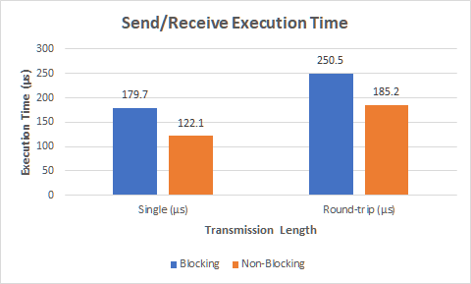

|  |  |  |  |  |
| --- | --- | --- | --- | --- |
|  | **Ring Mod Execution Time** | | | |
| **Run No.** | **4 Nodes (µs)** | **8 Nodes (µs)** | **10 Nodes (µs)** | **12 Nodes (µs)** |
| **1** | 361 | 341 | 376 | 717 |
| **2** | 316 | 487 | 631 | 499 |
| **3** | 472 | 655 | 407 | 656 |
| **4** | 258 | 516 | 560 | 853 |
| **5** | 205 | 469 | 695 | 679 |
| **6** | 391 | 315 | 619 | 666 |
| **7** | 214 | 610 | 576 | 483 |
| **8** | 266 | 490 | 372 | 659 |
| **9** | 268 | 654 | 662 | 710 |
| **10** | 217 | 314 | 633 | 644 |
| **Average** | **296.8 µs** | **485.1 µs** | **553.1 µs** | **656.6 µs** |

