PAPERLESS
Architecture, design decisions & testing strategy

Project overview
Paperless is a document-management prototype built as a containerized web application. The browser client calls a REST API; the API stores document metadata and file-version records in PostgreSQL and publishes document identifiers to RabbitMQ for background processing. The intended asynchronous path keeps potentially expensive OCR work outside the user-facing request path.

Architecture and responsibilities
Component | Responsibility and current implementation
Angular frontend | Single-page UI for listing, previewing, searching and uploading documents. DocumentApiService calls the API through the /api/Document route; Nginx serves the frontend container.
ASP.NET Core API | DocumentController exposes create, list, get, update, delete and file-version endpoints. It validates basic request fields, delegates use cases to IDocumentService and publishes the new document ID. Swagger is enabled.
Business + data layers | DocumentService maps DTOs to entities and applies use-case logic. IDocumentRepository isolates persistence; DocumentRepository uses EF Core and PaperlessDbContext. Schema changes are tracked with migrations, applied at API startup.
PostgreSQL + RabbitMQ worker | PostgreSQL stores documents, categories and version metadata; deleting a document cascades to its versions. RabbitMQ carries IDs on test_q. The .NET worker consumes messages, but currently only logs them; OCR and file storage are not implemented.

System Architecture & Layers

The app follows a clean, layered architecture to keep things modular and easy to unit test:
- Controllers: Handle HTTP requests and responses at the edge.
- Services: Contain the core business logic and use cases.
- Repositories & EF Core: Isolate database operations using Entity Framework Core.
- Interfaces: Used everywhere for dependency injection, which makes mocking for unit tests easy.
Request & Processing Flow
- The Client (Angular): Sends a document upload request to the API controller, which validates basic fields and calls the document service.
- The Backend: The service handles the business logic, mapping data into Document and FileVersion entities. The repository saves everything into PostgreSQL via EF Core.
- The Queue (RabbitMQ): After saving the record, the API publishes the new document's ID to a durable queue.
- The Worker: A background worker consumes the ID independently from the HTTP request. (Note: Right now, the worker just logs the ID; actually doing OCR and generating summaries is still a work in progress!)
Database & Versioning Design
- Entities: A Document represents the core item (identified by filename), while FileVersion represents immutable revisions. If you delete a document, EF Core automatically cascades and deletes all its versions.
- Storage: We store a StoragePath in the DB instead of raw binary files (saving bytes directly in a database row is a bad practice).
- Versioning: Version numbers start at 1 and increment based on existing versions. We'll eventually need database locks or transactions to handle race conditions if multiple uploads happen at the exact same time.
Asynchronous Processing (RabbitMQ)
RabbitMQ decouples heavy tasks (like OCR) from the web API so users don't have to wait around for uploads to finish processing.
- We use a durable quorum queue.

Deployment & Docker Compose
Everything runs locally via Docker Compose:
- Spins up PostgreSQL, RabbitMQ, the API, the background worker, and an Angular frontend (fronted by Nginx).
Current Status & What's Left to Do
Right now, the project is a solid prototype framework, but a few things are stubbed out:
- Uploads: The endpoint checks for titles and files, but it currently creates placeholder metadata and a dummy hash/path instead of actually saving the binary file bytes.
- Worker Tasks: The worker only prints IDs to the console—OCR and summary generation are next on the to-do list.
- Hardening: Before deploying this for real, we need to add proper authentication/authorization, file size limits, secure object storage, and proper error recovery for the queue.

TESTING STRATEGY

Principles
- Use fast, isolated unit tests for business logic.
- Reserve real infrastructure (PostgreSQL, RabbitMQ) for integration scenarios.
- Run tests without developer credentials or production data.
Test Levels
- Backend Unit Tests (xUnit + Moq): Verify business logic, DTO mapping, error handling, and versioning.
- Frontend Unit Tests (Angular TestBed): Verify component states and API calls using HttpTestingController.
- Integration Tests: Validate database operations (PostgreSQL, EF Core, cascades) and messaging (RabbitMQ publish/consume).
- End-to-End Tests: System validation via Docker Compose (API, worker, frontend).
Test Commands
- Backend tests: dotnet test paperless.slnx
- Frontend tests: npm ci && npm test -- --watch=false
- Frontend build: npm run build
- Local container test: docker compose up --build (verification via localhost:8080 and localhost:4200)
Current Gaps and Next Steps
- Current status: Backend tests rely on mocks; frontend tests are mostly basic smoke tests.
- Next steps:
  - Implement real file persistence and test the upload contract end-to-end.
  - Add integration tests for database operations and RabbitMQ worker acknowledgements.
  - Expand frontend HTTP tests and cover failure paths (retries/dead-lettering).

Wireframe
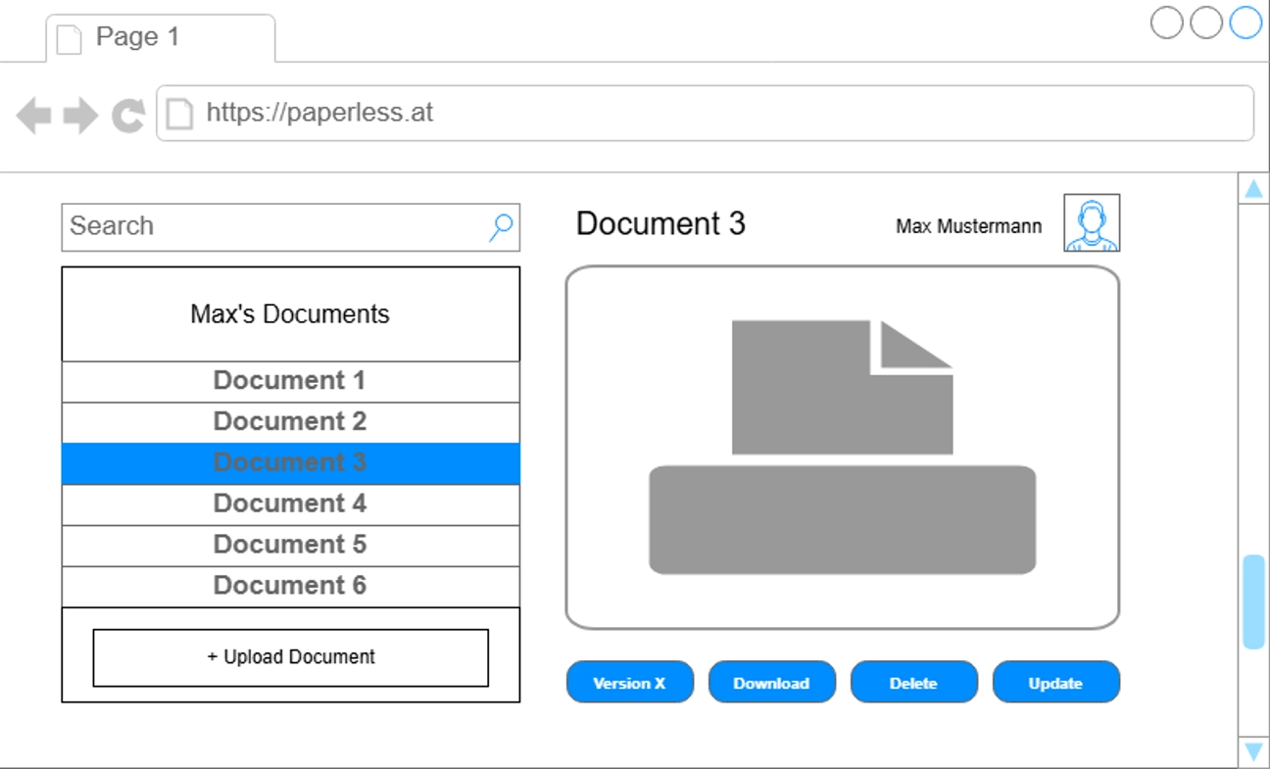

Tracked Work:

Anna Freiler
Backend Setup: Controller, BLL, DAL | 8h
Merge conflicts | 1h
Update Logic in backend (finish crud) | 2h
Frontend implementation of update | 4h
Empty OCR worker | 4h

Kacper Czerniawski

David Lenz

