Final Paper

Extend GoLightly to handle periodic structures, such as photonic crystals. A user should be able to create an input file that defines a unit cell, and GoLightly will extend the unit cell to ‘infinity’ along both the X and Y dimensions. To allow for crystal ‘defects’ (such as missing rods or holes as required to make resonators / waveguide) GoLightly should have an input for specifying a part of the domain that is not to be replicated.

The paper must be between 3 and 5 pages in length, following the OSA style guildines. A template provided from OSA has been provided. All references will be formatted per the OSA publication style guidelines (<https://opg.optica.org/submit/style/osa-styleguide.cfm>)

Following the submission of the paper, an in person presentation will be done. Your presentation will be between 15 – 30 minutes to the class.

To validate the model, run numerical experiments on the structures below. Numerical experiments are to find a) sweep through multiple frequencies of source to numerically identify resonant frequencies b) plot the E field distribution at least one of the resonant frequencies.

1. A square lattice of rods, where a = 1.2µm, r=0.2a, and epsr = 8.9 (similar to the example on pages 66-68 in the book).  
   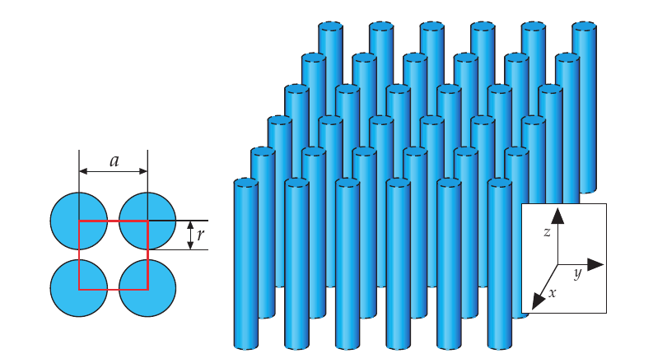
2. A square lattice of veins where a = 1.2µm, r=0.2a, and epsr = 8.9 (similar to the example on pages 72-74 in the book).  
   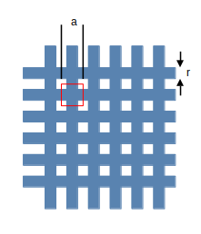
3. A lattice similar to problem 1, only a single rod is missing from the middle.  
   