${#Global#ZOD_uid_MBD}

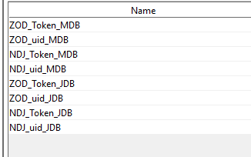

Setup as global properties