**David Olivero – Guided Capstone Report - last updated 6/1/20**

***Can we determine a way to utilize Big Mountain Resort’s new (12th) chair lift in a way that will increase resort revenues by at least $1,681,680 in the first year of operation?***

Big Mountain Resort is a large ski area in NW Montana comprised of 3,000 acres of accessible terrain. The Resort currently operates 105 trails serviced by 11 lifts, and 50% of the terrain is categorized as advanced or expert. 350,000 people use the operations annually. The Resort, like all large ski facilities, experiences congestion in small areas of the Resort, and has just installed an additional chair lift which will cost $1,540,000 a year to operate. It is hoped this chair lift can improve distribution. To maintain the investors’ goal of 9.2% profit margin, the lift will need to increase revenues by at least $1,681,680.

This amount of revenue increase can be accomplished if ticket fees for the 350,000 annual attendance are increased by $1,681,680 / 350,000 = $4.80 per ticket sold.

The question is, would such an increase be in line with comparable resort ticket prices?

To analyze this, data for 330 resorts across the US were compiled. This dataset included parameters such as number and type of lifts, skiable acreage, number of runs, vertical elevation drops, and terrain parks, among many other variables. A general linear model was fitted to the data, along with a K-Means clustering of data. As can be seen below, the clustering algorithm picked out three clusters centered on different summit elevations:

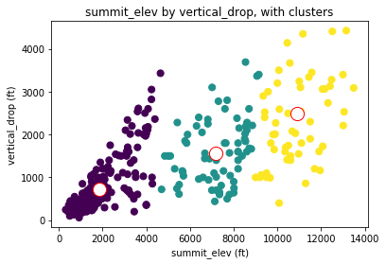

Using a training subset of the full dataset, good predictive modeling capability (with nearly 90% explained variance) was achieved on the remaining test set:

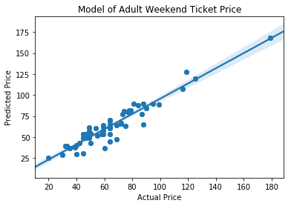

The following parameters in the dataset were found to have the greatest influence on ticket prices. It can be seen that fast Quads are the type of lift that increase ticket prices the most. Let’s assume that the new lift being installed at Big Mountain Resort is a fast Quad:

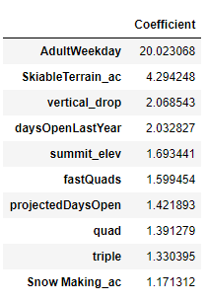

Using this model, we come up with the following modeled ticket prices compared to the actual, current adult ticket price at Big Mountain (aka Whitefish Mountain) Resort:

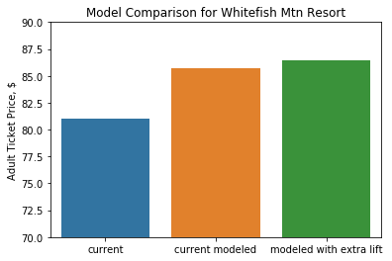

Big Mountain Resort with an extra fast Quad lift ahs a predicted ticket cost of $86.40, compared to the current lift ticket price of $81.00. This is a $5.40 per ticket increase, which if applied across 350,000 ticket holders results in increased revenues of $1.89M. This meets and exceeds the goals set forth to recover costs associated with the new lift.