Progress Report
AgAI Pesticide Residue & Leaf Classification Project
June 3 – June 16, 2026
1. Summary
This update focuses on strengthening the baseline evaluation pipeline for image-based pesticide residue prediction using the currently available 36 ICP-quantified leaf images.

Since the previous single train/validation split was highly sensitive to which images landed in validation, I moved to stratified 4-fold cross-validation and added additional regression and baseline metrics. The goal was to make the current baseline more reliable and prepare the pipeline for the incoming ICP samples.

Overall, the current results suggest weak image-related signal, especially in the low/medium/high classification formulation, but not yet enough to claim reliable quantitative residue prediction. The main limitation remains the small number of ICP-quantified samples.

2. Current Dataset and Labeling
The current experiments use 36 ICP-quantified leaf images. The original modeling direction was to treat the task as residue-bin classification using nominal spray concentration ranges, for example 200–400 ppm, 400–600 ppm, 600–800 ppm, and 800–1000 ppm. This made sense as an initial formulation before the ICP measurements were available, since the treatment concentrations provided a natural set of bins.

After receiving the ICP quantification data, it became clear that the measured values should be handled differently from the nominal spray concentrations. The raw ICP concentration values ranged from approximately 2.055 to 7.492 mg/L, or ppm-equivalent. These values are much lower than the nominal spray concentrations because they represent measured concentration from the ICP workflow rather than the original spray treatment level. Additionally, the raw mg/L value does not directly account for the size of the leaf that was measured.

For this reason, I used the already-provided area-normalized residue density values in mg/cm² as the main ground-truth label. This target is more appropriate for image-based prediction because it connects the measured residue amount to the physical leaf area visible in the image. Using mg/cm² also avoids treating nominal spray concentration as if it were the actual residue deposited on each individual leaf.

Once the labels were converted to residue density, the measured range was approximately 0.0475 to 0.269 mg/cm². At that point, the original nominal concentration bins were no longer directly applicable. Therefore, I computed both quartile and tertile splits but used tertiles for the initial classification experiments. This divided the 36 samples into three balanced groups: low, medium, and high residue density.

With only 36 ICP-quantified images, tertiles provide a balanced low/medium/high classification task while avoiding very small class sizes. However, because the underlying ICP measurement is continuous, binning can still introduce artificial boundaries. Leaves near the low/medium or medium/high cutoff may have very similar residue densities and visual appearance but receive different class labels.

For this reason, I evaluated both:
- A 3-class classification formulation using low, medium, and high residue-density tertiles.
- A regression formulation predicting continuous ICP-derived residue density in mg/cm².

3. Preprocessing and Data Pipeline
I continued organizing the preprocessing pipeline so that each cropped leaf image is linked to its ICP-derived residue value.

The current pipeline uses the Roboflow image annotations and ICP mapping information to crop the leaf corresponding to the ICP measurement, then saves a master CSV linking the cropped image path to the measured residue value. This CSV is then used by the custom PyTorch dataset for training and evaluation.

This workflow is important since the ICP measurement corresponds to only one leaf among many in the image. If all or many leaves in an image are annotated, the preprocessing step required manual verification to ensure that the cropped leaf corresponds to the leaf that was actually quantified by ICP. This is because my pipeline takes the annotation with the largest area to be the main leaf, which was not always the one that was quantified. Therefore, for the incoming samples, annotating only the ICP-measured leaf would reduce manual verification and make the preprocessing pipeline more reliable.

4. Classification Baseline: Stratified 4-Fold Cross-Validation
The first baseline formulation treated the problem as 3-class classification: low, medium, and high residue bins.

Previously, a single train/validation split was used. However, with only 36 images, the validation set contained only about 8 images. This makes validation accuracy unstable because one image can change the accuracy by more than 10 percentage points.

To address this, I switched to stratified 4-fold cross-validation. Each fold used approximately 27 images for training and 9 images for validation, with low, medium, and high bins balanced across folds, and ensuring each image was seen at least once for validation.

The 4-fold classification result was:

Metric | Result
Validation Accuracy | 50.0% ± 12.4%
Validation Loss | 0.978 ± 0.032

Since random guessing for three balanced classes would be around 33.3%, the result suggests that the model may be learning some image-related signal.

The medium class remains the most difficult category. This may be because the medium bin lies between low and high residue levels, or because tertile boundaries divide a continuous ICP distribution into artificial categories. Still, the medium class was predicted correctly in several folds, suggesting that it is difficult but not entirely unlearnable.

5. Regression Formulation
I also tested a regression version of the baseline, where the model predicts continuous ICP-derived residue density in mg/cm².

This formulation seems more scientifically direct because ICP provides a continuous measurement. It also avoids forcing samples near bin boundaries into separate classes when their visual differences may be subtle. The 4-fold regression result was:

Metric | Result
MAE | 0.0594 ± 0.0115 mg/cm²
RMSE | 0.0747 ± 0.0189 mg/cm²
R² | -0.7629 ± 0.4653
Pearson r | 0.1707 ± 0.4265
Baseline MAE | 0.0451 ± 0.0046 mg/cm²

The MAE means that, on average, the model’s prediction was off by about 0.059 mg/cm². However, this number needs to be interpreted relative to the scale of the measured residue values and a simple baseline predictor.

For context, the mean measured residue densities for the nominal treatment groups were approximately:

Nominal treatment | Mean measured residue density
400 ppm | ~0.074 mg/cm²
600 ppm | ~0.116 mg/cm²
800 ppm | ~0.127 mg/cm²
1000 ppm | ~0.178 mg/cm²

The difference between the 400 ppm and 1000 ppm group means is therefore about 0.104 mg/cm². A regression MAE of 0.059 mg/cm² is more than half of that treatment-mean span. This means the average prediction error is still large relative to the expected difference between low and high nominal treatment groups.

The negative R² and baseline MAE comparison are also important. The model did not yet outperform a simple mean-value predictor, meaning the current regression model has not demonstrated reliable continuous residue prediction from image features alone.

This does not necessarily mean there is no signal in the images. It means that, with only 36 ICP-quantified samples, the model is not yet reliably assigning the correct continuous residue value to each individual leaf.

6. Prediction Behavior
To better interpret the regression results, I tracked MAE, RMSE, R², Pearson correlation, target/prediction mean and standard deviation, and baseline MAE.

Together, these metrics separate prediction error from ranking and calibration. MAE and RMSE measure error size, R² and baseline MAE test whether the model improves over a simple mean-value predictor, and Pearson correlation indicates whether higher-residue leaves tend to receive higher predictions.

The model sometimes produced varied predictions rather than collapsing to a constant value, but those predictions were not consistently matched to the correct leaves. This is reflected by the negative R², weak/unstable Pearson correlation, and worse performance than the mean-value baseline.

7. Prediction-vs-Ground-Truth Plots
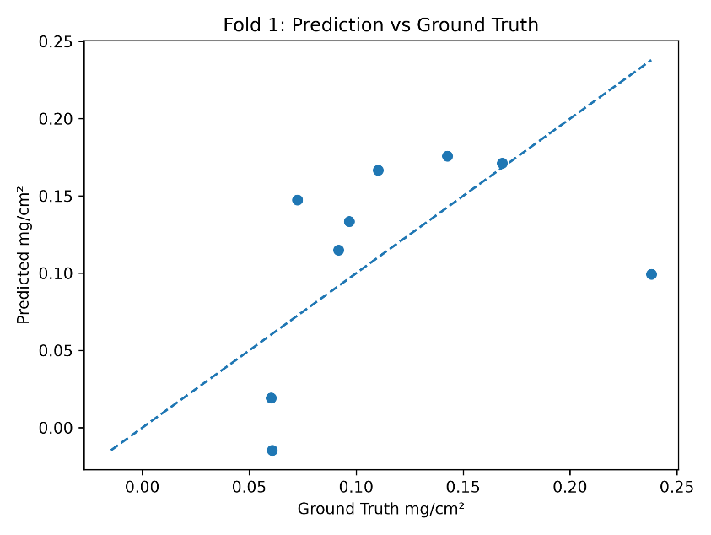
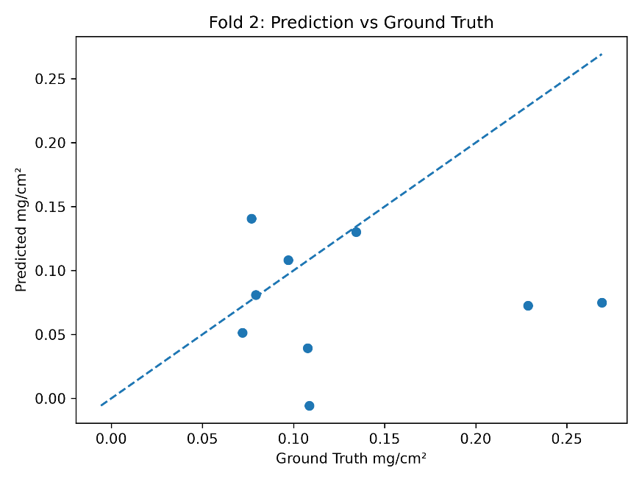
The scatterplots below show predicted residue density versus ICP-derived ground truth for each fold. Points closer to the diagonal indicate better predictions. The plots show substantial fold-to-fold variation, which is expected given that each validation fold contains only 9 images.

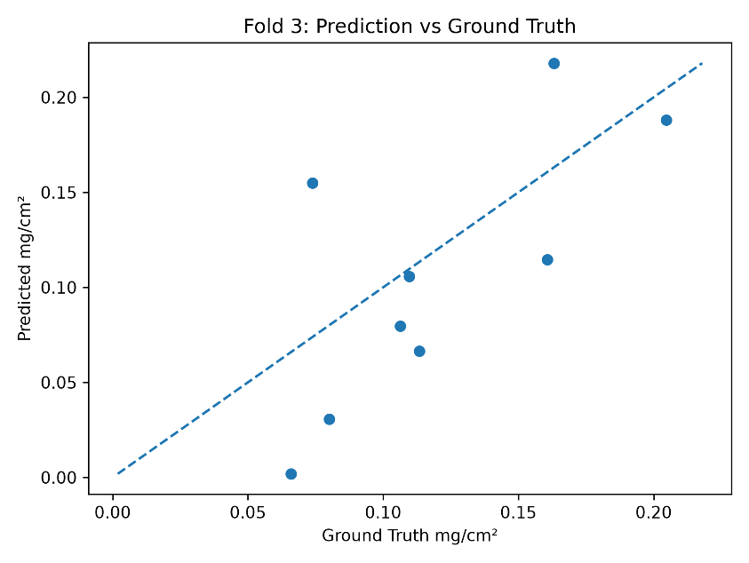
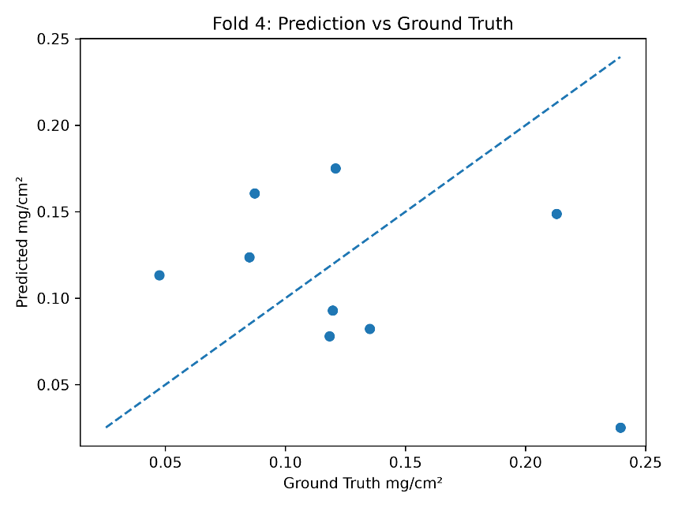
8. Overall Interpretation
Overall, the current results suggest weak but non-random residue-related signal in the images. The classification model performed above random chance across stratified folds, while the regression model produced varied continuous predictions but did not yet outperform a simple mean-value baseline.

This means the current pipeline is useful for evaluating the task, but the 36-image dataset is too small to support strong claims about reliable residue prediction. The incoming ICP samples will be important for determining whether the observed signal becomes more robust with additional measured data.
9. Next Steps
The next steps are:

- Ingest the newly analyzed ICP samples once available.
- Ensure each cropped image corresponds to the ICP-measured leaf.
- Rerun the stratified cross-validation experiments with the expanded dataset.
- Perform a binning sensitivity analysis, including the current 3-bin tertile formulation, a simpler 2-bin low/high formulation, and potentially treatment-informed bins once there are enough samples.
- Continue evaluating continuous regression alongside classification, since ICP residue density is naturally continuous.
- Continue tracking baseline MAE, model MAE, RMSE, R², Pearson correlation, target/prediction mean and standard deviation, and prediction-vs-ground-truth plots.
- Test augmentation and regularization after the expanded dataset is integrated.

The current 36-image dataset was useful for building the preprocessing and evaluation pipeline, but it is too small to determine the best label formulation definitively. Tertile bins are useful at this stage because they keep the classes balanced, but they may introduce artificial boundaries between visually similar leaves. A 2-bin formulation may be useful as a sanity check because it asks the simpler question of whether the model can distinguish lower-residue from higher-residue samples. Once the incoming ICP samples are available, it should be possible to evaluate these label formulations more meaningfully.

The incoming ICP samples will be critical for determining whether image-based residue prediction can become robust and scientifically meaningful.

