
PRACTICE VISIBILITY SCAN
Executive Summary
{{practice_name}}
{{location_city_state}} ({{market_area}})
Prepared by Jim McDannald, DPM
YOUR VISIBILITY SCORE
{{overall_score}}
{{score_label}}
Strengths | Problems
{#swot_items}{{strength_title}}  {{strength_description}} | {{problem_title}}  {{problem_description}}
{{strength_title}}  {{strength_description}} | {{problem_title}}  {{problem_description}}
{{strength_title}}  {{strength_description}} | {{problem_title}}  {{problem_description}}{/swot_items}
Where Patients Find You on Google
Each dot on these grids represents a Google search from that location. Green means you show up in the top 3. Yellow means patients have to scroll. Red means you don’t show up.
1–3 = Patients see you first | 4–7 = Have to scroll to find you | 8+ = You don’t show up
Keyword: "{{kw1_term}}"
Average Rank: {{kw1_avg_rank}} | Share of Local Voice: {{kw1_solv}} | Found in {{kw1_found}} of {{kw1_total}} points ({{kw1_pct}})
You’re consistently losing to the ORA Orthopedics podiatrists who dominate the western parts of your market. Christopher Collazo and Anthony Chesser have built massive review profiles that Google rewards with top rankings, often pushing you down to #5 where patients don’t see you. Your visibility drops significantly in key areas where established competitors have stronger local signals.
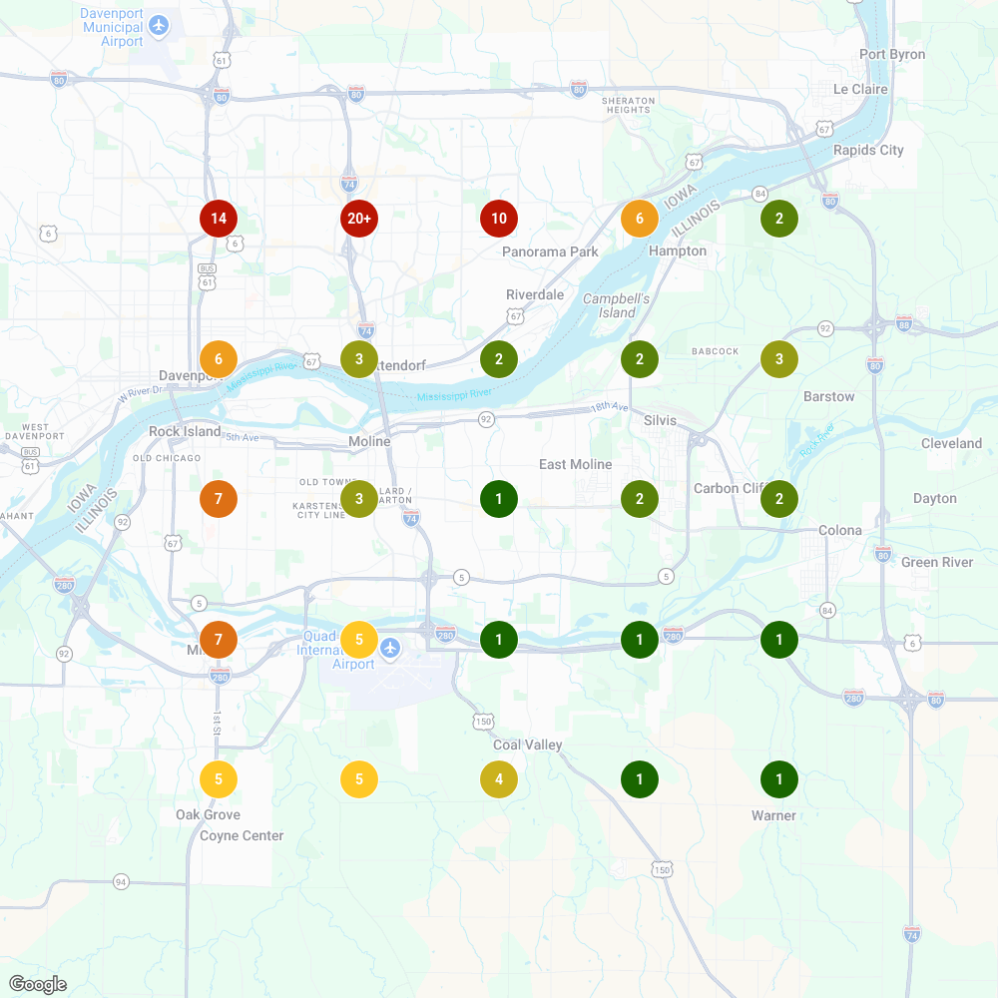
Keyword: "{{kw2_term}}"
Average Rank: {{kw2_avg_rank}} | Share of Local Voice: {{kw2_solv}} | Found in {{kw2_found}} of {{kw2_total}} points ({{kw2_pct}})
This keyword shows your best performance, with stronger visibility across all search points. You’re still losing prime real estate to Foot First Podiatry Centers and the same ORA docs, but the improved Share of Local Voice indicates patients using this term are more likely to find you. However, you’re still not consistently breaking into those crucial top 3 positions where most clicks happen.
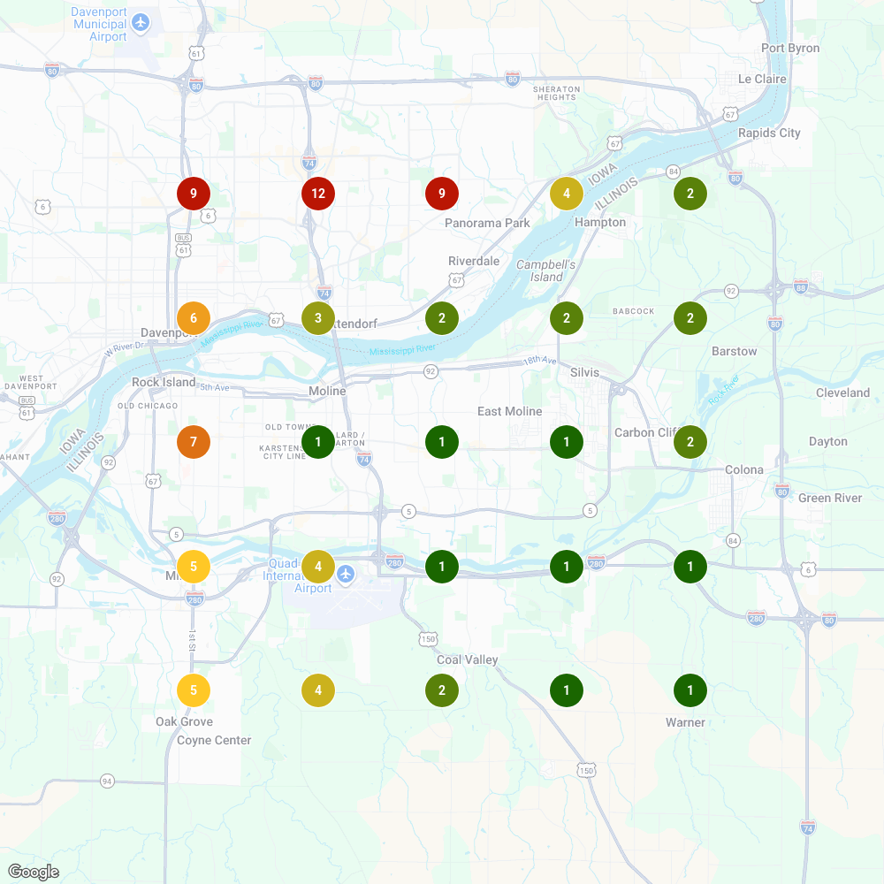

Bottom Line: {{bottom_line}}
DETAILED FINDINGS
Practice Name | {{practice_name}}
Doctor Name | {{doctor_name}}
Website | {{website}}
Location(s) | {{location_address}}
Report Date | {{report_date}}

Category | Score | Status
Website Fundamentals | {{score_website}} | {{status_website}}
Google Business Profile | {{score_gbp}} | {{status_gbp}}
Local Search Rankings | {{score_rankings}} | {{status_rankings}}
Online Reviews | {{score_reviews}} | {{status_reviews}}
Content & SEO | {{score_content}} | {{status_content}}
Patient Engagement | {{score_engagement}} | {{status_engagement}}
The Demographic Opportunity
{{demographic_intro}}
Neighborhood | Median Household Income
{#neighborhoods}{{neighborhood_name}} | {{neighborhood_income}}
{{neighborhood_name}} | {{neighborhood_income}}
{{neighborhood_name}} | {{neighborhood_income}}
{{neighborhood_name}} | {{neighborhood_income}}
{{neighborhood_name}} | {{neighborhood_income}}{/neighborhoods}
{{practice_city}} (practice location) | {{practice_city_income}}
{{demographic_conclusion}}
SUMMARY
General Observations
{#general_observations}{{obs_title}} — {{obs_description}}
{{obs_title}} — {{obs_description}}
{{obs_title}} — {{obs_description}}
{{obs_title}} — {{obs_description}}{/general_observations}

⚠ Critical Observations
{#critical_observations}{{obs_title}} — Christopher Collazo has 164 reviews and Anthony Chesser has 270 reviews while you’re sitting at 27. In local search, review volume often trumps rating, and you’re getting demolished by competitors who’ve mastered patient feedback generation.
{{obs_title}} — You’re consistently ranking #4–5 against the same ORA Orthopedics competitors across multiple search areas. They’ve cracked the code on local SEO dominance while you’re fighting for visibility scraps.
{{obs_title}} — {{obs_description}}{/critical_observations}

Questions about this report? Let’s talk.
jim@podiatrygrowth.com | podiatrygrowth.com
Schedule a call: calendar.app.google/VH7vVEeDHQARKM8x8

