# L04 Hardware Dissection Lab IST 110

## Description

In this assignment, two computing devices are analyzed to identify their key components from a teardown. Additionally, a comparison on the process of analyzation is given.

## Comparison

I chose to look through the teardowns for the Apple iPhone X and Apple MacBook Air 13 Inch (mid 2012 model). Having opened laptops before, the only thing that surprised me was how Apple handles batteries, in that they combine multiple batteries together instead of using a singular unit. The windows-based machines I’ve opened before all have used a singular battery. As for the iPhone, it seems to have a cramped internal layout generally like other smartphones.

As for identifying components, I found it much easier to spot them when looking through the MacBook compared to the iPhone. Due to its incredibly compact nature, the iPhone uses multiple logic boards and small components that look unlike what you would find on desktops or even laptop computers. Since the iPhone uses an SoC, the RAM is inbuilt into this chip instead of being on dedicated chips like in the MacBook. I find it incredibly interesting to see Apple’s approach to both these devices as someone much more familiar with windows and android devices. Though this “unique” choices when it comes to their internal components does explain the famously difficult repairs process on these devices.

## 3. Dissection & Labeling

### 3.1 Apple iPhone X

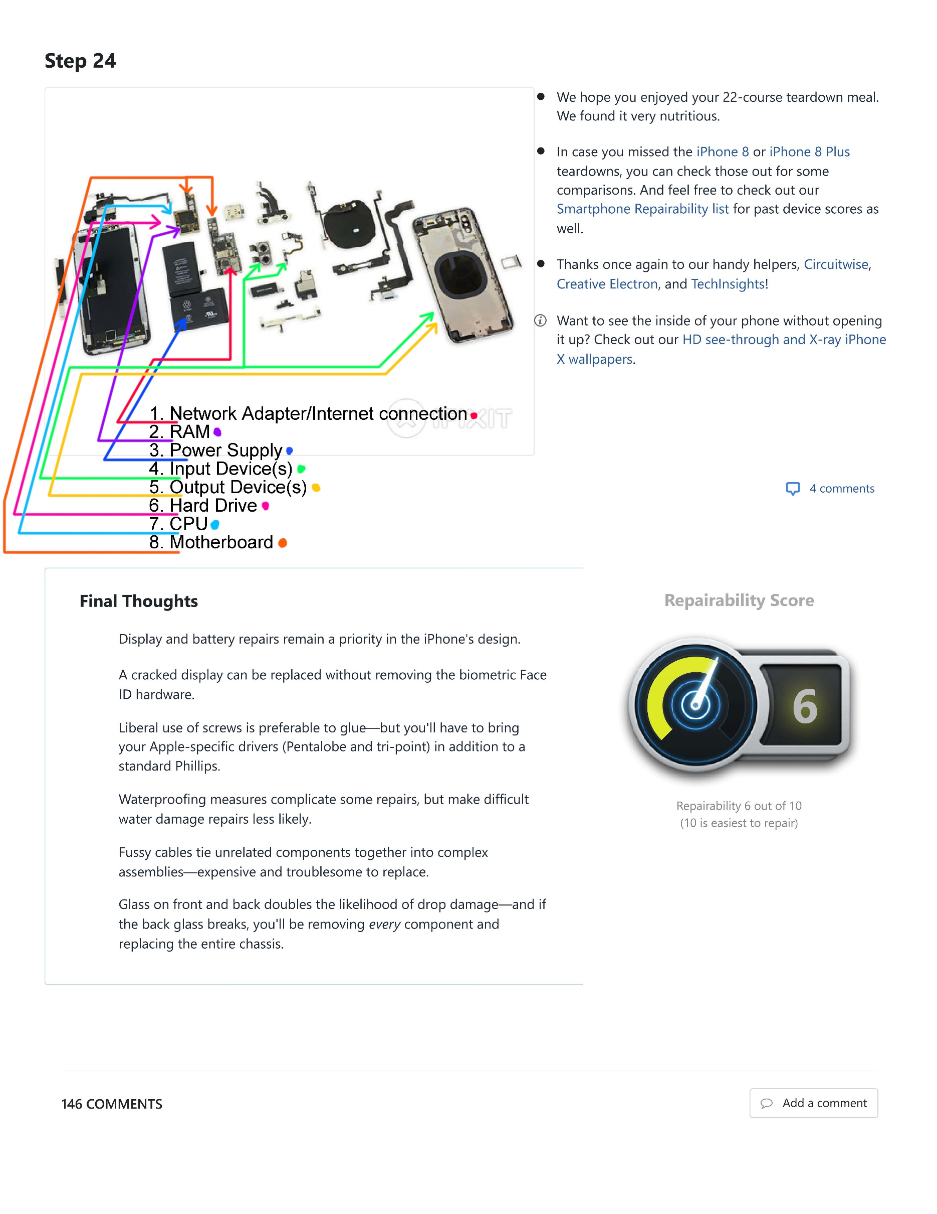

### 3.2 MacBook Air 13 inch (mid 2012 model)

