# Plots for Question 5-1:

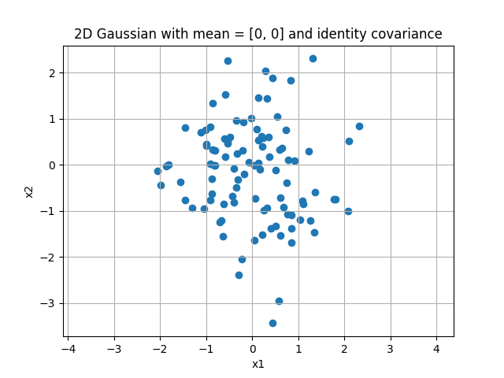

These points are distributed around the origin (the given mean), with most points falling within the range of ±2 for both the x1 and x2 values. There are a few outliers that exceed those values.

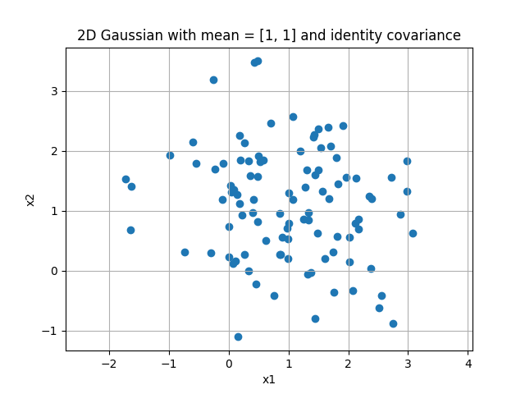

These points are distributed around the given mean [1, 1], with the range shifted so that most points fall within [-1, 3] for both the x1 and x2 values.

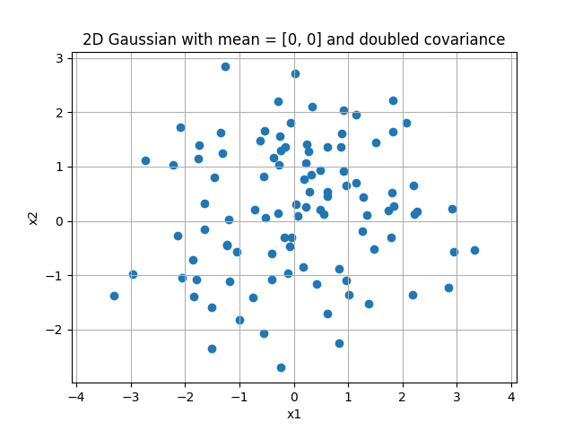

These points are dispersed evenly around the origin, but more widely than was seen with the identity covariance.

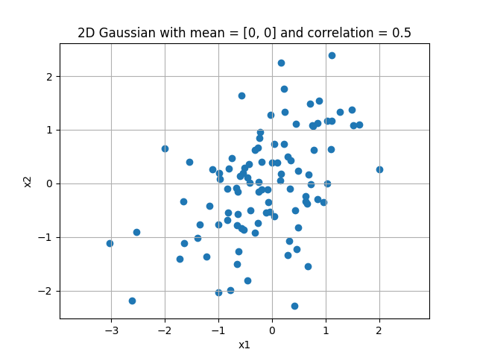

These points are still dispersed around the origin, but with a tendency toward the line y=x due to the correlation value.

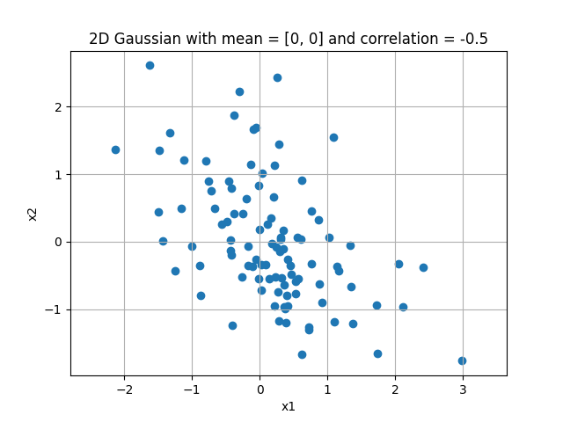

These points are still dispersed around the origin, but with a tendency toward the line y=-x due to the correlation value.