# Assignment 2

1. Classify the following attributes as nominal, ordinal, interval, or ratio. Explain why.
   1. Rating of an Amazon product on a scale of 1 to 5  
      This attribute is **ordinal**. The values have a meaningful order, but the difference between consecutive values (e.g., why a product might be rated as a 4 instead of a 3) is not always clear. In addition, there is no zero value, and mathematical operations are not meaningful.
   2. Internet Speed  
      This attribute is a **ratio**. Internet speed is measured in Mbps, which is inherently a ratio unit. It also has a zero value, and mathematical operations are meaningful.
   3. The number of customers in a store  
      This attribute is a **ratio**. It is a countable, non-negative integer value, with a zero value. In addition, mathematical operations, including ratio operations, are valid on this value.
   4. UCF Student ID  
      This attribute is a **nominal**. It is a unique identifier where ordering and numerical meaning are unimportant. There are no meaningful arithmetic operations and no meaningful comparative operations except equality.
   5. Letter grade (A, B, C, D)  
      This attribute is **interval**, but only because the letter grades have specific percentile ranges assigned to them in the course syllabus. When tied to specific percentile ranges, the differences between letter grades are numerically meaningful. There is no true zero (i.e., 0% is not the absence of a grade), and ratios are not meaningful in the sense that 80% is not “twice as much grade” as 40%. Note that if letter grades were not tied to specific percentile ranges, then they would be similar to the Amazon star rating example, and in that case would be **ordinal**.
2. Given the four boxes, answer the following questions:
   1. Which proximity measure would you use to group the boxes based on their shapes (length-width ratio)?  
      Given that we are comparing length-width ratios, we are concerned with proportionality rather than absolute size. In this case, **correlation similarity** is an appropriate measure. This measure will give a high correlation for boxes that have a similar proportion in length and width.
   2. Which proximity measure would you use to group the boxes based on their size?  
      To group by size, I would use **Euclidean distance**, which compares the difference in size between any two boxes. Compute the Euclidean distance for each of the six possible pairs of boxes (order is unimportant), and then group them by smallest distance.
3. Write Python code to calculate cosine similarity and Euclidean distance using numpy.  
   The code for this question is in the appendices at the end of this document. Here is the output:  
   Cosine Similarity: 0.9746318461970762  
   Euclidean Distance: 5.196152422706632
4. Implement linear regression to find the best linear model for the provided data. Plot the result using matplotlib.pyplot.  
   The code for this question is in the appendices at the end of this document. The console output produced during the run is:  
   Epoch 0: MSE = 5611.166153829125  
   Epoch 100: MSE = 111.05814971560669  
   Epoch 200: MSE = 111.05287287625939  
   Epoch 300: MSE = 111.04760379813368  
   Epoch 400: MSE = 111.04234246981433  
   Epoch 500: MSE = 111.03708887990277  
   Epoch 600: MSE = 111.03184301701742  
   Epoch 700: MSE = 111.02660486979315  
   Epoch 800: MSE = 111.0213744268818  
   Epoch 900: MSE = 111.0161516769518  
     
   Final slope (m): 1.4796491688881985  
   Final intercept (c): 0.10148121497503654

Here is the plot of the data and the regression line:

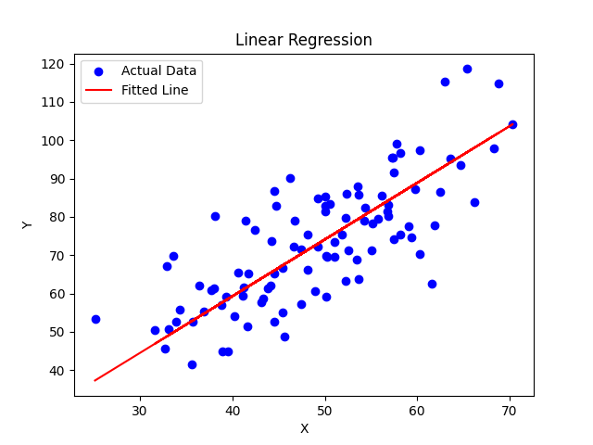

1. Implement non-linear regression to find the best cubic function model for the provided HW2_nonlinear_data.csv. Plot the result.

The code for this question is in the appendices at the end of this document. The console output produced during the run is:  
Epoch 0: MSE = 17080373.135286063  
Epoch 1000: MSE = 593493.028363112  
Epoch 2000: MSE = 592151.1002388574  
Epoch 3000: MSE = 591529.5514476604  
Epoch 4000: MSE = 590910.5835438783  
Epoch 5000: MSE = 590293.4908234598  
Epoch 6000: MSE = 589678.2549125683  
Epoch 7000: MSE = 589064.8583982155  
Epoch 8000: MSE = 588453.2841650217  
Epoch 9000: MSE = 587843.5153890359  
Final coefficients:  
 a=10.655168698725843  
 b=20.970276527941813  
 c=-1.8103041714197277  
 d=7.989333607627859

Here is the plot of the data and the predicted values after training:

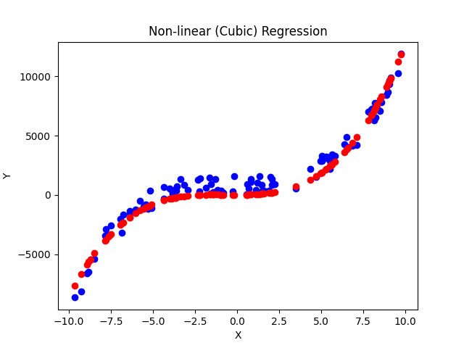

# Appendices

The following pages contain the source code for questions 3, 4, and 5.