**Supplementary Materials and Methods**

**Surgical Procedure**

Prior to surgery, the surgical team implanted a sterile carbon fiber microelectrode into the brain along a guide cannula which was positioned in accordance with DBS navigation and planning. The tip of the fiber was inserted into the dorsal striatum. The body of the caudate was the target for 14 of the measurements and the putamen was the target for the remaining 2 measurements (Table S1). This carbon fiber was used for voltammetry recordings. Once the carbon fiber was situated and recordings had begun the patient began the investment game. For the experiment, patients sat in a semi-upright condition and watched a monitor placed ~1m in front of them. Patients were given a button box to register their bet and submit decisions and used the less-affected side for submitting responses. The box contained four buttons; one was used to increase the bet amount, a second to reduce the bet amount and a third to submit the decision. Button-box responses were recorded and time aligned to the voltammetry recordings.

**Carbon Fiber Fabrication & FSCV**

During surgery, the carbon-fiber electrode was inserted through a guide tube (the guide tube and cannula are the same as those used for clinical microelectrodes). The carbon fiber microelectrode tip measures 7µm in diameter and extended 10mm beyond the guide tube (and embedded reference electrode). The probe was designed for human biocompatibility by modifying existing carbon fiber technology where structural stability and responsiveness to in vivo dopamine release was tested over a period of weeks in the rodent and was safely used in prior work. Our final probe included elongation and custom fitting of the carbon fiber microelectrode to a stereotactic targeting system used during human neurosurgery (here we used FHC microTargeting® system and Leksell stereotactic system®), with a biocompatible reference electrode. See Kishida et al. (Kishida, Sandberg et al. 2011) for construction details. The final human compatible carbon fiber microelectrode assembly was sterilized using ethelene oxide gas.

Serotonin oxidizes at ~0.2V to 0.4V, and produces a reduction reaction at potentials ~0V to -0.2V (Selvaraju and Ramaraj 2003, Wu, Fei et al. 2003, Yao, Li et al. 2009). In general, fast-scan cyclic voltammetry delivers a rapid change in electrical potential around these values to a suitable electrode, ramping up and down over a time scale in the order of milliseconds. Then in the presence of transmitter, the electrode will register changes in current commensurate with oxidation and reduction ion-flow in and around the respective potentials. Here, current measurements were extracted over the course of the experiment at a frequency of 10 Hz. Triangular voltage ramps (-0.6V to +1.4V to -0.6V, at 400V/s) were of 10 msec duration followed by a 90 msec period where voltage was held at -0.6V. This protocol has previously provided behaviorally relevant, trial dependent dopamine measurements (Kishida, Saez et al. 2016), as well as measures of slower signal changes over the course of an experiment (Kishida, Sandberg et al. 2011).

**Serotonin-concentration Model; Training & Testing**

For the laboratory experiments, we fabricated three carbon fiber electrodes according to surgical standards described above. Using these probes we acquired voltammetry recordings from a flow cell, where three types of mixture solutions were measured for each probe. These included solutions containing 1) only serotonin at concentrations of 0-8 μM, in 100 nM increments and saline at a pH level of 7.4, 2) only dopamine, at concentrations of 0-8 μM, in 100 nM increments and saline at a pH level of 7.4, and 3) mixtures of dopamine and serotonin each randomly sampled from the range 0.1 - 8 μM, (at 100nM increments) with varying pH levels from 6.8 to 7.8. From these solutions N ~= 23,000 voltammograms were recorded for each probe, with different solutions passed through the flow cell for each probe.

Using these training sets we optimized a linear multivariate Gaussian regression model using a LASSO (least absolute shrinkage and selection operator) approach (Tibshirani 1996). Specifically, we predicted the square root of each concentration level using the derivative of each voltammogram (Figure 1A). The square root operator was applied to the concentration levels to impose positivity constraints and to condition high concentration estimates. Thus we had dependent variables which were contained in an N x 3 matrix denoted Y: of concentration values for dopamine, serotonin and pH and prediction matrix X which was an N x p matrix of differentiated voltammograms (where p = 1000-1 given a sampling rate of 10 kHz over 100 msec), for each of the N mixtures. This scheme uses a coordinate descent to find the regression coefficient matrix β, here of size p x 3. Using the glmnet package (Tibshirani 1996) we employed cross fold (10-fold) validation to select the optimal lambda parameter for each probe.

$$\hat{β }={argmin}_{β }\frac{1}{2}{\left\|\begin{matrix}Y- & Xβ\end{matrix}\right\|}_{F}^{2} +λ\sum_{k=1}^{p}{{\left\|β_{k}\right\|}_{2}}$$

This λ determines the size of a complexity penalty over regression coefficients - given by the L2-norm of each row of β - relative to the accuracy of the predictions. Given that this L2-norm is computed over each row – this penalty is equivalent to the L1-norm in the univariate setting. The derivative of X was used as a preprocessing step following (Kishida, Sandberg et al. 2011) while the square root operation was performed to ensure positivity in concentration estimates.

Using the estimates ($\hat{β }$) that produce the minimum mean square error over folds, we predicted concentrations in the training probe and the two unseen datasets from the two remaining probes (Figure 1B-D). We analyzed the cross-probe generalizability in terms of prediction accuracy on unseen data by randomly sampling 200 tests from each known concentration level 100 times (0 – 8 μM at 100nM increments) and calculating the root mean squared error for both DA and 5-HT using the average prediction from each concentration level . Over the two chemicals, the R.M.S error in predictions was found to be on average 1.9 μM, 2.3 μM and 2.5 μM for probes 1-3 respectively. Probe 1’s regression model was thus selected to apply to our patient recordings and is reported in Figure 1.

While other analytes could undergo redox reaction at our scanning voltage in the real brain; in particular the 5-HT metabolite 5-H1AA, ascorbic acid, epinephrine and adenosine these signals are unlikely to systematically align with our regression coefficients given their distinct electrochemical profiles. Studies have shown that 5-H1AA does not have a large effect on 5-HT measures (Broderick 1988) in comparison to changing pH or changing temperatures and that epinephrine and ascorbic acid and adenosine can be distinguished from their peak oxidation potential alone (Fang, Pajski et al. 2013, Shankar and Swamy 2014).

**Computing Reward Prediction Errors**

In this game, stock markets rise and fall according to historic recorded prices and we calculate the return on each investment on each trial as a percentage change in market price for each reveal event $r^{t}={ ∆p^{t}}/{p^{t-1}}$. In order to calculate the reward prediction error (RPE) on each trial we employed a running average RPE. For this we considered the bet submitted on that trial, $b^{t}$ and the history of bets and returns over each of the six markets:

$RPE\left(t\right)= \frac{b^{t}r^{t}-E(b^{t}r^{t})}{σ_{t}}$ (Eqn. 1)

With $E\left(b^{t}r^{t}\right)$ the running average return on investment from trial t = 3 for each market and $σ_{t}$ its standard deviation. For trial t = 1 the RPE was set to $b^{1}r^{1}$ and t = 2 was set to the difference: $b^{2}r^{2}- b^{1}r^{1}$. We used this computation of RPE to retain consistency with Kishida et al. 2016. Other computations e.g. including adaptive learning rates could also have been applied but there was no structure per se in the markets that were used in this task.

**Supplementary Figures**

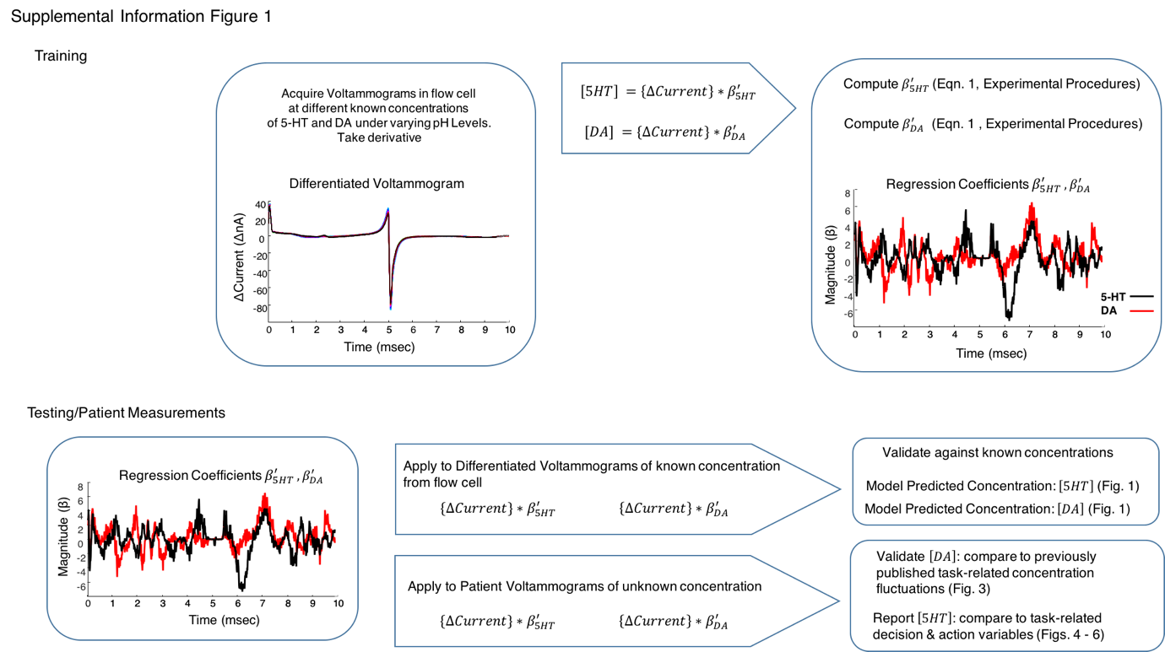

Supplement Figure S1. This flow-chart illustrates the supervised learning approach used to train a regression model which could predict concentration changes in serotonin and dopamine (Top panel). The Bottom panel illustrates how the model was tested *in vitro*; using substances with known amounts of each analyte and *in vivo*; using previously published fluctuations in dopamine.

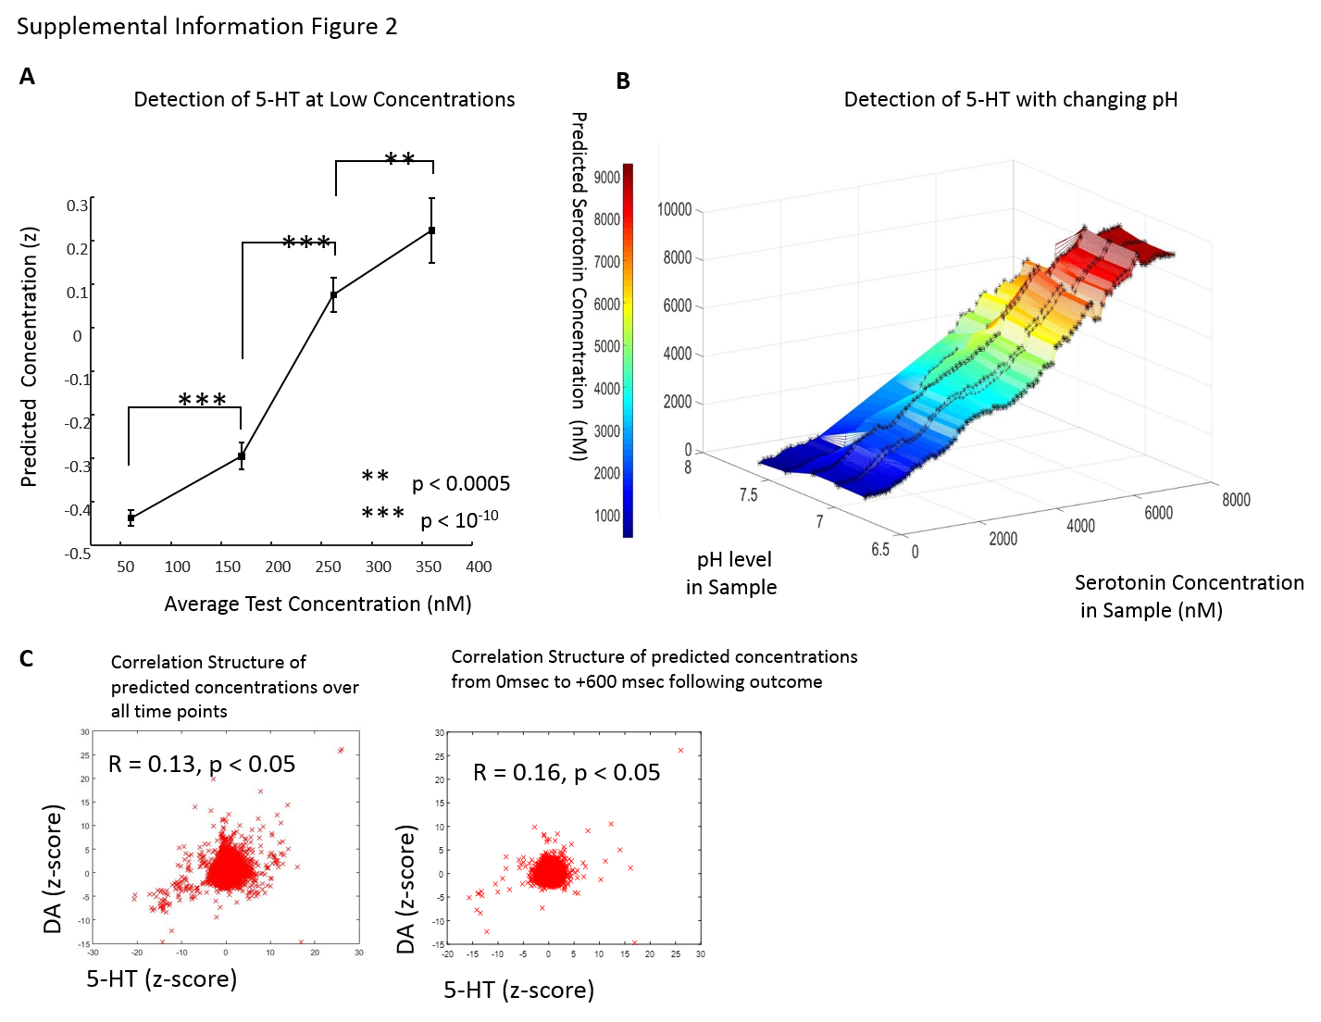

Supplement Figure S2. (A) Using a test-set created out of low-concentration mixtures we tested whether our method could distinguish small fluctuations in 5-HT. We used mixtures with 20-100 nM of 5-HT, (in the presence of fluctuating dopamine) mixtures with 120 – 200 nM of 5-HT, mixtures with 220 – 300 nM of 5-HT and mixtures with 320 – 400 nM of 5-HT. We found that pooling within these concentration bands (x-axis) our method could correctly detect increases across each band (y-axis), with high confidence p < 0.0005. (B) Serotonin predictions are not affected by pH levels in a flow cell using a LASSO regression model. The flow cell predictions are illustrated for serotonin under varying levels of pH in the mixture. Serotonin was sampled at each level of concentration from 0.1 - 8µM in 0.1µM increments. For each of these 80 concentrations we computed the serotonin prediction over different levels of sample pH. Over this test grid we interpolated (using linear triangulation) across the acquired tests samples (denoted by an asterisk) to produce a 3-dimensional heat map of serotonin predictions. This plot show that serotonin predictions do not vary systematically with alterations in pH but remain linear. (C) Correlations among the predicted concentrations were calculated for the whole experiment (left) and at the 0-600 msec time period which is the focus of our analysis. We measured small but positive, correlations among these transmitter estimates which suggests that the RPE effects are not confused between the two transmitters (since they ae negatively correlated in terms of the direction of the expressed effects).

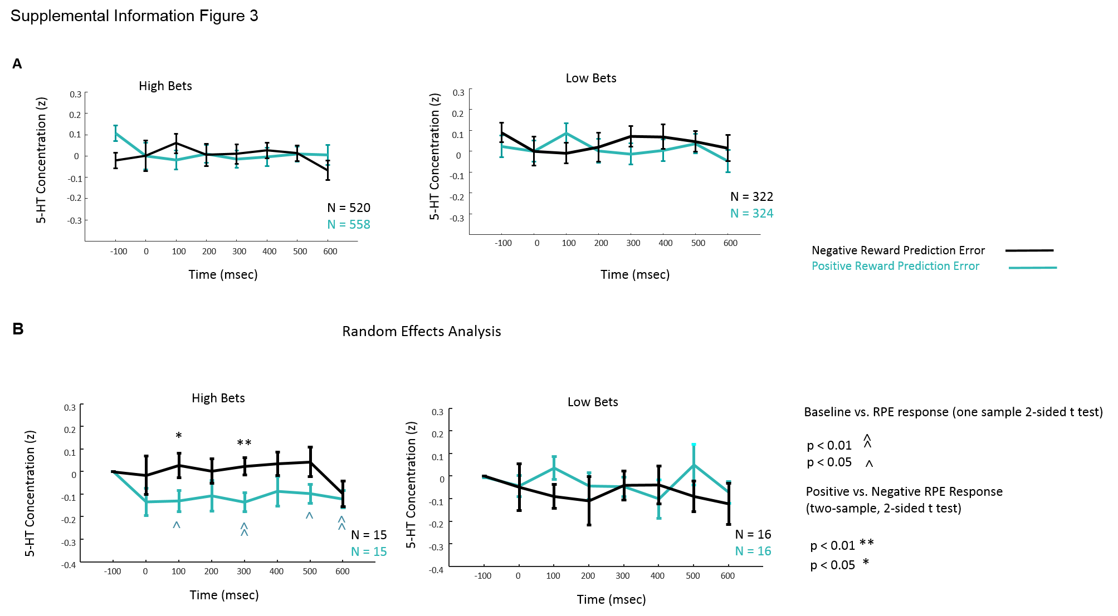

Supplement Figure S3. (A) Here, instead of a pre-stimulus baseline as per (figure 4 main text), we tested a baseline at 0 msec and found a similar profile but reduced-magnitude response. Using a non-parametric approach we tested within each bet level band (high and low), the relative difference of serotonin responses to negative compared to positive reward prediction errors. With this baseline a significant interaction effect of bet on (negative – positive) prediction errors was found for 100 msec with a larger positive response at high compared to low bet levels (p =0.047), consistent with figure 4. However, this did not survive correction. These baseline changes are worth further exploration and have been reported in basal ganglia structures previously for cued stopping and behavioural inhibition tasks in rodents (Schmidt et al. 2013). (B) Using a random effects analysis we tested whether the RPE effect was significant across our population. Specifically, we employed a summary statistic approach – averaging four 5-HT responses (high, low bets and positive and negative RPEs) for each of the 16 records and then performed a two-sample two–sided t test for responses under high and low betting levels (df = 30). We observed a significant effect at high bets for positive compared to negative reward prediction errors (*p < 0.05, **p< 0.05). Using a one sample t test (df = 15), we tested which effects differed from zero and found this effect for positive reward prediction error responses following high bets (^p < 0.05, ^^p< 0.001).

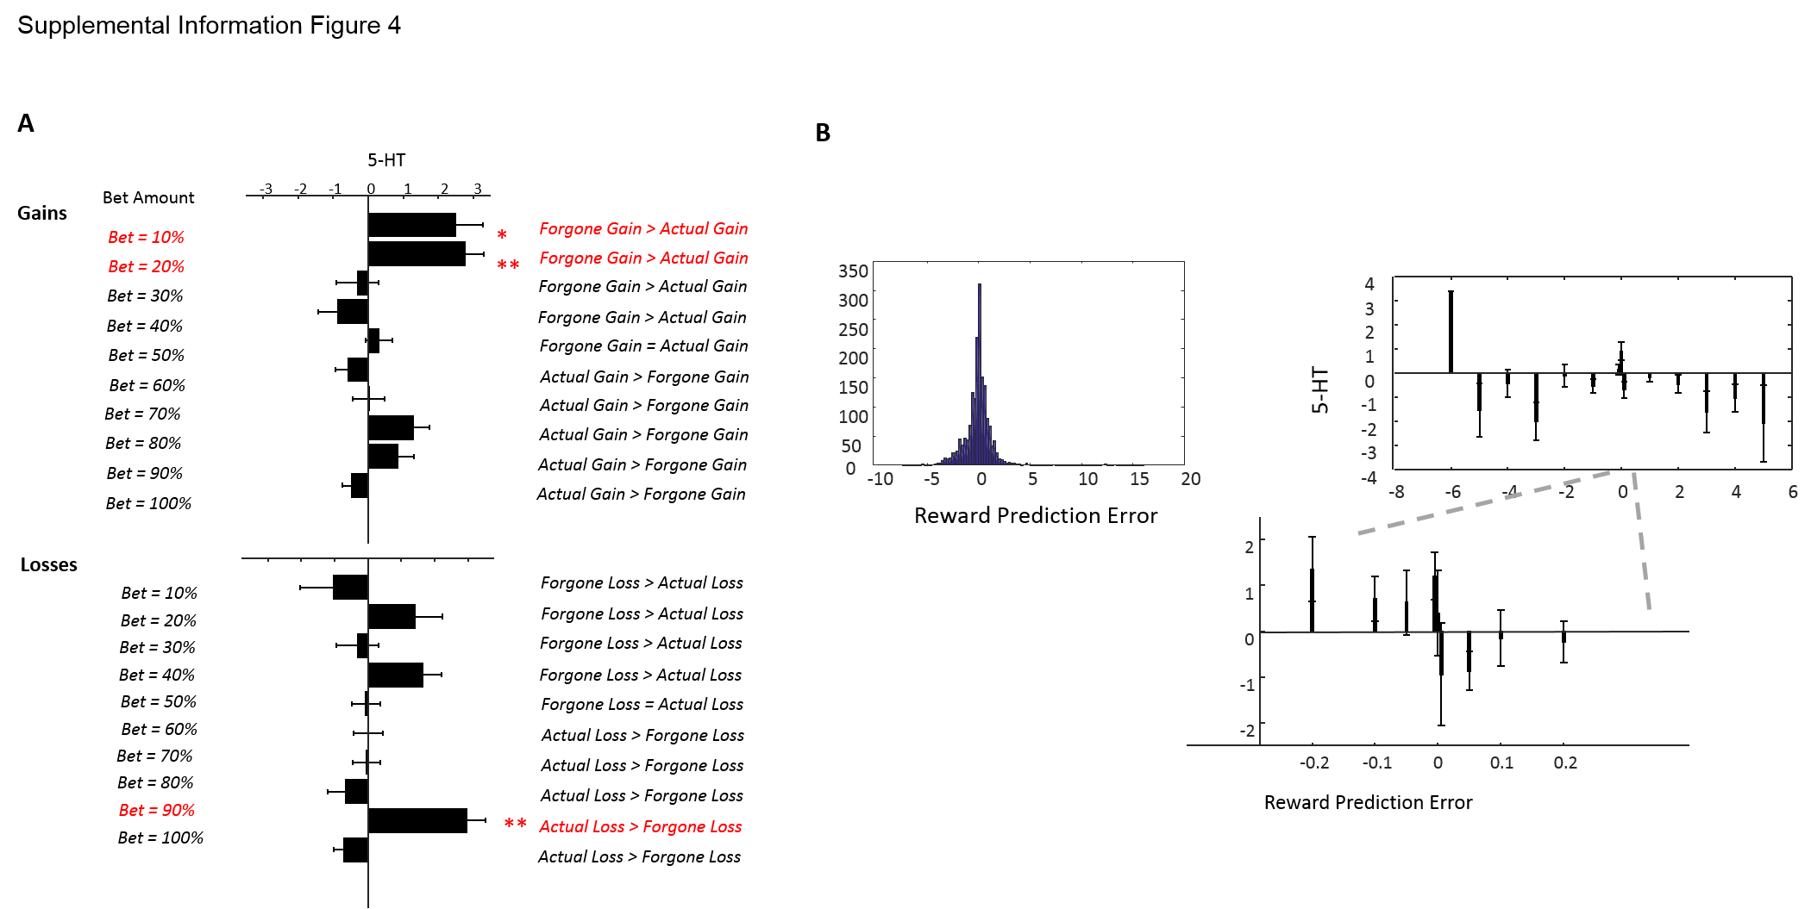

**Supplement Figure S4**. Parametric Investigations

(A)**.** To examine for the subjective ‘flip’ in serotonin responses to actual or forgone gains and losses we split the data at different bet levels. We did not see a consistent parametric effect but rather observed a large responses to positive gains at 10 and 20% betting levels and a large response to actual losses at 90%. The lack of a linear effect (e.g. from which we could calculate an indifference point) could be due to noise or a binary regret/relief cut off that differs for gains and losses.

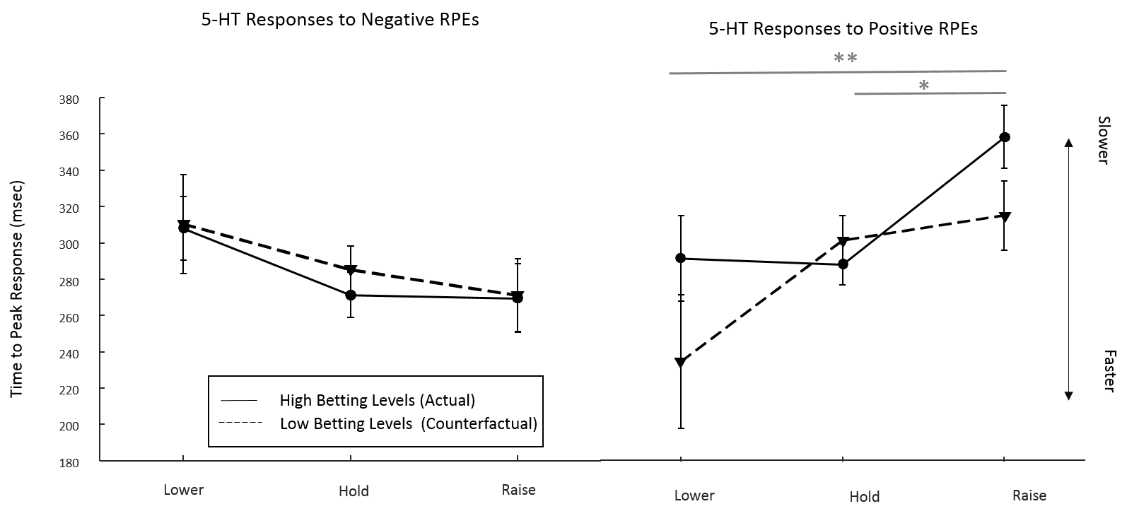

**Supplement Figure S5.** Timing Effects on Decision Making

Timing effects were examined using a 2x3 analysis of variance with time to peak transient the dependent variables and low/high current betting levels and decisions to lower, hold or raise market investments as independent variables. While no significant effects were observed for the responses to negative reward prediction errors, positive reward prediction errors led to transients whose timing was associated with the next decision (main effect of decision, F = 5.59, p = 0.004). Faster transients were observed for hold compared to raise decisions (post-hoc t-test p = 0.022 bonferroni corrected for 6 comparisons; comparing lower and hold, lower and raise and raise and hold for positive and negative RPE outcomes). We also observed a significantly faster response for lower compared to raise decisions (post-hoc t-test p = 0.040 bonferroni corrected for 6 comparisons).

**Supplementary Tables**

**Supplement Table S1.** Patient Demographics and medical status (n = 14, hemispheres = 16) NaN: Unknown

|  |  |  |  |  |  |  |  |
| --- | --- | --- | --- | --- | --- | --- | --- |
| **Patient Number** | **Gender** | | **Age** | **Disease Details** | | **Electrochemical Target** | |
|  | M | F | age_at_surgery | dyskinesia | duration_of_disease | caudate | putamen |
| 1 | 1 | 0 | 54 | 1 | 8 | 1 | 0 |
| 2 | 1 | 0 | 76 | 1 | 9 | 1 | 0 |
| 3 | 1 | 0 | 42 | 1 | 15 | 0 | 1 |
| 4 | 1 | 0 | 63 | 1 | 5 | 1 | 0 |
| 5 | 1 | 0 | 70 | 0 | 7 | 1 | 0 |
| 6 | 1 | 0 | 65 | 0 | 4 | 1 | 0 |
| 7 | 1 | 0 | 56 | 1 | 13 | 1 | 0 |
| 8 | 0 | 1 | 71 | 1 | 7 | 1 | 0 |
| 9 | 1 | 0 | 64 | 0 | 4 | 1 | 0 |
| 10 | 1 | 0 | 52 | 0 | NaN | 1 | 0 |
| 11 | 1 | 0 | 51 | 0 | 7 | 1 | 0 |
| 12 | 0 | 1 | 74 | 1 | 10 | 0 | 1 |
| 13 | 1 | 0 | 64 | 0 | NaN | 1 | 0 |
| 14 | 1 | 0 | 63 | 0 | 4 | 1 | 0 |

|  |  |  |  |  |  |  |  |  |
| --- | --- | --- | --- | --- | --- | --- | --- | --- |
| **Patient Number** | **5-HT Medication (On during task)** | | | | **Dopamine Medication (Off during task)** | | | |
|  | SSRIS | SNRS | SARIS | TCAS | NDRI_D | DA_agonists | MAOB_inhibitors | DA_replacement |
| 1 | 0 | 0 | 0 | 0 | 0 | 0 | 0 | 1 |
| 2 | 0 | 0 | 0 | 0 | 0 | 1 | 0 | 1 |
| 3 | 0 | 0 | 0 | 0 | 0 | 0 | 0 | 1 |
| 4 | 0 | 0 | 0 | 1 | 0 | 1 | 1 | 1 |
| 5 | 0 | 0 | 0 | 0 | 1 | 0 | 0 | 1 |
| 6 | 1 | 0 | 0 | 0 | 0 | 0 | 0 | 0 |
| 7 | 0 | 0 | 0 | 0 | 0 | 1 | 1 | 1 |
| 8 | 0 | 0 | 0 | 0 | 0 | 1 | 0 | 1 |
| 9 | 1 | 0 | 0 | 0 | 0 | 1 | 1 | 1 |
| 10 | 0 | 0 | 0 | 0 | 1 | 0 | 0 | 1 |
| 11 | 0 | 0 | 0 | 0 | 0 | 0 | 0 | 1 |
| 12 | 0 | 0 | 0 | 0 | 0 | 1 | 0 | 1 |
| 13 | 0 | 0 | 0 | 0 | 0 | 1 | 0 | 1 |
| 14 | 0 | 0 | 0 | 0 | 0 | 1 | 1 | 1 |

|  |  |  |  |  |
| --- | --- | --- | --- | --- |
| **Patient Number** | **Norepinephrine (On during task)** | | | **GABA (On during task)** |
|  | NDRI_N | TCA_N | SNRI_N | GABA_analogues |
| 1 | 0 | 0 | 0 | 0 |
| 2 | 0 | 0 | 0 | 0 |
| 3 | 0 | 0 | 0 | 0 |
| 4 | 0 | 1 | 0 | 0 |
| 5 | 1 | 0 | 0 | 0 |
| 6 | 0 | 0 | 0 | 0 |
| 7 | 0 | 0 | 0 | 0 |
| 8 | 0 | 0 | 0 | 1 |
| 9 | 0 | 0 | 0 | 0 |
| 10 | 1 | 0 | 0 | 0 |
| 11 | 0 | 0 | 0 | 1 |
| 12 | 0 | 0 | 0 | 0 |
| 13 | 0 | 0 | 0 | 0 |
| 14 | 0 | 0 | 0 | 0 |

|  |  |  |  |  |
| --- | --- | --- | --- | --- |
| **Patient Number** | **Depression** | | **Anxiety** | |
|  | current_depression_dx | past_or_unclear_depression_dx | current_anxiety_dx | past_or_unclear_anxiety_dx |
| 1 | 0 | 0 | 0 | 0 |
| 2 | 0 | 0 | 0 | 0 |
| 3 | 0 | 0 | 0 | 0 |
| 4 | 0 | 0 | 0 | 0 |
| 5 | 0 | 1 | 0 | 0 |
| 6 | 1 | 1 | 0 | 0 |
| 7 | 0 | 0 | 0 | 0 |
| 8 | 0 | 0 | 0 | 0 |
| 9 | 1 | 0 | 0 | 0 |
| 10 | 0 | 1 | 0 | 0 |
| 11 | 0 | 1 | 0 | 0 |
| 12 | 0 | 0 | 0 | 0 |
| 13 | 0 | 0 | 0 | 0 |
| 14 | 0 | 0 | 1 | 1 |

**Supplement Table S2.** Predicting Action Selection

|  |  |  |  |  |
| --- | --- | --- | --- | --- |
|  | Estimate | Standard Error | T Statistic | P Value |
| **Intercept** | 0.12296 | 0.010 | 11.915 | 0 |
| **x1** | 0.003 | 0.002 | 1.245 | 0.213 |
| **x2** | -0.191 | 0.0148 | -12.927 | 0 |
| **x3** | -0.0089 | 0.0106 | -0.836 | 0.403 |
| **x1*x2** | -0.007 | 0.0035 | -2.012 | **0.044** |
| **x1*x3** | -0.002 | 0.0026 | -0.770 | 0.441 |
| **x2*x3** | 0.054 | 0.015 | 3.547 | 0.0003 |
| **x1*x2*x3** | 0.0055 | 0.0037 | 1.50 | 0.133 |

Results of our regression analysis show that together the serotonin response (x1), current bet level (x2) and sign of the reward prediction error (x3) on trial (t), as well as their two-way (x1*x2, x1*x3, x2*x3) and three-way interactions (x1*x2*x3), predict the change in investment on trial (t+1): F-statistic vs. constant model: 32.4, p-value < 0.00001. Individually, the current betting level is a significant predictor of change in bet (At low betting levels participants tended to increase their bets and at high betting levels participants tended to decrease their bets). Importantly the interaction of serotonin responses and current bet levels (**x1*x2**) is also a significant predictor of change in bet. In other words, for large serotonin responses and large bets, participants tended to decrease their bet and vice versa. We also found a trend-level significant three-way interaction of serotonin, bet level and RPE sign in predicting the next response. Figures 5 and 6 investigate these interaction effects in more detail.